### **1. Nondeterministic automaton**

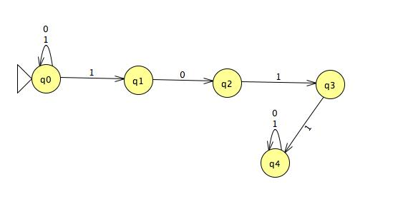

### **2. Conversion to deterministic automaton**

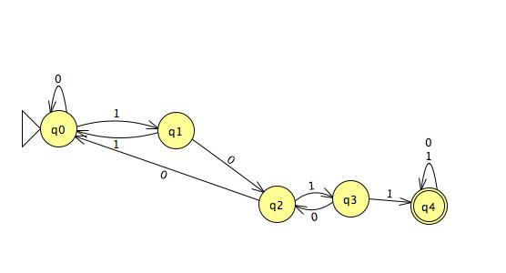

|  |  |  |
| --- | --- | --- |
| state | 0 | 1 |
| q0 | q0 | q1 |
| q1 | q2 | q0 |
| q2 | q0 | q3 |
| q3 | q2 | q4 |
| q4 | q4 | q4 |

### **3. Larger alphabet**

I do think a machine with the the alphabet {a,b,c,d} is indeed more powerful. Let’s try to mimic a machine with alphabet with {a,b,c,d} by a another simpler machine with only {0,1}. Let’s set a = 0, b = 1, c =01, d =00. Then the first following image shows the DFA of the simpler machine to detect a,b,c,d and the second following image shows DFA of the larger alphabet machine to detect a,b,c,d. In the first image, in order to detect letter d and c, the machine has to make exact 2 decisions but in the second image, the machine only requires one decision which means less computing, more efficiency. By this reasoning, I do think a machine with the the alphabet {a,b,c,d} is indeed more powerful.

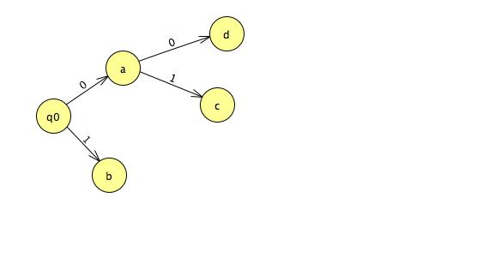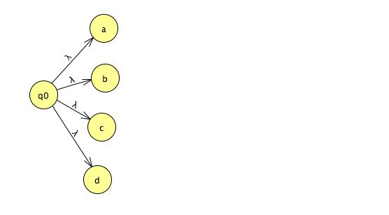

### **6. Regular Expression Practice**

0*10*