# FOCS Homework for Day 9

You may edit your answers into this file, or add a separate file in the same directory.

If you add a separate file, please include the following at the top:

```

Student Name: Zhecan Wang[change to your name]

Check one:

[ ] I completed this assignment without assistance or external resources.

[1] I completed this assignment with assistance from ___

and/or using these external resources: ___

```

## 1. For each of the following languages, decide whether it is regular

For each of the following languages, decide whether it is regular. If it is regular, give a regular expression or finite automaton that recognizes the language. If it is not regular, demonstrate that using the pumping lemma.

a) Strings containing only the symbol a whose length is a power of 2 (*i.e.* length 2^n)

[The strings `a`, `aa`, `aaaa`, and `aaaaaaaa` are in this language; the string `aaaaa` is not.]

Let this language, L be a regular language. Then there exists an integer p≥1 such that every string w in L of length at least p can be written as w=x(y^i)z, satisfying the following conditions: |y|≥1 xy|≤p and for all i≥0, x(y^i)z∈L. In our case, in order to let x(y^i)z still in L, y has to be the distance between consecutive 2^n. However, the difference between 2^n is not consistant so we cannot find such y value. Thus a^(2^n) cannot be guranteed to be still in L.

b) All strings with an equal number of occurrences of the substrings `01` and `10`.

[010 is in this language; `000110` is in the language; `0101010` is in the language; but `010101` is not.]

In order to let the string be in the language, since it is binary, we only need to make sure the string starts or ends with the same character (either both 0 or both 1). Thus, the regular expression will be (0+Σ0+|1+Σ1+).

c) All strings (over {0,1}) consisting of a substring _w_ followed by the reverse of the substring.

[The strings `00100100` and `11110101011010101111` are in this language; the strings `00100` and `010101 `are not.]

Let language L = {ss^R| w contains only strings over {0,1}} be a regular language, then there exists an integer p≥1 such that every string w in L of length at least p can be written as w=x(y^i)z. Let say if the loop y is bigger than the length of s and smaller than the length of ss^R, then x(y^i)z cannot be in the language for different i values. If the loop is within the range of s, as we increase the iteraion of y,s^R would not still be the reverse of new updated s. So the string fails to be in the string again. There is one case when the loop is exactly at the center of the whole string which means it covers the same length of s and s^R. Only in this case, if we increase y, the string will still be in the language. So since we cannot prove that all possible loops of the strings faill to be in the language, we cannot officially state there that the language is not regular. However, intuitively the first part of the lanuage, s can be infinitely long before reaching the reverse part. In order to track the pattern, we need infinitely states in the machine to do this. In that sense, this should be non-regular still.

## 2. Play the pumping game

Play the **pumping game** (referenced on the [Day 8 page](https://sites.google.com/site/focs16fall/in-class-exercises/day-8) and also found at [http://weitz.de/pump/](http://weitz.de/pump/)). Solve at least two puzzles from that page (that do NOT appear in question 1, above) and provide the word you chose, the substring the computer chose, and your successfully pumped string.

Notation notes:

- The notation |w| sub a means the number of `a`'s in the word _w_.

- _a_^_n_ means _n_ occurrences of `a` (e.g. _a_^8 is `aaaaaaaa`)

If you have other questions about notation (or anything else), please post them to [Piazza](https://piazza.com) so that we can clarify for everyone.

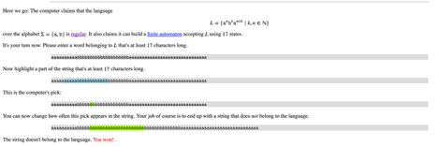

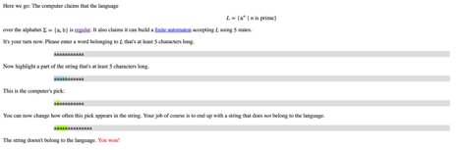

## 3. Create a PDA

For one of the non-regular languages in problem 1 or 2 above, create a PDA (preferably in JFLAP) and include it with your completed homework.

L={𝚊^n𝚋^k𝚊^(n+k)∣k,n∈ℕ}

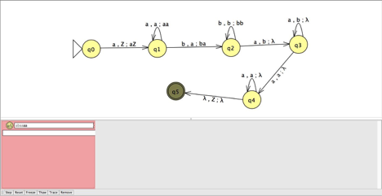

## 4. Reading

Done

## 5. Install gprolog

Done