PHINMA-Cagayan de Oro College  
Max Suniel St. Carmen, Cagayan de Oro City  
College of information Technology  
  
  
  
Max Suniel Street Foods  
  
  
  
  
  
Submitted by:   
  
Mila Mae G. Daluz  
Jansmile G. Aligato  
Zhedrick A. Mangondato  
Princess Aliah F. Mangondato  
  
  
  
Section:   
  
COC-FA2-ITE1-03  
  
  
  
  
Submitted to:   
Joannie Mae T. Taypin  
  
  
  
  
  
  
  
  
April 12, 2023  
  
 **PHASE 1: Proposal**  
  
  
**TITLE**: Max Suniel Street Foods

**HOME PAGE** - An overview of our Max Suniel Street foods and its location.  
 - The different variety of street foods to choose from that are cost-effective.  
  
 **SITEMAP**

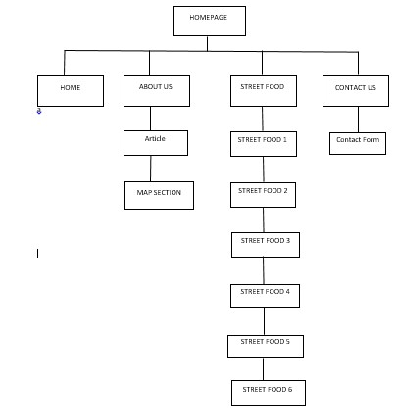  
  
  
  
  
  
  
  
  
  
  
  
**ABOUT US**

We created this website to assist, support, and recognize the various types of street foods that are available near the school campus that are cost-effective, especially for those people/students who are hungry and wants to save money. The website focuses on street foods that we see located at Max Suniel St. near Phinma COC.  
  
  
  
  
  
**GALLERY**

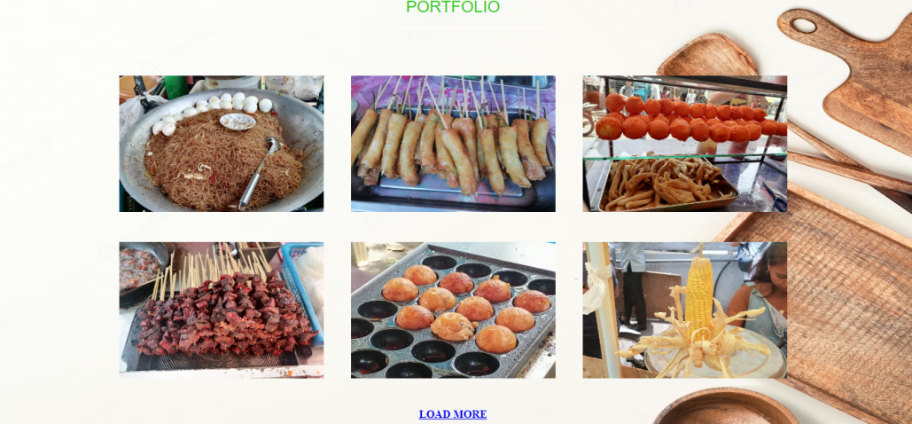

This feature shows the insight of the content on the website, were there are many foods to choose from and the descriptions of different kinds of street foods that are only available near the campus.

**CONTACT US**

Contact number: 0991178505

Location: Max Y. Suniel St, Cagayan de Oro 9000 Misamis Oriental  
  
Social media links:   
  
https://www.facebook.com/profile.php?id=100091692762754&mibextid=ZbWKwL  
  
  
  
  
  
  
**POSSIBLE FEATURES**

* LOCATION MAP-Shows location of possible street food shop near at the site and this well help the user to identify where it’s located.
* PRODUCT CATALOG- This shows the classifications of the food.
* HEALTH CONTENTS- For able to help the user to maintain health issues regarding to the food it takes to provide information of how much carbohydrate the it takes for consuming a specific street food .
* USER FEEDBACK -A feature that allows the user to submit their own comment about the website and to their own idea about other street food.

Our website is effective that we simply use a simple and minimalist design that could attract user especially those who don’t have idea where to eat. This website is easy to learn and use, by considering the users’ needs and minds that we create a website that is intuitive and user-friendly

**IV. MOCKUPS**

|  |
| --- |
|  |

|  |
| --- |
| **HOMEPAGE**  LOGO  Portfolio  HOME ABOUT US FOODS CONTACT US      **PAGE 1** **PAGE 2**    About Us  **PAGE 3**  Send  CONTACT US |

**II. WIREFRAME**

**III. STORYBOARD**

|  |  |  |
| --- | --- | --- |
| ARTICLE ELEMENT  PAGE 3  PAGE 2  PAGE 1  HOMEPAGE  Header Section  Map Section  Contact Page  SEND  Main Content Section  Features and Benefits | | |
|  |
|  |
|  |
|  |
|  |
|  |
|  | |
|  | | |
|  | | |
|  | | |
|  | | |
|  | | |