Final Report

Group : Zhe Yang, Zidong Yao, Lei Nie, Xiaoyin Li

- Overview

Traffic accidents are a major source of fatalities and serious injuries. Our report is based on the USSeatbelts data to predict the number of fatalities per million of traffic miles.

The balanced panel data is for the years 1983–1997 from 50 US States, plus the District of Columbia, for assessing traffic fatalities and seat belt usage. The dataset contains a total of 12 variables. State, year, miles, fatalities, seatbelt, speed65, speed70, drinkage, alcohol, age, enforce.

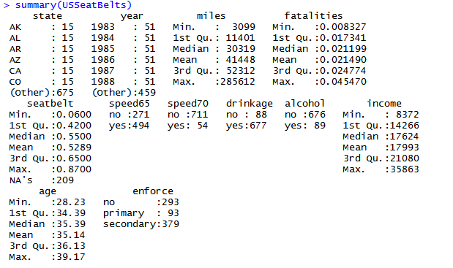

There are some missing values which reveal NAs in seatbelt. We removed the missing values and then analyze the variables.

First of all, we use xyplot to analyze the correlation between the time and fatalities based on the different states.

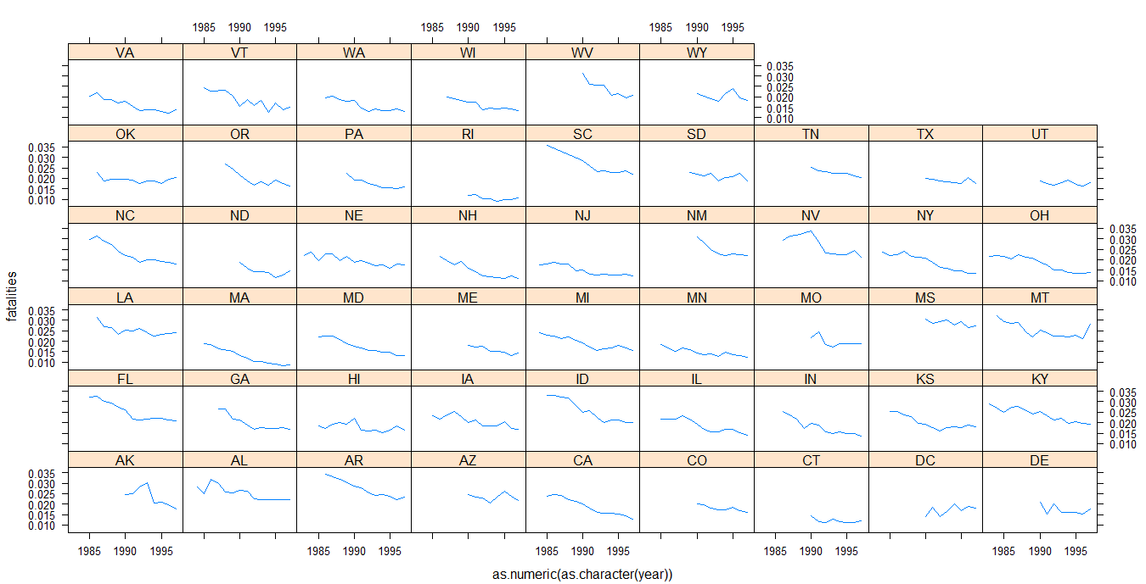

Obviously, we can notice that with the time goes by, the fatalities went down. And then in order to find correlation between all the variables, we decided to use scatter plot matrix to analyze them.

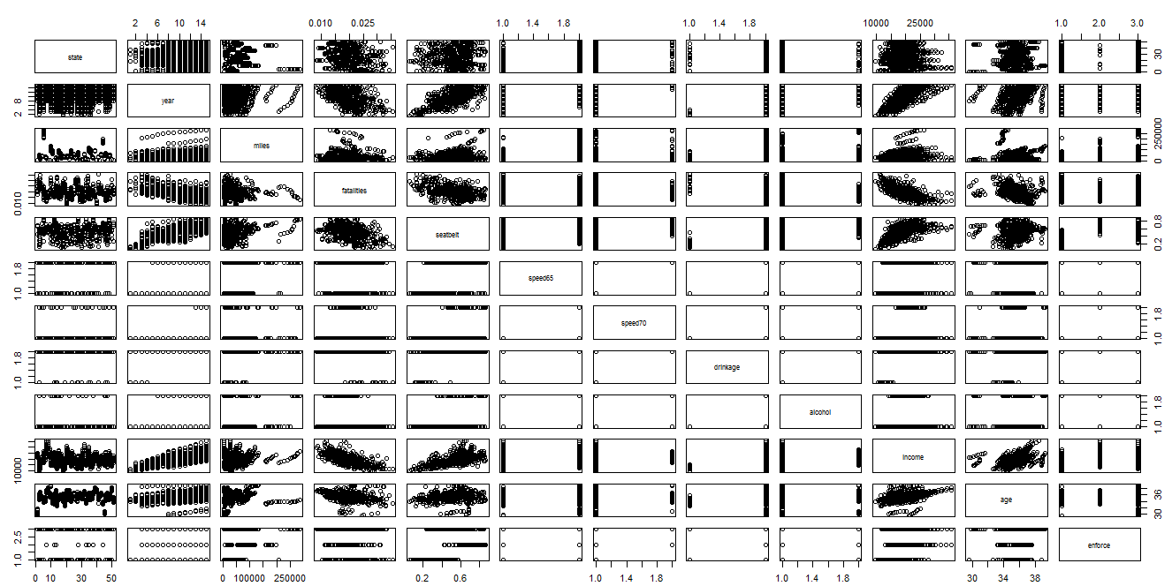

Because there are too many states and factors variables in this plot, we try to remove the factor variables and chose one state to draw scatter plot again.

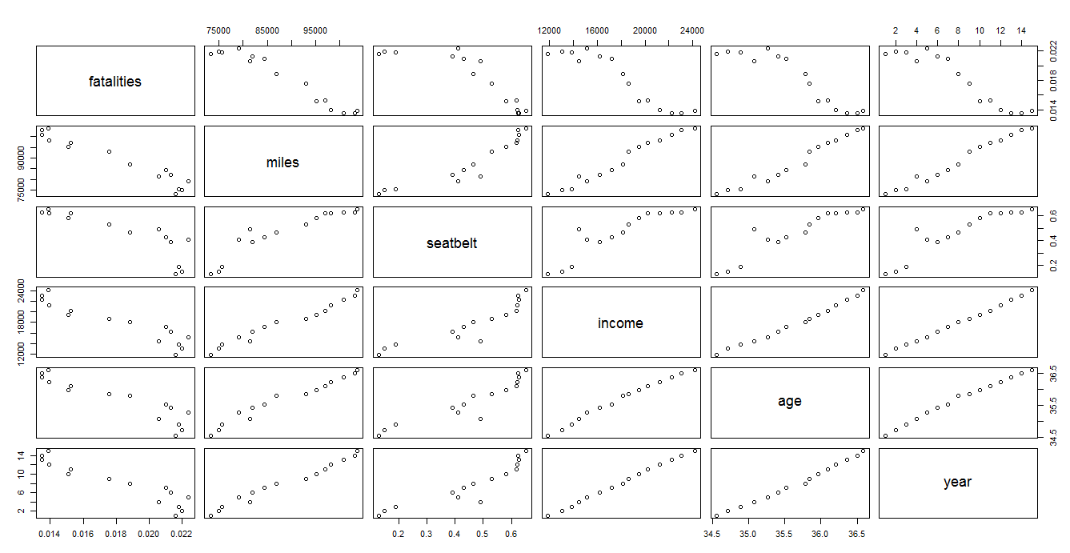

Considering the scatter plot matrix, it shows clearly that each numeric variables are correlated to each others and are serial correlated to years. So, we decided to use linear model to fit the data at the beginning.

- Linear Model
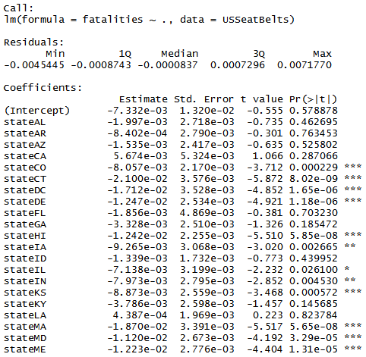
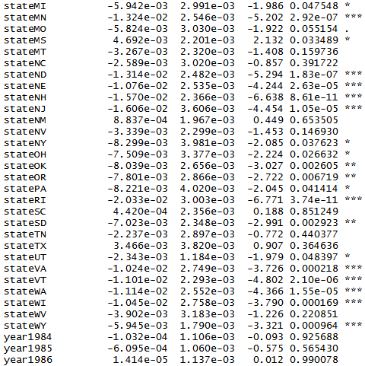
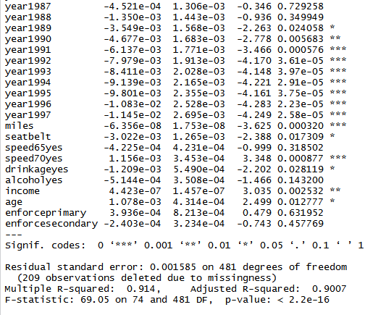
From the summary, we can see the coefficients of years go down roughly, which accords with the analysis before of the xyplot between fatalities and time. And the coefficient of seat belt usage rate is -0.003, which means the higher seat belt usage rate causes the lower fatalities. It makes sense. But the absolute value of coefficient is too small, which means the seat belt usage rate doesn’t have an influence to reduce the fatalities as significantly as we expected. The coefficient of alcohol is -0.0005, which means if there is a maximum of 0.08 blood alcohol content, the fatalities will be lower. What is more, the coefficient of speed65 is -0.0004 and the coefficient of speed70 is 0.001, which means higher speed limitation may cause the higher fatalities. Additionally, the coefficient of drinkage is -0.037, which means if there is a minimum drinking age of 21 years, the fatalities will be lower. They also makes sense. However the coefficient of enforce primary is 0.0004, which means if there is a seat belt law primary enforcement, the fatalities will be higher. It clearly makes no sense. We also noticed that the adjusted r-square of this model is 0.9007 close to 1. We think fit degree is pretty good.

Then we plotted fit plot.

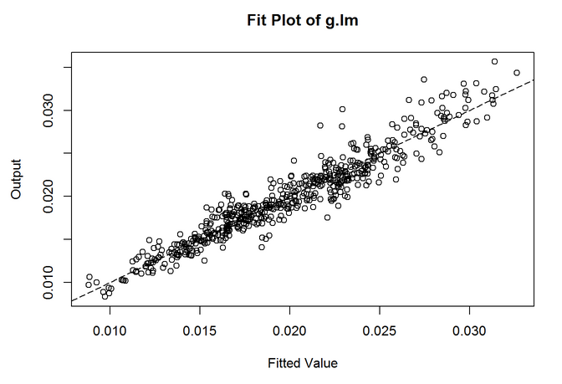
From that plot we can visually find the fit line fits well.

We also plotted the residuals vs fitted plot,normal QQ plot, scale-location plot, residuals vs leverage plot.

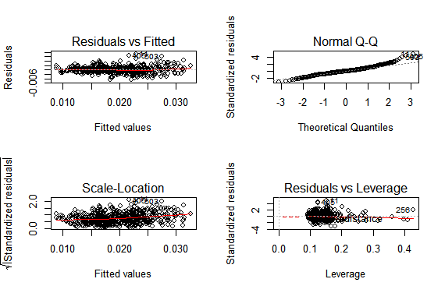

From our plot above, we can see that the Scale-Location plot show some evidence of heterskedasticity, and in Normal Q-Q plot, we can see that residuals are not in normal density distribution. Than we use Shapiro-Test to check.
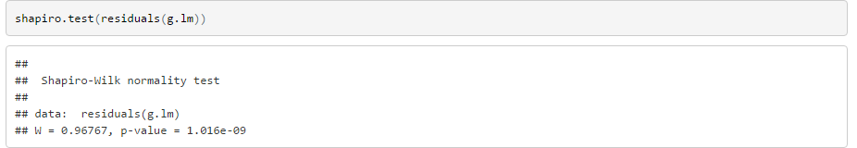
The Shapiro test value is pretty small, we can conclude that in our linear model the residuals are not in normal density distribution.

Since the linear model is not good enough, we decided to use adjusted linear model to fit the data. We used logarithmic function with fatalities.
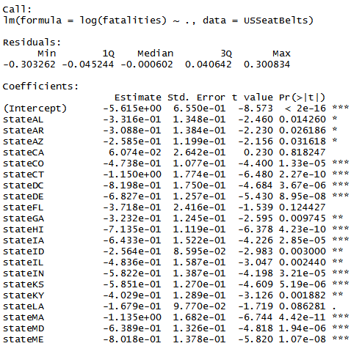
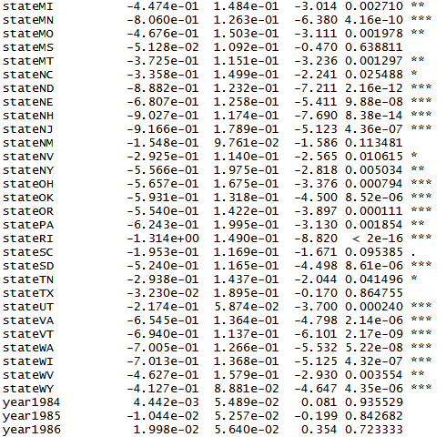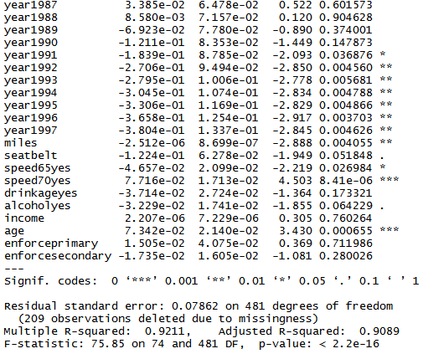
From the summary we can see the coefficients of years also go down roughly , which accords with the analysis before of the xyplot between fatalities and time. And other coefficients are roughly same with the linear model, except age. The coefficient of age increased sharply from 0.001 to 0.07. However, we don’t believe age is a key factor causing the traffic fatalities. And the adjusted r-square of this model is 0.9089, which is better than the linear model’s.

We also plot the fit plot, residuals vs fitted plot,normal QQ plot, scale-location plot, residuals vs leverage plot.

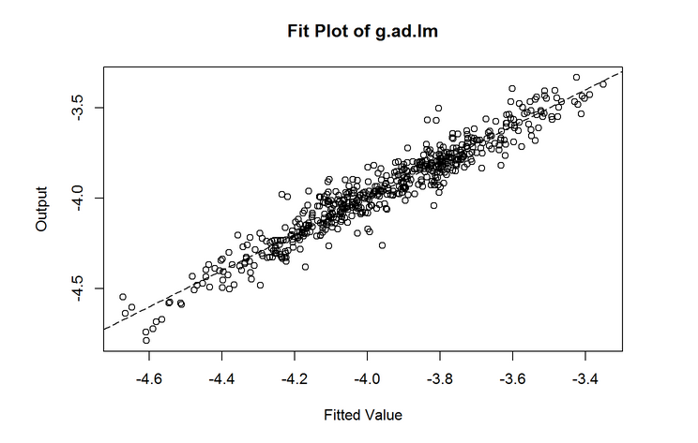

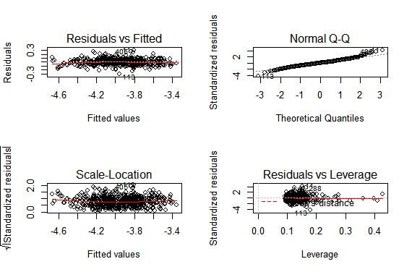

We can find that in this plot the residuals are much better than our initial linear model, it looks much more like a normal density distribution.

And we use Shapiro test again.

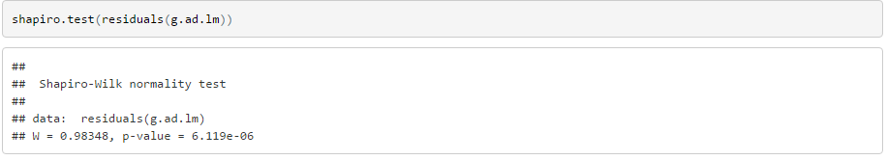

The result is better in our initial model, however, it is still less than 0.05, we still need to reject our NULL hypothesis.

And then we compared these plots between the linear model and adjusted model.

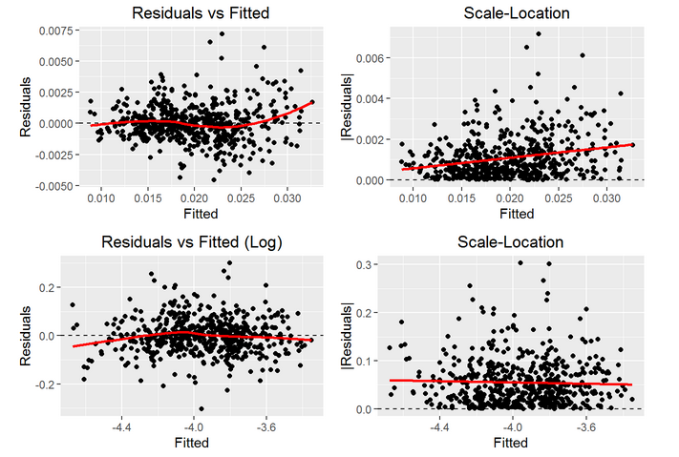
In our Scale - Location plots, we can find that there are evidences of heterskedasticity in initial model, and in our adjusted model, the smooth line is horizontal. Therefore we think that adjusted one is better.

Then we use Durbin-Watson test, VIF, and ACF to analyze out initial and adjusted linear model.

Durbin-Watson test

We can see that the Durbin-Watson value in these two linear models is less than 1.5, which means that the residuals have evidence of serial correlation with residuals themselves. This is not good for a linear model.

VIF test

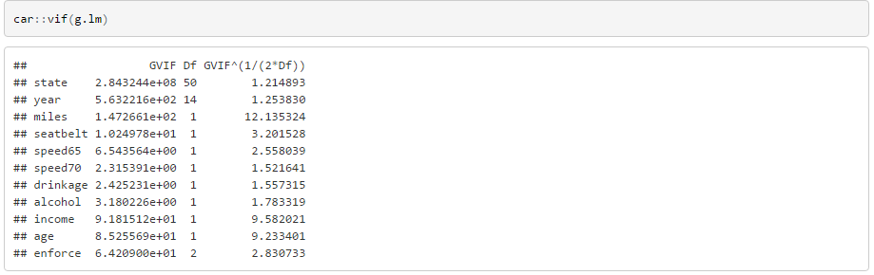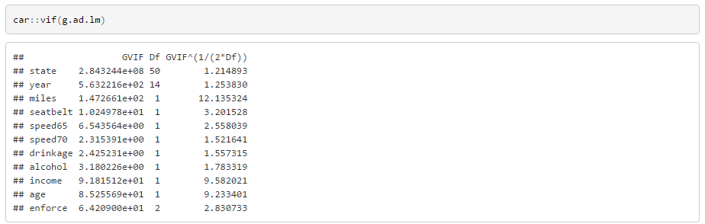

We can find that in our two linear models, miles, income, age have VIF value bigger than 4, which means that they can be predicted by other predictors in our model. This is not a good sign for linear models.

AIF Plot

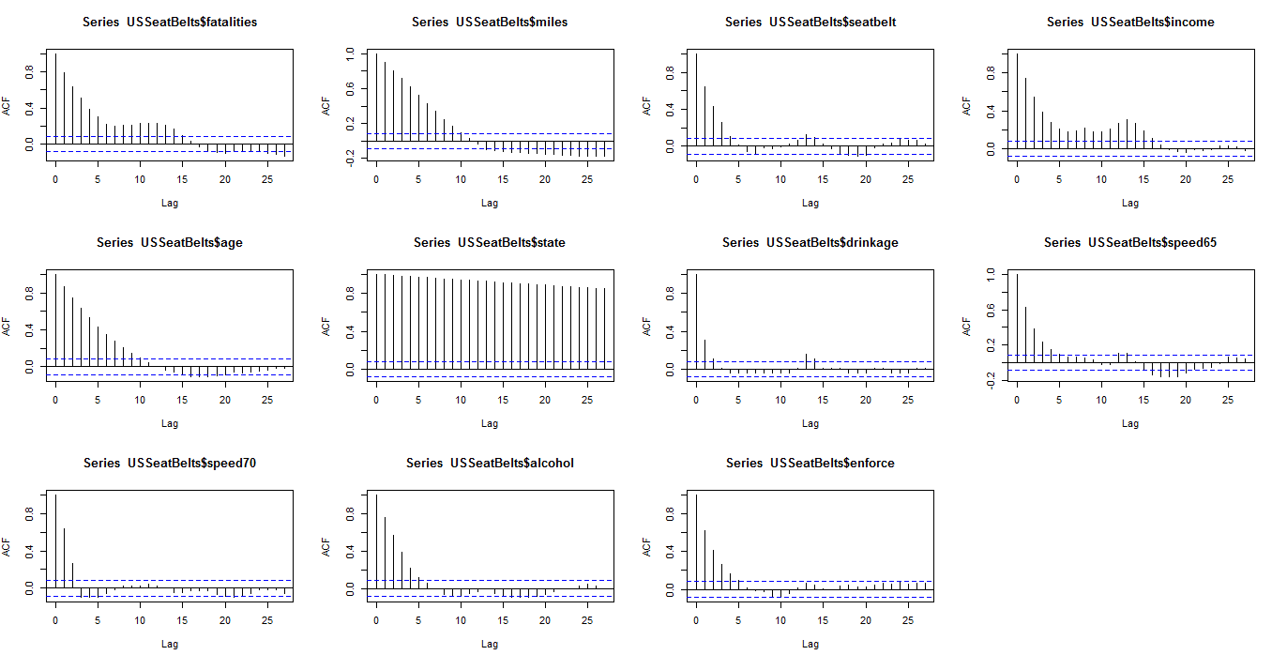
We can find that all factors except drinkage are statistical significant in first and second lag. This means that they are correlated with time. Just like we assume in before, we can use GLS model to fit.

- GLS model

Eventually we tried to use GLS model with logarithmic function on fatalities to fit data.

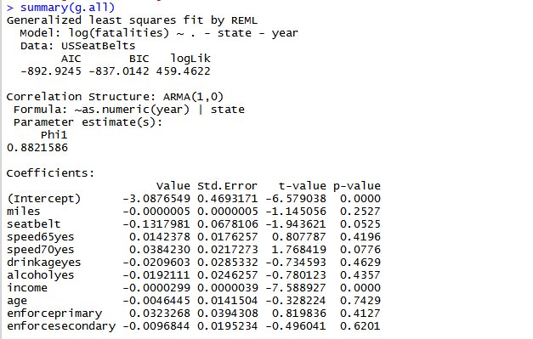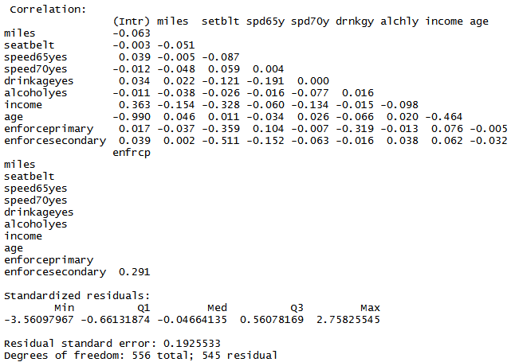

According the following result plot, we find the coefficient of seat belt is -0.13, which is more accord with our expect than linear model and adjusted linear model. And all the other coefficient make sense except enforce primary that is equal to 0.032, which means if there is a seat belt law primary enforcement, the fatalities will be higher. It makes no sense.

Then we plot the fit plot of GLS model with all the variables.

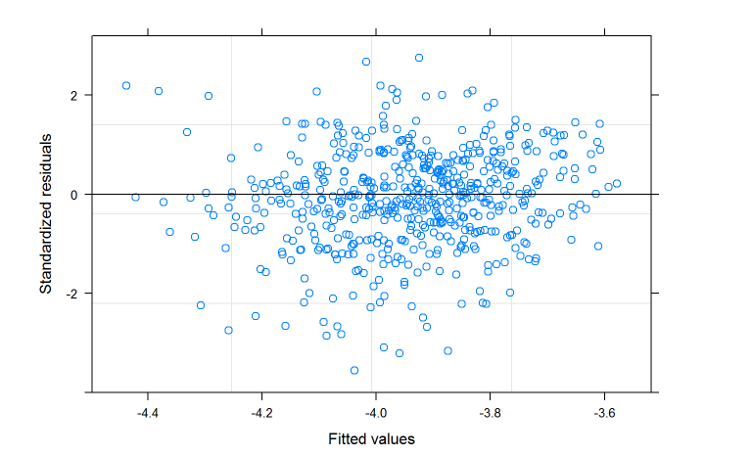

It looks not bad. However, the p-values of many factors are bigger than 0.05, so we need to remove some of them to make our model better.

Since we cannot use step function on GLS model in R studio. We decided to select variables manually.

Step 1, we removed age. because the P-value of age is 0.7429 which is greater than 0.1.
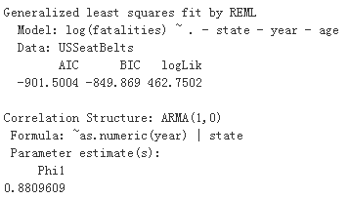

Step 2, we removed enforce. because the P-value of enforce is 0.4114 which is greater than 0.1.
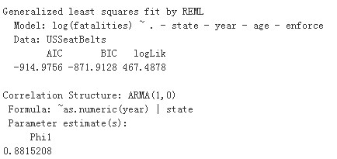

Step 3, we removed drinkage. because the P-value of drinkage is 0.6444 which is greater than 0.1.
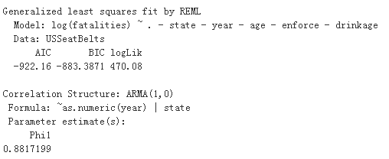

Step 4, we removed speed65. because the P-value of speed65 is 0.6092 which is greater than 0.1.
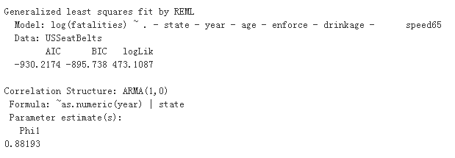

Step 5, we removed alcohol. because the P-value of alcohol is 0.4687 which is greater than 0.1.
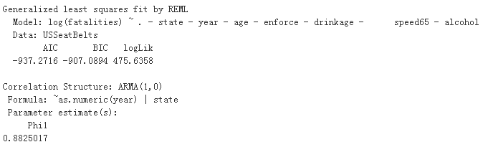

Step 6, we removed miles. because the P-value of drinkage is 0.2620 which is greater than 0.1.
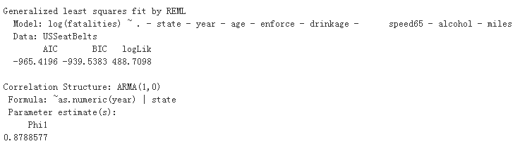

After removing 6 variables, we plotted the new fit plot.

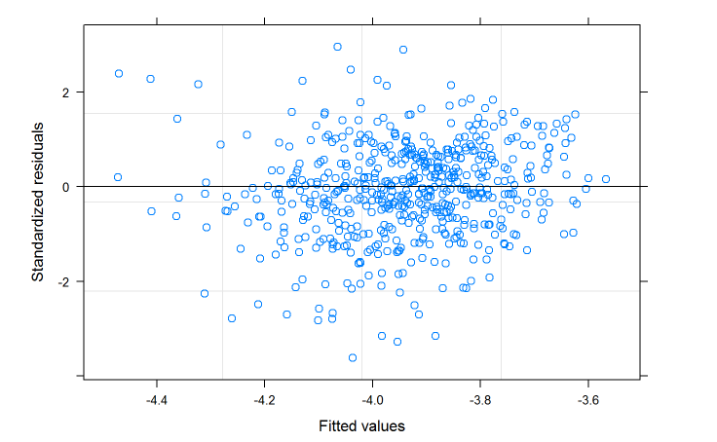
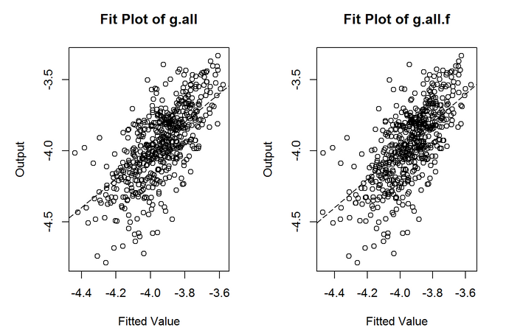

They looked pretty same. Then we use Shapiro - test and AIC value to compare them.

Shapiro - test

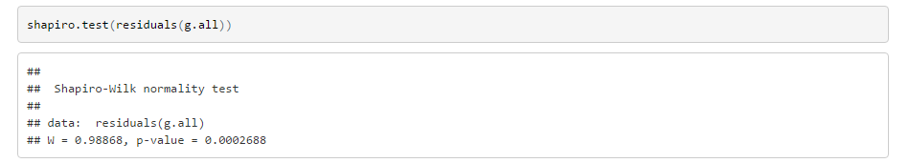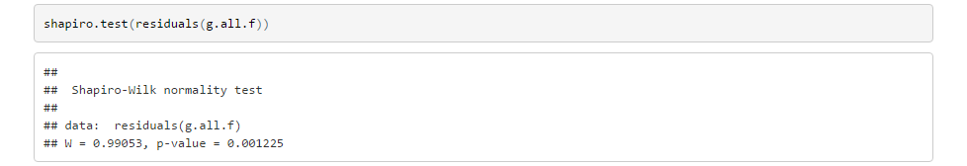

AIC value

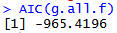

We can find that the Both Shapiro - test value and AIC value of g.all.f model is smaller than our initial GLS model, so we think that the g.all.f model is better one.

- Conclusion

According to the analysis above, eventually we decided to use GLS Model to fit our data. And keep variables: “seatbelt”, “income”, “speed70”, “year” and “state” as predictors to predict the number of fatalities per million of traffic miles.

