1. Install git on PC

2. Create repository

3. Create brach "Lab1"

4. Commit one file with info about student

5. Create pull request

6. Create merge

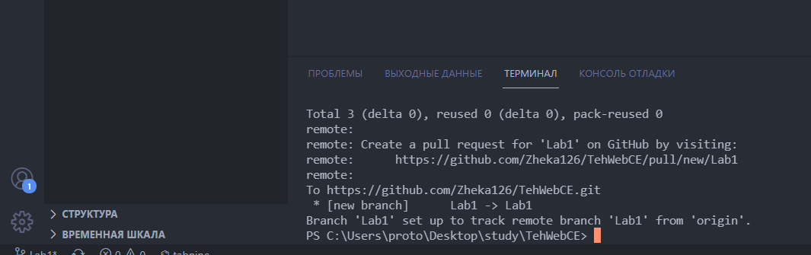

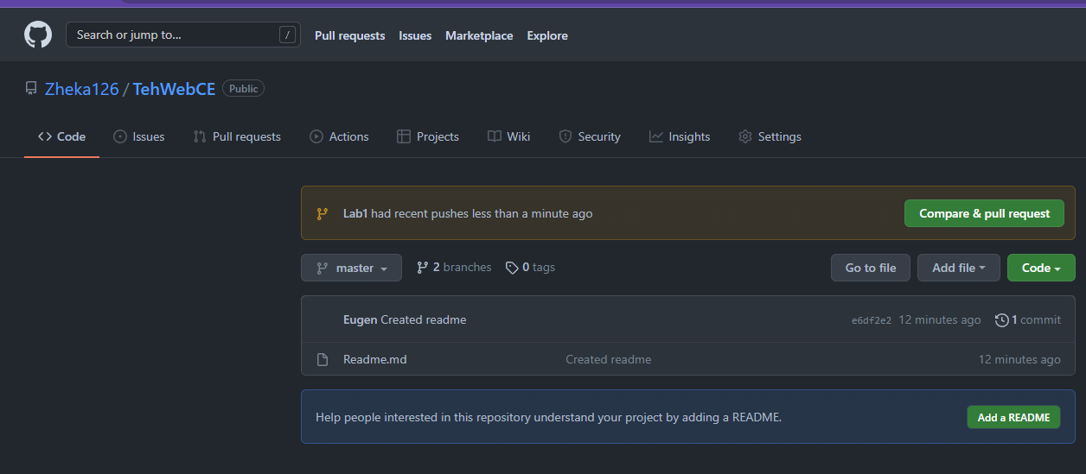

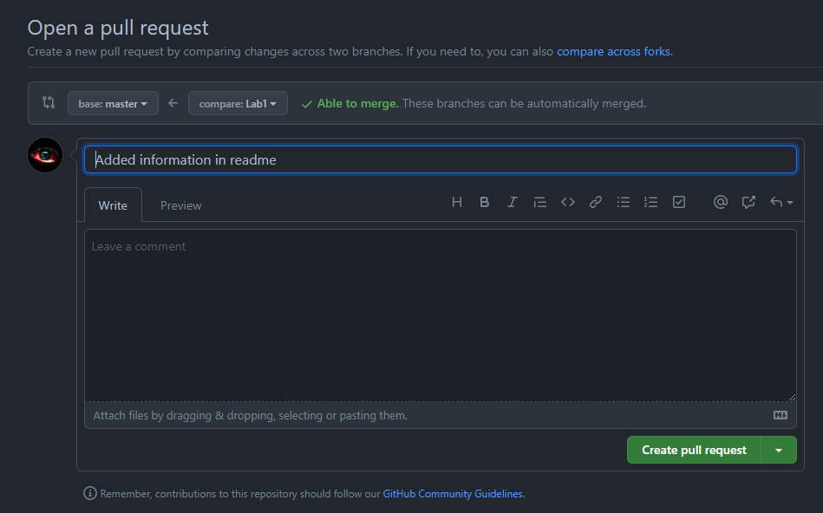

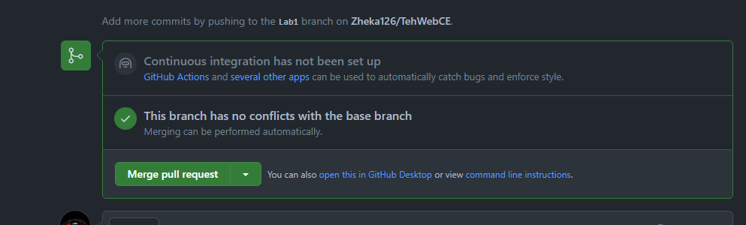

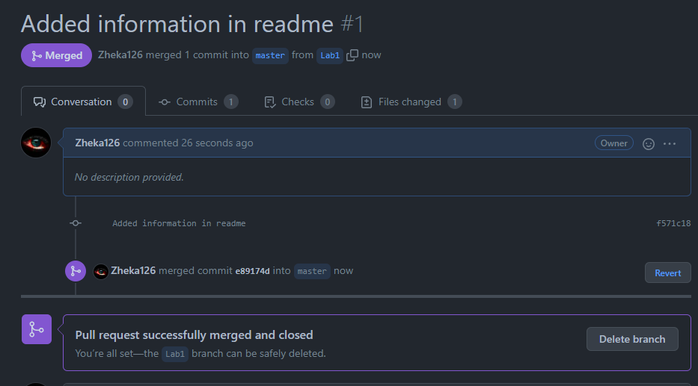

<https://github.com/Zheka126/TehWebCE>