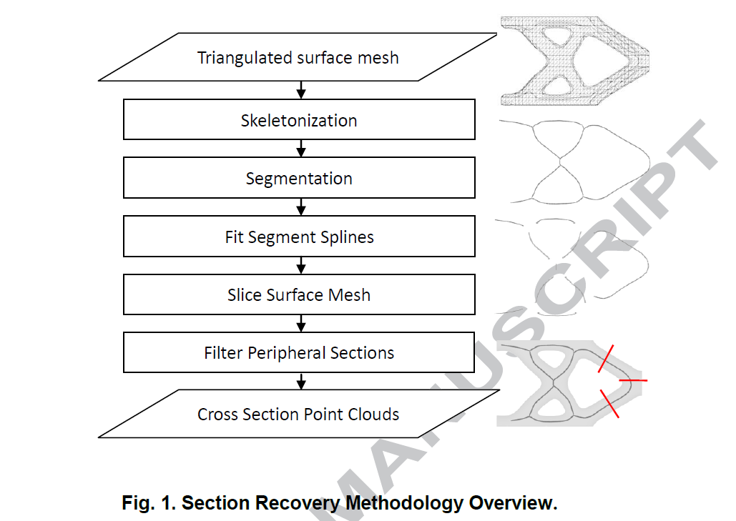

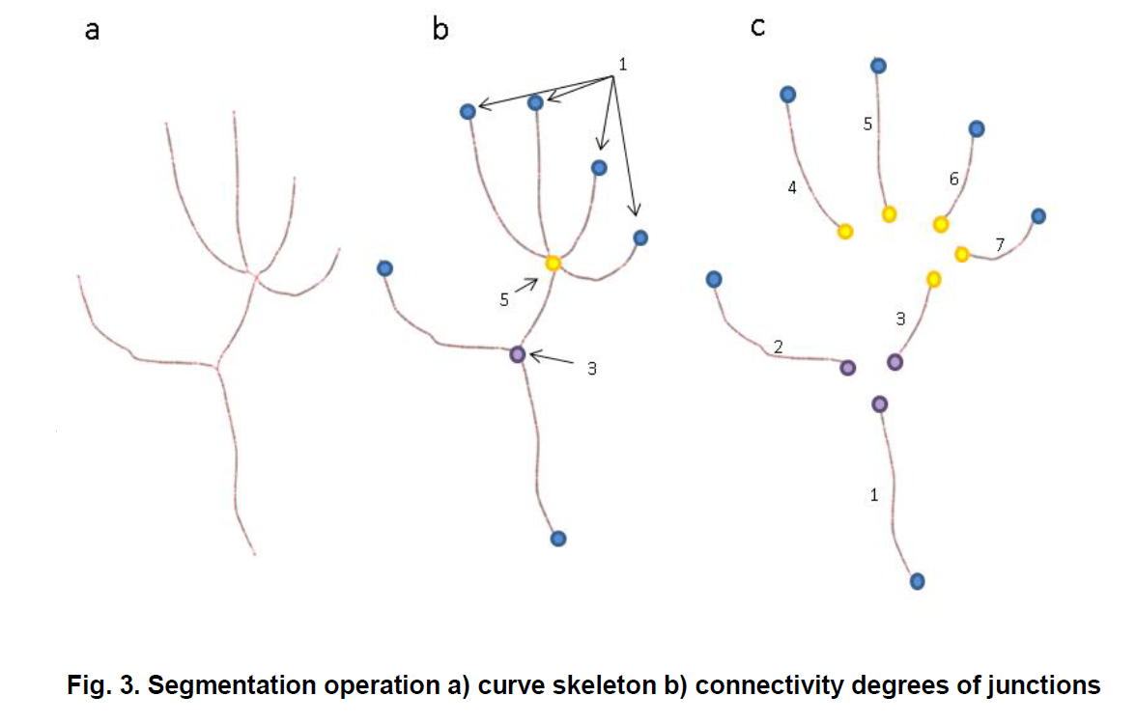
We first define the connectivity degree for each vertex to be the number of vertices which are connected to that vertex by one edge. The curve skeleton is segmented at any vertex where the connectivity degree is greater than 2, which are the junction vertices. We define end vertices to be vertices with degree 1. A curve segment can, therefore, be bounded by junction or end vertices. Figure 3 illustrates the connectivity degrees of a curve skeleton and how they lead to segmentation. For the skeleton shown, there are two junction vertices, one of them is degree 3, and the other is degree 5 (Figure3(b)). The vertices of degree 1 are also shown. Figure 3(c) shows seven curve skeleton segments that are generated as a result of segmenting the overall curve skeleton at both of the junctions.
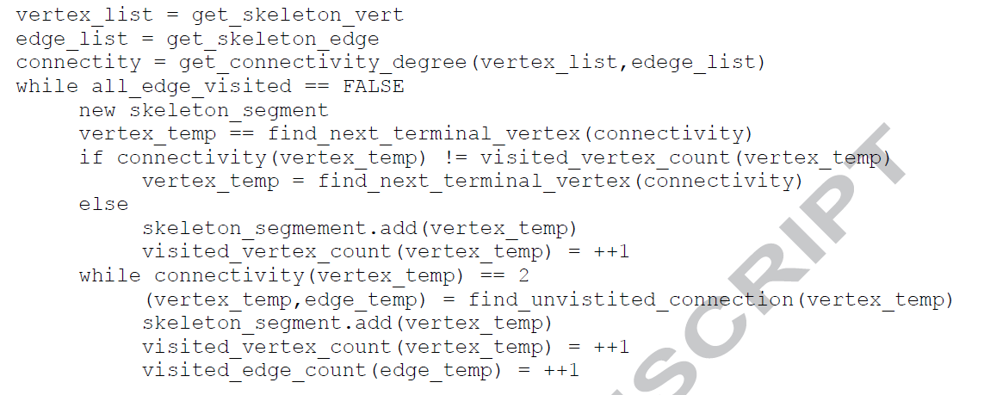

b-spine
https://blog.csdn.net/qq_40597317/article/details/81155571
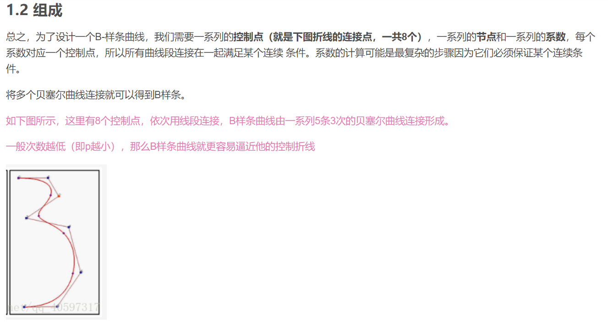

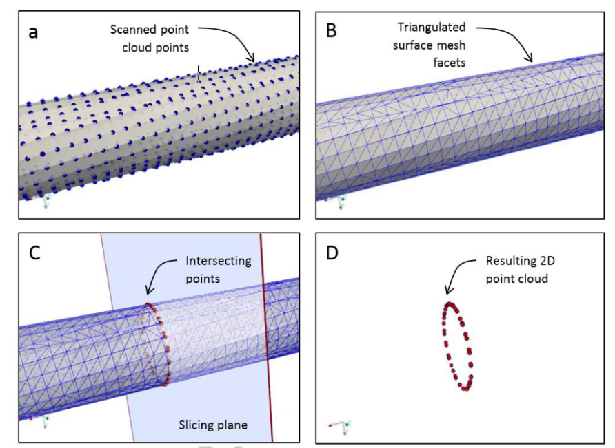
Fig 4. Plane Slicing. (a) Scanned point cloud (b) Surface Mesh (c) Sampling Plane
intersecting surface mesh edges (d) 2D point cloud of intersection between edges
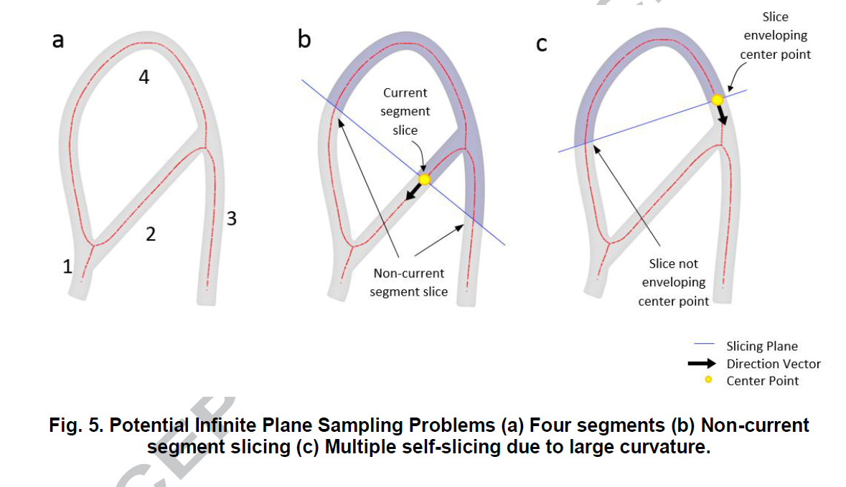
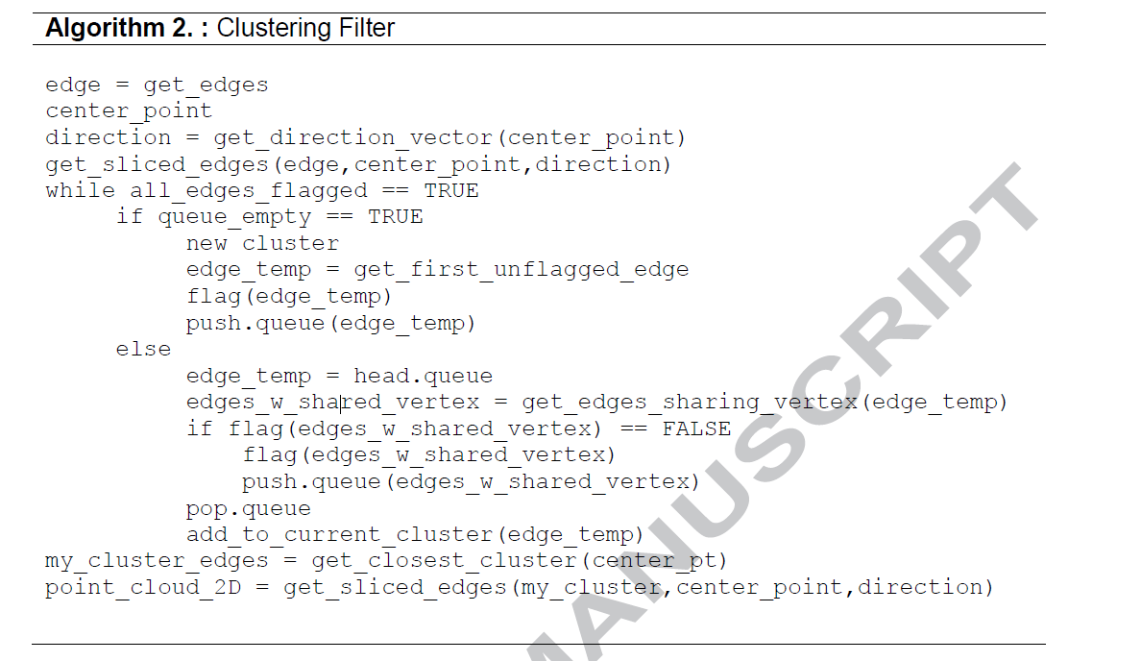
3.1 Simple Truss:
