Software Requirements Specification

for

Online marketplace for vehicle sales and purchases

Version 1.0 approved

Prepared by Deriugin Egor

Institute for Applied System Analysis

November 7, 2021

Table of Contents

Table of Contents ii

Revision History ii

1. Introduction 1

1.1 Purpose 1

1.2 Document Conventions 1

1.3 Intended Audience and Reading Suggestions 1

1.4 Product Scope 1

1.5 References 1

2. Overall Description 2

2.1 Product Perspective 2

2.2 Product Functions 2

2.3 User Classes and Characteristics 2

2.4 Operating Environment 2

2.5 Design and Implementation Constraints 2

2.6 User Documentation 2

2.7 Assumptions and Dependencies 3

3. External Interface Requirements 3

3.1 User Interfaces 3

3.2 Hardware Interfaces 3

3.3 Software Interfaces 3

3.4 Communications Interfaces 3

4. System Features 4

4.1 System Feature 1 4

4.2 System Feature 2 (and so on) 4

5. Other Nonfunctional Requirements 4

5.1 Performance Requirements 4

5.2 Safety Requirements 5

5.3 Security Requirements 5

5.4 Software Quality Attributes 5

5.5 Business Rules 5

Revision History

|  |  |  |  |
| --- | --- | --- | --- |
| **Name** | **Date** | **Reason For Changes** | **Version** |
| Deriugin Egor | November 7, 2021 | Initial revision | 1.0 |
|  |  |  |  |

# Introduction

## Purpose

The purpose of this project is to create an online vehicle marketplace which allows purchase and sale of new and used vehicles cars by people or companies/corporations. This document created to describe all requirements of platform.

## Document Conventions

There are no special designations in this document.

## Intended Audience and Reading Suggestions

This project is an online vehicle marketplace which allows purchase and sale of new and used vehicles cars by people or companies/corporations. This project is an educational project. The main audience of this service are physical/corporative persons who need to sell or purchase a vehicle.

## Product Scope

The main purpose of the online platform is to mate it easy to find information about the vehicle person want buy (price, photo, video, kitting, condition, segment, comments, news, sellers/dealers information and rating) and to easily publish advertisement about selling a vehicle. User have an opportunity to communicate with seller/dealer in this service.

## References

<https://auto.ria.com/>

<https://mobile.de/>

# Overall Description

## Product Perspective

The platform created will include such functions:

* **Viewing information** about the vehicle which described in advertisement, namely its model, year of enterprising, kitting, photos, videos, description, seller/dealer information, rating.
* **Posting own advertisement** about the vehicle to sell it.
* **Communicating** with seller/dealer or buyer of the vehicle.
* **Reading and writing** comments under advertisement.

## Product Functions

The main functions of the platform are shown in the Use Case UML diagram:

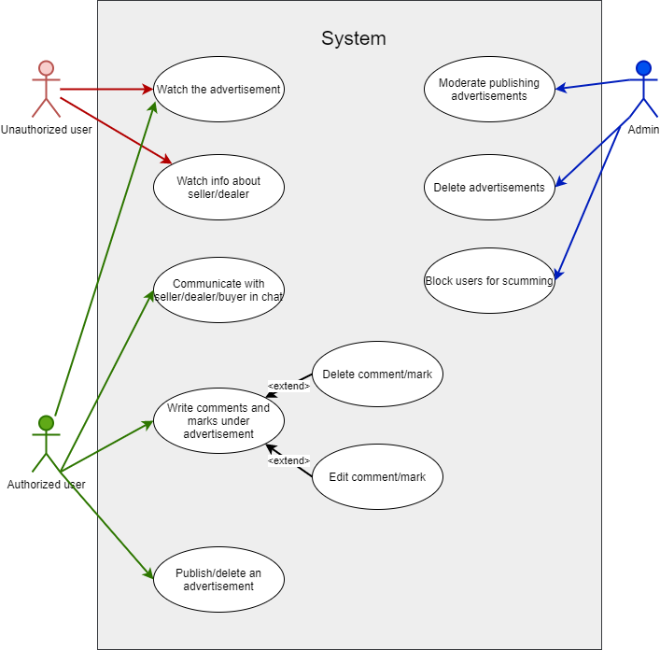

Figure 2.1 Use Case UML diagram

## User Classes and Characteristics

The system includes three types of users: anonymous user, authorized user, and administrator.

Functions of anonymous user:

* Watch the advertisement
* Watch info about seller/dealer

Functions of authorized user:

* Watch the advertisement
* Watch info about seller/dealer
* Communicate with seller/dealer/buyer in chat
* Watch rating of films based on genre
* Write comments and give marks under advertisement
* Publish/delete an advertisement

Functions of administrator:

* Moderate publishing advertisements
* Delete advertisements
* Block users for scumming

## Operating Environment

* Environment: Amazon Web Services (AWS)
* Database: MySQL
* Client/Server system
* Client side: PWA build with VueJS
* Server side: PHP

## Design and Implementation Constraints

The service should be autoscalable to ensure that the service runs smoothly with any number of users. Requests should be processed very quickly, around 95% in 200ms. When analyzing the platform speed on Google Lighthouse, the score on desktop should be at least 95%, on mobile at least 80%.

## User Documentation

The platform should have its own support cent and a section with answers to frequently asked questions.

## Assumptions and Dependencies

As the platform is completely dependent on AWS, the service may suffer disruptions if AWS fails.

# External Interface Requirements

## User Interfaces

The service should have a simple and clear design that has been tested for user experience.

## Hardware Interfaces

As we use VueJS, we need to be able to run the server and client side on existing platforms.

## Software Interfaces

Integration of authorization with Google account, Twitter account, Facebook account and Telegram account.

## Communications Interfaces

The service communicates with the user by sending a confirmation email and by sending emails with new advertisements regarding the user's search history.

# System Features

## Vehicle advertising database

### Description and Priority

Database that will contain vehicle advertisements. Priority: High

## Users database

### Description and Priority

Database that will contain user information. Priority: High

## Advertisement system

### Description and Priority

User must be able to watch/publish/delete advertisements. Priority: High

# Other Nonfunctional Requirements

## Performance Requirements

The system must be competitive with other services on the market, so the platform must be optimized and the download speed of the service must not exceed 3 seconds, no matter what device is used.

## Safety Requirements

There are no special requirements for data integrity.

## Security Requirements

User data should be stored in a closed database using encryption to keep user data secure and impossible for third parties to use.

## Software Quality Attributes

The system should be implemented with modules that can be reused.

## Business Rules

No special business requirements.