BI Workshop 3

DB103,Group3:葉佐霖,邱嘉錞,張楨杰,陳聖函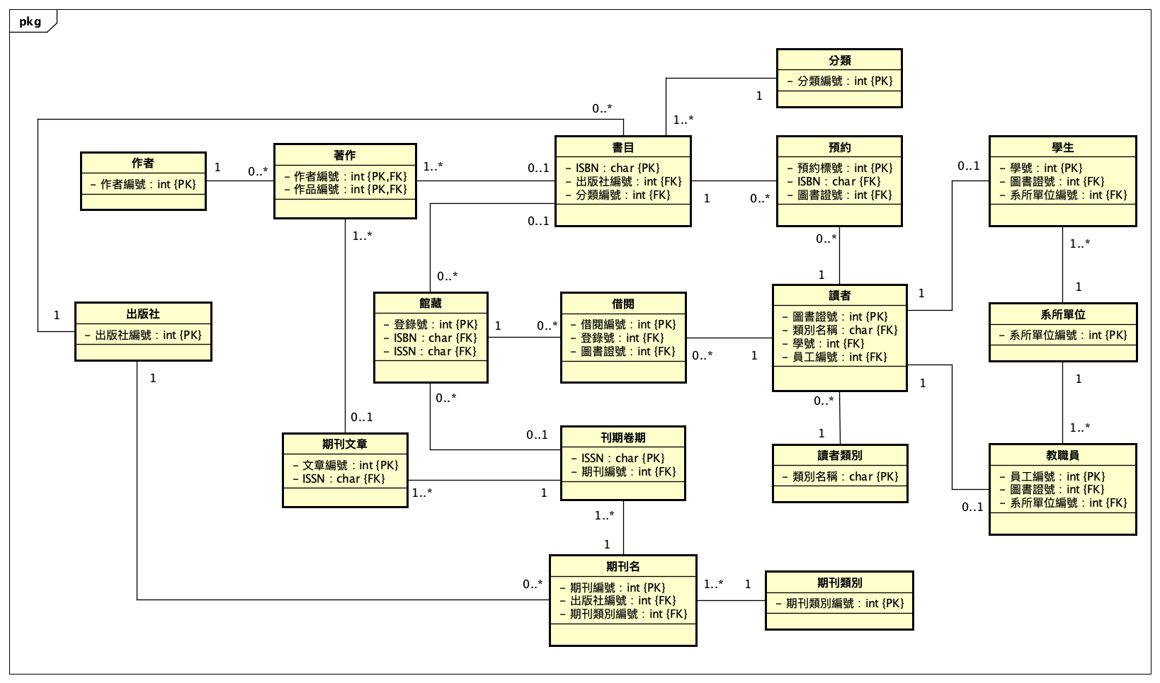

老師範例之圖書館**ER Model**

依照**Workshop2**需求**11~17**進行群組化後的**ER Model**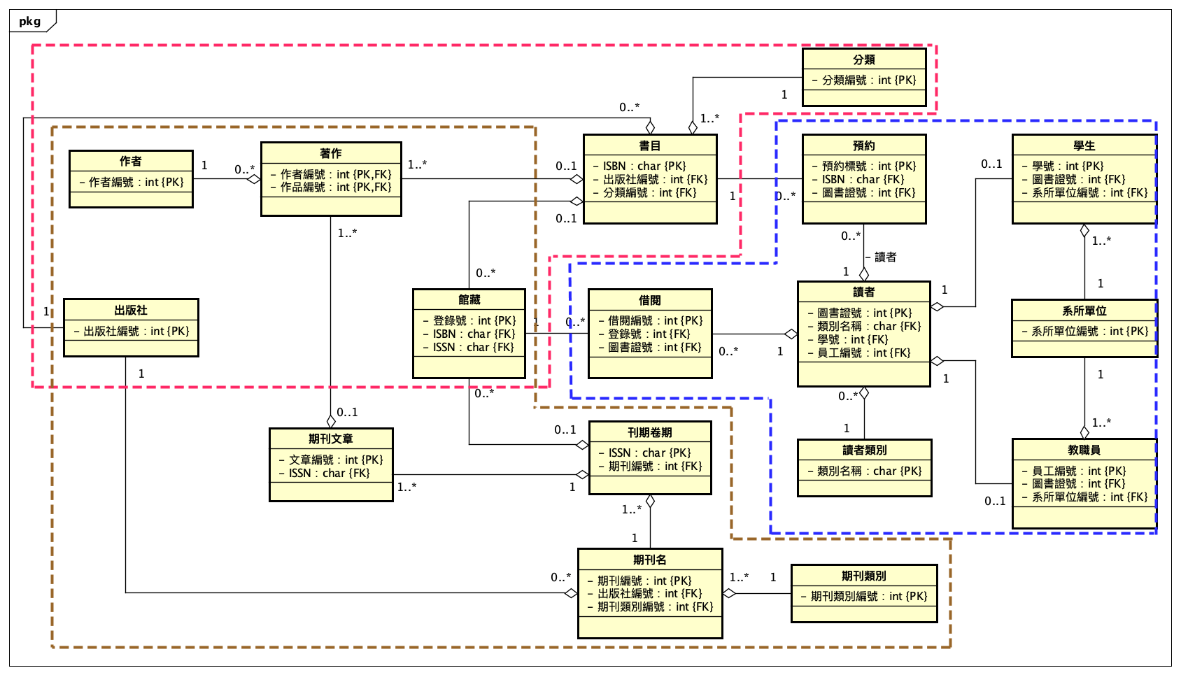

因應上述群組化之**PDM**如下

|  |  |
| --- | --- |
|  | **書目:**  {ISBN, 書名, 分類, 語文, 出版日, 館藏數, 在館數, 預約人數,  出版社:[{出版社名稱, 國別, 地址, 電話, 負責人, 傳真, 電子郵件}],  館藏:[{登錄號, 入館日期, 購入價格, 館藏位置, 是否在館, 可否借閱}]  作者:[{作者, 別名, 年代, 國籍, 角色}]  } |
|  | **期刊:**  {ISSN, 期刊名, 期刊編號, 主題, 期刊類別, 期別, 出版日期, 館藏數,  出版社:[{出版社名稱, 國別, 地址, 電話, 負責人, 傳真, 電子郵件}],  館藏:[{登錄號, 入館日期, 購入價格, 館藏位置, 是否在館, 可否借閱}]  期刊文章:[{標題, 摘要, 作者, 別名, 年代, 國籍}]  } |
|  | **讀者:**  {圖書證號, 姓名, 學號, 員工編號, 類別, 停權與否, 系所單位, 身分, 年級, 班級,  身分證號, 電子郵件, 可借閱數量,  借閱:[{借閱編號, 登錄號, 預計歸還日, 歸還日, 續借次數}],  預約:[{預約編號, ISBN, 預約日期, 處理狀況}]  } |

因應此**PDM**之實際**JSON**格式如下

**"**書目**"**: {

"ISBN": “vchar", "書名": “vchar", "分類": “vchar", "語文": “int", "出版日": "date",

"出版社": [

{"出版社名稱": “vchar", "國別": “int", "地址": “vchar", "電話": “vchar", "負責人": “vchar", "傳真": “vchar", "電子郵件": "vchar"}

],

"館藏數": “int", "在館數": “int", "預約人數": "int",

"館藏": [

{"登錄號": “vchar", "入館日期": “date", "購入價格": “int", "館藏位置": “vchar", "是否在館": “bool", "可否借閱": "bool"},

{"登錄號2": “vchar", "入館日期2": “date", "購入價格2": “int", "館藏位置2": “vchar", "是否在館": “bool", "可否借閱": "bool"}

],

"作者": [

{"作者": “vchar", "別名": “vchar", "年代": “date", "國籍": "int"},

{"作者2": “vchar", "作者2別名": “vchar", "年代": “date", "國籍": "int"}

]

},

**"**期刊**"**: {

"ISSN": “vchar", "期刊名": “vchar”, "期刊編號": “vchar", "主題": “vchar", "期刊類別": “vchar", "期別": "vchar",

"出版社": [

{"出版社名稱": "vchar","國別": "int","地址": “vchar", "電話": “vchar", "負責人": “vchar", "傳真": “vchar", "電子郵件": "vchar"}

],

"出版日": "date","館藏數": "int",

"館藏": [

{"登錄號": “vchar”, "入館日期": “date", "購入價格": “int", "館藏位置": “vchar", "是否在館": “bool", "可否借閱": "bool"},

{"登錄號2": “vchar", "入館日期2": “date”, "購入價格2": “int", "館藏位置2": “vchar", "是否在館": “bool", "可否借閱": "bool"}

],

"期刊文章": [

{"標題": “vchar", "摘要": “vchar", "作者": “vchar", "別名": “vchar", "年代": “date", "國籍": "int"},

{"標題2": “vchar", "摘要2": “vchar", "作者2": “vchar", "別名2": “vchar", "年代2": “date", "國籍2": "int"}

]

},

**"**讀者**"**: {

"圖書證號": “int”, "姓名": “vchar”, "學號": “vchar”, "員工編號": “vchar", "類別": “vchar", "停權與否": “bool", "系所單位": “vchar",

"身分": “vchar”, "年級": “int", "班級": “vchar", "身分證號": “vchar", "電子郵件": “vchar", "可借閱數量": "int",

"借閱": [

{"借閱編號": “vchar", "登錄號": “vchar", "預計歸還日": “date", "歸還日": “date", "續借次數": "int"},

{"借閱編號2": “vchar", "登錄號2": “vchar", "預計歸還日2": “date", "歸還日2": “date", "續借次數2": "int"}

],

"預約": [

{"預約編號": “vchar", "ISBN": “vchar", "預約日期": “date", "處理狀況": "int"},

{"預約編號2": “vchar", "ISBN2": “vchar", "預約日期2": “date", "處理狀況2": "int"}

]

}