# Color Defect flow

Step.1 Remove Backgroud - <https://www.remove.bg/>

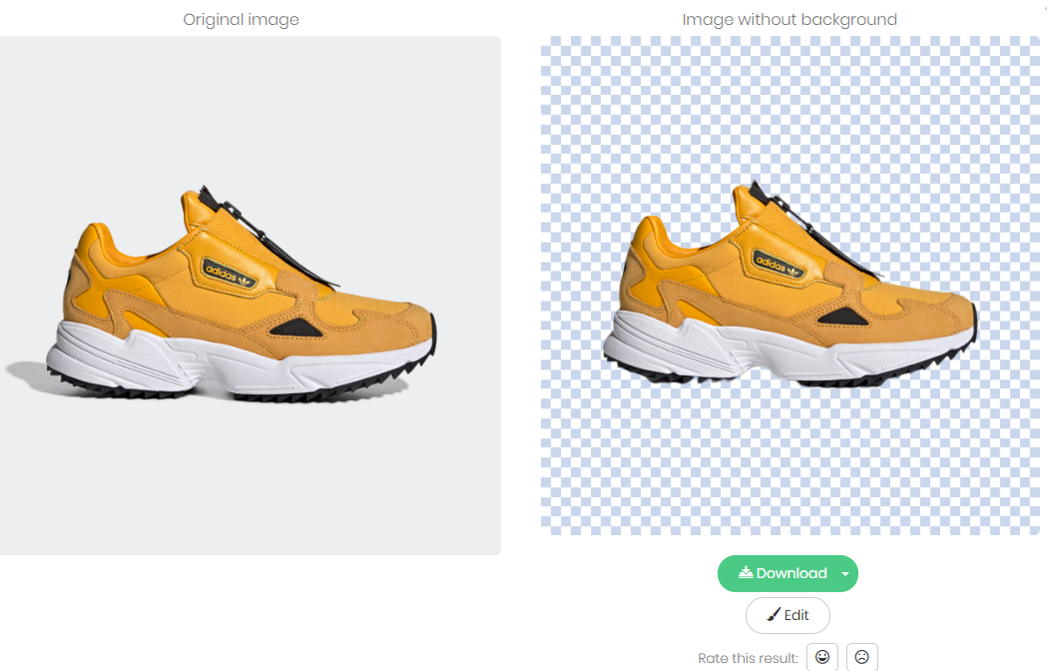

Step.2 Defect Image Color - <https://www.clarifai.com/demo>

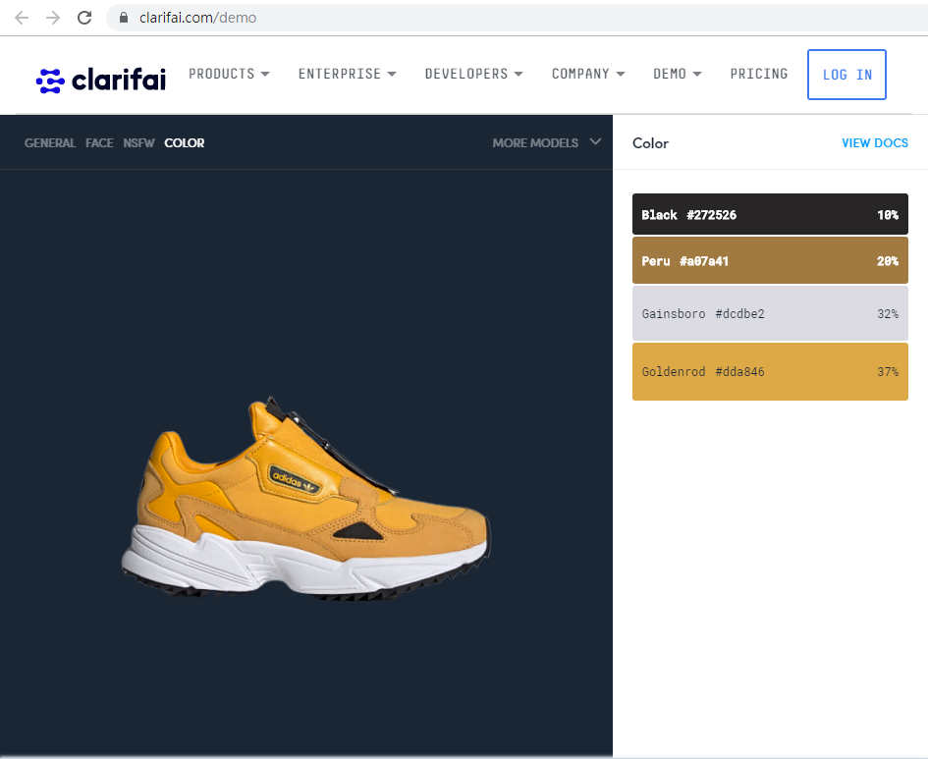

# How to Get API – remove.bg

<https://www.remove.bg/>

<https://github.com/brilam/remove-bg>

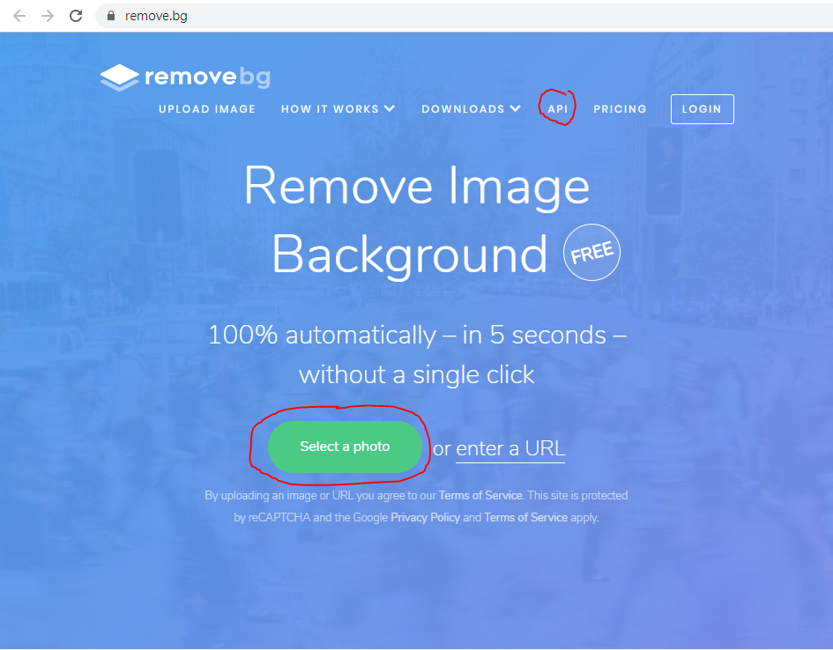

<https://www.remove.bg/api>

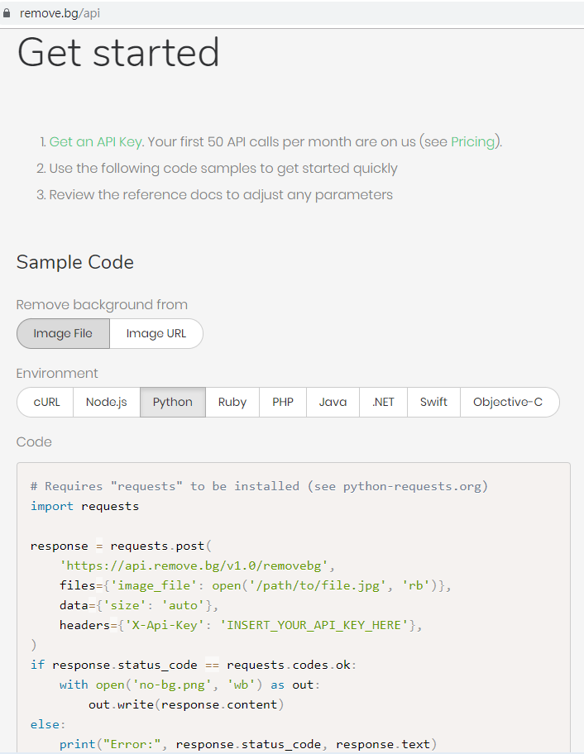

# How to Get API – clarifai

<https://github.com/Clarifai/clarifai-python>

<https://www.clarifai.com/demo>

<https://github.com/Clarifai/docs/blob/master/getting-started.md>

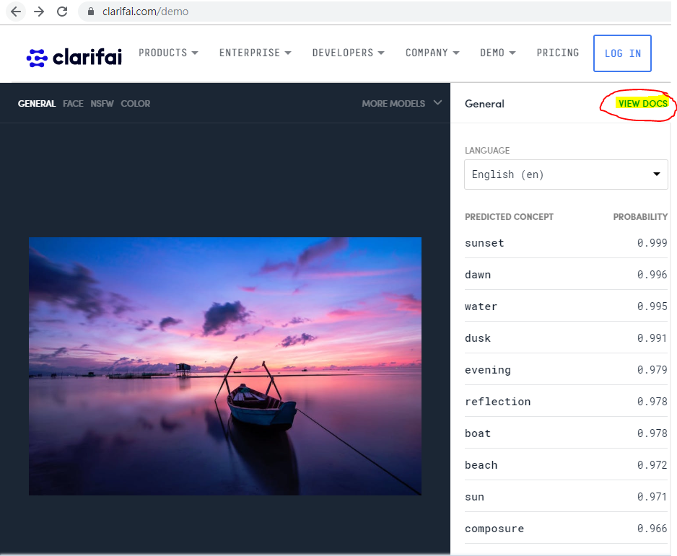

<https://www.clarifai.com/models/general-image-recognition-model-aaa03c23b3724a16a56b629203edc62c>

