Chris Miller
Zhen Wang
Analytics mindset
Big Deals
Part IIb:
Background:
You spent time discussing the strategy with your team and came up with a series of questions to ask to gain insights from company data. These are listed below.
- Redesign the operations and marketing strategy for stores in Florida and specifically target non-performing stores
  - How are the sales patterns compared with customer patterns?
Sales patterns showed that August was the peak month in terms of sales averaging $948,683 in total; customer patterns indicated that customer numbers did not vary significantly by month, and the average customer number was approximately 10,500 per month. On one hand, this demonstrates that customers buy more than ever during the peak month. The strong sales during August could be explained by back-to-school purchases and higher sales persist through the holiday shopping seasons. On the other hand, sales dropped off in January after the holidays ended and then gradually built back up to the August peak. Comparing the number of customers with and without purchase showed that roughly half of all customers that visited a store at least bought something and the ratio was consistent across different store types. Given the average number of customers and ratios of customers with and without purchase stayed constant, we could conclude that the average number of customers changed slightly over months, but the money they spent varied over months based on special events.
  - How do the sales and customers of each store-type compare?

The number of customers remained nearly constant between different types of stores, but the sales varied by the type of stores. All the store types showed that the total customer average number was approximately 60 monthly. Further, Mini-mall, Movie Center, and Plaza store types showed significantly less sales which were approximately $2,000. This number was less than Corner, Inside Mall, Mini Mall, Premium, Super Store, and Tower store types. It was sufficient to show some types of stores had significantly less sales, despite having similar traffic. In other words, some types of stores tend to be more profitable with the more sales they generate. The higher average purchase price in the well-performing stores is one reason. For example, customers rarely buy a computer, TV or some high-priced items in a Movie Center. It is much more likely that they would buy them in a Premium or Super Store. What’s more, seasonality drives sales during the back-to-school season. It is understandable that customers would go to malls or bigger stores for the seasonal types of shopping with more deals and choices. Without knowing the expenses of different store types, it is difficult to evaluate their selling performance. However, current recommendations can be adding more stores of the better-performing types such as Corner, Inside Mall, Mini Mall, Premium, Super Store, or Tower Types; having marketing strategies paid attention to high-priced items, back-to-school and holiday shopping to increase revenue. In terms of the worst-performing stores such as Movie Center stores, it is considered to conduct a profitability analysis.

  - How are the sales of each store compared with other stores?
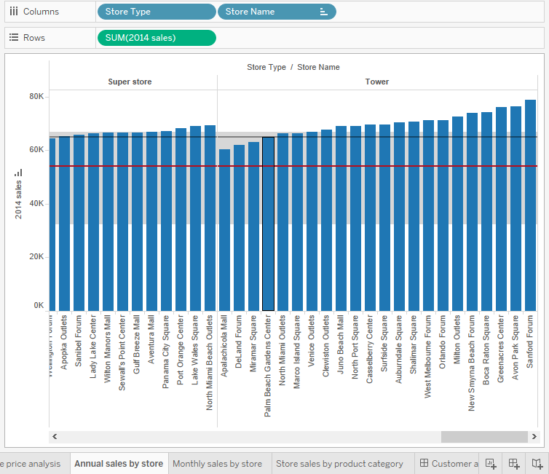
Being compared with others in the same type, the sales of each store did not show much variation overall except the Tower type of stores. It showed that the Tower type had relatively high variation in sales. This might be beneficial to see why some stores are outperforming others and try to find the secret to their success. On the opposite, Cocoa Beach Center as a Corner Store type, had unusually lower sales of only $40,253. Most of the other Corner Store types had sales near the median of $65,000. It would be beneficial to see what they are doing wrong, that prevents them from selling so few TV’s and computers and fix the problem or possibly look at closing that location if it is not profitable.
  - Does any store have any unusual pattern in sales that could indicate an issue or opportunity?
From the Annual sales by store sheet, we could see that the sales had an obvious improvement from Cocoa Beach Center to Apalachicola Mall. And comparing this result with the Purchase price analysis sheet, we learned that the Cocoa Beach Center had the worst sales from the same store type. Specifically, Cocoa Beach Center’s Computer Sales and TV Sales were the lowest comparing to other stores. This indicated an issue of Cocoa Beach Center’s selling performance and it should improve its sales of computer and TV to improve its overall sales performance. Oppositely, Lake Alfred Outlet performed well based on its high sales level. This can be considered as an opportunity that other stores in the same store types or needing experience of selling could learn from it.

  - Does any store have any unusual pattern in the number of customers who have visited or purchased or not purchased products at the store that could indicate an issue or opportunity?
Cocoa Beach Center, which mainly sold audio and video players, had a bad sales performance based on the highest customers it has, but the total sales under 40k in 2014. The median customers with purchase only counted about 35%. This meant most the customers who came into the store did not buy products. So, a probable reason might be bad customer service at the store. On the other hand, Lake Alfred Outlet had outstanding sales with the similar number of customers it had. Estimated 70% of 819 customers in total had bought products at the store, which generated more than 68k sales in 2014. Therefore, with the similar number of customers, Cocoa Beach Center could learn some experience from Lake Alfred to improve its performance

- Summary dashboard: provides sales and total customers (visitors to the stores) for each month in 2014 and provides 2014 average monthly sales and average monthly customers by store type
- Purchase price analysis: provides a tree map to show average purchase price by store type with the upper left corner being the highest and the lower right corner being the lowest. By clicking on the store type in the legend, all stores within that category will be highlighted for viewing.
- Monthly sales by store: provides monthly sales by store along with an average and median for all stores in alphabetical order.
- Store sales by product category: provides 2014 sales by product category by store
- Annual sales by store: provides annual sales by store trending from the lowest performing stores to the highest performing stores with an average and median for all stores.
- Customer analysis dashboard: provides total customers with purchases and customers without purchases by store with an average and median for all stores in alphabetical order. It also provides a circle analysis of the median of the percentage of customer purchasers to the total customers by store type. By clicking on the store type in the legend, all stores within that category will be highlighted for viewing.

