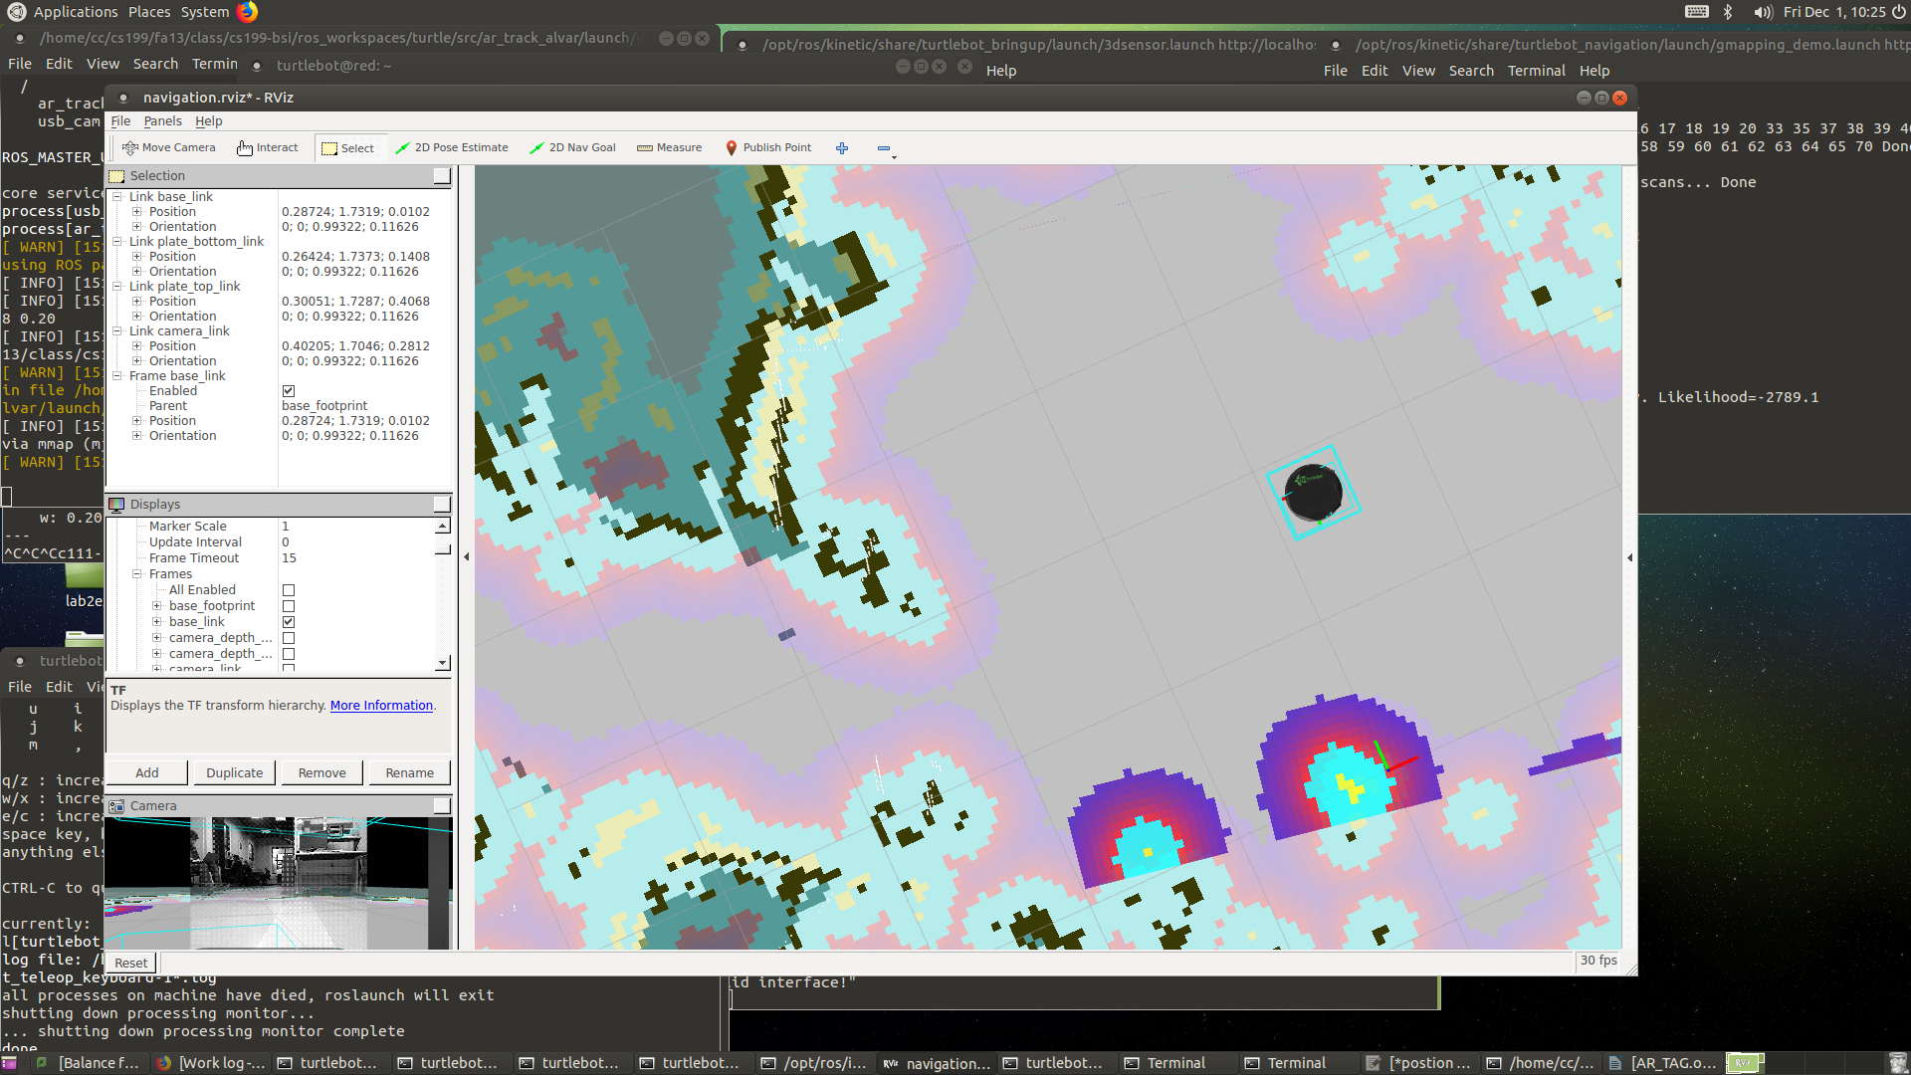
Initial Pose( 2D nAVIGATION)

Initial Postion

seq: 9
stamp:
secs: 1512152125
nsecs: 799135532
frame_id: map
pose:
position:
x: 0.333835750818
y: 1.71722459793
z: 0.0
orientation:
x: 0.0
y: 0.0
z: 0.979302940617
w: 0.202399976528

Marker 1

- Translation: [0.059, 1.831, 0.158]
- Rotation: in Quaternion [-0.568, -0.438, 0.416, 0.559]
in RPY (radian) [-1.600, -0.017, 1.297]
in RPY (degree) [-91.687, -0.955, 74.331]

