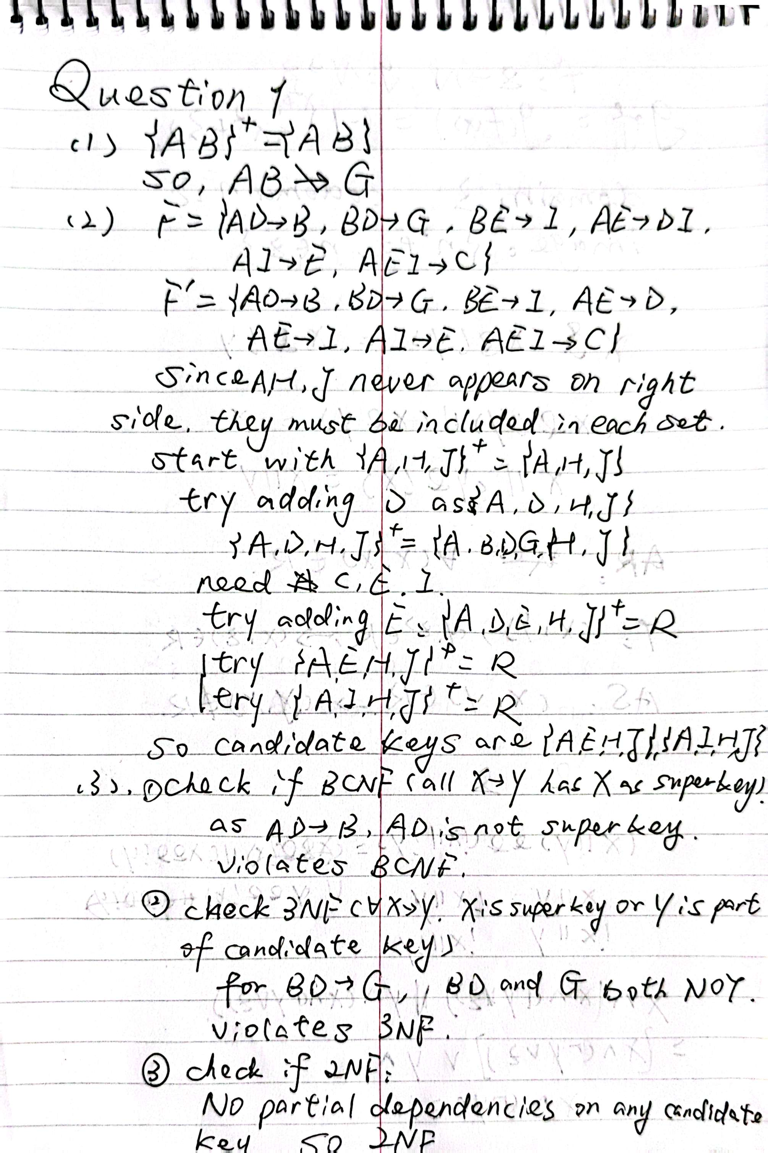

Since there is partial dependency (AD->B), violates 2NF.

Since atomicity exists, R is 1NF.

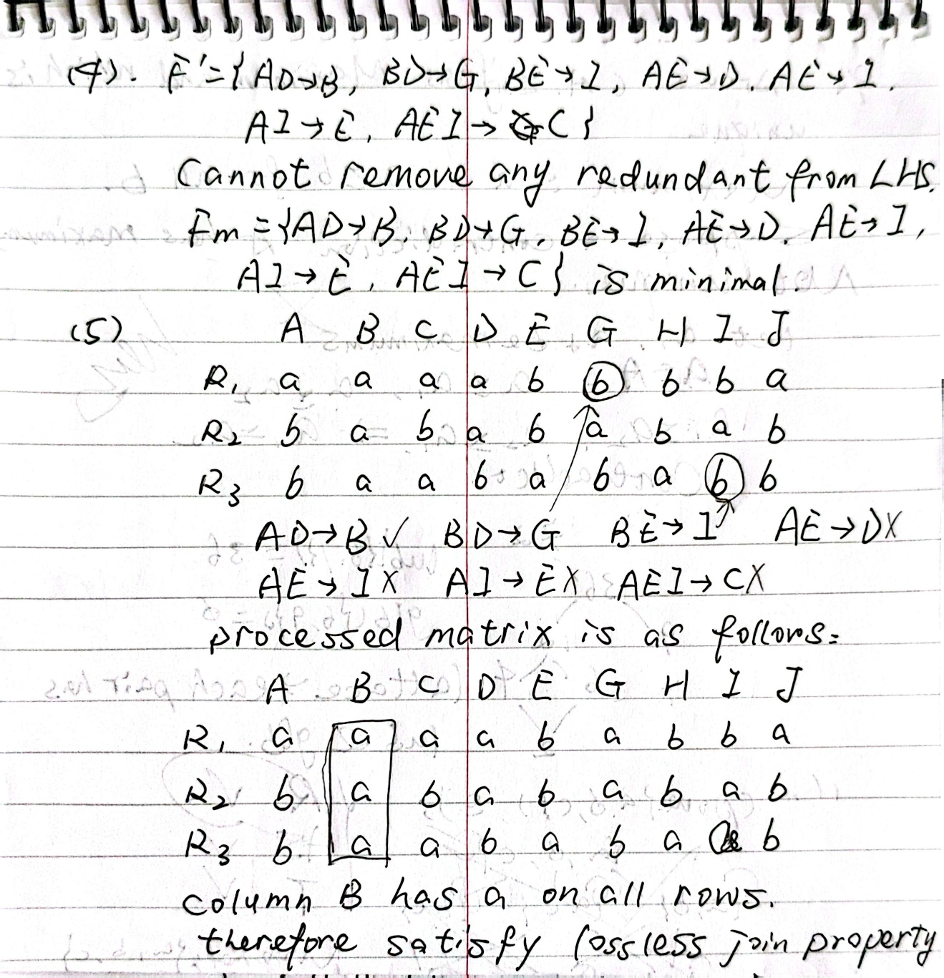

Since there’s not any row with full of a’s

R is NOT lossless join.

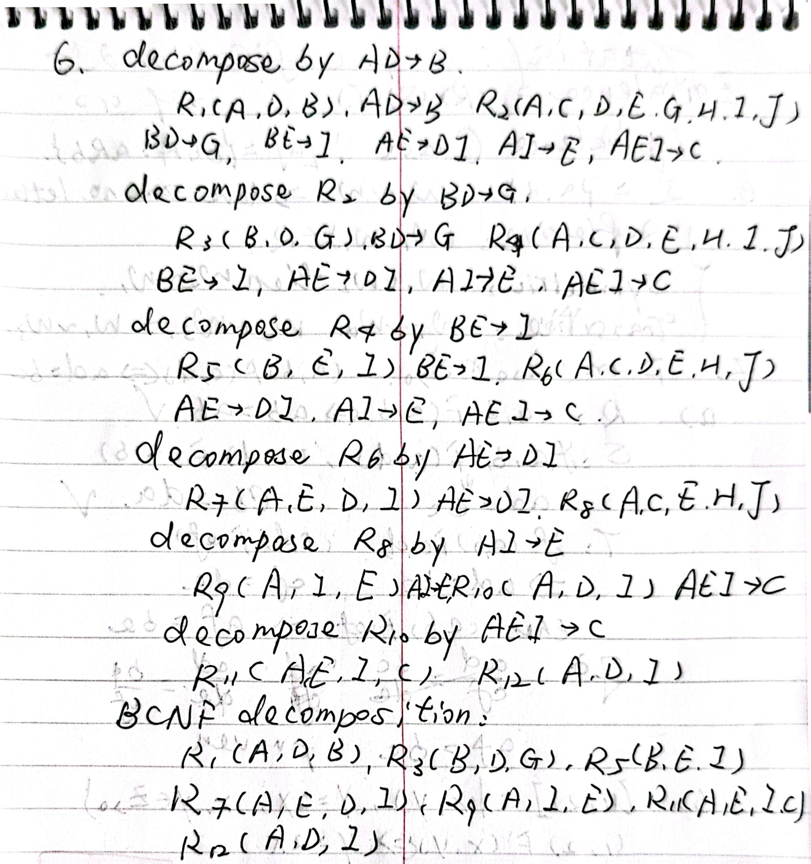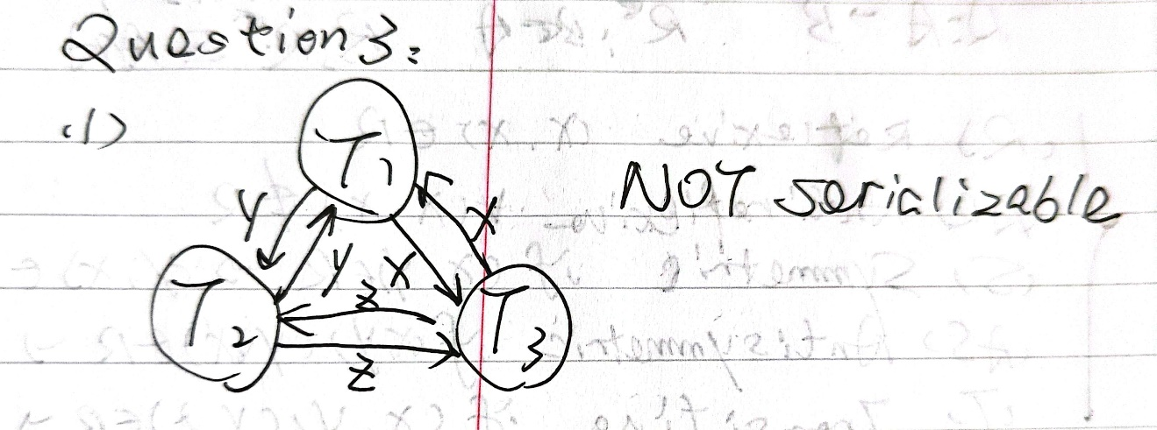

)

)

2

(2)

Lock Sequence for T1:

1. t1: Acquire shared lock on x, then read x.

2. t4: Acquire shared lock on y, then read y.

3. t8: Upgrade to exclusive lock on x, then write x.

4. t12: Upgrade to exclusive lock on y, then write y.

5. After committing: Release all locks.

Lock Sequence for T2:

1. t3: Acquire shared lock on y, then read y.

2. t5: Acquire shared lock on z, then read z.

3. t9: Upgrade to exclusive lock on y, then write y.

4. t12: Upgrade to exclusive lock on z, then write z.

5. After committing: Release all locks.

Lock Sequence for T3:

1. t2: Acquire shared lock on z, then read z.

2. t6: Acquire shared lock on x, then read x.

3. t7: Upgrade to exclusive lock on z, then write z.

4. t10: Upgrade to exclusive lock on x, then write x.

5. After committing: Release all locks.

(3)

1) Timeline Analysis:

t1: T1 acquires slock(x) and reads x ✓ (successful)

t2: T3 acquires slock(z) and reads z ✓ (successful)

t3: T2 acquires slock(y) and reads y ✓ (successful)

t4: FIRST BLOCKING POINT

T1 tries to acquire slock(y). However, T1 will need xlock(y) later at t12. Cannot acquire just slock(y) due to 2PL upgrade requirement

T2 already holds slock(y). Therefore, T1 must WAIT for T2

t5: SECOND BLOCKING POINT

T2 tries to acquire slock(z)

- However, T2 will need xlock(z) later at t12

- Cannot acquire just slock(z) due to 2PL upgrade requirement

- T3 already holds slock(z)

- Therefore, T2 must WAIT for T3

t6: DEADLOCK COMPLETION

- T3 tries to acquire slock(x)

- However, T3 will need xlock(x) later at t10

- Cannot acquire just slock(x) due to 2PL upgrade requirement

- T1 already holds slock(x)

- Therefore, T3 must WAIT for T1

2) Wait-For Graph Analysis:

- T1 waits for T2 (needs y which T2 holds)

- T2 waits for T3 (needs z which T3 holds)

- T3 waits for T1 (needs x which T1 holds)

This creates a cycle: T1 → T2 → T3 → T1

Therefore, this schedule will result in a deadlock at t6, making it impossible to complete as specified in the original schedule without deadlock resolution mechanisms.

**Question 3:**

**LRU Cache Simulation:**

Access P1: Miss - Cache: ['P1']

Access P2: Miss - Cache: ['P1', 'P2']

Access P1: Hit - Cache: ['P2', 'P1']

Access P4: Miss - Cache: ['P2', 'P1', 'P4']

Access P3: Miss - Cache: ['P1', 'P4', 'P3']

Access P7: Miss - Cache: ['P4', 'P3', 'P7']

Access P2: Miss - Cache: ['P3', 'P7', 'P2']

Access P1: Miss - Cache: ['P7', 'P2', 'P1']

Access P4: Miss - Cache: ['P2', 'P1', 'P4']

Access P5: Miss - Cache: ['P1', 'P4', 'P5']

Access P8: Miss - Cache: ['P4', 'P5', 'P8']

Access P6: Miss - Cache: ['P5', 'P8', 'P6']

Access P8: Hit - Cache: ['P5', 'P6', 'P8']

Access P2: Miss - Cache: ['P6', 'P8', 'P2']

Access P8: Hit - Cache: ['P6', 'P2', 'P8']

LRU Hit Rate: 20.00%

**MRU Cache Simulation:**

Access P1: Miss - Cache: ['P1']

Access P2: Miss - Cache: ['P1', 'P2']

Access P1: Hit - Cache: ['P2', 'P1']

Access P4: Miss - Cache: ['P2', 'P1', 'P4']

Access P3: Miss - Cache: ['P2', 'P1', 'P3']

Access P7: Miss - Cache: ['P2', 'P1', 'P7']

Access P2: Hit - Cache: ['P1', 'P7', 'P2']

Access P1: Hit - Cache: ['P7', 'P2', 'P1']

Access P4: Miss - Cache: ['P7', 'P2', 'P4']

Access P5: Miss - Cache: ['P7', 'P2', 'P5']

Access P8: Miss - Cache: ['P7', 'P2', 'P8']

Access P6: Miss - Cache: ['P7', 'P2', 'P6']

Access P8: Miss - Cache: ['P7', 'P2', 'P8']

Access P2: Hit - Cache: ['P7', 'P8', 'P2']

Access P8: Hit - Cache: ['P7', 'P2', 'P8']

MRU Hit Rate: 33.33%

**FIFO Cache Simulation:**

Access P1: Miss - Cache: ['P1']

Access P2: Miss - Cache: ['P1', 'P2']

Access P1: Hit - Cache: ['P1', 'P2']

Access P4: Miss - Cache: ['P1', 'P2', 'P4']

Access P3: Miss - Cache: ['P2', 'P4', 'P3']

Access P7: Miss - Cache: ['P4', 'P3', 'P7']

Access P2: Miss - Cache: ['P3', 'P7', 'P2']

Access P1: Miss - Cache: ['P7', 'P2', 'P1']

Access P4: Miss - Cache: ['P2', 'P1', 'P4']

Access P5: Miss - Cache: ['P1', 'P4', 'P5']

Access P8: Miss - Cache: ['P4', 'P5', 'P8']

Access P6: Miss - Cache: ['P5', 'P8', 'P6']

Access P8: Hit - Cache: ['P5', 'P8', 'P6']

Access P2: Miss - Cache: ['P8', 'P6', 'P2']

Access P8: Hit - Cache: ['P8', 'P6', 'P2']

FIFO Hit Rate: 20.00%

Python Code is as follows:

from collections import OrderedDict

from typing import List, Any, Optional

import time

class CacheBase:

    def __init__(self, capacity: int):

        self.capacity = capacity

        self.cache: OrderedDict = OrderedDict()

        self.hits = 0

        self.total_accesses = 0

    def get_hit_rate(self) -> float:

        """计算缓存命中率"""

        if self.total_accesses == 0:

            return 0.0

        return self.hits / self.total_accesses * 100

    def _debug_print(self, page: Any, is_hit: bool):

        """打印当前缓存状态，用于调试"""

        status = "Hit" if is_hit else "Miss"

        print(f"Access {page}: {status} - Cache: {list(self.cache.keys())}")

    def access(self, page: Any, debug: bool = False) -> bool:

        """访问一个页面，返回是否命中"""

        raise NotImplementedError("Subclasses must implement access()")

class LRUCache(CacheBase):

    def access(self, page: Any, debug: bool = False) -> bool:

        """

        访问一个页面，如果页面在缓存中，更新其位置；

        如果不在缓存中，添加到缓存，必要时删除最久未使用的页面

        """

        self.total_accesses += 1

        is_hit = False

        if page in self.cache:

            # 页面命中，移动到OrderedDict的末尾（表示最近使用）

            self.cache.move_to_end(page)

            self.hits += 1

            is_hit = True

        else:

            # 页面未命中，需要载入

            if len(self.cache) >= self.capacity:

                # 缓存已满，删除最久未使用的页面（OrderedDict的第一个元素）

                self.cache.popitem(last=False)

            self.cache[page] = True  # 值不重要，我们只关心键

        if debug:

            self._debug_print(page, is_hit)

        return is_hit

class MRUCache(CacheBase):

    def access(self, page: Any, debug: bool = False) -> bool:

        """

        访问一个页面，如果页面在缓存中，更新其位置；

        如果不在缓存中，添加到缓存，必要时删除最近使用的页面

        """

        self.total_accesses += 1

        is_hit = False

        if page in self.cache:

            # 页面命中

            self.cache.move_to_end(page)

            self.hits += 1

            is_hit = True

        else:

            # 页面未命中，需要载入

            if len(self.cache) >= self.capacity:

                # 缓存已满，删除最近使用的页面（OrderedDict的最后一个元素）

                self.cache.popitem(last=True)  # last=True表示移除最近的元素

            self.cache[page] = True

            self.cache.move_to_end(page)  # 将新页面移到末尾

        if debug:

            self._debug_print(page, is_hit)

        return is_hit

class FIFOCache(CacheBase):

    def access(self, page: Any, debug: bool = False) -> bool:

        """

        访问一个页面，如果页面在缓存中，保持其位置不变；

        如果不在缓存中，添加到缓存，必要时删除最先进入的页面

        """

        self.total_accesses += 1

        is_hit = False

        if page in self.cache:

            # 页面命中，位置保持不变

            self.hits += 1

            is_hit = True

        else:

            # 页面未命中，需要载入

            if len(self.cache) >= self.capacity:

                # 缓存已满，删除最先进入的页面

                self.cache.popitem(last=False)

            self.cache[page] = True

        if debug:

            self._debug_print(page, is_hit)

        return is_hit

def test_cache_replacement():

    # 测试序列

    page_sequence = ['P1', 'P2', 'P1', 'P4', 'P3', 'P7', 'P2', 'P1', 'P4', 'P5', 'P8', 'P6', 'P8', 'P2', 'P8']

    buffer_size = 3

    # 创建三种不同的缓存

    lru_cache = LRUCache(buffer_size)

    mru_cache = MRUCache(buffer_size)

    fifo_cache = FIFOCache(buffer_size)

    print("\nLRU Cache Simulation:")

    for page in page_sequence:

        lru_cache.access(page, debug=True)

    print(f"LRU Hit Rate: {lru_cache.get_hit_rate():.2f}%")

    print("\nMRU Cache Simulation:")

    for page in page_sequence:

        mru_cache.access(page, debug=True)

    print(f"MRU Hit Rate: {mru_cache.get_hit_rate():.2f}%")

    print("\nFIFO Cache Simulation:")

    for page in page_sequence:

        fifo_cache.access(page, debug=True)

    print(f"FIFO Hit Rate: {fifo_cache.get_hit_rate():.2f}%")

if __name__ == "__main__":

    test_cache_replacement()