**Exercise 2: Use ping to test host reachability (2 marks. 0.2 per each host)**

Are the following hosts reachable from your machine by using ping:

If you observe that some hosts are unreachable, can you explain why? Check if the addresses unreachable by the ping command are reachable from the Web browser.

* [www.google.co.uk](http://www.google.co.uk/) -Yes, I can reach it!

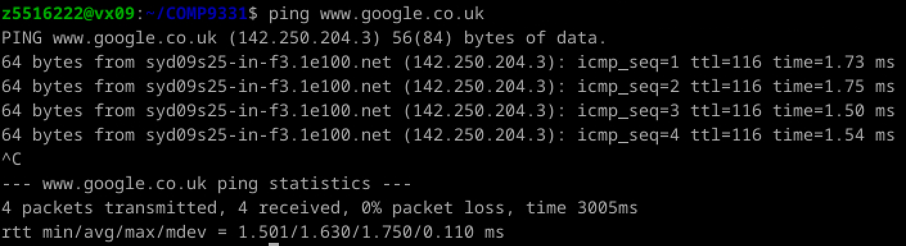

* [www.utoronto.ca](http://www.utoronto.ca/) -Yes, I can reach it!

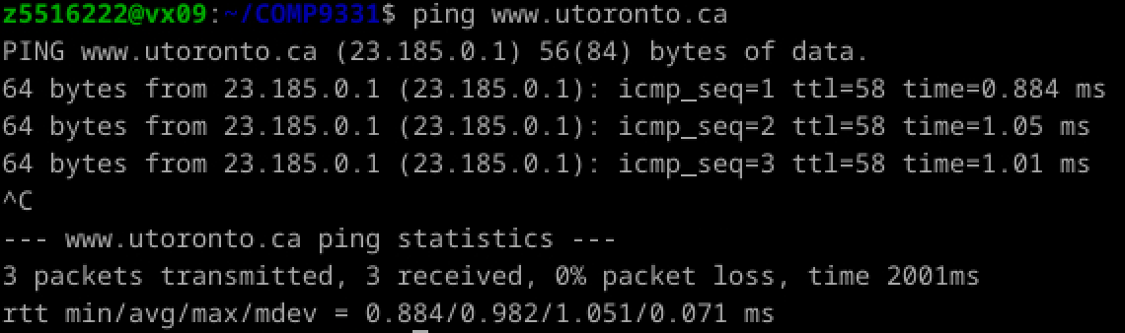

* [www.cloudflare.com](http://www.cloudflare.com/) -No, I may be unable to ping cloudflare.com due to network connectivity issues, DNS resolution problems, or Cloudflare's security measures that block ICMP ping requests.

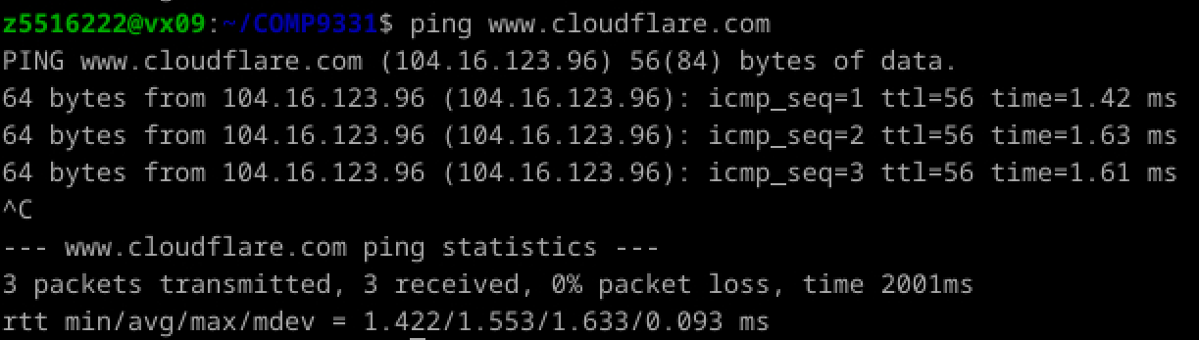

* [ec.ho](http://ec.ho/) -No, because this is not a valid address.

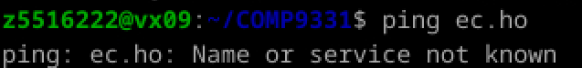

* [west.cn](http://west.cn/) -Yes, but with packet losses.

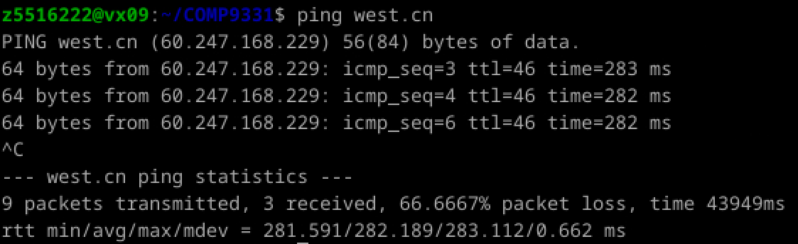

* [defence.gov.au](http://defence.gov.au/) -No, because ICMP echo requests (used by the ping command) are blocked by their firewall settings.

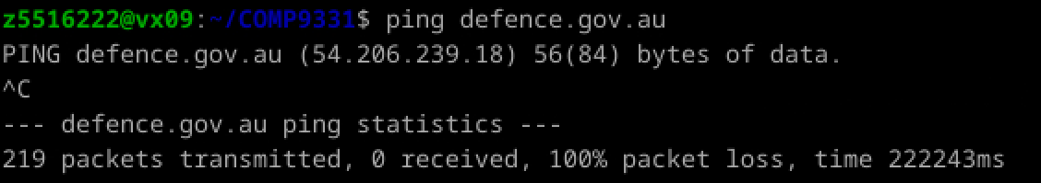

* [yes.no](http://yes.no/) -Yes, I can reach it!

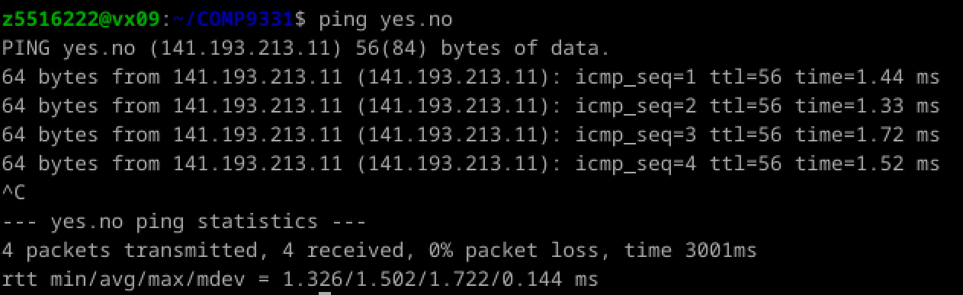

* [one.one.one.one](http://one.one.one.one/) -Yes, I can reach it!

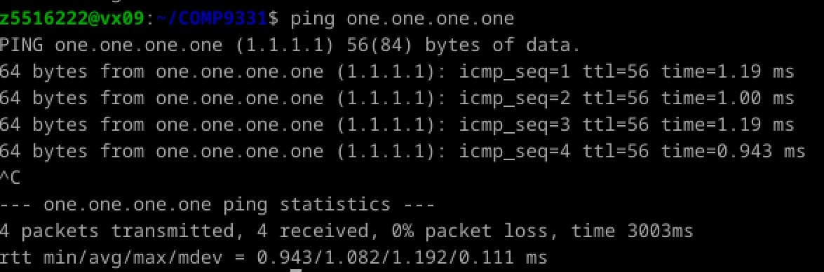

* [theguardian.com](http://theguardian.com/) -Yes, I can reach it!

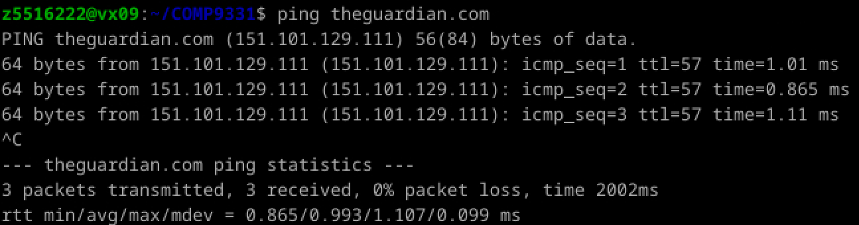

* [xn--i-7iq.ws](http://xn--i-7iq.ws/) -Yes, I can reach it!

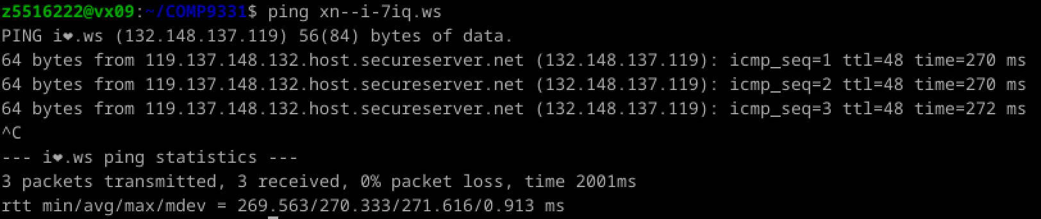

**Exercise 3: Use traceroute to understand the network topology (4 marks)**

*Note: Include all traceroute outputs in your report.*

1. Run traceroute (s) on your machine to uzh.ch **(NOT www.uzh.ch)**. You might have slightly different outputs, and your tutor will explain why.

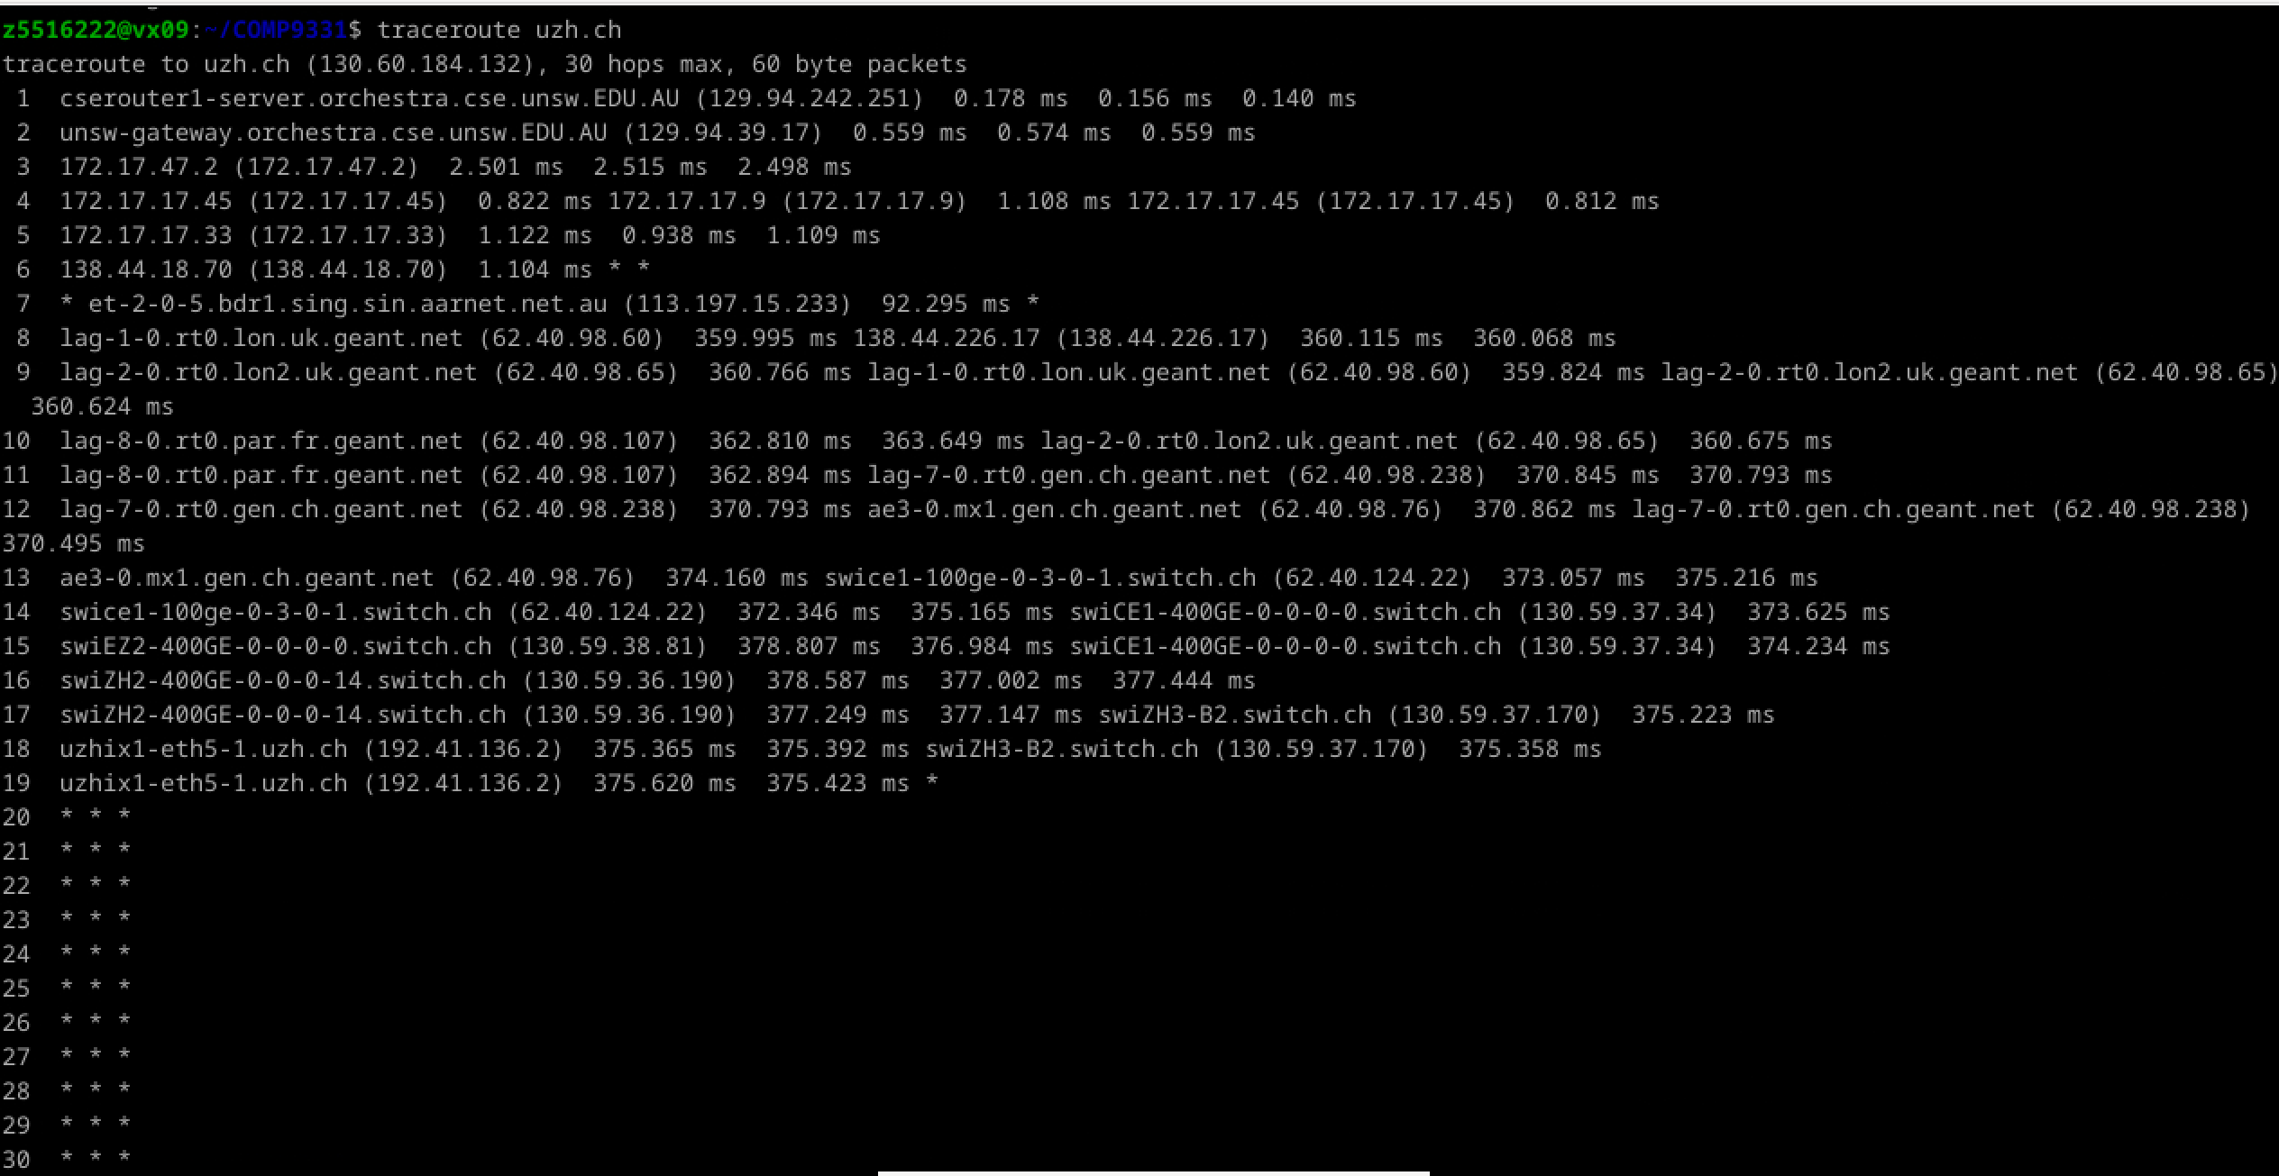

* 1. How many routers are there between your workstation and uzh.ch? How many routers along the path are part of the UNSW network?

- 18 routers. In the traceroute result, each line represents a router, except for the last hop which may be the destination host itself. And the “* * *”, indicating no response. So from hop 1 to hop 18, they are all valid, with a total of 18 routers.

- 2 routers. The 1st and 2nd router are part of the UNSW network, since UNSW inside network addresses are with the string “unsw”.

* 1. Which router is the first router outside of Australia?

- Hop 7 “et - 2 - 0 - 5.bdr1.sing.sin.aarnet.net.au (113.197.15.233)” is the first router outside Australia since the string “sing”, which indicates the first router outside of Australia is Singapore.

* 1. Which router is the first router to be found in UK? HINT: compare the round trip times from your machine to the routers. You might also find some router names informative and/or looking at network maps (e.g. for AARNET/ [www.submarinecablemap.com](http://www.submarinecablemap.com/)).

- Hop 11 “lag - 8 - 0.rt0.par.fr.geant.net (62.40.98.107)” is the first router found in the UK. The judgment is based on comparing the round - trip times and the geographical location information in the router names. From hop 10 to hop 11, the round - trip time changes, and the router name contains “par.fr” (Paris, France). According to the network topology, France is a European country. It is reasonable that France is passed before reaching the UK, so we judge that hop 11 is the first router found in the UK.

1. Run a traceroute from your machine to the following destinations:

(i) [aut.ac.nz](http://aut.ac.nz/)

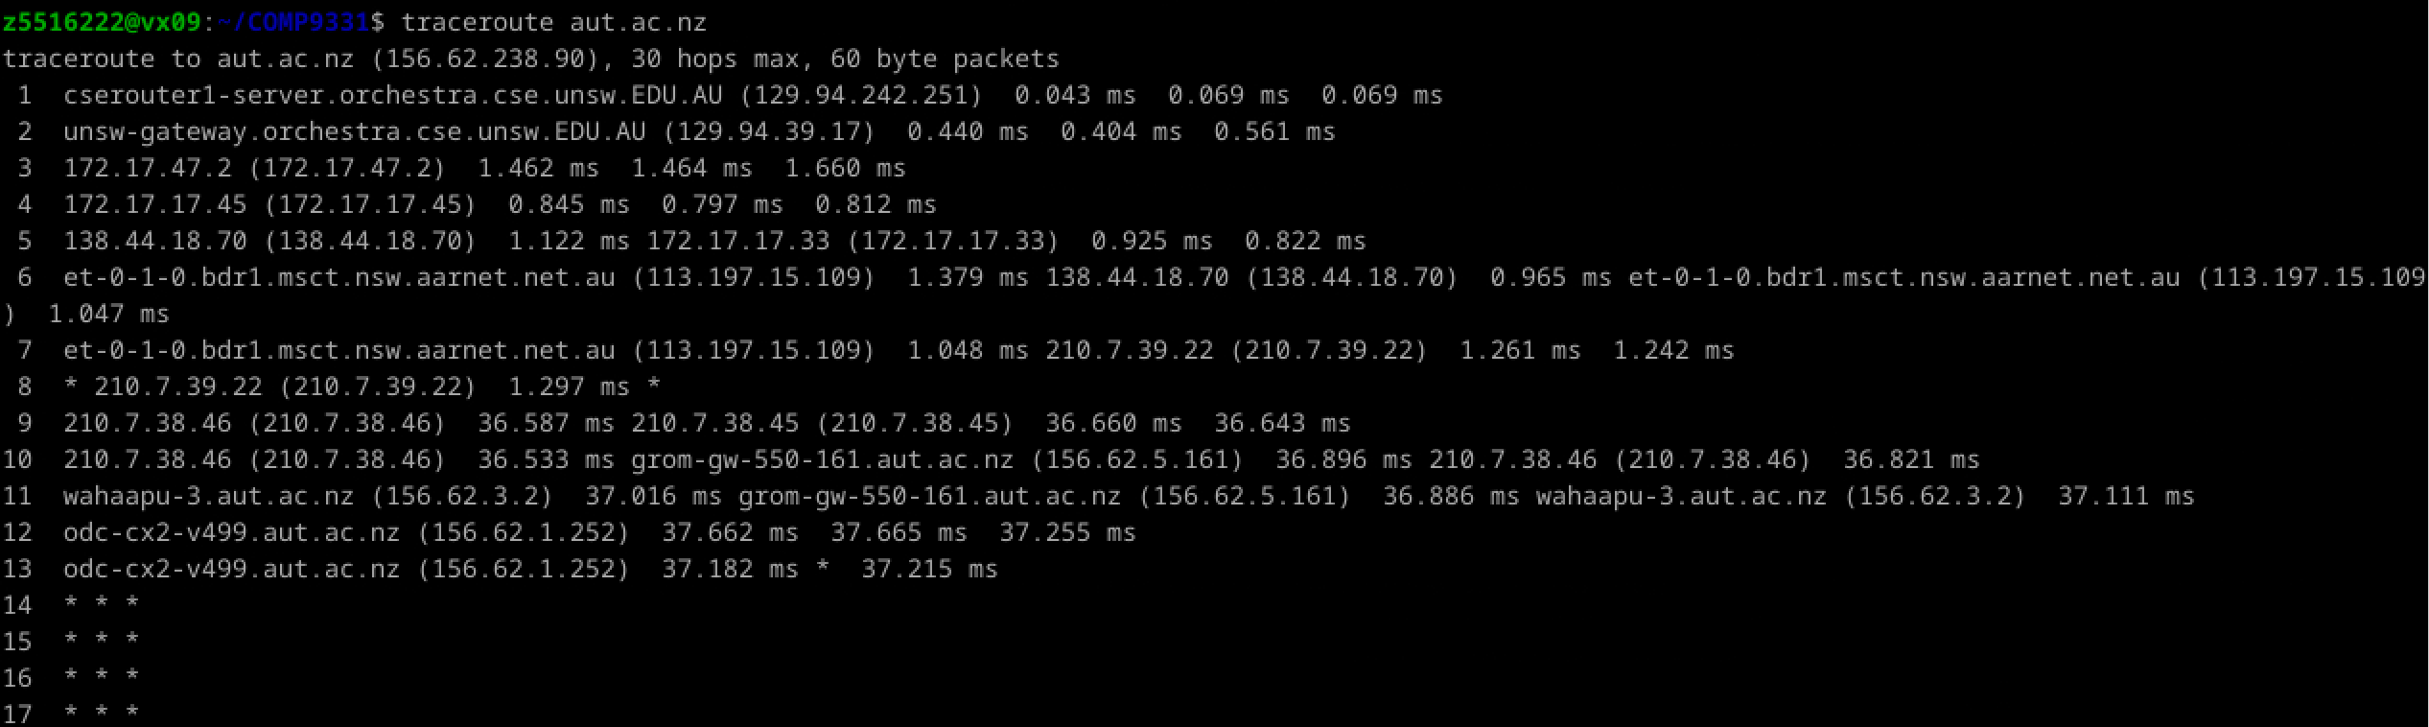 (ii) [stanford.edu](http://stanford.edu/)

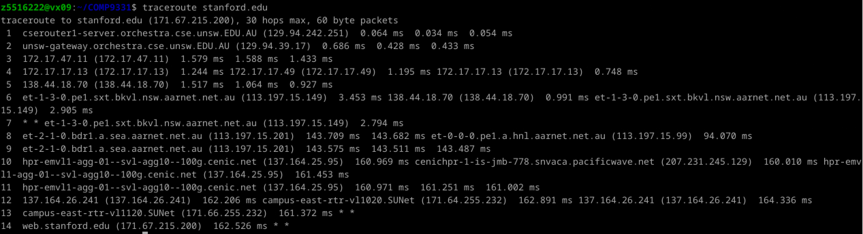

(iii) [reading.ac.uk](http://reading.ac.uk/)

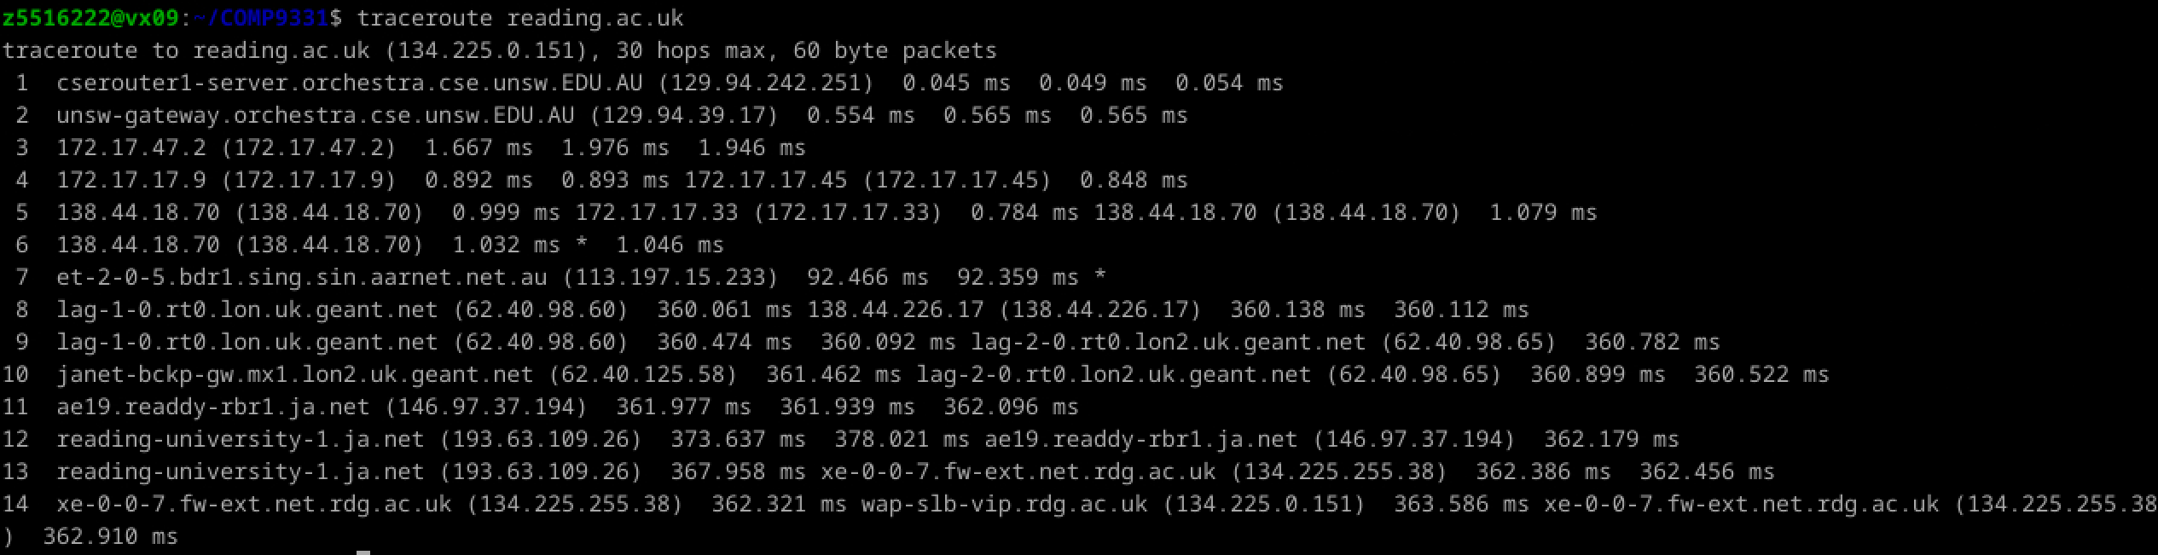

* 1. At which router do the paths from your machine to these three destinations diverge (i.e. which is the last router they have in common)? Find out further details about this router. HINT: You can learn more about a router by running the Whois command: whois router-IP-address.

- The paths to these three diverge at ​hop 6. The last common router is ​138.44.18.70. This router belongs to ​AARNet​ (Australia’s Academic and Research Network). And below is result running command ‘whois 138.44.18.70’.

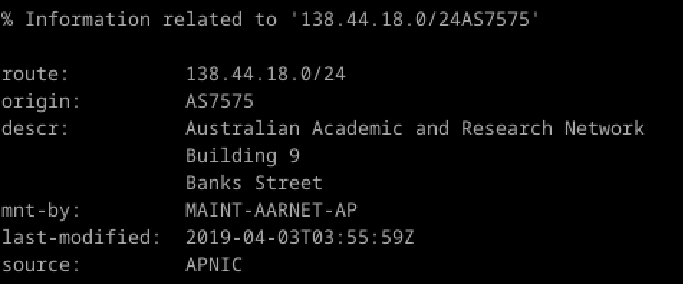

* 1. Is the number of hops on each path proportional to the physical distance? HINT: You can use the following tool to find the geographical location of a server - <https://iplocation.io/>.

- The number of hops is not necessarily proportional to the physical distance. Here’s the analysis:

​aut.ac.nz (New Zealand): 12 hops, relatively short physical distance.

​stanford.edu (USA): 14 hops, moderate physical distance.

reading.ac.uk (UK): 14 hops, longer physical distance.

While the hop counts are similar, the physical distances vary significantly. The number of hops depends more on the network topology and routing policies than on the physical distance.

1. Several servers are distributed worldwide to provide a web interface from which you can perform a traceroute to any other host on the Internet. Here are two examples: (i) <http://lg.nexlinx.net.pk/>and (ii) [www.as13030.net/traceroute.php](http://www.as13030.net/traceroute.php).
   1. Run a traceroute from both these servers towards your machine and in the reverse direction (from your machine to these servers - do not include the full URL while doing this, e.g. just " [**lg.nexlinx.net.pk**](http://lg.nexlinx.net.pk/)". You may also try other traceroute servers from the list at [www.traceroute.org](http://www.traceroute.org/). What are the IP addresses of the two servers that you have chosen?

- Use ‘nslookup’ command to get the ip of addresses given:

They are 129.94.242.2:53 for lg.nexlinx.net.pk; and 129.94.242.2:53 for www.as13030.net.

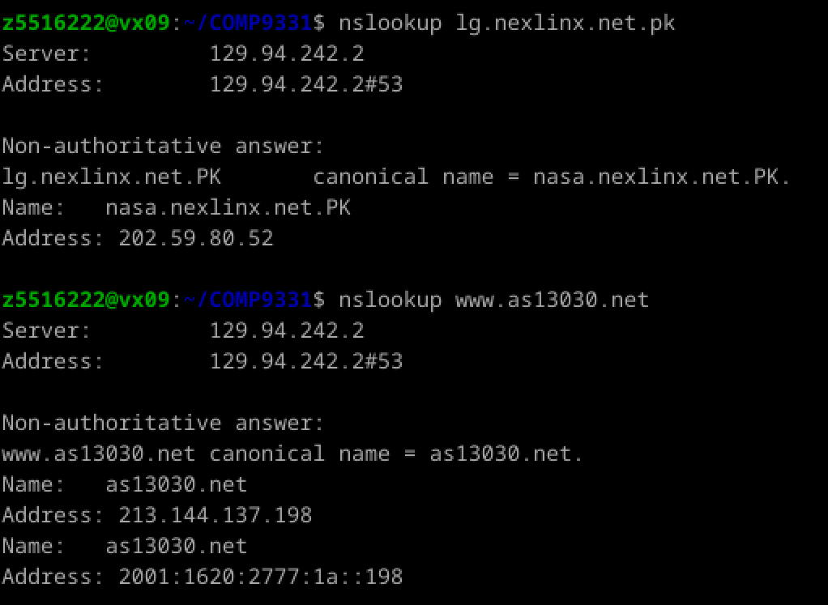

* 1. Does the reverse path go through the same routers as the forward path?

- My ip address is fetched by command ‘curl ifconfig.me’:

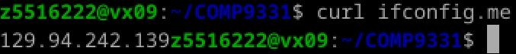

Visit http://lg.nexlinx.net.pk/ and www.as13030.net/traceroute.php, enter the ip address, and run traceroute. Record the router information for the forward path.

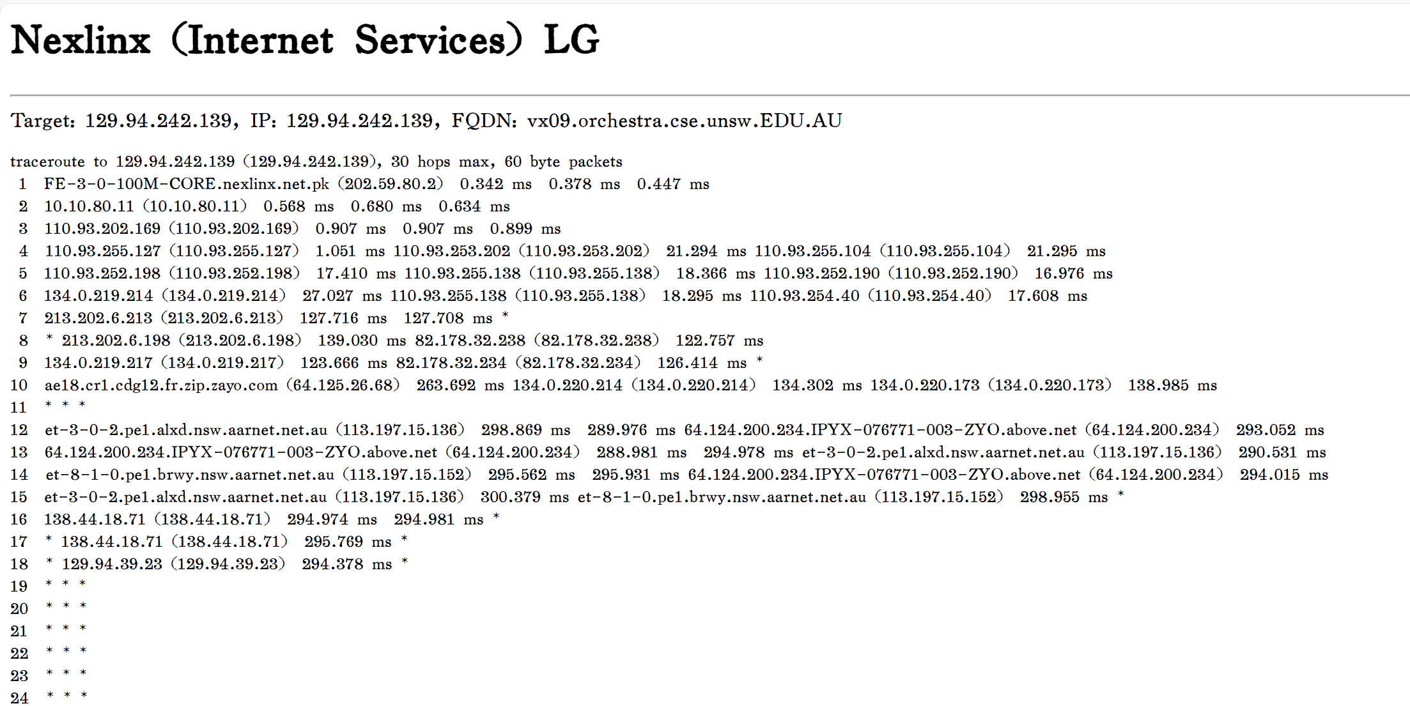

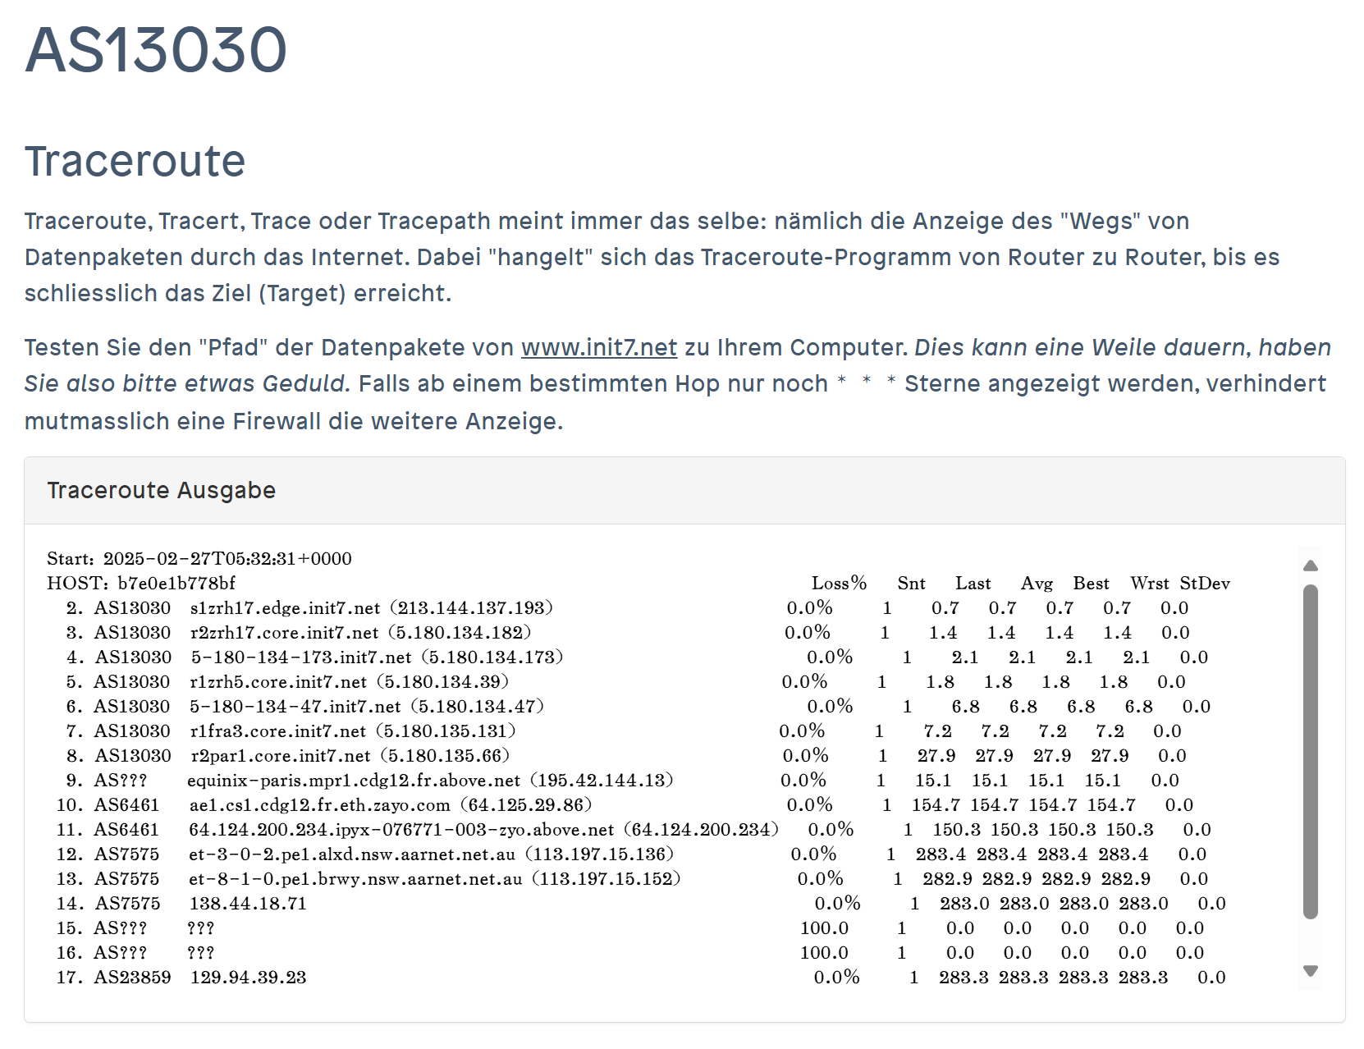

run the following commands:

traceroute lg.nexlinx.net.pk

traceroute www.as13030.net

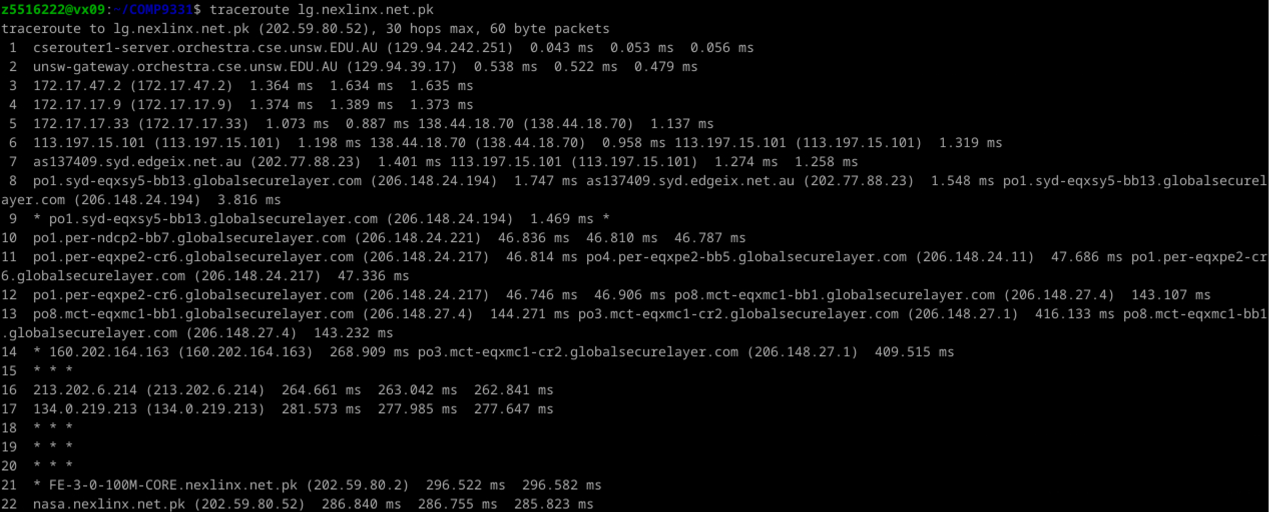

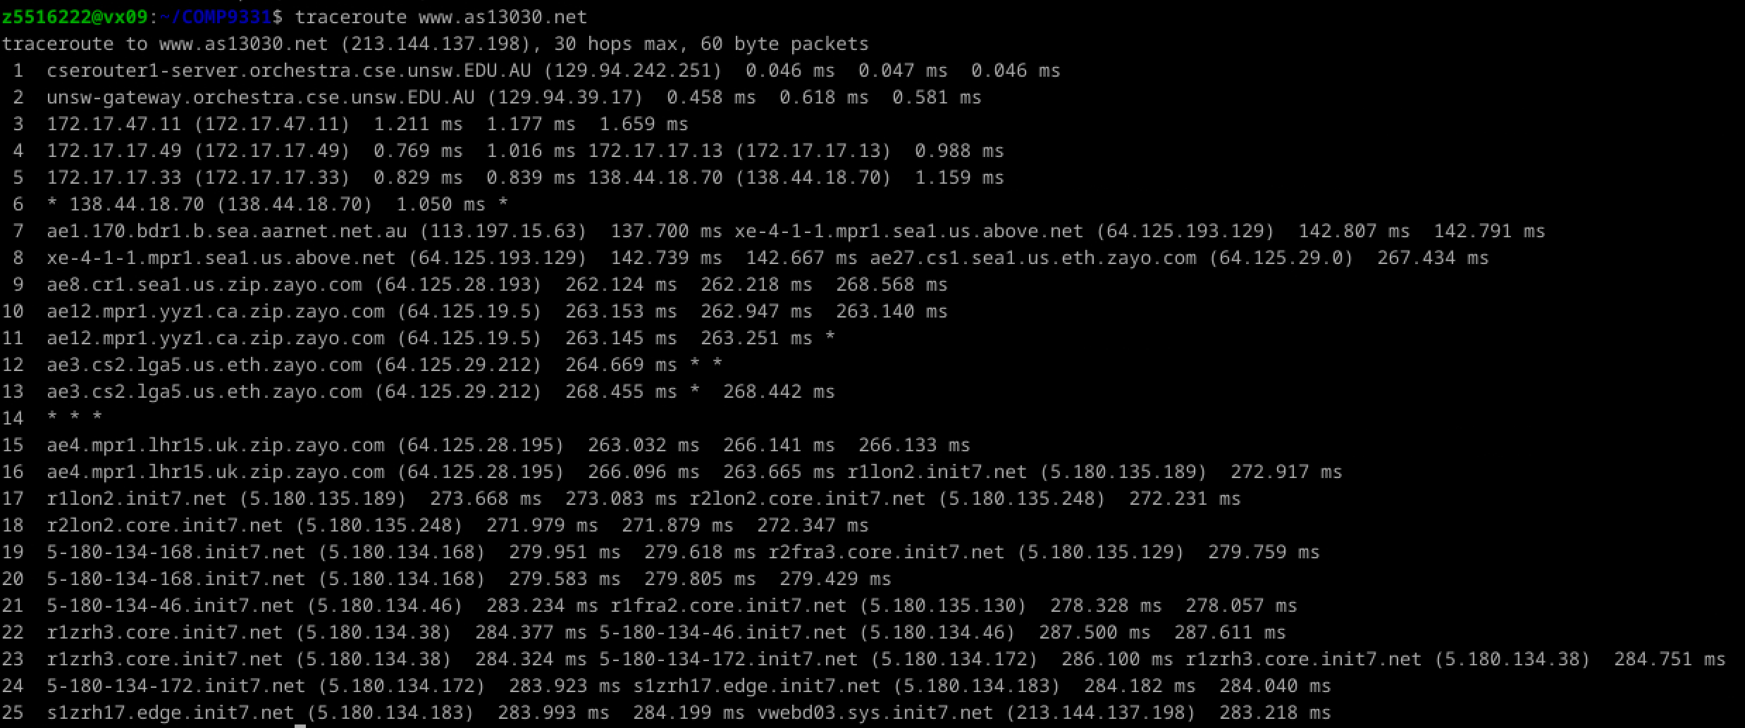

No. Forward and reverse paths may pass through different routers because Internet routing is asymmetric. The path of packets depends on network topology, routing policies, and load balancing.

* 1. If you observe common routers between the forward and the reverse path, do you also observe the same IP addresses? Why or why not?

- Not necessarily. Even if the same routers are used, the forward and reverse paths may use different interfaces, so the IP addresses may differ. Additionally, routers may be configured with multiple IP addresses for traffic in different directions.

**IMPORTANT**: (1) When running this test on your machine connected to UniWide, the reverse traceroute fails because of the 10.x.x.x IP address assigned to your machine is a private IP address (i.e. it is behind a NAT) and thus not publicly routable. So, make sure you conduct the above experiment through VLAB. (2) Feel free to terminate the traceroute if you start receiving output with multiple " * * * " responses or if you can confirm that the traceroute messages have reached the destination network.

**Exercise 4: Use ping to gain insights into network performance (4 marks)**

*Note: Include all graphs in your report. You need to run the scripts (runping.sh and plot.sh) when you are physically using a lab machine or connected to a CSE server/lab machine using VLAB / VNC client. You need to ensure gnuplot and ps2pdf are available on your system if you plan to do this exercise on your machine.*

We now use the ping utility to investigate network delay and its implications on network performance. In particular, we will analyze the dependency of packet size and delay.

There is a shell script [runping.sh](https://webcms3.cse.unsw.edu.au/COMP3331/25T1/resources/107382), provided that you can use it instead of running many pings with different packet sizes by hand. After downloading this script on your machine, make sure you can execute it. If not, you must execute the following command in the command line: *chmod u+x runping.sh*. To run the ping traces, you may use the runping.sh script as follows: ./runping.sh [www.abc.net](http://www.abc.net/)(or whatever other destination you want to ping). It will automatically run ping for different packet sizes, with 50 ping packets per size (-c 50). This script will take a few minutes to finish since ping is sent once per second (-i 1). Additional options are enabled to use IPv4 only (-4) and not lookup symbolic names for host addresses (-n). This script only executes the commands:

$ ping -4 -n -c 50 -i 1 -s 22 www.abc.net > www.abc.net -p50

...

$ ping -4 -n -c 50 -i 1 -s 1472 www.abc.net > www.abc.net -p1500

and writes the output of the pings to the corresponding files.

- Download and test the script:

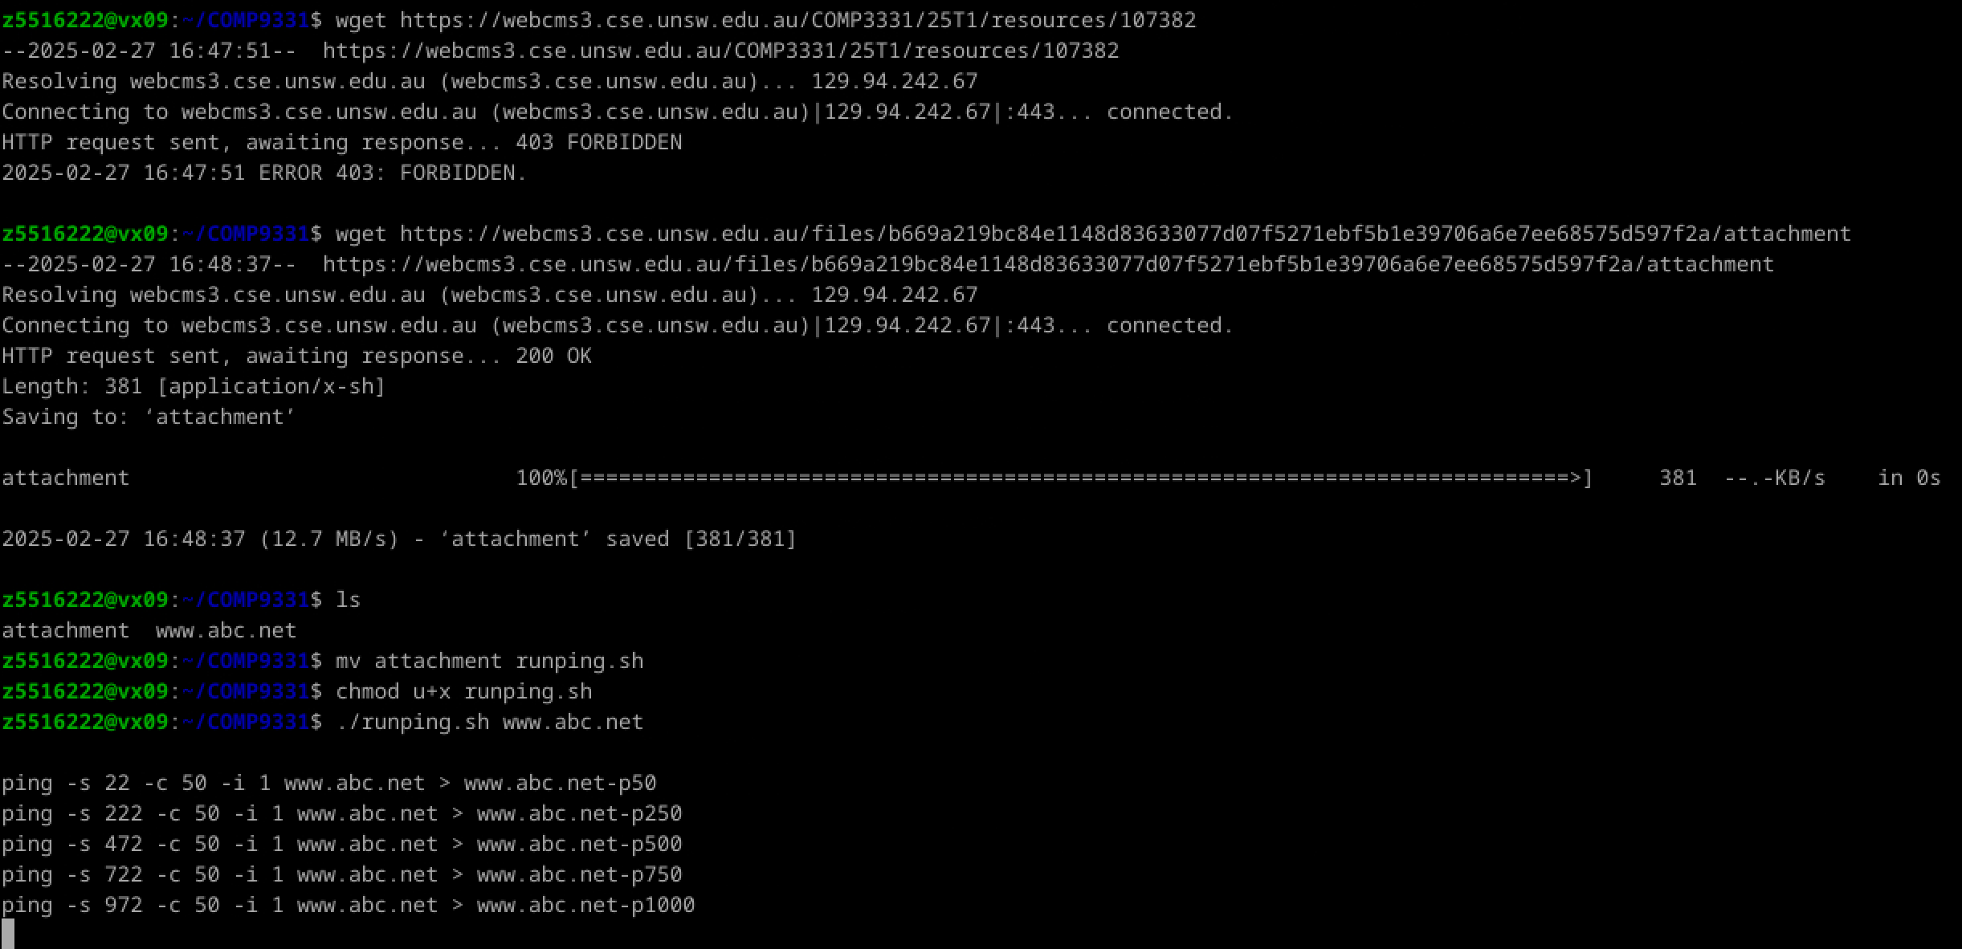

Use this script for the following destinations:

1. [flinders.edu.au](http://flinders.edu.au/)(Flinders University - Adelaide, Australia)
2. [upd.edu.ph](http://upd.edu.ph/)(University of the Philippines Diliman - Quezon City, Philippines)
3. [uio.no](http://uio.no/)(University of Oslo - Oslo, Norway)

Alternatively, use **kcl.ac.uk (King's College, London, UK) / columbia.edu ( Columbia University, New York, USA)**if any of the above destinations are down.

In other words, execute the following commands:

$ ./runping.sh flinders.edu.au

$ ./runping.sh upd.edu.ph

$ ./runping.sh uio.no

- Run the script:

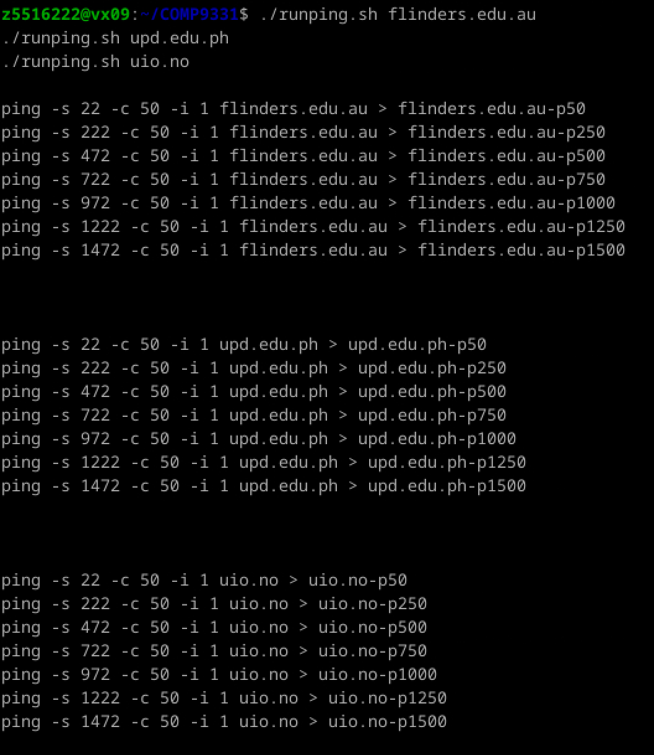

**Note that all delay values reported are in milliseconds (ms) and reflect the round trip time (RTT) between your host and the destinations.**

If you cannot execute runping.sh, then fix the permissions by running the following command in the command line:

$ chmod u+x runping.sh

When the runping.sh script is finished for all destinations, you can plot the results using another provided script, [plot.sh](https://webcms3.cse.unsw.edu.au/COMP3331/25T1/resources/107388), as follows:

- Download and test the script:

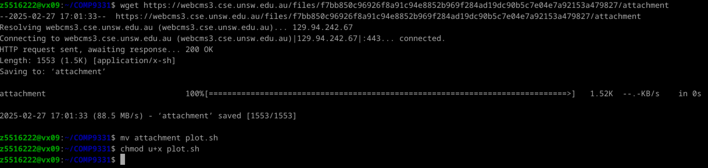

$ ./plot.sh flinders.edu.au*

$ ./plot.sh upd.edu.ph*

$ ./plot.sh uio.no*

If you cannot execute plot.sh, then fix the permissions by running the following command in the command line:

$ chmod u+x plot.sh

- Run the script:

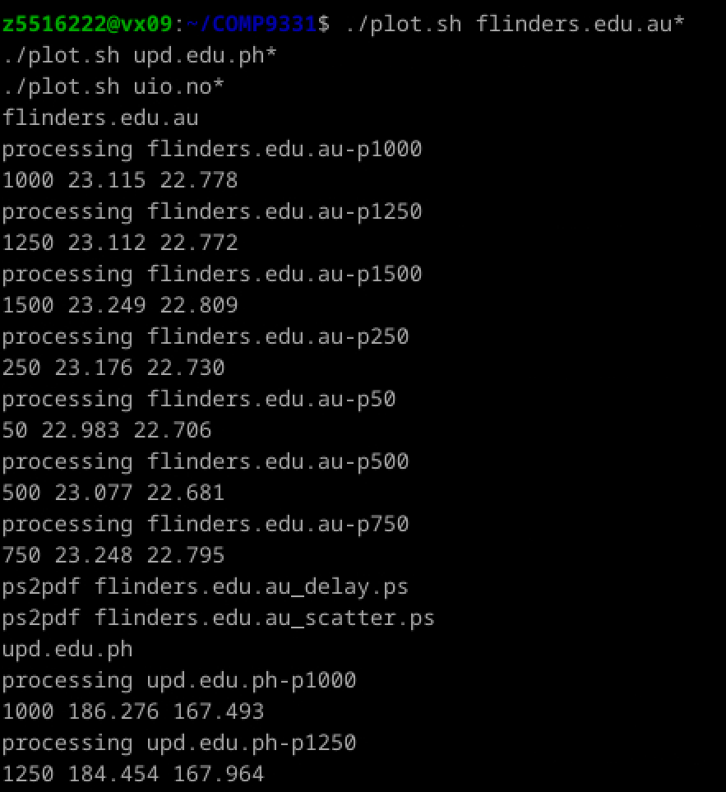

The script plot.sh will produce the following files: *destination_delay.pdf*, *destination_scatter.pdf,*and *destination_avg.txt*for each destination (e.g., for cdu.edu.au we have *cdu.edu.au_delay.pdf*and *cdu.edu.au_scatter.pdf*and *cdu.edu.au_avg.txt*).

The graph *destination_delay.pdf*shows how delay varies over time (different colours correspond to different packet sizes), and *destination_scatter.pdf*shows delay vs. packet size as a scatter plot. *destination_avg.txt*contains the average (2nd column) and minimum (3rd column) delay values corresponding to each packet size (1st column).

1. For each location, ﬁnd the (approximate) physical distance from UNSW . You can use a site like [Distance Calculator](https://www.distancecalculator.net/), [Google Maps](https://www.google.com/maps), or whatever you prefer to take this measurement. Then, compute the shortest possible time T for a packet from UNSW to reach that location. You should assume that the packet moves (i.e. propagates) at the speed of light, 3 x 10^8 m/s. Note that the shortest possible time will be the distance divided by the propagation speed.

-Distance to Adelaide, Quezon City, Oslo: 1161.71, 6272.09, 15950.20

Such that, in the code, distances = [1164, 6110, 16210]

Shortest possible time: 0.00388s, 0.02037s, 0.05403s

T= Distance/Speed of Light ​(Speed of Light=3×10^8m/s)

1. Plot a graph where the x-axis represents the distance to each city (i.e. **Adelaide, Australia**, **Quezon City, Philippines**and **Oslo, Norway**). The y-axis represents the ratio between the minimum delay (i.e. RTT) measured by the ping program (select the values for 50-byte packets) and the shortest possible time T to reach that city from UNSW. (Note that the y-values are no smaller than 2 since it takes at least 2*T time for any packet to reach the destination from UNSW and return).

- Ratio= Min.RTT/(2×T)

So the ratio in the code is: ratios = [1.29, 1.96, 1.85]

You can also use the provided [generate_plot.py](https://webcms3.cse.unsw.edu.au/COMP3331/25T1/resources/107416)to generate the plot. Download (to Vlab or personal machines with Python 3 installed). Open the [generate_plot.py](https://webcms3.cse.unsw.edu.au/COMP3331/25T1/resources/107416)and uncomment the designated lists, and replace them with the actual values.

-The plot is shown as below:

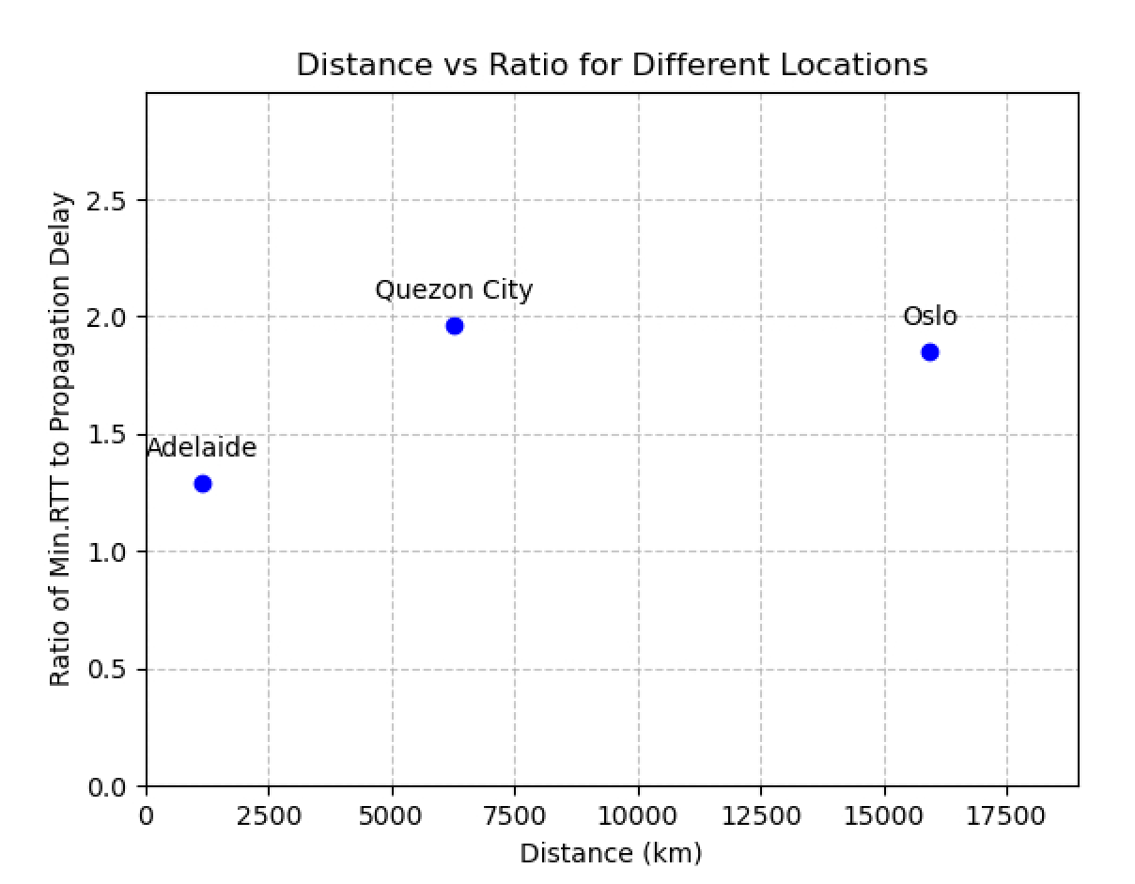

1. Can you think of at least two reasons why the y-axis values you plot are greater than 2?

- Reason 1: Packets pass through multiple routers, and each router introduces processing and queuing delays.

​Reason 2: Network congestion or poor link quality may cause packet retransmission or increased delay.

1. Is the delay to the destinations constant, or does it vary over time? Explain why.

- The delay varies over time. Factors such as network traffic, router load, and link quality can cause fluctuations in delay.

1. The measured delay (i.e., the delay you can see in the graphs) comprises propagation, transmission, processing, and queuing delays. Which of these delays depend on the packet size and which do not?

- ​Depends on packet size: Transmission delay (proportional to packet size).

​Does not depend on packet size: Propagation delay, processing delay, and queuing delay.