Work Package 1 (WP1): Simple Guide to the Analysis, Notebook & Findings
Early Discharge Planning to Reduce Excess Bed-Days in the Finger Lakes Health System (NY SPARCS)
Course: Applied Data Science for Business and Science (UPM)
Team Members: Andrea Brugnera & Luigi (Jin fa Zheng)
Target Audience: Hospital Board, Chief Medical Officer, Director of Patient Flow, and Head of Case Management
The Whole Project in 30 Seconds (Plain English):
1. THE PROBLEM: Hospitals are paid a fixed amount per stay (based on diagnosis), not per day. When a patient stays longer than normal for their condition ('excess bed-days'), the hospital gets no extra payment, pays for the extra days, and loses a bed another patient needs.
2. WHERE THE DAYS GO: Patients who leave for a nursing home (SNF), home health care, rehab or hospice are 41% of stays but 74.8% of all excess bed-days. This is consistent with their post-hospital care being arranged too late.
3. THE DECISION: On Day 1 (at admission), flag patients likely to overstay so Case Managers start arranging their nursing home or home care on Day 1, not at the end of the stay.
4. THE PAYOFF: In the Finger Lakes system (17 hospitals around Rochester, NY), the KPI is 192.8 excess bed-days per 100 admissions in 2023: up 78% since 2017 like for like, and the highest of New York's 8 regions. The addressable gap is 79,700 bed-days a year (218 beds every day). Flagging the 30% highest-risk admissions costs $5.65M a year and returns +$17.5M net in the base case (1 day saved per caught stay, half the freed beds refilled). It is +$1.5M in the conservative case, and it breaks even at 1.0 day saved per caught stay on cash savings alone.

1. How the Notebook Works (Step-by-Step in Plain English)
The Jupyter notebook (WP1_Executive_EDA_and_Business_Case.ipynb) has 8 steps. Here is what each part does and why:
- Step 1: Loading the filtered data and checking the funnel. We load the Parquet files created by download_sparcs.py. Of 2.13 million stays in New York State in 2023 (137,867 in Finger Lakes), we keep adult acute medical-surgical stays (99,880 in Finger Lakes). Obstetrics, newborns, psychiatry, substance use, paediatrics and rehab have separate beds and rules. Patients who died or were transferred to another acute hospital are left out of the KPI (leaving 94,132 KPI-eligible stays), because nobody could plan their discharge. They stay in the data for the model, since on Day 1 nobody knows how a stay will end.
- Step 2: The 2017 frozen ruler (what counts as a prolonged stay). For every diagnosis group (APR-DRG) and severity level (1 = minor to 4 = extreme), we take the 75th percentile (P75) length of stay in New York State in 2017. A stay longer than its group's P75 is prolonged (target = 1), and every day past P75 is an excess bed-day. The ruler is frozen for the whole project, so WP4 measures impact against the same yardstick.
- Step 3: Two data quirks we found and fixed. (1) 2016 stores diagnosis codes without leading zeros ('4' instead of '004'); we pad them to 3 digits. (2) After 2017, 3M split 12 surgical diagnosis groups (e.g. hip and knee replacement) into new codes, covering 7.8% of 2023 stays. Those stays use the 2017 P75 for their severity level as a back-up ruler. The headline KPI uses all stays (192.8). On the 92.2% of stays whose code existed in 2017 it is 192.5, almost identical, and that like-for-like series is used only for the trend chart.
- Steps 4 to 7: six charts and the financial model. (Chart 1) the problem grew 78% since 2017, and 79,700 days a year are addressable; (Chart 2) post-hospital placement holds three quarters of excess days; (Chart 3) Finger Lakes is the highest region, and 4 Rochester hospitals hold 76% of stays and 89% of excess days; (Chart 4) 30 conditions drive over half of excess days; (Chart 5) information known on Day 1 separates high- and low-risk stays, plus a fairness baseline; (Chart 6) the value of early planning in cash and capacity, with break-even and sensitivity.

2. All 8 WP1 Requirements Answered Simply
WP1 Task | Plain-English Answer for the Board | Key Numbers from NY SPARCS
1. Case & Context | We represent the Finger Lakes Health System (17 hospitals in the Rochester, NY region). Under DRG payment, hospitals are paid per admission, not per day: an excess day brings no revenue, costs money and blocks a bed. | 137,867 raw stays in Finger Lakes (2023) → 99,880 adult medical-surgical → 94,132 KPI-eligible.
2. Decision & Owner | DECISION: at admission (Day 1), flag patients likely to overstay so Case Managers start arranging nursing home or home care on Day 1.  OWNER: Director of Patient Flow & Head of Case Management. | Flag the top 30% = 28,240 patients a year (~77 a day). Start in the 4 Rochester hospitals (76% of stays, 89% of excess days).
3. KPI & Baseline | PRIMARY KPI: excess bed-days per 100 admissions, beyond the frozen 2017 statewide P75 for the same diagnosis and severity.  TARGET VARIABLE: 1 if length of stay > P75, else 0. | 2023 baseline: 192.8 per 100 stays  181,460 excess bed-days  24.4% of stays prolonged  6.69-day average stay
4. Executive EDA | Excess days are concentrated in post-hospital placement, in 4 Rochester hospitals and in about 30 diagnoses, and the problem grew sharply after COVID. | Post-hospital care: 41% of stays, 74.8% of excess days (135,668)  Nursing home: 515 per 100 stays (6.6× home)  Top 30 diagnoses: 52.6%
5. Expected Value vs. Cost of Doing Nothing | DOING NOTHING: an addressable gap of 79,700 bed-days a year (218 beds daily) above our own 2017 rate: at least $29.9M a year in cash, plus the capacity for ~11,900 admissions.  ACTING: $200 per flag vs. $375 cash + $2,359 capacity per refilled bed-day saved. | Programme $5.65M a year (28,240 flagged)  Conservative: +$1.5M a year  Base: +$17.5M a year (41 beds freed daily)  Optimistic: +$42.3M a year  Break-even: 1.0 day (cash only)
6. Data Sources, Gaps & Privacy | Public NY SPARCS, de-identified at source (no patient consent needed). Missing: patient id (no readmissions per patient), dates and ward census, Day-1 provisional diagnosis, social factors. | 6.23M stays downloaded (2017, 2018, 2019, 2023) + trend counts 2016–2021, 2023. In production (WP2), the hospital EHR/ADT supplies dates, census and provisional diagnosis.
7. Hypotheses (to prove) | H1: Day-1 data catches ≥65% of prolonged stays while flagging 30% of admissions (WP3).  H2: the need for post-hospital care can be predicted on Day 1.  H3: hospital differences remain after more patient-mix controls (process, not patients).  H4: early planning saves more than break-even per caught stay (WP4 pilot). | Break-even: 1.0 day per caught stay on cash alone, 0.24 day if half the freed beds are refilled, out of 7.9 excess days per prolonged stay.
8. Decision Delivery & Lifecycle | DELIVERY: 07:00 daily risk list in the EHR case-management worklist.  LIFECYCLE: the ruler stays frozen; the model is retrained each year with the new SPARCS release or when drift appears. Monthly: KPI vs. baseline, flag precision and recall, fairness by payer and race. | Fairness baseline: 287.6 (Black) vs. 174.6 (White) excess days per 100 stays, monitored, never a model input.

3. Visual Walkthrough of the 6 Charts in the Notebook

Chart 1: The Cost of Doing Nothing (2016–2023 Trend)
What we did: We measured excess bed-days per 100 admissions every year from 2016 to 2023 against the frozen 2017 ruler, like for like (codes that existed in 2017), for Finger Lakes and the rest of New York State. We then split the 2023 total into the normal tail of the ruler and the addressable gap.
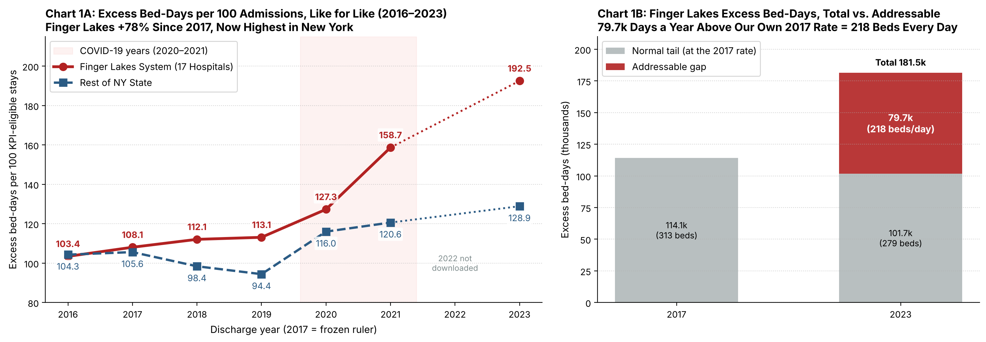
Figure 1: Excess bed-days per 100 admissions, like for like (left), and 2023 excess bed-days split into normal tail and addressable gap (right). 2022 was not downloaded.
Year | Finger Lakes Stays (codes in 2017) | Avg Stay | % Prolonged | Finger Lakes Excess Days / 100 | Rest of NY Excess Days / 100 | Finger Lakes Excess Bed-Days
2016 | 99,935 | 5.30 d | 17.9% | 103.4 | 104.3 | 103,373
2017 (ruler) | 105,631 | 5.28 d | 18.3% | 108.1 | 105.6 | 114,146
2018 | 102,622 | 5.35 d | 19.0% | 112.1 | 98.4 | 115,013
2019 | 103,358 | 5.53 d | 17.8% | 113.1 | 94.4 | 116,903
2020 (COVID) | 91,690 | 5.66 d | 20.9% | 127.3 | 116.0 | 116,720
2021 (COVID) | 88,955 | 6.47 d | 22.8% | 158.7 | 120.6 | 141,170
2023 | 86,831 | 6.73 d | 24.0% | 192.5 | 128.9 | 167,181
Headline 2023 KPI on all stays (including codes created after 2017): 192.8 per 100 stays, 94,132 stays, 181,460 excess bed-days.
Key Takeaway from Chart 1 (Why the Board Cares):
Before COVID, Finger Lakes was close to the rest of New York State (108.1 vs. 105.6 in 2017). By 2023 it reached 192.5 like for like (+78%), the highest in the state.
A P75 ruler always leaves a normal tail, so not every excess day is avoidable. At our own 2017 rate we would still have ~101,700. The addressable gap is ~79,700 bed-days a year: 218 beds every day, or room for ~11,900 more admissions.

Chart 2: Where the Excess Days Go (Discharge Destination)
What we did: We grouped all 94,132 KPI-eligible stays in Finger Lakes (2023) by where the patient went after the hospital (patient_disposition). This is known only at discharge, so it explains the problem and is never a model input.
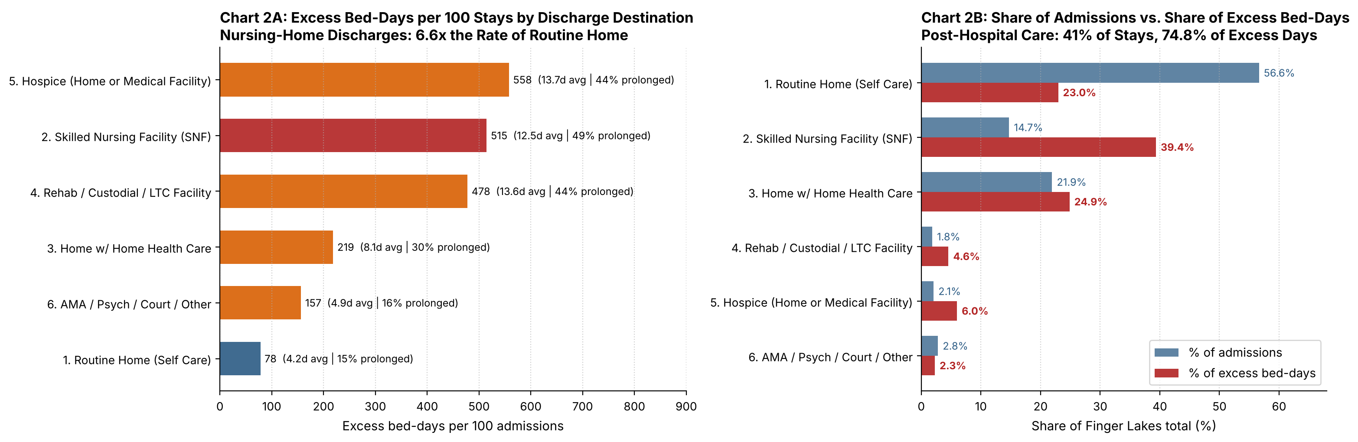
Figure 2: Excess bed-days per 100 admissions by discharge destination (left) and share of admissions vs. share of excess bed-days (right).
Discharge Destination Group | Stays (2023) | % of All Stays | Avg Stay | % Prolonged | Excess Days / 100 Stays | Total Excess Bed-Days | % of All Excess Days
1. Routine Home (Self Care) | 53,303 | 56.6% | 4.22 d | 14.6% | 78.2 | 41,662 | 23.0%
2. Skilled Nursing Facility (SNF) | 13,871 | 14.7% | 12.48 d | 49.3% | 514.8 | 71,407 | 39.4%
3. Home w/ Home Health Care | 20,642 | 21.9% | 8.14 d | 30.5% | 218.6 | 45,128 | 24.9%
4. Rehab / Custodial / LTC Facility | 1,729 | 1.8% | 13.58 d | 44.2% | 477.8 | 8,262 | 4.6%
5. Hospice (Home or Medical) | 1,949 | 2.1% | 13.69 d | 44.0% | 557.8 | 10,871 | 6.0%
6. AMA / Psych / Court / Other | 2,638 | 2.8% | 4.88 d | 16.1% | 156.6 | 4,130 | 2.3%
TOTAL (Finger Lakes 2023) | 94,132 | 100.0% | 6.69 d | 24.4% | 192.8 | 181,460 | 100.0%

Key Takeaway from Chart 2:
Patients going to a nursing home (SNF) are only 14.7% of admissions, but half of them (49.3%) overstay: 514.8 excess bed-days per 100 stays (6.6× routine home) and 39.4% of all excess bed-days.
All post-hospital destinations together (SNF, home health, rehab, hospice) are 41% of patients but 74.8% (135,668 days) of all excess bed-days. The data shows where the days are, not why: it can't tell us when a patient was ready to leave. But the pattern is consistent with placement being arranged too late, which Day-1 planning addresses.

Chart 3: Comparing NY Regions & Finger Lakes Hospitals
What we did: Because the ruler adjusts for diagnosis and severity, we compared the 8 New York regions and the hospitals inside Finger Lakes (2023, all stays).
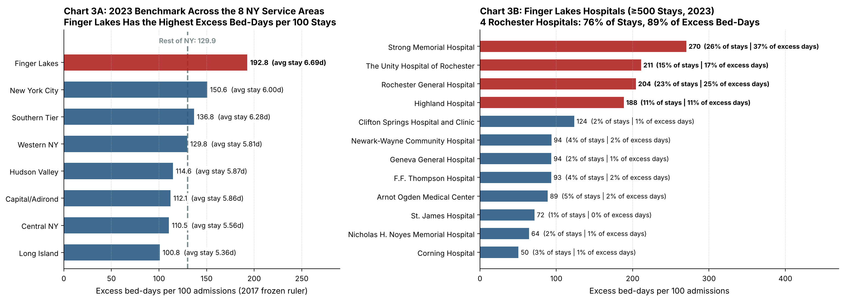
Figure 3: 2023 benchmark across the 8 NY service areas (left) and Finger Lakes hospitals with ≥500 stays (right).
Hospital (Top 8 in Finger Lakes) | KPI Stays | % of Stays | Avg Stay | % Prolonged | % to SNF | Excess Days / 100 | Excess Bed-Days | % of Excess Days | Cumulative %
Strong Memorial Hospital | 24,536 | 26.1% | 8.33 d | 25.4% | 10.7% | 270.3 | 66,326 | 36.6% | 36.6%
Rochester General Hospital | 21,936 | 23.3% | 6.77 d | 25.6% | 13.6% | 204.2 | 44,784 | 24.7% | 61.2%
The Unity Hospital of Rochester | 14,464 | 15.4% | 6.83 d | 29.9% | 17.5% | 211.0 | 30,515 | 16.8% | 78.0%
Highland Hospital | 10,818 | 11.5% | 6.40 d | 25.1% | 17.4% | 188.5 | 20,393 | 11.2% | 89.3%
Arnot Ogden Medical Center | 5,034 | 5.3% | 4.67 d | 18.9% | 17.1% | 88.7 | 4,464 | 2.5% | 91.7%
F.F. Thompson Hospital | 3,830 | 4.1% | 5.20 d | 18.2% | 17.5% | 93.4 | 3,579 | 2.0% | 93.7%
Newark-Wayne Community Hospital | 3,629 | 3.9% | 4.88 d | 20.0% | 15.3% | 93.7 | 3,401 | 1.9% | 95.6%
Geneva General Hospital | 2,253 | 2.4% | 4.88 d | 18.7% | 15.2% | 93.5 | 2,106 | 1.2% | 96.8%

Key Takeaway from Chart 3 (Where to Deploy First):
Finger Lakes (192.8) is the highest of the 8 regions; the rest of New York averages 129.9 and Long Island 100.8. The ruler adjusts for diagnosis and severity but not for everything: a referral centre such as Strong Memorial receives harder cases within the same group, which WP3 will test with more patient-mix controls (H3).
The 4 large Rochester hospitals (Strong Memorial, Rochester General, Unity, Highland) hold 76% of stays but 89% of excess bed-days (162,018 days), and they also have the highest rates per stay. That is where the programme should start.

Chart 4: Which Medical Conditions Cause the Most Excess Bed-Days?
What we did: We ranked all 272 active medical-surgical diagnosis groups (APR-DRGs) in Finger Lakes by total excess bed-days.
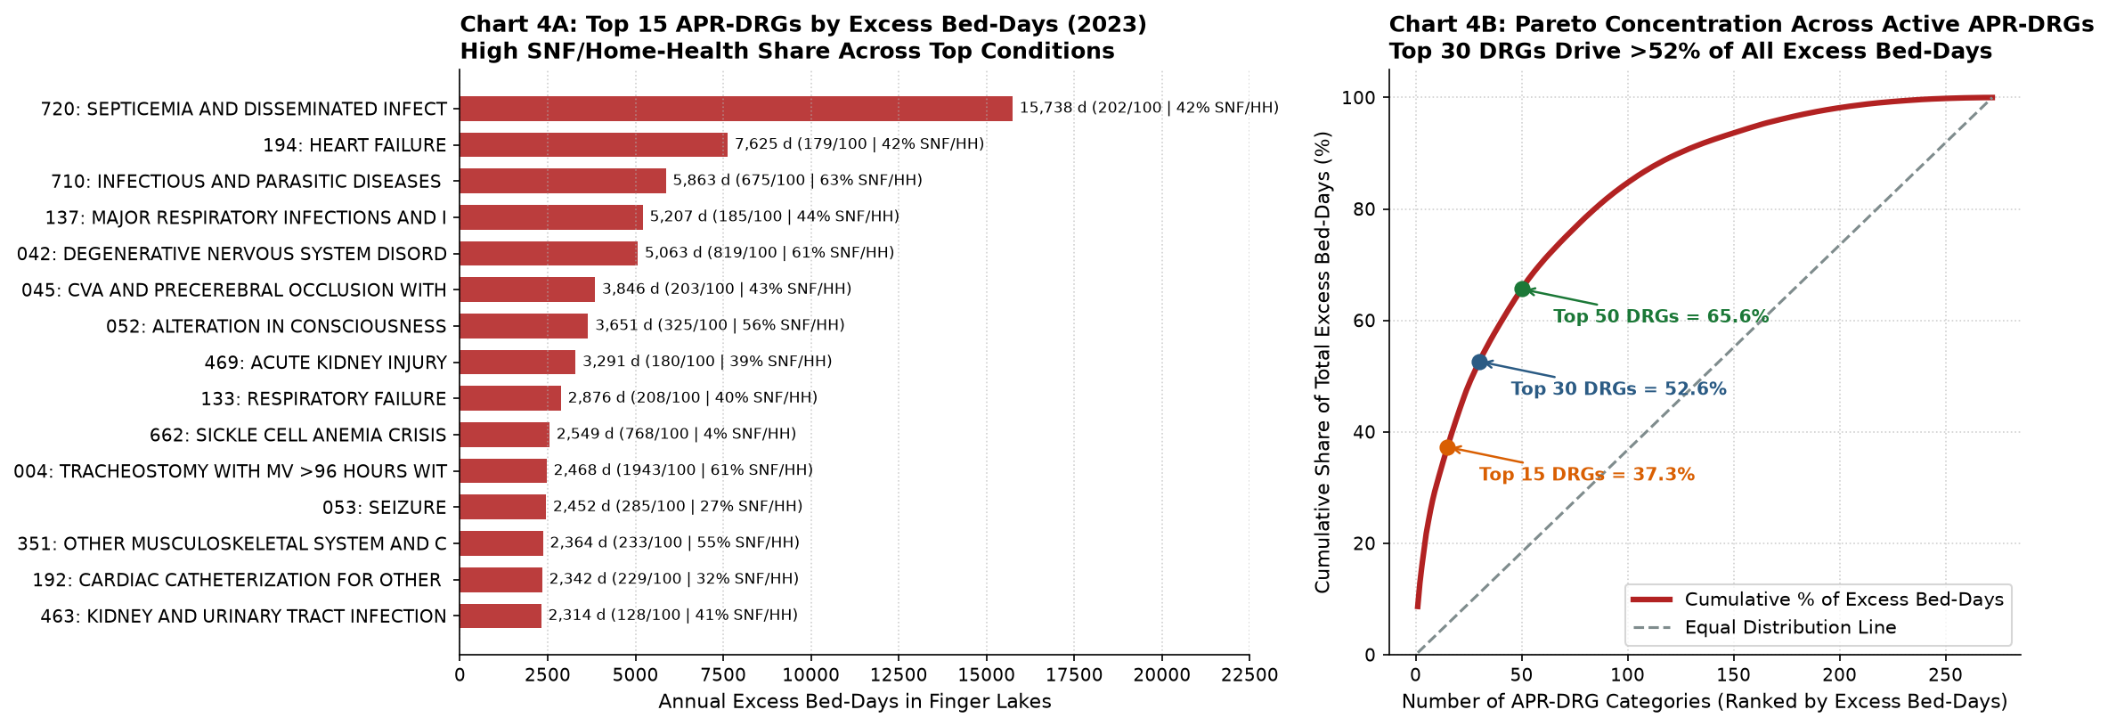
Figure 4: Top 15 diagnosis groups by excess bed-days (left) and cumulative Pareto curve across all 272 active groups (right).
Key Takeaway from Chart 4 (Clinical Concentration):
Case Managers don't need to watch 272 conditions equally: the top 15 diagnoses generate 37.3% of excess bed-days, and the top 30 (11% of groups) generate 52.6%. Leading conditions such as septicaemia (15,738 excess days), heart failure (7,625), major lung infections (5,207) and degenerative nervous system disorders (5,063) have 40–63% of patients leaving for a nursing home or home health care.

Chart 5: Day-1 Clues, Avoiding Data Leakage & Fairness Baseline
What we did: We checked whether information known on Day 1 separates high-risk from normal stays, and recorded a fairness baseline by race.
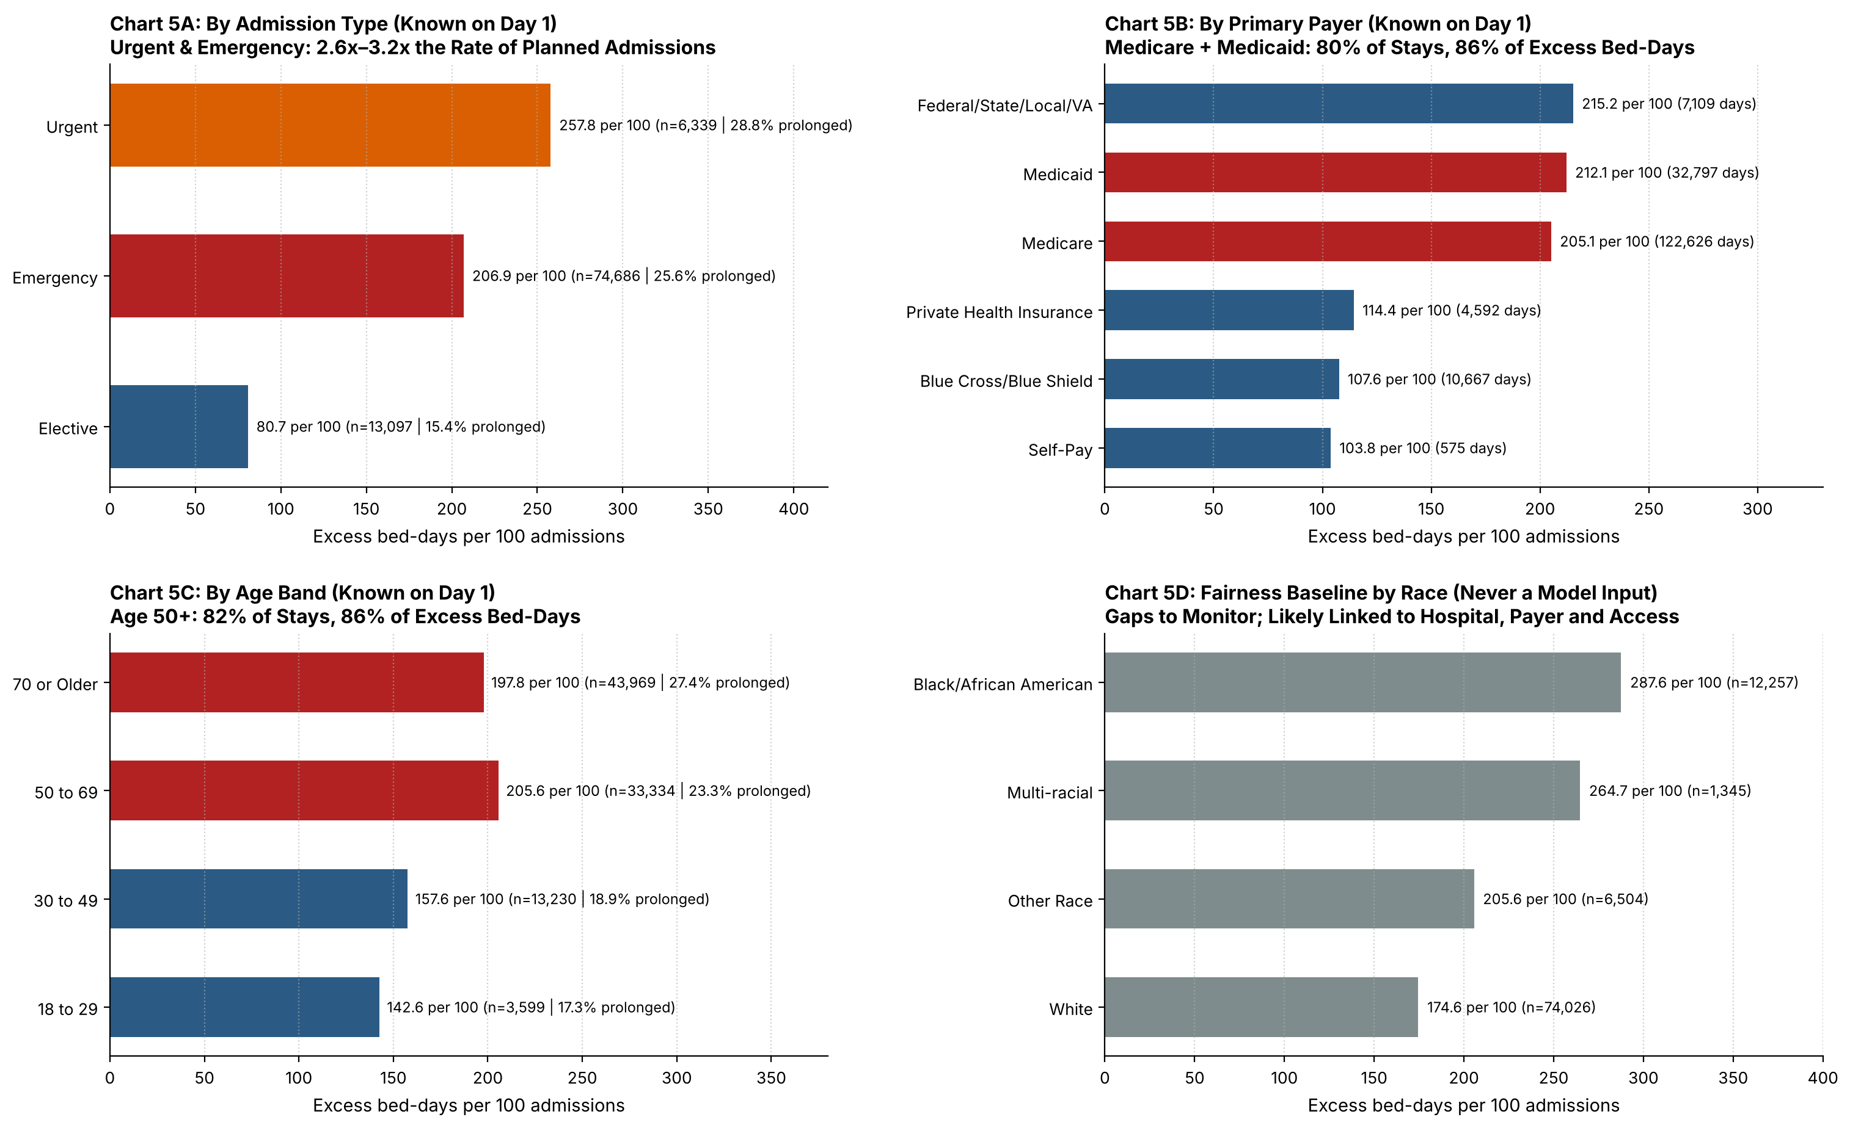
Figure 5: Excess bed-days per 100 admissions by admission type (5A), payer (5B), age band (5C) and race, as a fairness baseline (5D).
Key Takeaway from Chart 5 (Day-1 Predictability & Fairness):
1. Day-1 clues work. Urgent (257.8) and emergency (206.9) admissions have 2.6–3.2× the excess days of planned admissions (80.7). Medicare (205.1) and Medicaid (212.1) have nearly twice the rate of Blue Cross (107.6) and private insurance (114.4): together they are 80% of stays and 86% of excess bed-days. Payer is closely tied to age, so the data can't separate the two. Patients aged 50+ are 82% of stays and 86% of excess bed-days.
2. Avoiding data leakage in WP3. Diagnosis group and severity are coded at discharge. In WP3 we compare a strict Day-1 model (age, sex, zip, hospital, admission type, ED arrival, payer, clinical area) with one that adds the provisional diagnosis recorded at admission.
3. Fairness baseline. Race and ethnicity are never model inputs. Stays of Black patients have 287.6 excess days per 100 vs. 174.6 for White patients. This is not a cause; it is likely linked to hospital, payer and access to post-hospital care. We monitor it, and because payer and zip code can stand in for race, WP3 checks the flag's accuracy for every group.

Chart 6: The Reviewer's Cost Scenario & Annual Value
What we did: Following the reviewer's feedback, we built the cost scenario from Finger Lakes 2023 data. Four assumptions are marked ▲.
- 1. What an excess bed-day is worth (two value streams). The full cost of a prolonged stay's day is $2,344. ▲ Only the variable part is saved as cash: we use 16% (Roberts et al., JAMA 1999: 84% of hospital costs are fixed), so $375 per day. ▲ Under per-case payment, a freed bed is worth more when it is refilled: an extra admission pays about the average cost of a stay ($18,777) and uses its own variable cost, leaving $15,773 per admission, or $2,359 per refilled bed-day.
- 2. What early discharge planning costs. ▲ $200 per flagged patient (about 3 hours of case manager time), paid for every flag including false alarms. Flagging 30% of admissions = 28,240 a year = $5.65M a year.
- 3. Annual impact. ▲ H1: the flag catches 65% of prolonged stays (14,914 caught, 13,326 false alarms). The share of freed beds that is refilled depends on unmet demand, so it is tested from 0% to 100%.
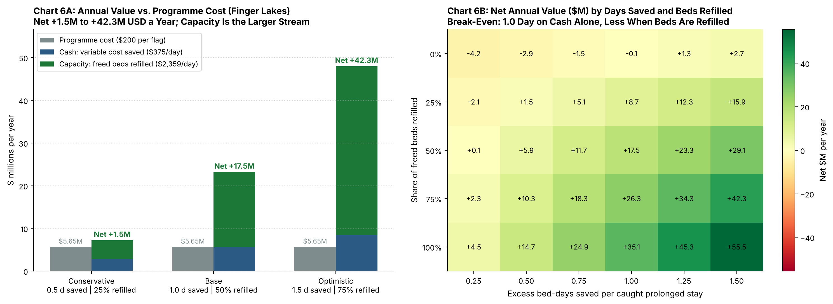
Figure 6: Annual value (cash + capacity) vs. programme cost in 3 scenarios (left) and net annual value by days saved and share of freed beds refilled (right).
Scenario | Days Saved per Caught Stay | Freed Beds Refilled | Bed-Days Saved / Year | Beds Freed Daily | Programme Cost | Cash Value ($375/d) | Capacity Value ($2,359/d) | Net Value / Year
Conservative | 0.5 | 25% | 7,457 | 20 | $5.65M | $2.8M | $4.4M | +$1.5M
Base | 1.0 | 50% | 14,914 | 41 | $5.65M | $5.6M | $17.6M | +$17.5M
Optimistic | 1.5 | 75% | 22,371 | 61 | $5.65M | $8.4M | $39.6M | +$42.3M

Key Takeaway from Chart 6:
Break-even: 1.0 day saved per caught stay on cash alone; 0.39 day if a quarter of freed beds are refilled; 0.24 day if half are (out of 7.9 excess days per prolonged stay).
Robust to the cost assumption: with a 45% variable share instead of 16%, the base case is +$21.6M instead of +$17.5M. What is not saved as cash comes back as capacity.
Cost of doing nothing: the 79,700-day addressable gap is worth at least $29.9M a year in cash alone, plus the capacity for ~11,900 admissions.

Sources
- Roberts RR et al. Distribution of variable vs fixed costs of hospital care. JAMA 1999;281(7):644–649
- NYS DOH – Hospital Inpatient Discharges (SPARCS De-Identified), Health Data NY

