**1. Generic methods & Generic classes**

**2. Java Collection Framework (LinkedList, ArrayList)**

a) ListIterator interface

1. *b) TreeSet, HashSet, LinkedHashSet, TreeMap, HashMap, LinkedHashMap*

**3. Using ArrayList class and its methods add(), size(), get()**

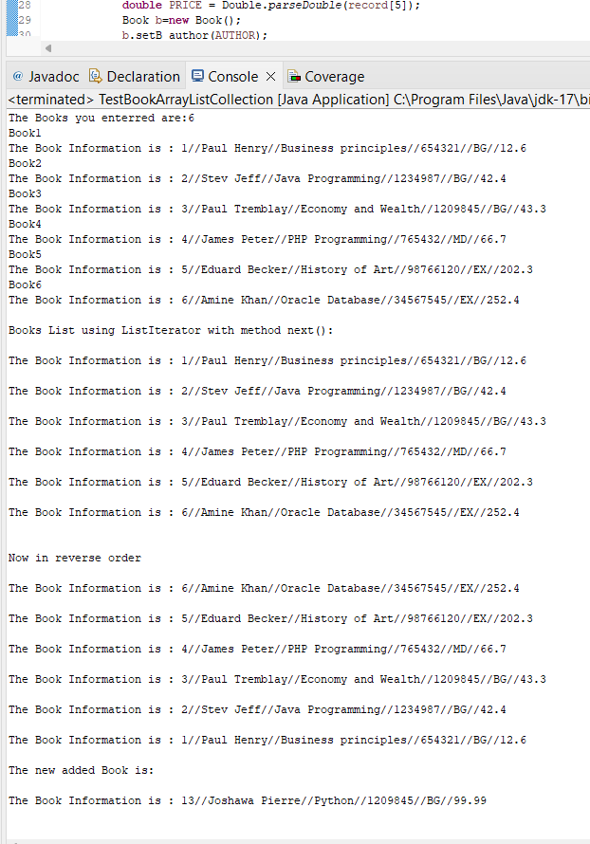

**4. Using HashSet class and its methods add(), size()**

Without proper overrides, the HashSet will use the default implementations from the Trip class, which checks for reference equality rather than the actual content.

**5. Using HashMap class and the methods put(), size(), get(), keyset(), values()**

