文 藝 復 興 展 展 板 與 說 明 牌 文 字 (中文)

A-01 | 展覽概述 掛軸  About the Exhibition
A-02 | 中西大事件年表 掛軸
B-01 | 超級比一比
B-02 | 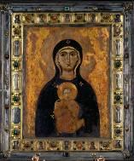  聖母與聖子 Icon of the Virgin and Child  佚名│約1203│蛋彩、木板  Basilica di San Marco, Venice, Italy  畫中表情莊嚴的聖母與聖子，襯上金光閃閃的背景，是不是讓人感受到中世紀畫家想強調對宗教人物的敬仰呢？  What painting techniques did medieval artists use to manifest and emphasize the greatness of the religious figures they depicted?
B-03 | 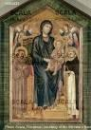  聖母子與天使Madonna Enthroned with Saints Francis and Damian© 2013. Photo Scala, Florence - courtesy of the Ministero Beni e Att. Culturali  奇馬布伊Cimabue│約1290│蛋彩、木板│133 x 81cm  Galleria degli Uffizi, Florence, Italy  坐在椅子上的聖母與聖子與身旁圍繞的天使與聖徒，讓畫面呈現空間感，但人物大小與位置安排有點奇怪，找找看有哪些不合理的地方？  This picture has a sense of perspective, but the size and positioning of people and objects in the painting are slightly strange. What discrepancies can you see?
B-04 | 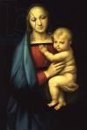  大公爵聖母The Grand Duke's Madonna  拉斐爾Raphael Santi│1504-05│油彩、畫板│56 x 85cm  Palazzo Pitti, Florence, Italy  文藝復興時期的畫家拉斐爾所畫的聖母與聖子，比起中世紀同樣的聖母題材繪畫有何不同呢？  What differences are there between depictions of the Virgin Mary from Renaissance and medieval periods?
C-01 | 完美無所不在
C-02 | 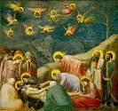  哀悼耶穌 The Lamentation of Christ  喬托Giotto│1305│濕壁畫│200 x 185cm  Scrovegni(Arena) Chapel, Padua, Italy  喬托試圖表現出耶穌逝去的戲劇性時刻，讓人深深感受到畫中人物們的悲痛與哀悽。  Here, Giotto has attempted to capture the dramatic instant of Jesus’s death and to give viewers a sense of the grief and sorrow of the people depicted in his tableau.
C-03 | 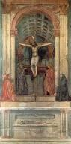  聖三位一體 The Trinity© 2013. Photo Scala, Florence/Fondo Edifici di Culto - Min.  dell'Interno  馬薩奇歐Masaccio│1425-28│濕壁畫│667 x 317cm  Santa Maria Novella, Florence, Italy  這幅壁畫真實的就像牆面上鑿出一個空間，透視技法可以表現視覺上的幻象，在平面上創造出空間與距離感。  This mural creates the extremely convincing illusion that a space has been carved into the wall. Techniques of perspective can create a sense of space and distance on a flat surface.
C-04 | 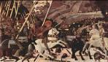  聖馬諾之戰The Battle of San Romano  烏切羅Uccello│1438-40│蛋彩、畫板│182 x 320cm  National Gallery, London, UK  烏切羅為了追求真實，窮其一生都在鑽研透視技法，在這幅畫中他是如何運用的呢？仔細觀察地上的線索吧！  In pursuit of realism, Uccello meticulously studied perspective techniques. Close examination of this picture reveals the trail he took to achieve his effects!
C-05 | 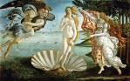  維納斯的誕生The Birth of Venus  波提切利Botticelli│1484-86│蛋彩、畫布│172.8 x 278.5cm  Galleria degli Uffizi, Florence, Italy  維納斯是希臘神話中代表「愛與美」的女神，這幅畫中波提切利描繪的維納斯形象，是不是顯得優雅又迷人呢？  Do you think the Venus in this picture is both graceful and alluring?
C-06 | 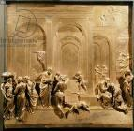  天堂之門（局部）Porta del Paradiso(The Story of Jacob and Esau)  吉貝爾蒂Ghiberti│1425-52│鍍金銅板│40 x 40 cm  Battistero di San Giovanni, Florence, Italy  吉貝爾蒂以透視技法將場景及人物表現得很真實；他花了近30年才完成《天堂之門》的浮雕作品，是不是很驚人呢？  Ghiberti has used perspective techniques to great effect in this relief, making the figures in the scene seem both realistic and natural.
C-07 | 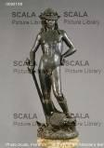  大衛像David  多那太羅Donatello│1440│銅像│H:158cm  Museo Nazionale del Bargello, Florence, Italy  多那太羅表現《聖經》故事中大衛取得勝利踩著巨人哥利亞的樣子，為了準確呈現人體構造，他還研究解剖學呢！  In order to accurately portray the structure of the human body, Donatello went as far as studying dissection!
C-08 | 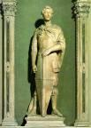  聖喬治像 St. George  多那太羅Donatello,│1416-17│大理石│H:209cm  Museo Nazionale del Bargello, Florence, Italy  「聖喬治屠龍」是西方流傳的古老傳說；聖喬治即將出發拯救被惡龍攻擊的村莊，你感受到他臉上那股意氣風發的自信嗎？  Here, St George is depicted on the point of departure to rescue a village from an evil dragon. Can you sense his vigor and self-confidence?
C-09 | 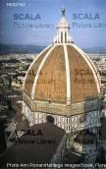  聖母百花大教堂(圓頂) Basilica di Santa Maria del Fior’s Duomo © 2013. Photo Ann  Ronan/Heritage Images/Scala, Florence  布魯內利奇Filippo Brunelleschi│1419-36│Florence, Italy  圓頂是文藝復興建築的代表象徵，這可是當時最創新的建築方法。想一想，這樣的圓頂是如何蓋出來的？  The dome is considered to be symbolic of Renaissance architecture, and was the most innovative building method of its day.
C-10 | 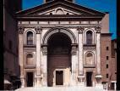  聖安德烈教堂Basilica of Sant’ Andrea  阿爾伯蒂Leon Battista Alberti│1472-1790│Mantua, Italy  仔細觀察這棟建築正面的左右兩邊，是不是像照鏡子一樣？這樣的對稱形式，是不是有一種穩定的感覺呢？  Do you think symmetrical buildings have an innate air of stability?
D-01 | 大師工作坊
D-02 | 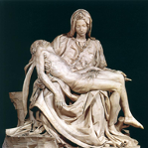  聖殤 The Pieta  米開朗基羅Michelangelo│1498-99│大理石│174 x 195 x 100cm（含台座）  St. Peter's Basilica, Vatican City  這件作品表現出藝術家細膩的情感與高超技巧，為了讓大家記住，藝術家還刻上自己的大名，找找看在哪裡呢？  To ensure that they were remembered, artists would carve their names into their work. Can you find the name on this statue?
D-03 | 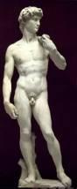  大衛 David  米開朗基羅Michelangelo│1501-04│大理石│H:516cm  Galleria dell'Accademia, Florence, Italy  米開朗基羅擅長以完美的肌肉線條來表現人體的力量感，大衛側身站立，迎面而戰巨人哥利亞，隨著他的眼神看去，氣勢凌人。  Michelangelo specialized in the depiction of perfect muscles to display the power and strength of the human body.
D-04 | 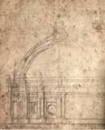  聖彼得教堂圓頂設計草稿 Study for St. Peter’s Dome  米開朗基羅Michelangelo│1546│鉛筆、紙  米開朗基羅繪製了許多圓頂建築草圖，比比看和聖母百花大教堂有何不同？  Michelangelo sketched many draft designs for domes. Can you see where the differences between this sketch and the dome of the Cathedral of Santa Maria del Fiore are?
E-01 | 天才達人大集合
E-02 | 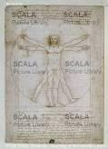  維特魯威人The Proportions of the human figure(after Vitruvius)  達文西Leonardo da Vinci│1492│鋼筆、墨水、紙│34.3 x 24.5cm  Galleria dell’Accademia, Venice, Italy  這是達文西所畫的人體比例圖，找找看其中藏著什麼完美比例呢？下方的筆記文字，又有何特別之處？  This is Da Vinci’s sketch of the proportions of the human body. Can you find the golden ratio hidden within?
E-03 | 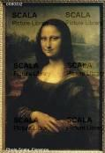  蒙娜麗莎 Mona Lisa  達文西Leonardo da Vinci│1503-06│油彩、畫板│77x53 cm  Louvre, Paris, France  蒙娜麗莎的那一抹淺淺微笑，你知道藝術家施了什麼樣的魔法嗎？你可以說出這幅畫還蘊藏了多少精采故事呢？  Do you know what magic the painter used to paint the mystical smile of the Mona Lisa?
E-04 | 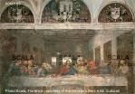  最後的晚餐The Last Supper  達文西Leonardo da Vinci│1495-98│壁畫│460 x 880cm  Santa Maria della Grazie, Milan, Italy  你知道「最後的晚餐」這個聖經故事嗎？達文西描繪這個極富戲劇性的情節，找找看誰是那個出賣耶穌的人呢？  ‘The Last Supper’ is one of the most richly dramatic episodes of the Bible. Can you find who it was who betrayed Jesus?
E-05 | 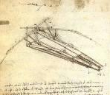  飛行器Macchina Volante  達文西Leonardo da Vinci│1505│鉛筆、紙  達文西懷抱著飛行夢，所以他花了許多時間設計草稿，你是否也有什麼天馬行空的想像與發明呢？  Da Vinci cherished dreams of flight, and spent much of his time on draft designs for flying machines.
E-06 | 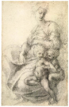  聖母與聖嬰習作Studies for Madonna and child  米開朗基羅Michelangelo│1530-32│鉛筆、紙│37x51cm  British Museum, London, UK  聖子與聖母身體的親密交疊是文藝復興時期突破性的表現，這種表現方法，是不是給人更生動親切的感受呢？  The intimate intertwining of the bodies of the Holy Son and the Virgin Mother was groundbreaking for art of the Renaissance period.
E-07 | 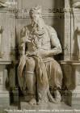  摩西 Moses © 2013. Photo Scala, Florence - courtesy of the Ministero Beni e Att. Culturali  米開朗基羅Michelangelo│1513-15│大理石│H:235cm  San Pietro in Vincoli, Rome, Italy  摩西是猶太民族的英雄領袖。米開朗基羅以一位智者的形象描繪他，栩栩如生的樣貌，可看出藝術家純熟的雕刻技術。  The vivid and lifelike appearance of this statue of Moses displays the artist’s mastery of carving techniques.
E-08 | 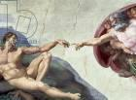  創造亞當 The Creation of Adam  米開朗基羅Michelangelo│1511│濕壁畫│480 x 230cm  Sistine Chapel Ceiling, Musei Vaticani, Vatican City  畫面中兩隻手交會的一瞬間，象徵上帝為人類注入滿滿的生命、智慧與力量，你是否感受到了那股能量呢？  The fleeting gesture of the two hands in this painting symbolizes God’s bestowal of the gifts of life, wisdom and strength upon man.
E-09 | 最後的審判The Last Judgment  米開朗基羅Michelangelo│1537-41│濕壁畫│1370 x 1200cm  Sistine Chapel , Musei Vaticani, Vatican City  「最後的審判」是聖經故事，描繪末日來臨的景象，仔細觀察畫面中蘊藏了多少故事？找找看，米開朗基羅也將自己畫在裡面喔！  ‘The Last Judgment’ is based on a Biblical tale, and describes the period leading up to Judgment Day itself. How many stories can you find hidden in this painting?
E-10 | 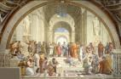  雅典學院School of Athens, from the Stanza della Segnatura  拉斐爾Raphael Santi│1510-11│濕壁畫│500 × 770 cm  Apostolic Palace, Musei Vaticani, Vatican City  這幅畫中的人物有許多不同時代、不同學術領域的偉大著名學者，他們正在專注討論著各種重要事情，你知道有誰嗎？  This painting shows great scholars from many different eras and many different spheres. Can you identify them?
E-11 | 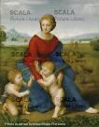  草地上的聖母Madonna del Prato  拉斐爾Raphael Santi│1506│油彩、畫板│ 113 x 88.5cm  Kunsthistorisches Museum, Vienna, Austria  拉斐爾總能將聖母祥和、溫暖的氣質表現得淋漓盡致，而小耶穌與小施洗者約翰，則如一般孩子般調皮活潑。  Raphael always vividly portrayed the warmth and peaceful nature of the Virgin Mary in his work.

