1.(a) L_1 = {aa, aaa, aaaa…, baa, baa, baba, baaa…}
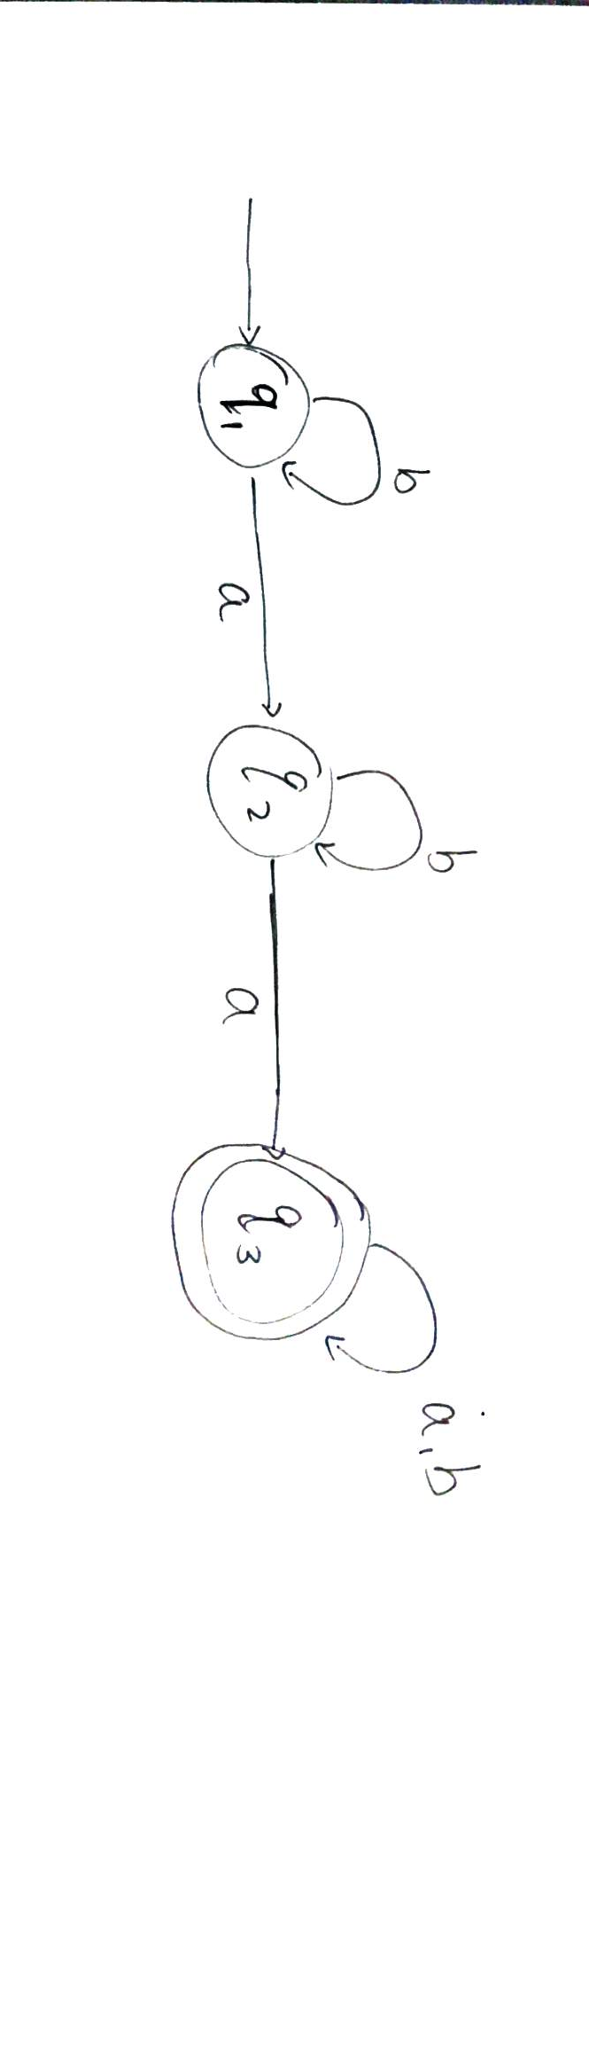
(b)L_2= {aa, a, ba, baa, bba, bbaa, bab, baab,…}
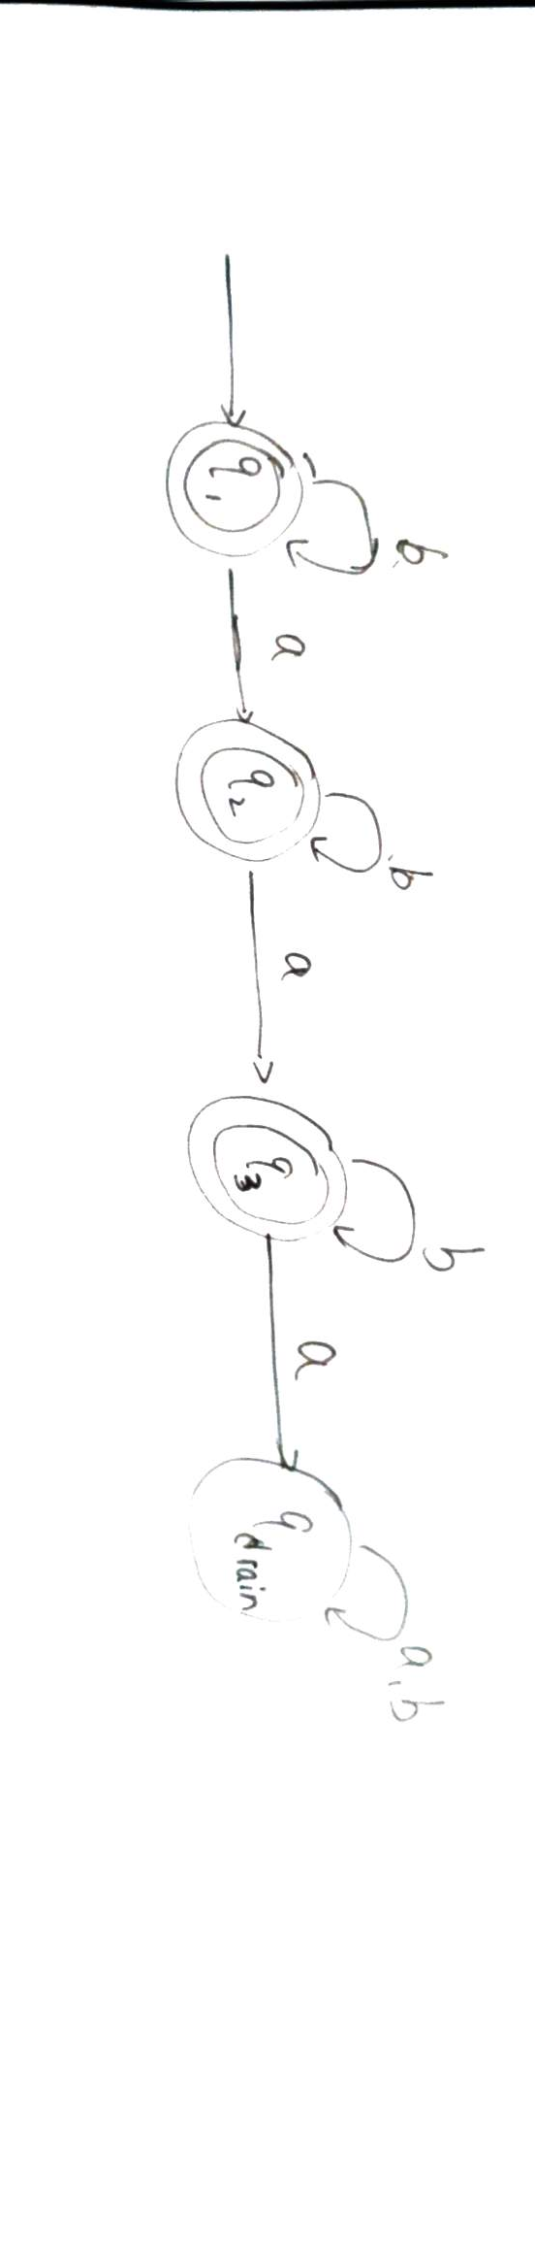
(c)
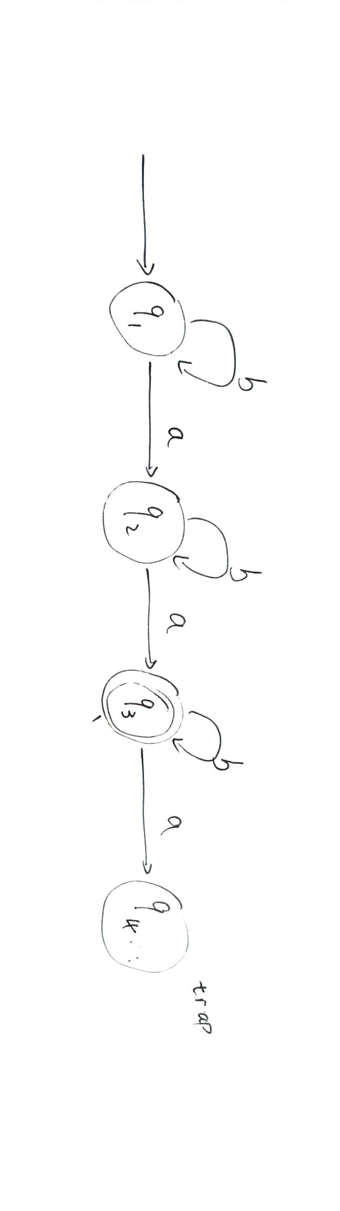

2.
Transition tables
NFA | a | b
1 | 123 | 123
2 | 123 | 123
3 | 123 | 123

DFA | a | b
1 | 123 | 123
123 | 123 | 123
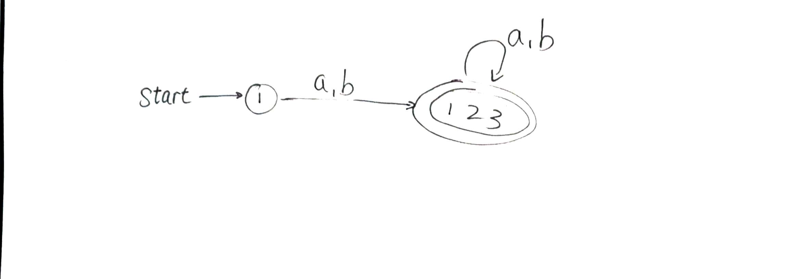
3.
(00):
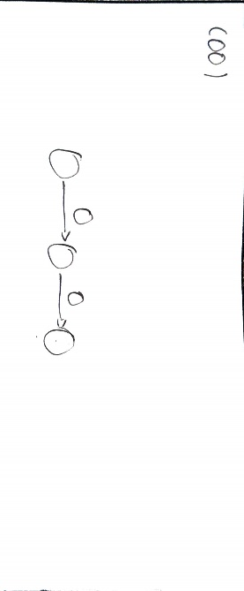
(00)*:
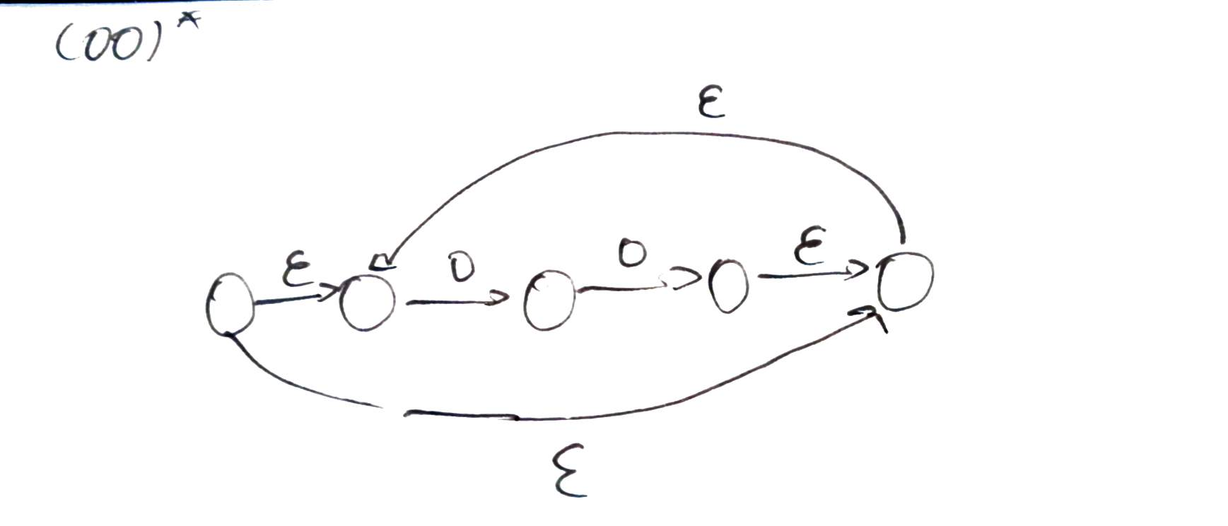
(00)*(11):
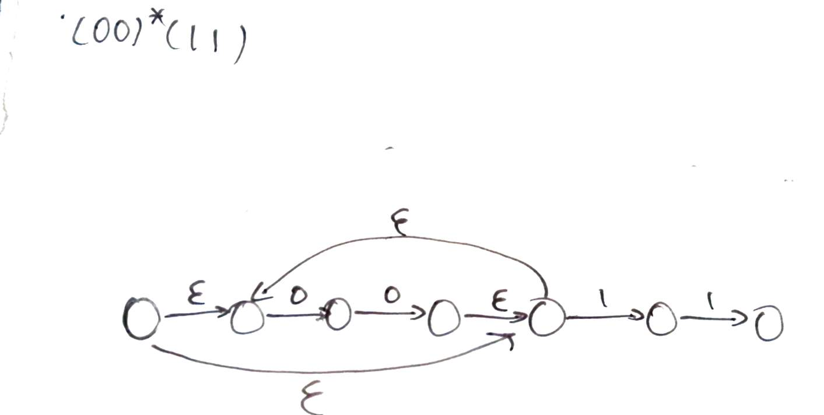
((00)*(11))U(01):
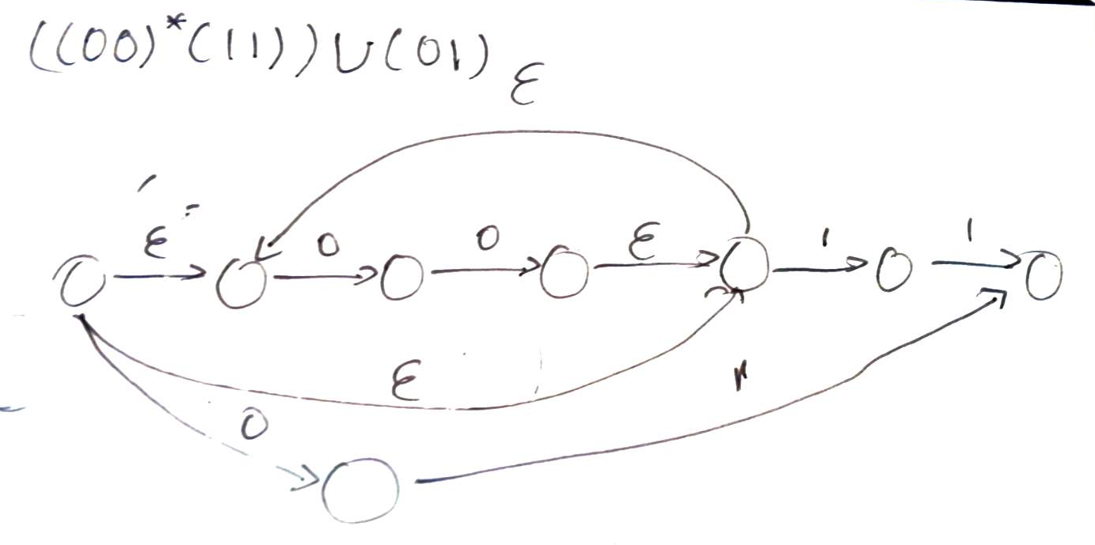
(((00)*(11))U(01))*:
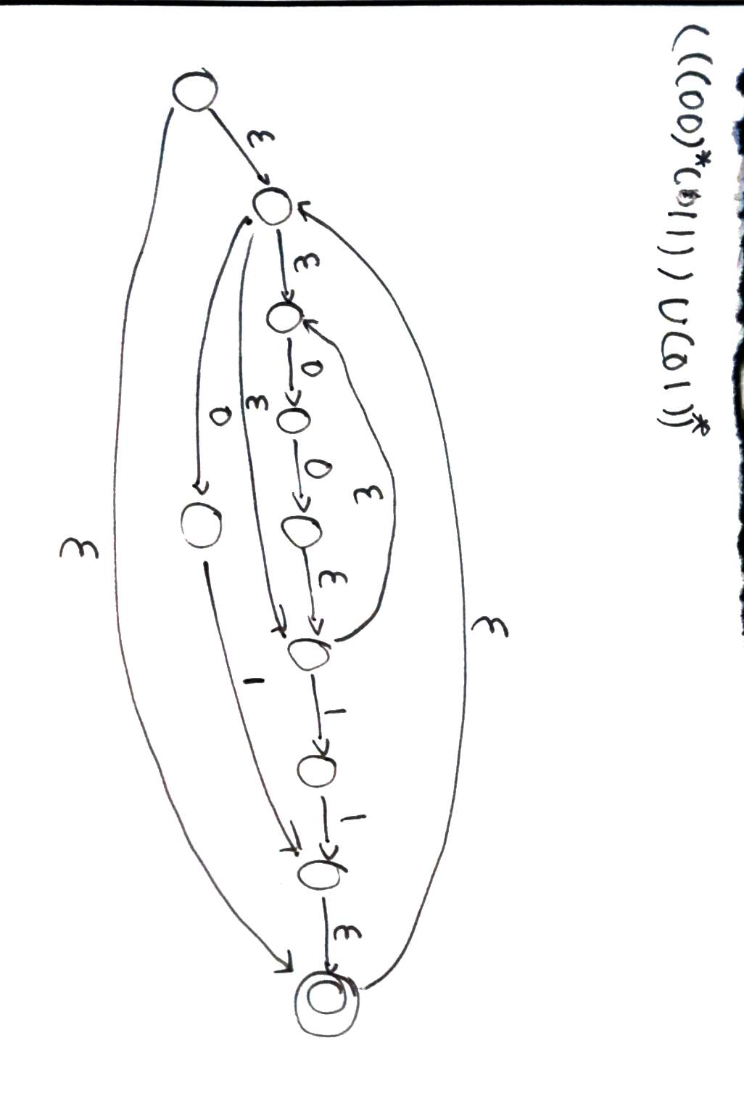

4. The regular expression for this DFA is:
a*b(a+b)(ba*b(a+b))+a)*

5. Assume A and B are regular and that their corresponding DFAs are M1=(Q1, Σ, δ1, q0,F1) and M2 = (Q2, Σ, δ2, q02, F2). Now create a DFA M3 = (Q3, Σ, δ3, q03, F3) as follows:
Q3 = Q1 *Q2*{1,2}. Elements of this set look like tuple(qi, qj, k), where qi ∈Q1, qj ∈ Q2, k ∈{1,2}.
Q03 = (q01,q02,1)
F3 = {(qa,qb,1)|qa∈F11 ∧ qb ∈ F2}
δ3((qi , qj , k), σ) = (qm, qn, l)
We know A o B = {w ∈ Σ ∗ | for some k ≥ 0, w = u ok v, where u ∈ A and v ∈ B}
So t if A is regular, and B is regular, then AoB is regular.

