Zheng Yin

Assignment 3

CSC 349A

V00915261

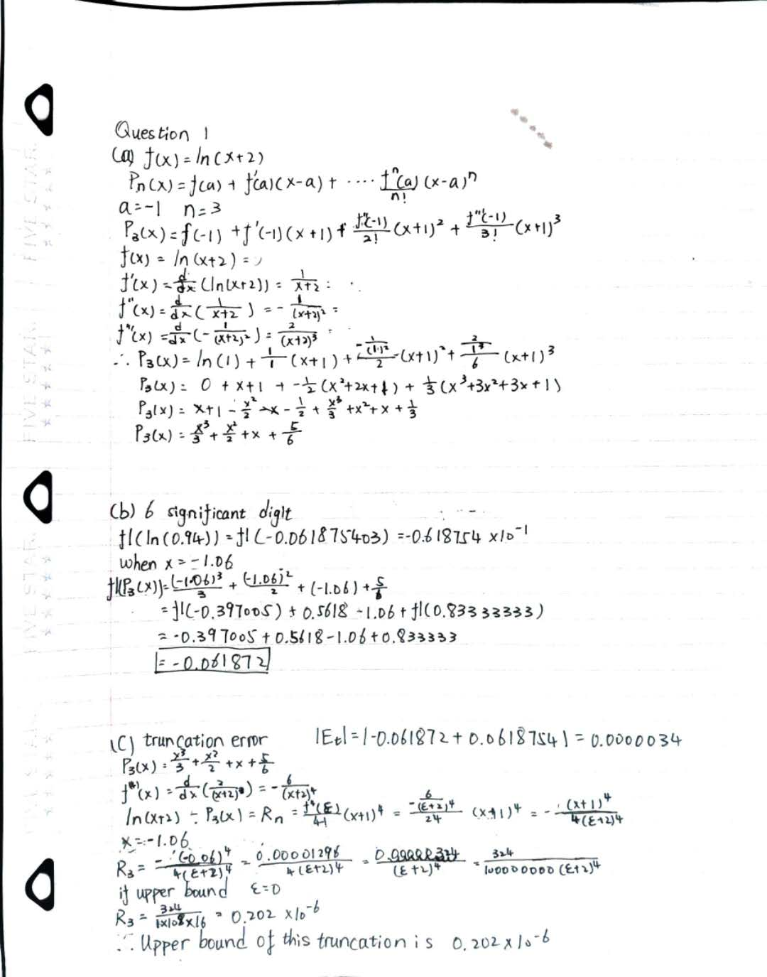

(e)E

function polynomialApp()

x=[-2:0.01:1];

fx = log(x+2);

Px1 = x+1;

Px2 = Px1-(1/2)\*(x.^2+2\*x+1);

Px3 = Px2+1/3\*(x.^3+3\*x.^2+3\*x+1);

plot(x,fx,'r',x,Px1,'b',x,Px2,'g', x,Px3,'c');

