Assignment 4

ZhengYin

I use ncaa_basketball in Google BigQuery.

1. How many teams in NCAA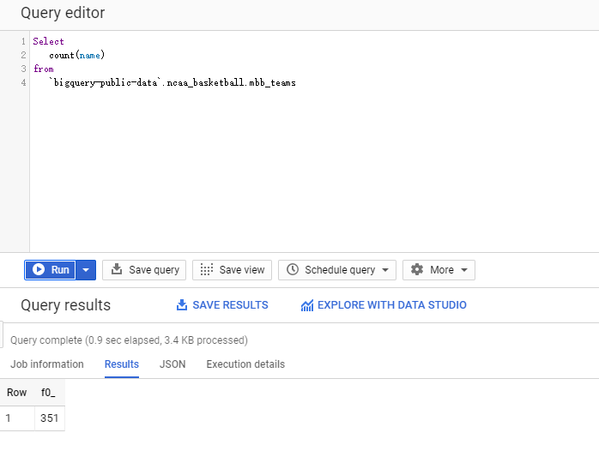
2. What is the average score of winners in every game from 1984? 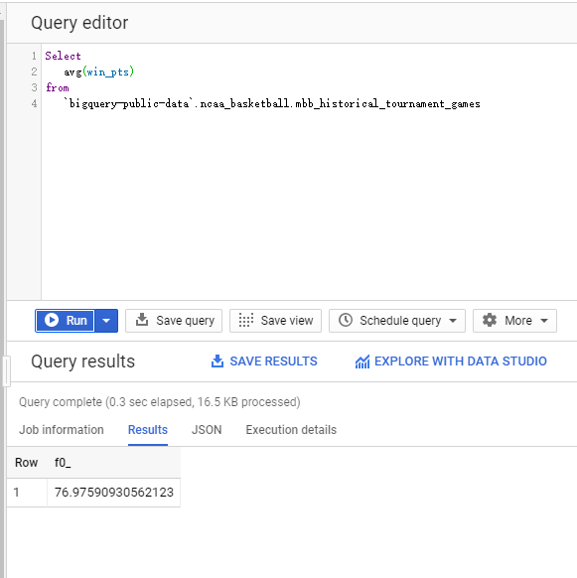
3. How many score the winner win loser in the games after 2002?

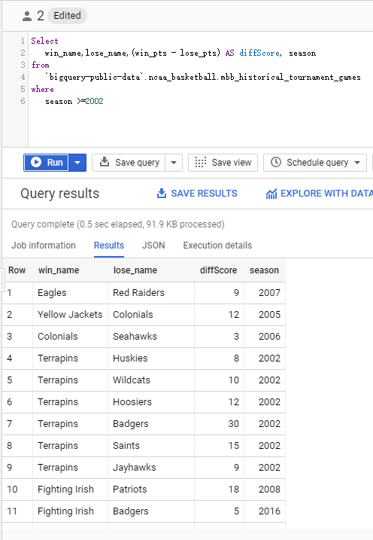

1. which teams are the top-5 win-teams in the history?

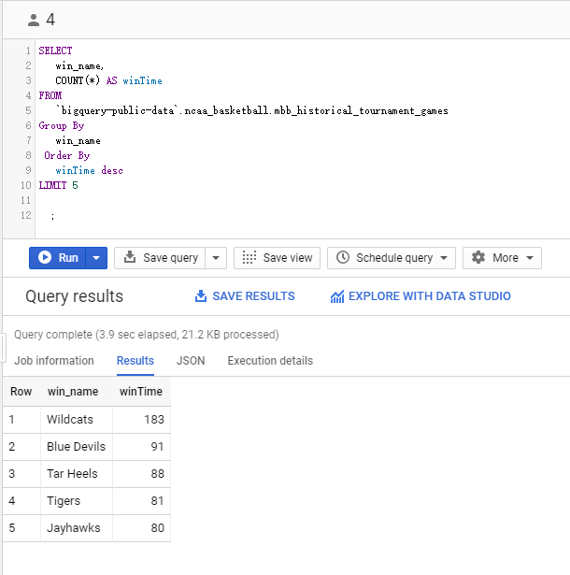

1. Which color is the most welcome for all the team?

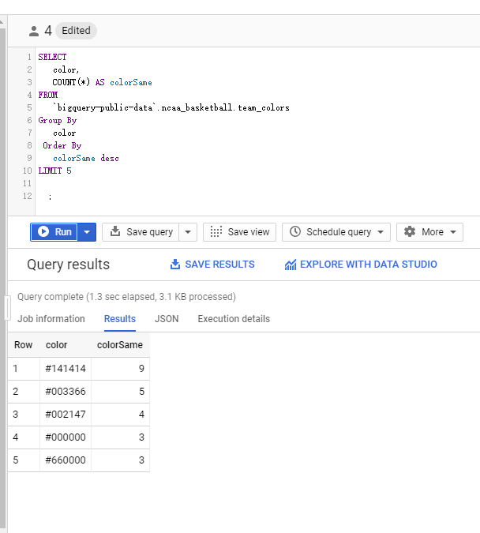

1. Who got highest score in game of 2017?

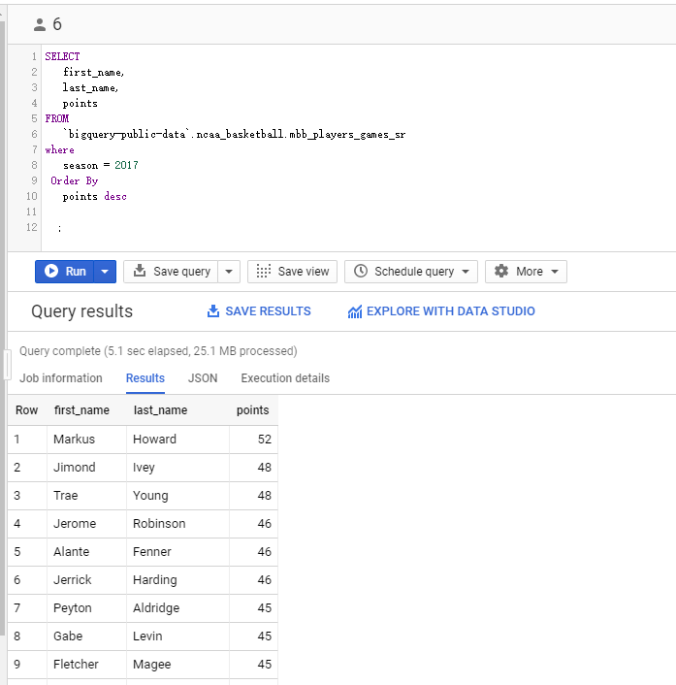

1. What is the average height and weight of players in ncaa?

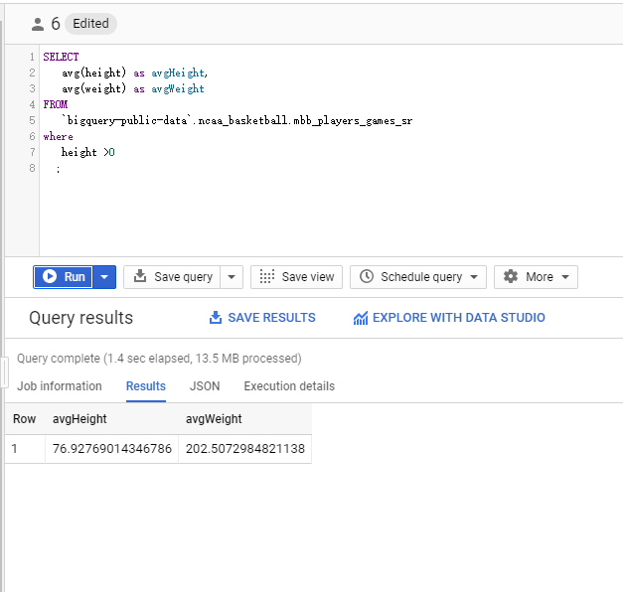

1. Who get the higher score in a minute game in 2017?

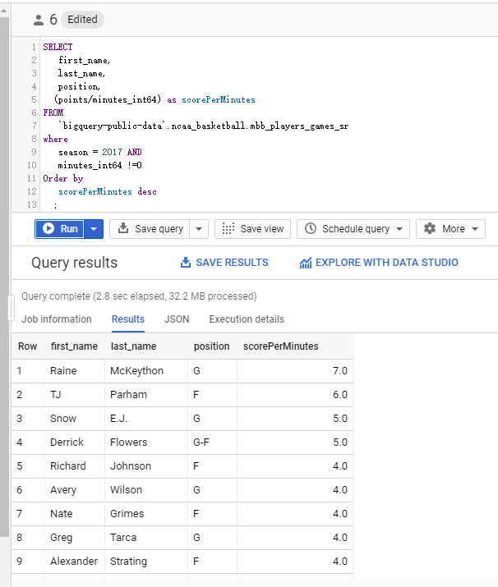

1. Who got more times of triple-double?

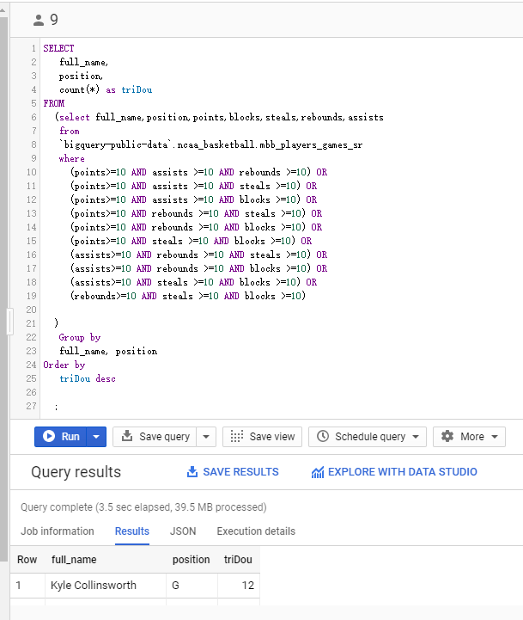

1. Which team got more fouls in 2017?

