**A. 按分数输出成绩等级（选择）**

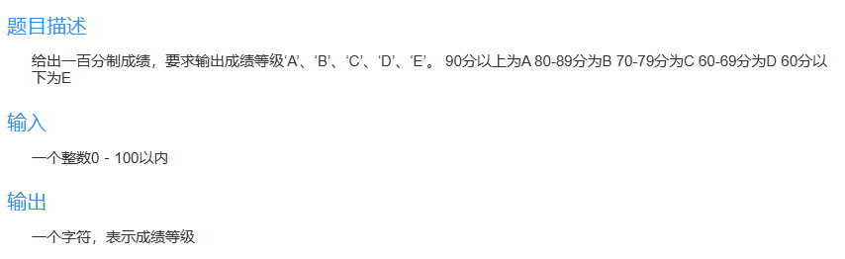

#include<stdio.h>

int main() {

int grade;

scanf("%d", &grade);

if (grade >= 90)

printf("A");

else if (grade >= 80)

printf("B");

else if (grade >= 70)

printf("C");

else if (grade >= 60)

printf("D");

else

printf("E");

return 0;

}

### B. 求解ax2+bx+c=0

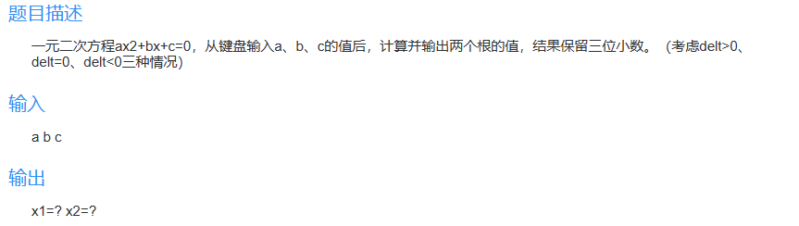

#include <stdio.h>

#include <math.h>

int main() {

double a, b, c, x1, x2, delt;

scanf("%lf%lf%lf", &a, &b, &c);

delt = b * b - 4.0 * a * c;

if (delt > 0) {

x1 = (-b + sqrt(delt)) / (2.0 * a);

x2 = (-b - sqrt(delt)) / (2.0 * a);

printf("x1=%.3lf x2=%.3lf", x1, x2);

} else if (delt == 0) {

x1 = (-b) / (2.0 * a);

x2 = x1;

printf("x1=%.3lf x2=%.3lf", x1, x2);

} else {

x1 = -b / (2.0 * a);

x2 = sqrt(-delt) / (2.0 * a);

printf("x1=%.3lf+%.3lfi x2=%.3lf-%.3lfi", x1, x2, x1, x2);

}

return 0;

}

### C. 小三的幸运日（选择）

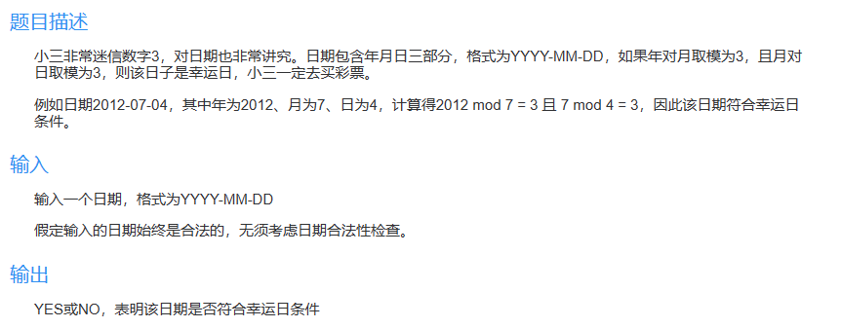

#include<stdio.h>

int main() {

int a, b, c;

scanf("%d-%d-%d", &a, &b, &c);

if ((a % b == 3) && (b % c == 3)) {

printf("YES");

} else

printf("NO");

return 0;

}

### D. 判定水仙花数2（选择）

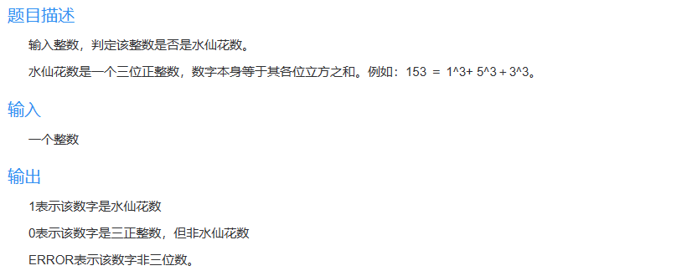

#include<stdio.h>

int main() {

int x;

int a, b, c;

scanf("%d", &x);

if (x < 100 || x > 999)

printf("ERROR");

else {

a = x / 100;

b = (x - a * 100) / 10;

c = x % 10;

if (x == a * a * a + b * b * b + c * c * c)

printf("1");

else

printf("0");

}

return 0;

}