**A. 初中数学题**

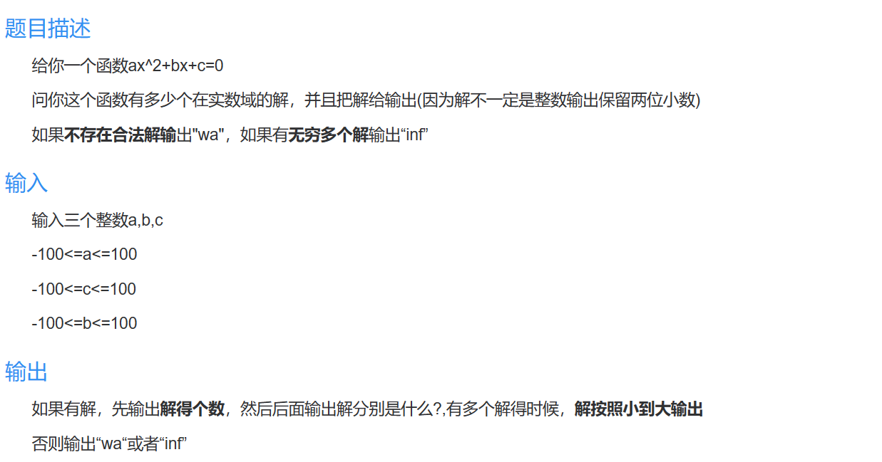

#include <stdio.h>

#include <math.h>

int main() {

double a, b, c;

scanf("%lf %lf %lf", &a, &b, &c);

if (a < -100 || a > 100 || b < -100 || b > 100 || c < -100 || c > 100)

printf("wa");

else if (b * b - 4 * a * c < 0 || (a == 0 && b == 0 && c != 0))

printf("wa");

else if (a == 0 && b == 0 && c == 0)

printf("inf");

else if (a == 0)

printf("1 %.2lf", -c / b);

else if (b * b - 4 * a * c == 0)

printf("1 %.2lf", -b / 2 / a);

else {

if (a > 0)

printf("2 %.2lf %.2lf", (-b - sqrt(b * b - 4 * a * c)) / 2 / a, (-b + sqrt(b * b - 4 * a * c)) / 2 / a);

else

printf("2 %.2lf %.2lf", (-b + sqrt(b * b - 4 * a * c)) / 2 / a, (-b - sqrt(b * b - 4 * a * c)) / 2 / a);

}

return 0;

}

**B. 算命先生**

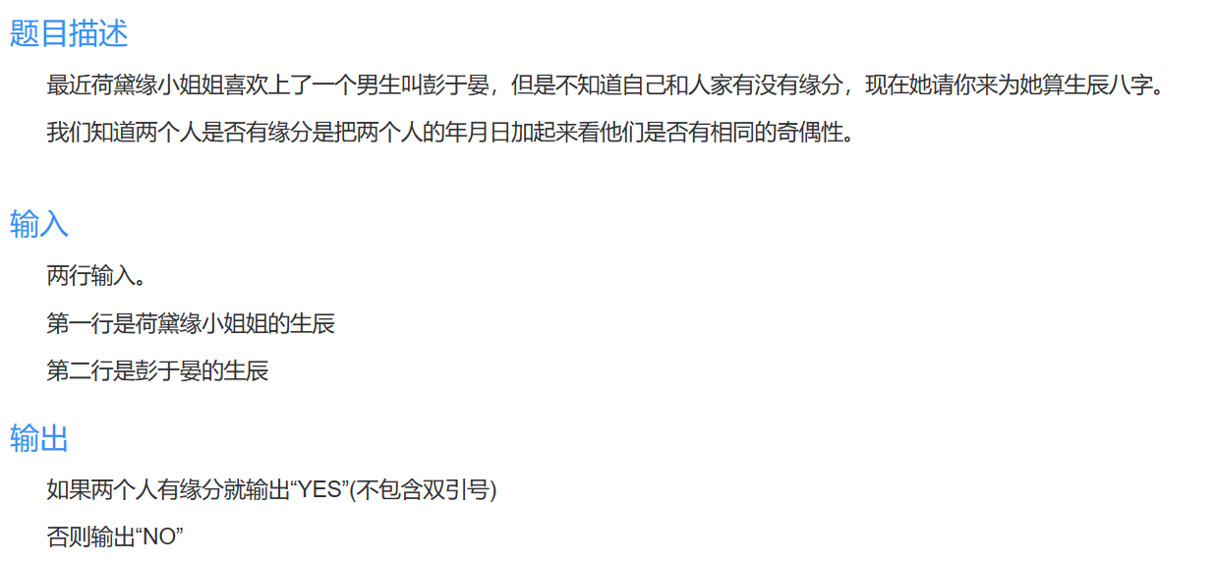

#include <stdio.h>

int main() {

int a, b, c, x, y, z;

scanf("%d/%d/%d", &a, &b, &c);

scanf("%d/%d/%d", &x, &y, &z);

if ((a + b + c) % 2 == (x + y + z) % 2) {

printf("YES\n");

} else {

printf("NO\n");

}

return 0;

}

**C. 圆规来袭**

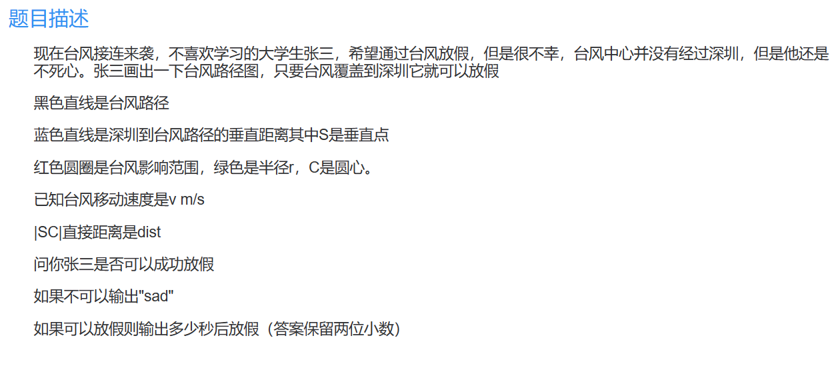

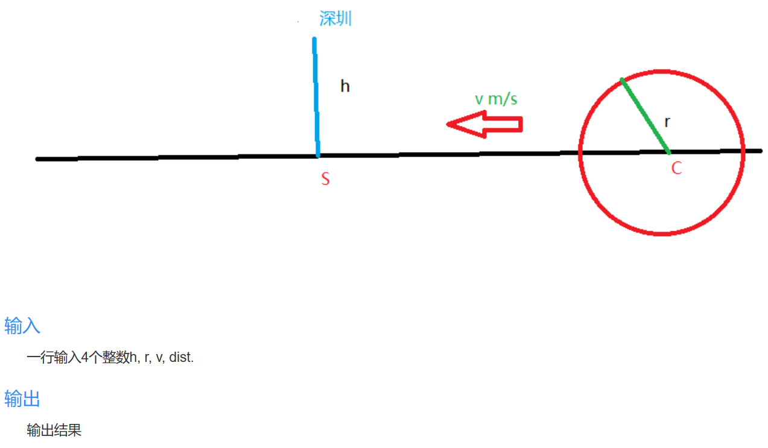

#include <stdio.h>

#include<math.h>

int main() {

int h, r, v, dist;

float t;

scanf("%d%d%d%d", &h, &r, &v, &dist);

t = (dist - sqrt(r * r - h * h)) / v;

if (r < h) {

printf("sad\n");

} else if (r >= h && dist >= sqrt(r * r - h * h)) {

printf("%.2f\n", t);

} else {

printf("0.00\n");

}

return 0;

}

**D. 16进制的简单运算(选择结构）**

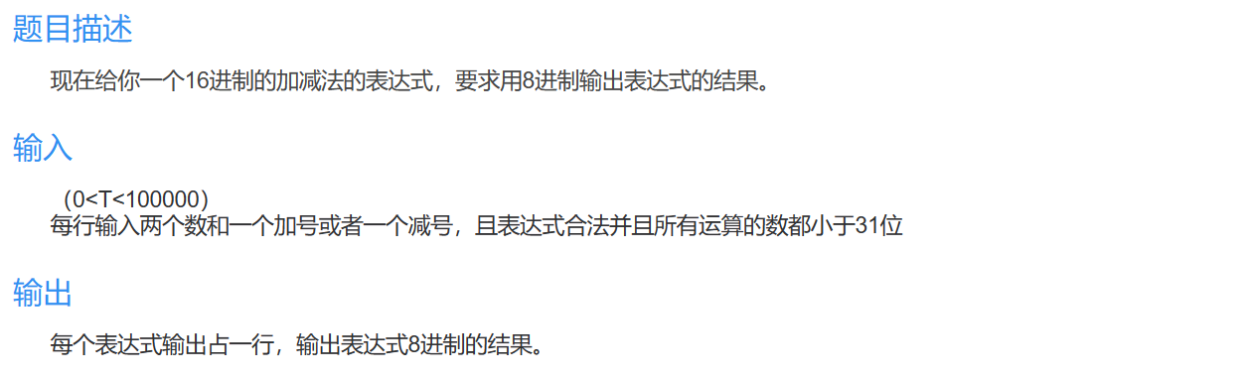

#include <stdio.h>

int main() {

int a, b, c;

char ch;

scanf("%x%c%x", &a, &ch, &b);

switch (ch) {

case '+':

c = a + b;

break;

case '-':

c = a - b;

break;

}

printf("%o", c);

return 0;

}

**E. 点和正方形的关系（选择）**

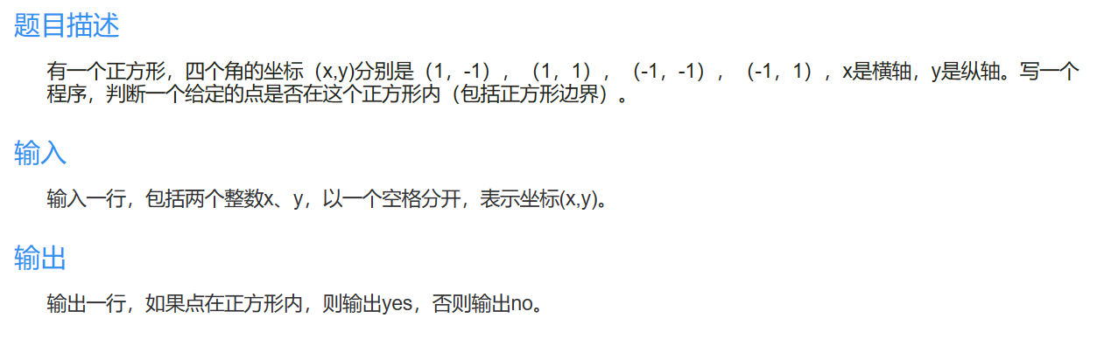

#include <stdio.h>

int main() {

int x, y;

scanf("%d %d", &x, &y);

if (x >= -1 && x <= 1 && y >= -1 && y <= 1) {

printf("yes\n");

} else {

printf("no\n");

}

return 0;

}

**F. 期末评价（选择）**

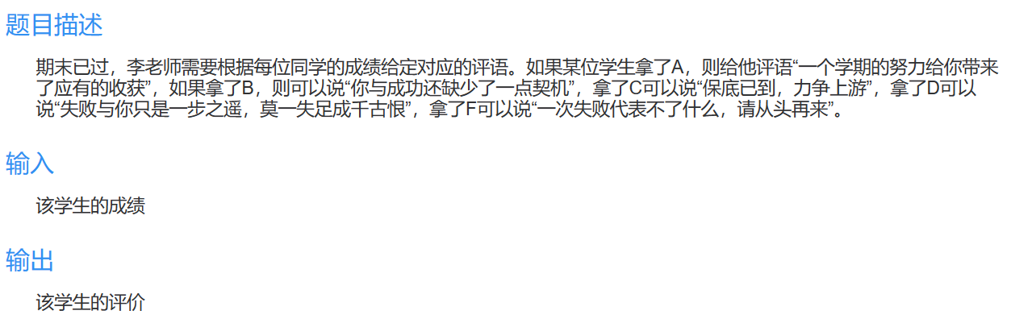

#include <stdio.h>

int main(){

char grade;

scanf("%c", &grade);

switch (grade) {

case 'A':printf("一个学期的努力给你带来了应有的收获"); break;

case 'B':printf("你与成功还缺少了一点契机"); break;

case 'C':printf("保底已到，力争上游"); break;

case 'D':printf("失败与你只是一步之遥，莫一失足成千古恨"); break;

case 'E':printf("一次失败代表不了什么，请从头再来");break;

default :break;

}

return 0;

}

**G. 数据的操作（选择）**

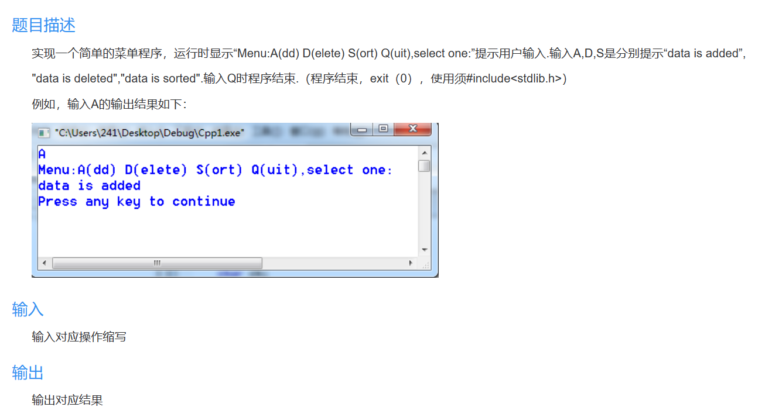

#include<stdio.h>

int main()

{char a;

printf("Menu:A(dd) D(elete) S(ort) Q(uit),select one:\n");

scanf("%c",&a);

switch(a){

case 'A':printf("data is added");break;

case 'D':printf("data is deleted");break;

case 'S':printf("data is sorted");break;

default :break;

}

return 0;}

**H. 菜单选择（选择）**

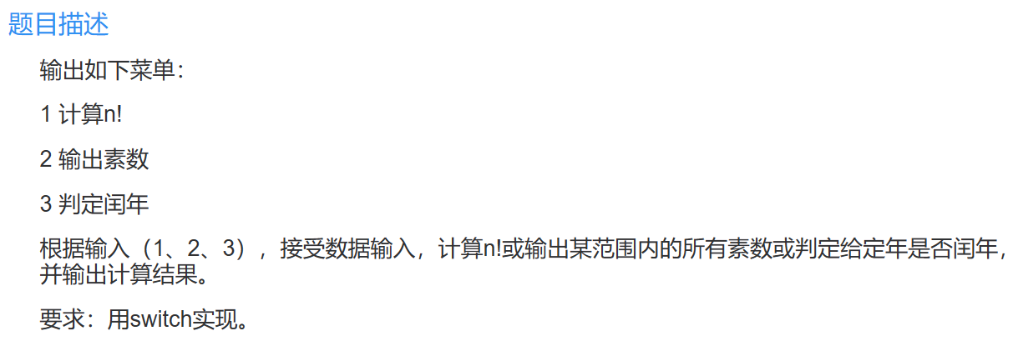

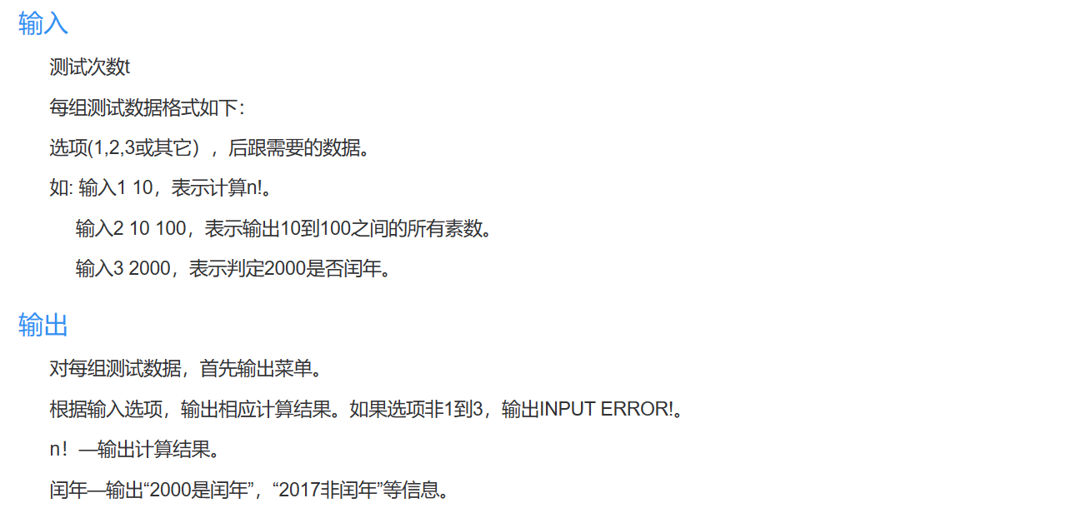

#include <stdio.h>

long long muti(int n) {

if (n == 1)

return 1;

return n * muti(n - 1);

}

int prime(int n) {

if (n == 1)

return 0;

for (int i = 2; i <= n / 2; i++) {

if (n % i == 0)

return 0;

}

return 1;

}

int main() {

int t;

int x;

int n;

int a, b;

scanf("%d", &t);

while (t--) {

printf("1 计算n!\n2 输出素数\n3 判定闰年\n");

scanf("%d", &x);

switch (x) {

case 1:

scanf("%d", &n);

printf("%lld", muti(n));

break;

case 2: {

scanf("%d %d", &a, &b);

for (int i = a; i <= b; i++) {

if (prime(i))

printf("%d ", i);

}

}

break;

case 3:

scanf("%d", &n);

if ((n % 4 == 0 && n % 100) || n % 400 == 0)

printf("%d是闰年", n);

else

printf("%d非闰年", n);

break;

default:

printf("INPUT ERROR!");

break;

}

printf("\n\n");

}

return 0;

}