Please check the course slides and review the background of Hamming Codes. For the very typical example, namely q=3, n=2^q-1=7, k=n-q=4, and d=3, we call it (7,4,3) Hamming code.

For the famous parity check matrix H:

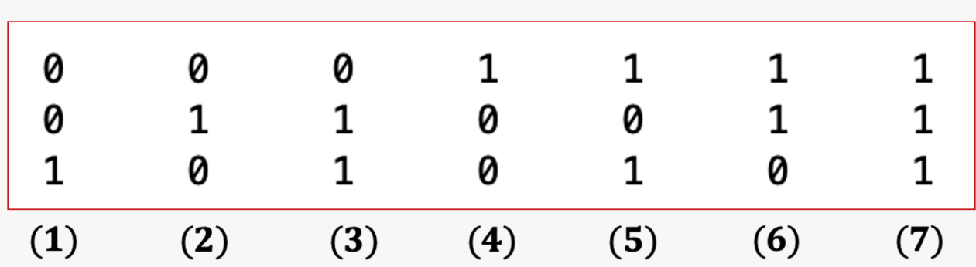

 we know that H\*[x1, x2, x3, x4, x5, x6, x7]^T= [0,0,0]^T, where [a,b,c]^T means that you transfer a row matrix [a,b,c] to a column matrix. More explicitly,

we have the following equations:

x4+x5+x6+x7=0;

x2+x3+x6+x7=0;

x1+x3+x5+x7=0;

Try to write down all the valid row vectors [x1, x2, x3, x4, x5, x6, x7] such that the above equtions hold. (We showed that there are 2^4=16 vectors)

Then you can compare their distances with the all zero vector  [x1=0, x2=0, x3=0, x4=0, x5=0, x6=0, x7=0], and then find the minimum distance d.