Female Pelvic Floor Diffusion Tensor Imaging Enabled by Multi-Shot EPI and ADMM Unrolled Reconstruction
Zhengguo Tan, John DeLancey, Yun Jiang, Vikas Gulani

Impact (40 words)
This study develops a high-resolution DTI technique, which may serve as a useful and quantitative tool to study the integrity of female pelvic floor mscle fibers and to understand the mechnisum behind pelvic floor disorders.

Synopsis (100 words)
Motivation: Approximately one in four women suffer from pelvic floor disorders after childbirth. Due to the anatomical complex of female pelvic floor, the underlying mechanism that leads to muscular microstructure change is yet understood.
Goal: The goal is to develop fast high-resolution female pelvic floor diffusion tensor imaging.
Approach: We leverage multi-shot EPI acquisition and self-supervised unrolled joint reconstruction.
Results: We report pelvic floor DTI at 1.5 mm in-plane resolution. Compared to published studies that employed coarse resolution (2.4 mm), our method demonstrates the DTI maps of the main pelvic floor muscle, including the iliococcygeus and the puborectalis.

INTRODUCTION
(Why was this study/research performed? What unsolved problem are you addressing?)
Vaginal delivery has been the single risk factor most likely to cause maternal pelvic floor trauma, which may cause urinary incontinence, bowel dysfunction, chronic pelvic pain, and even pelvic organ prolapse [1]. Although diffusion MRI is a well-established technique for mapping white matter tracts in the brain, its clinical utility in the pelvic floor remains largely unexplored due to the region’s complex anatomy and the fine-scale structure of its muscles [2], which we find insufficient to study the pelvic floor muscular integrity. Previous studies on perineum diffusion tensor imaging (DTI) rendered only limited resolution. Therefore, the goal of this study is to achieve fast high-resolution female pelvic floor diffusion tensor imaging (DTI) leveraging multi-shot EPI acquisition and self-supervised ADMM unrolled joint reconstruction.

METHODS
(How did you study this problem?)
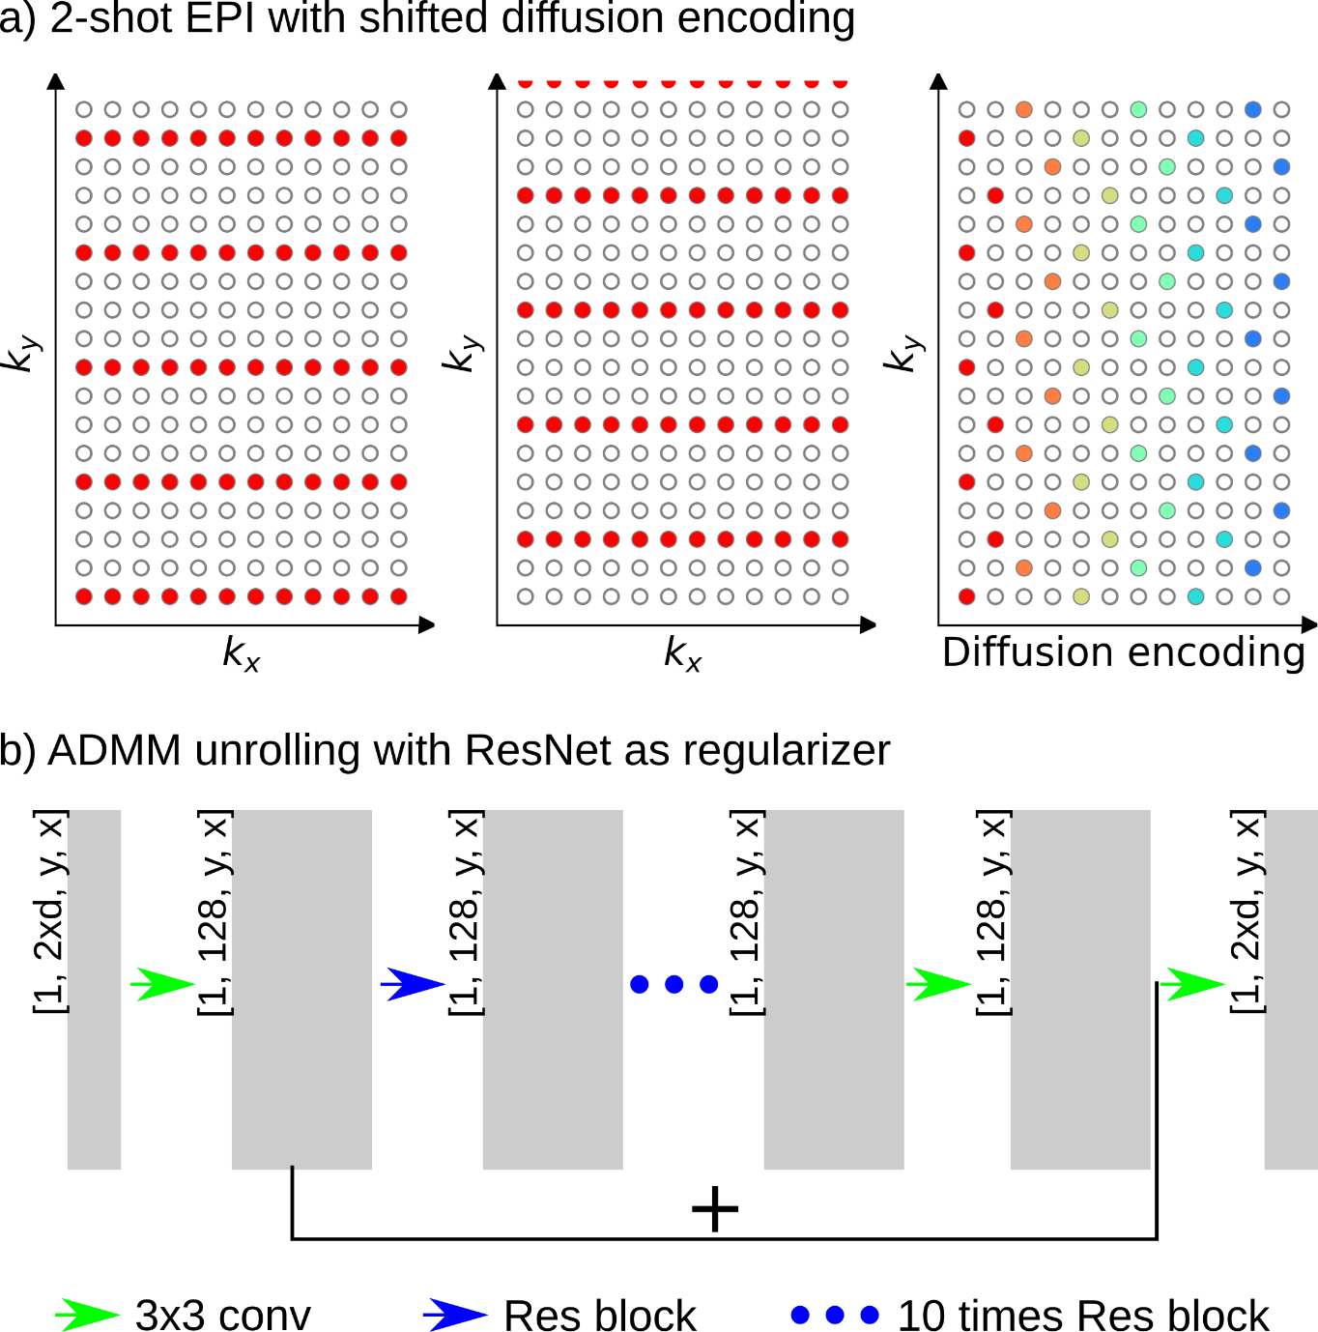
Figure 1. a) Multi-shot EPI with shifted diffusion encoding and b) ADMM unrolling with 2D ResNet as the regularization.

Figure 1 summarizes the employed multi-shot EPI and ADMM unrolling reconstruction. For every diffusion-weighted encoding, 2 shots were used. Each shot has an undersampling factor 4. In addition, the acquired ky lines of a diffusion encoding is shifted with respect to its adjacent encoding [3], as colored differently every 2 columns in Figure 1 a). On the other hand, we propose a joint reconstruction [4],
$$argmin{\left|\left|y-Ax\right|\right|}_{2}+λR(x)$$
x consists of all diffusion-weighted images per slice, and A is a chained operator that maps x to y. The regularization term is represented as the ResNet [5], as shown in Figure 1 b). We employ the data splitting mechanism to train the ResNet model parameters [6,7]. Building upon the fundamental of cross validation, every diffusion encoding sampling pattern is split into three subsets: the training mask used for the data consistency term, the loss mask used for the loss function during training, and the validation mask used to control early stopping. All reconstruction was performed on a A40 GPU with 48 GB memory (NVIDIA, Santa Clara, CA).

Nine female volunteers with written consent in compliance with IRB participated in the experiment at 3T (Magnetom Vida, Siemens, Erlangen, Germany) with the 18-channel body matrix coil. Figure 2 lists two acquisition protocols: #1 single-shot EPI with 2.4 mm resolution and #2 multi-shot EPI with 1.5 mm resolution. After image reconstruction, DTI parameter mapping and fiber tracking were performed using DIPY.

Figure 2. Acquisition protocols.

RESULTS
(Report the data, analyses and/or outcomes)
Figures 3 and 4 list from left to right the T2-weighted images acquired by turbo spin echo (TSE) at 0.6 mm resolution as reference, the parallel imaging (PI) reconstruction of single-shot EPI acquisition at 2.4 mm (Protocol #1) [8], as well as the multiplexed encoding reconstruction (MUSE) [9] with local-PCA denoiser [10] and the proposed ADMM unrolling on 1.5 mm data from Protocol #2.
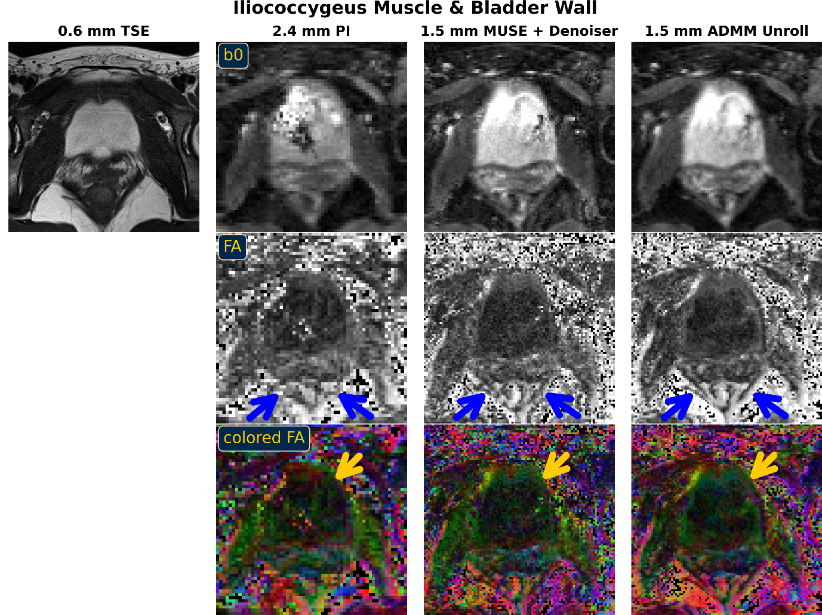
Figure 3. High-resolution multi-shot EPI with ADMM unrolling reconstruction enables the visualization of the iliococcygeus muscle and the bladder wall.

Figure 3 highlights the reconstructed iliococcygeus muscle (blue arrows) in fractional anisotropy (FA) maps and the bladder wall (yellow arrows) in colored FA maps. Protocol #1 does not have sufficient resolution to resolve the iliococcygeus muscle. MUSE with the local-PCA denoiser suffers from blurring artifacts. Only the proposed ADMM unrolling illustrates sharp delineation of the iliococcygeus muscle. The Iliococcygeus is a thin muscle, inserting onto the coccyx, perineal body and anococcygeal ligament. On the other hand, we observe that the FA map (and diffusion-weighted images, not shown here) shows good contrast of the bladder wall.

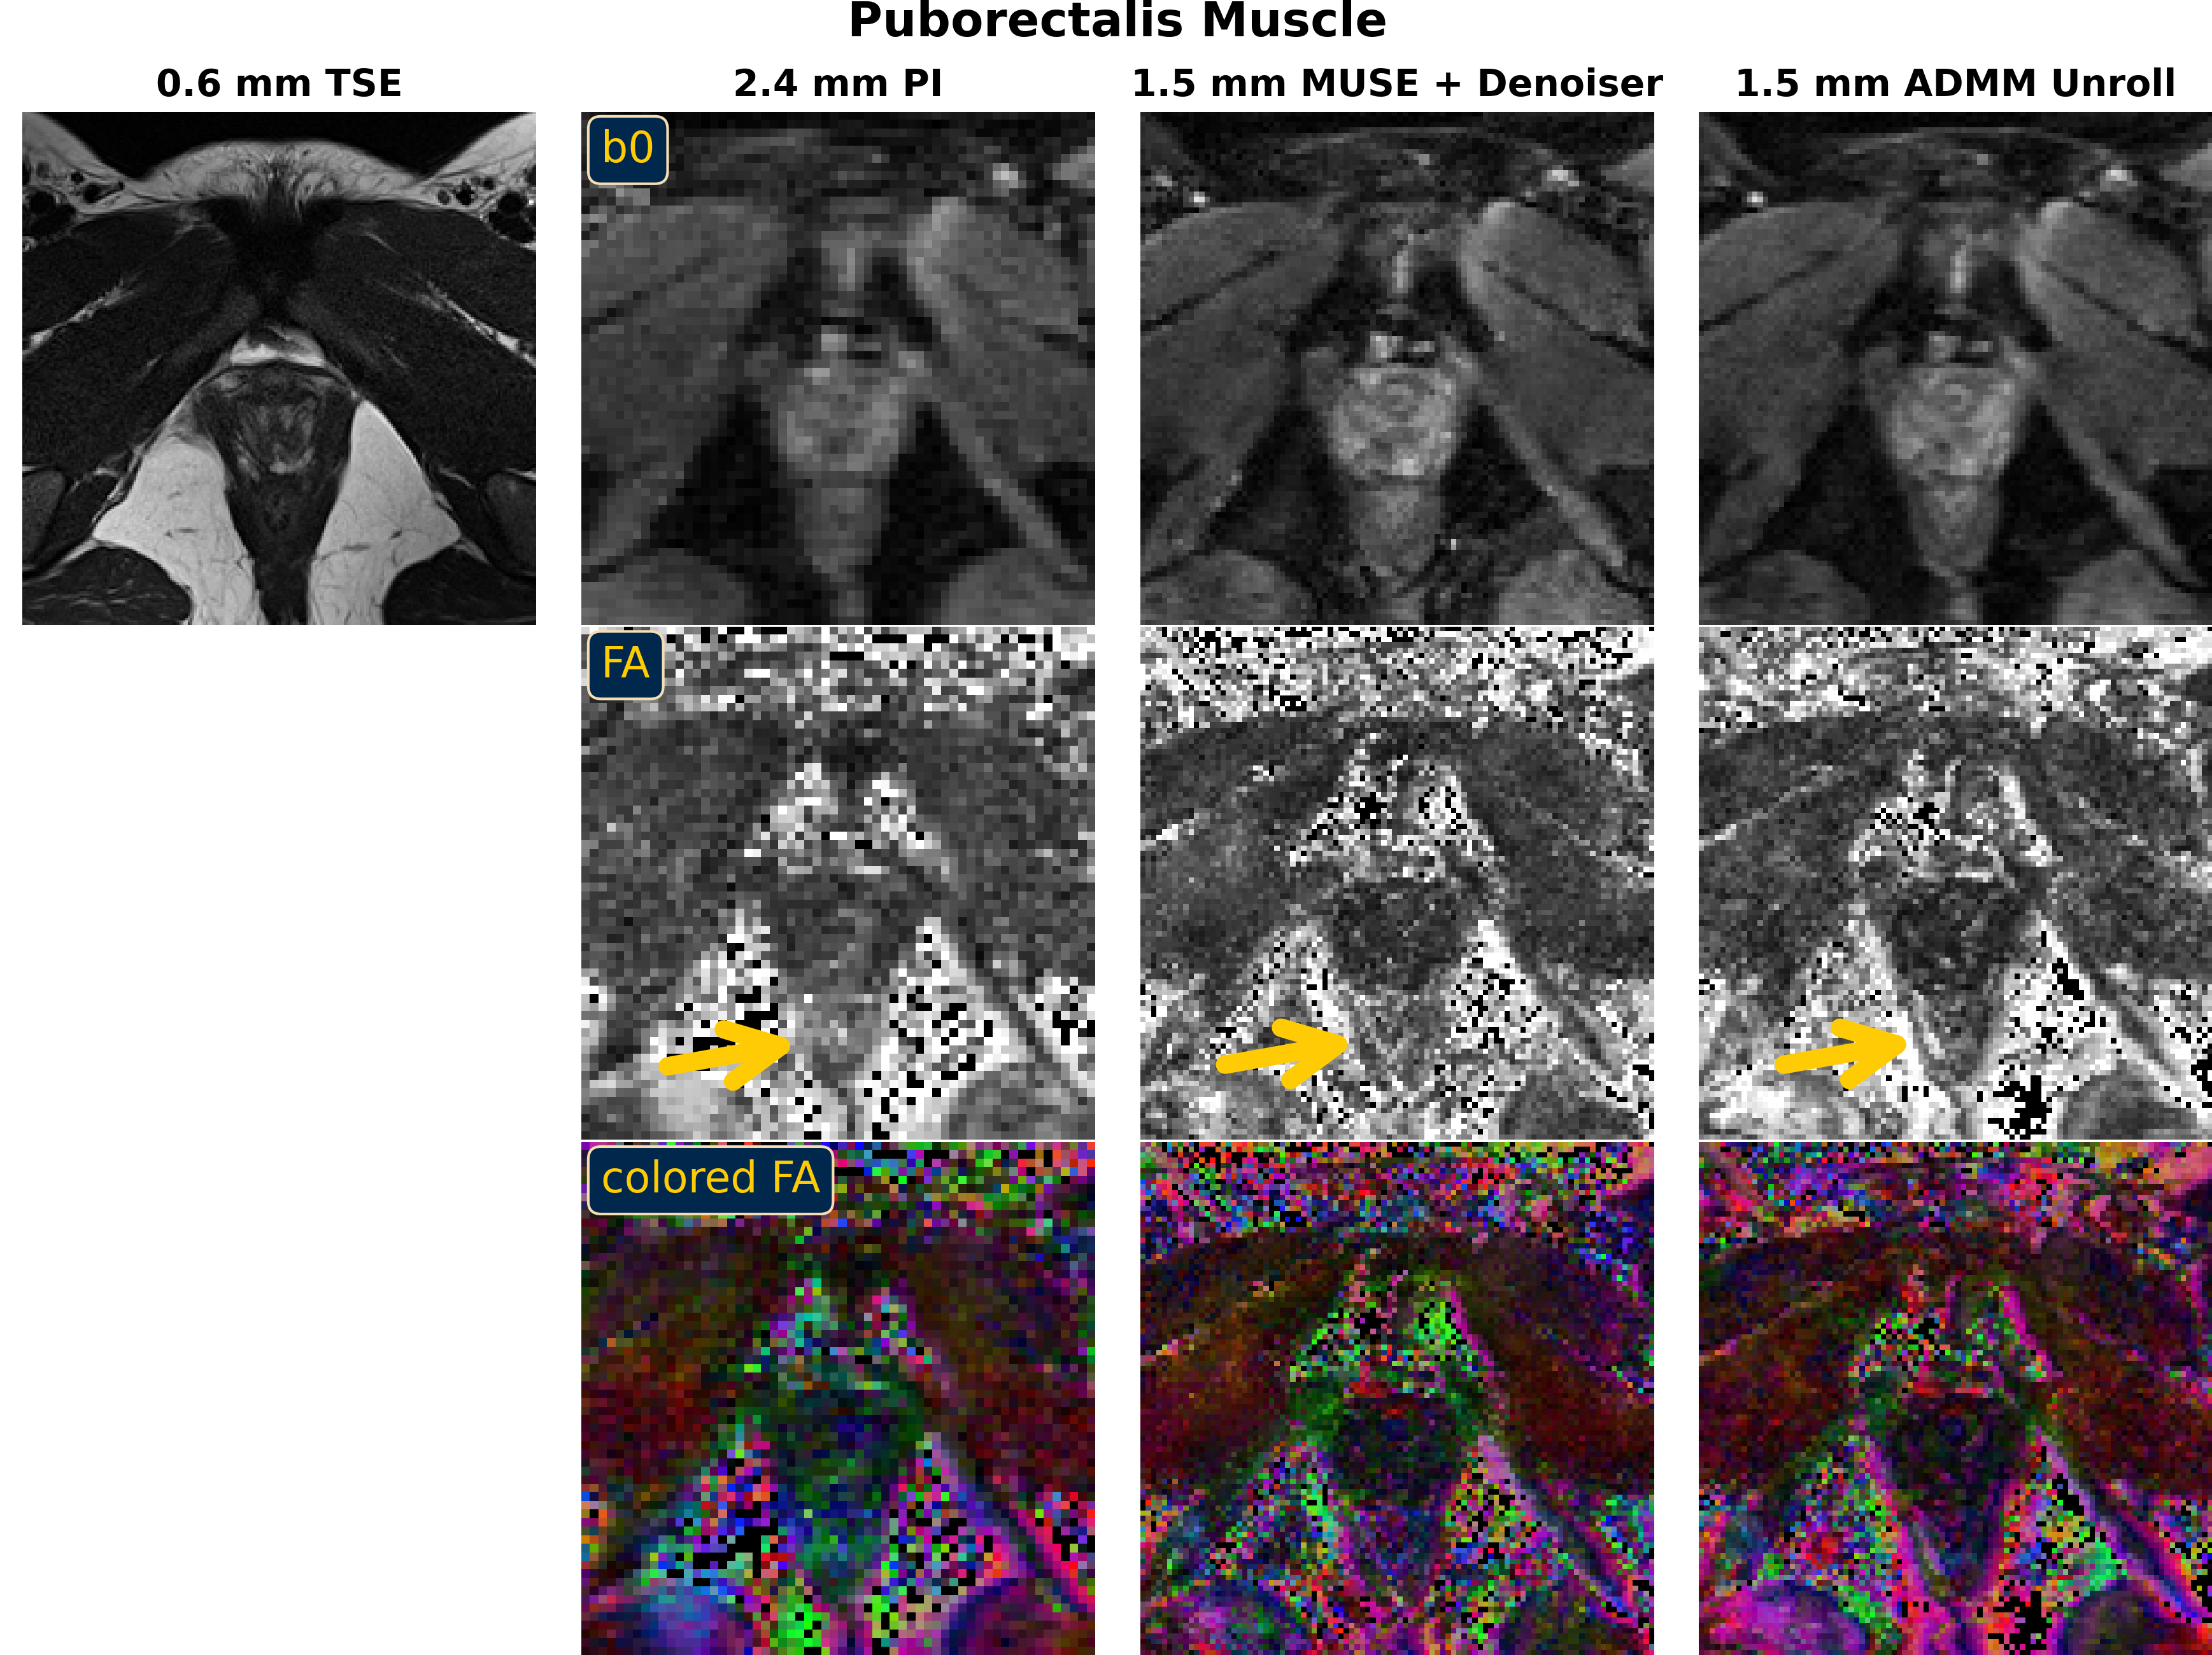
Figure 4. High-resolution multi-shot EPI with ADMM unrolling reconstruction enables the visualization of the puborectalis muscle.

Figure 4 highlights the puborectalis muscle, which is clearly depicted by the proposed ADMM unrolling reconstruction. Green in the color FA map of the ADMM unrolling reconstruction indicates that the puborectalis muscular fiber goes from anterior to posterior. Puborectalis muscle forms a U-shape sling wrapping around the posterior side of the anorectal junction, the most important muscle for maintaining fecal continence.

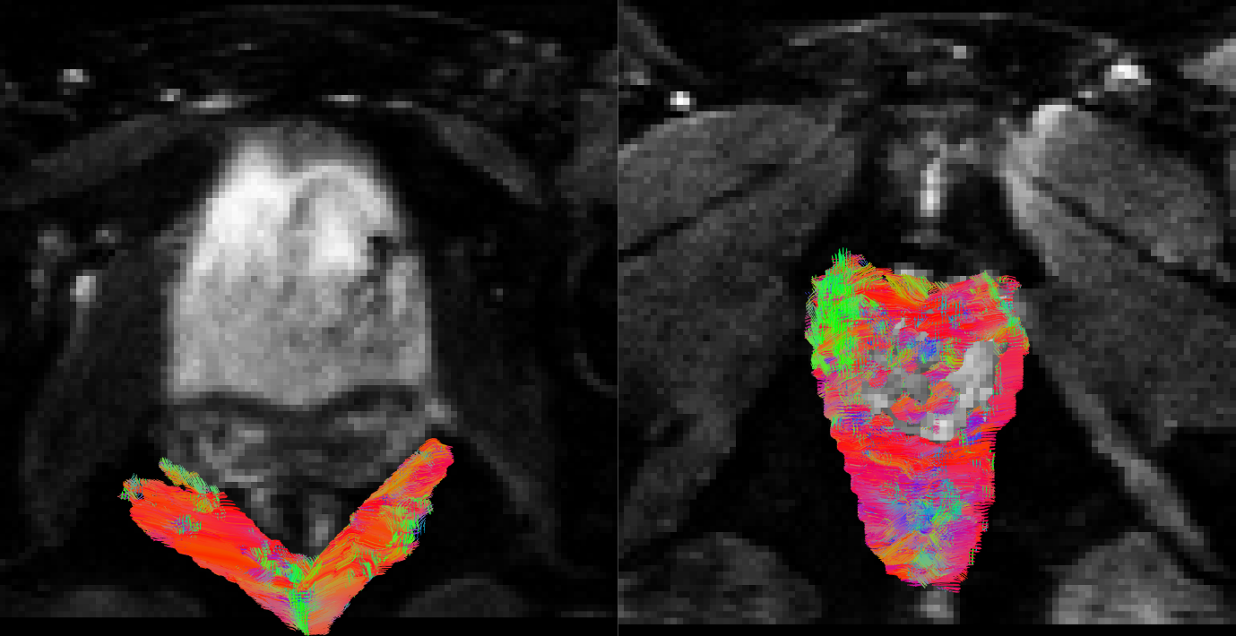
Figure 5. Preliminary fiber tracking results of the iliococcygeus and the puborectalis muscles.

Figure 5 displays the preliminary results on pelvic floor muscle fiber tracking. The iliococcygeus fiber runs from anterior to posterior. The fiber direction from the puborectalis muscle is ambiguous, likely because of partial volume effects.

DISCUSSION
(How do you interpret the results?)

This study reports initial results on pelvic floor DTI at high resolution (1.5 mm in-plane), enabled by multi-shot EPI acquisition and ADMM unrolled reconstruction. The results confirm the need for high-resolution DTI to probe pelvic floor microstructure, which otherwise is invisible from the clinical protocol at 2.4 mm resolution. Further investigation on fiber tractography is needed to ensure accurate fiber tracking results.

CONCLUSION
(What is the relevance to clinical practice or future research?)

This study develops a high-resolution pelvic floor DTI technique at 3T. This technique may serve as a new tool for the investigation of female pelvis floor injury.

REFERENCES
[1] DeLancey J, Masteling M, Pipitone F, LaCross J, Mastrovito S, Ashton-Miller JA. Pelvic floor injury during vaginal birth is life-altering and preventable: what can we do about it? Am J Obstet Gynecol 2024;230:279-294. doi:10.1016/j.ajog.2023.11.1253
[2] Zifan A, Reisert M, Sinha S, et al. Connectivity of the superficial muscles of the human perineum: a diffusion tensor imaging-based global tractography study. Sci Rep 2018;8:17867. doi:10.1038/s41598-018-36099-4
[3] Tan Z, Liebig PA, Heidemann RM, Laun FB, Knoll F. Accelerated diffusion-weighted MRI at 7T: joint reconstruction for shift-encoded navigator-based interleaved EPI (JETS-NAViEPI). Imaging Neuroscience 2024;2:imag-2-00085. doi:10.1162/imag_a_00085
[4] Tan Z, Liebig PA, Hofmann A, Laun FB, Knoll F. High-resolution diffusion-weighted imaging with self-gated self-supervised unrolled reconstruction. Magn Reson Med (2025).
[5] He K, Zhang X, Ren S, Sun J. Deep residual learning for image recognition. CVPR (2016). doi:10.1109/CVPR.2016.90
[6] Yaman B, Hosseini SAH, Moeller S, Ellermann J, Ugurbil K, Akcakaya M. Self-supervised learning of physics-guided reconstruction neural networks without fully sampled reference data. Magn Reson Med 2020;84:3172-3191. doi:10.1002/mrm.28378
[7] Yaman B, Hossein SAH, Akcakaya M. Zero-shot self-supervised learning for MRI reconstruction. ICLR (2022).
[8] Pruessmann KP, Weiger M, Boernert P, Boesiger P. Advances in sensitivity encoding with arbitrary k-space trajectories. Magn Reson Med 2001;46:638-651. doi:10.1002/mrm.1241
[9] Chen NK, Guidon A, Chang HC, Song AW. A robust multi-shot scan strategy for high-resolution diffusion weighted MRI enabled by multiplexed sensitivity-encoding (MUSE). NeuroImage 2013;72:41-47. doi:10.1016/j.neuroimage.2013.01.038
[10] Cordero-Grande L, Christiaens D, Hutter J, Price AN, Hajnal JV. Complex diffusion-weighted image estimation via matrix recovery under general noise models. NeuroImage 2019;200:391-404. doi:10.1016.j.neuroimage.2019.06.039

