## Individual Visualization Project Report

The visualization project utilizes data from the Met Office Climate Data Portal, specifically the Monthly Temperature Observations 1991-2020 dataset. This dataset presents monthly averages of surface temperature (°C) spanning the years 1991-2020, relying on HadUK gridded data and provided on a 2km British National Grid (BNG). The visualization of this dataset offers a valuable tool for studying temperature variations across diverse regions and seasons in the UK, also allowing exploration of phenomena such as the urban heat island effect.

The webpage design comprises two main sections:

1. Interactive Choropleth Map (Right Side): The map showcases surface temperatures for a selected month (default is January) from 1991-2020 in the UK, presented as a heatmap.
2. Control Panel (Left Side): The control panel provides several functionalities:

* A month selector enabling users to choose the month they wish to visualize.

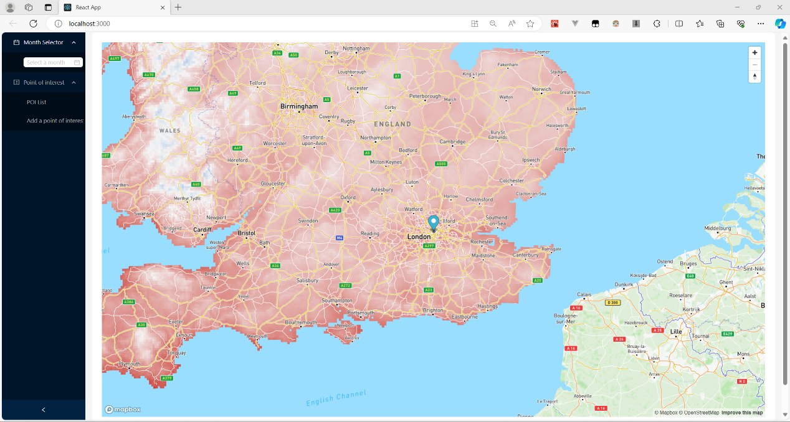

* Quick addition of the current map center to the Points of Interest (POI) List.
* Manual addition of a POI by entering its name, latitude, longitude, and description.

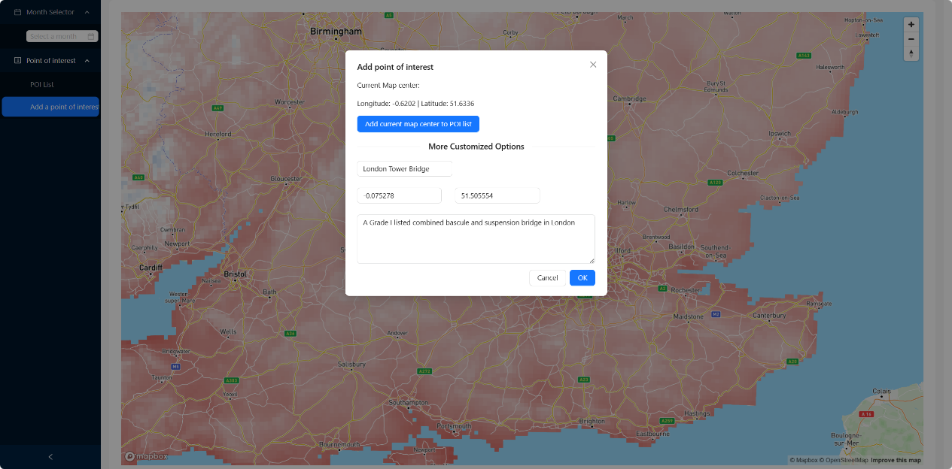

* Browsing information about POIs, including names, coordinates, and descriptions, with markers on the map.
* Deletion of POIs.

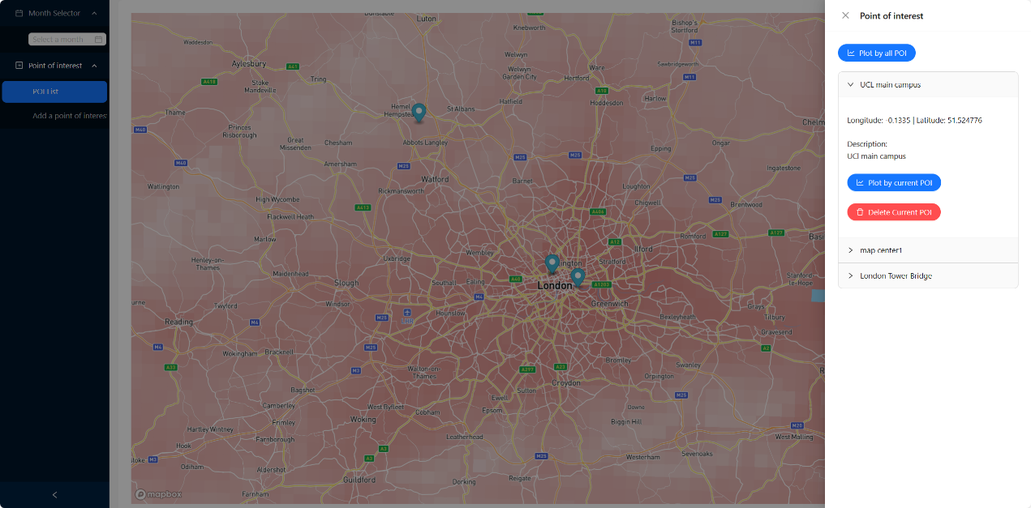

* Line chart plotting for a single POI.

* Line chart plotting for all POIs.

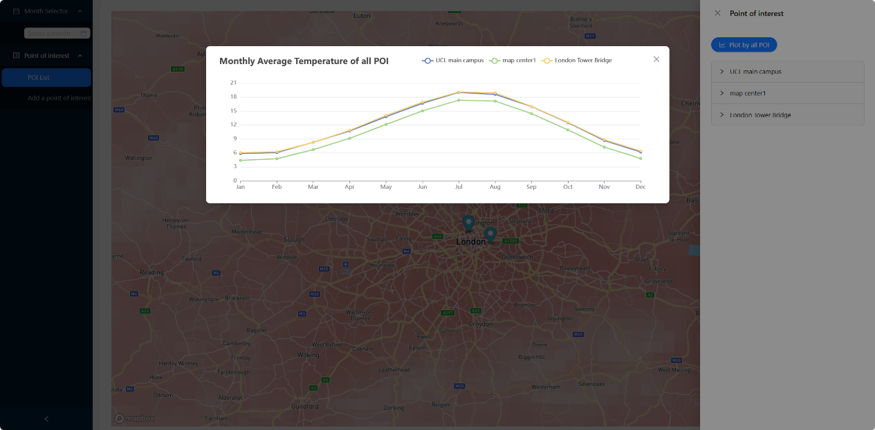

In terms of technological aspects in website development, the entire webpage is constructed using React JS. Given the substantial amount of data used in the visualization project and the high-performance rendering required for the map component, React's diff algorithm effectively reduces unnecessary webpage re-renders, minimizing user wait times during usage. For interactive data visualization on the map, Mapbox has been selected, providing basic functionalities such as drag-and-drop and zoom, along with additional options for customizing map layers. The line chart is drawn using ECharts, offering aesthetically pleasing and clear line charts. It also supports functionality to show or hide specific data series by clicking on the legend. This feature proves beneficial when users create a large number of POIs, ensuring the cleanliness of the chart by avoiding redundant data plotting.

P.S. Instructions on how to run this app are given in the README.md file.