5.13

A.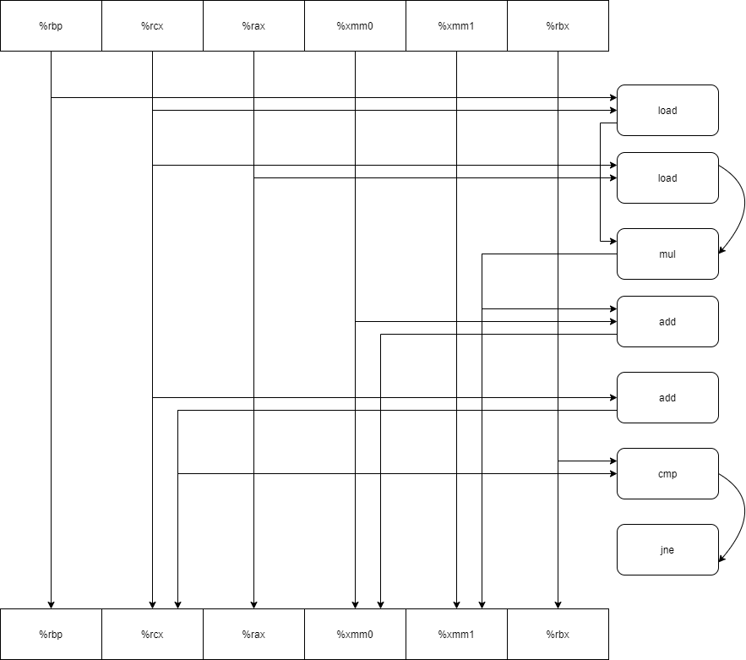

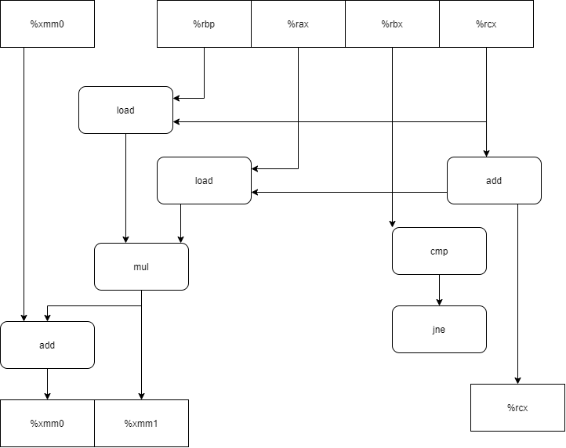

B.3.0

C.1.0

D.关键路径上没有乘法，只有浮点加法

5.15

代码：

void inner6(vec_ptr u, vec_ptr v, data_t *dest) {

long i;

long length = vec_length(u);

long limit = length - 5;

data_t *udata = get_ver_start(u);

data_t *vdata = get_vec_start(v);

data_t sum0 = (data_t)0;

data_t sum1 = (data_t)0;

data_t sum2 = (data_t)0;

data_t sum3 = (data_t)0;

data_t sum4 = (data_t)0;

data_t sum5 = (data_t)0;

for (i = 0; i < limit; i += 6) {

sum0 = sum0 + udata[i] * vdata[i];

sum1 = sum1 + udata[i + 1] * vdata[i + 1];

sum2 = sum2 + udata[i + 2] * vdata[i + 2];

sum3 = sum3 + udata[i + 3] * vdata[i + 3];

sum4 = sum4 + udata[i + 4] * vdata[i + 4];

sum5 = sum5 + udata[i + 5] * vdata[i + 5];

}

for (; i < length; i++) {

sum0 = sum0 + udata[i] * vdata[i];

}

*dest = sum0 + sum1 + sum2 + sum3 + sum4 + sum5;

}

原因：一次最多加载两个值，那么就限制了CPE的下限是1.0。而且在HasWell架构中加法延迟为一个周期，因此这么编写CPE下限不可能低于1.0。

5.17

#include <stdio.h>

#include <stdint.h>

#include <stdlib.h>

#include <string.h>

#include <assert.h>

#include<Windows.h>

void* memset_5_17(void *s, int c, size_t n) {

size_t K = sizeof(unsigned long);

size_t cnt = 0;

unsigned long ul;

unsigned char *temp=(unsigned char *)&ul;

unsigned char *schar = (unsigned char*)s;//强制类型转换

while (cnt < K) {

*temp++ = (unsigned char)c;

cnt++;

}

cnt=0;

while (cnt < n)

{

//对齐

if ((size_t)schar % K == 0) {

break;

}

*schar++ = (unsigned char)c;

cnt++;

}

unsigned long *ulong = (unsigned long *)schar;

size_t res = n - cnt;

size_t res2 = res % K;

size_t num = res / K;

for (size_t i = 0; i < num; i++) {

*ulong++ = ul;

}

schar = (unsigned char *)ulong;

for (size_t i = 0; i < res2;i++) {

*schar++ = (unsigned char)c;

}

return s;

}

5.19

void psum4(float a[], float p[], long n)

{

long i;

float last_val,val;

float temp0, temp1, temp2, temp3;

last_val = p[0] = a[0];

for (i = 1; i < n - 4; i++) {

temp0 = last_val + a[i];

temp1 = temp0 + a[i+1];

temp2 = temp1 + a[i+2];

temp3 = temp2 + a[i+3];

p[i] = temp0;

p[i+1] = temp1;

p[i+2] = temp2;

p[i+3] = temp3;

last_val += (a[i] + a[i+1] + a[i+2] + a[i+3]);

}

for (; i < n; i++) {

last_val += a[i];

p[i] = last_val;

}

}