HW5:

The step to complete the assignment:

Spell correction:

1. write the JAVA code to create the big.txt.
2. change some of the method in php code.
3. For the phrase query, split the words into part and try to find the best part of each other and then combine them together.

Auto completion:

1. I configure the solr and add the component and request handler to it.
2. Using the code of jQuery and some of the php code to achieve the function of Auto complete.
3. Write the auto.php to handle auto complete request.
4. Remove the unusual word such as “.html”,”title.
5. Split to the words and find suggest list of each part and combine together.

Snippet:

1. Download simple_html_dom.php and using the function which is called file_get_html.
2. Find the target of the texts and try to get test of sentences that include those query term.

Analysis of the results:

Spell correction:

1.

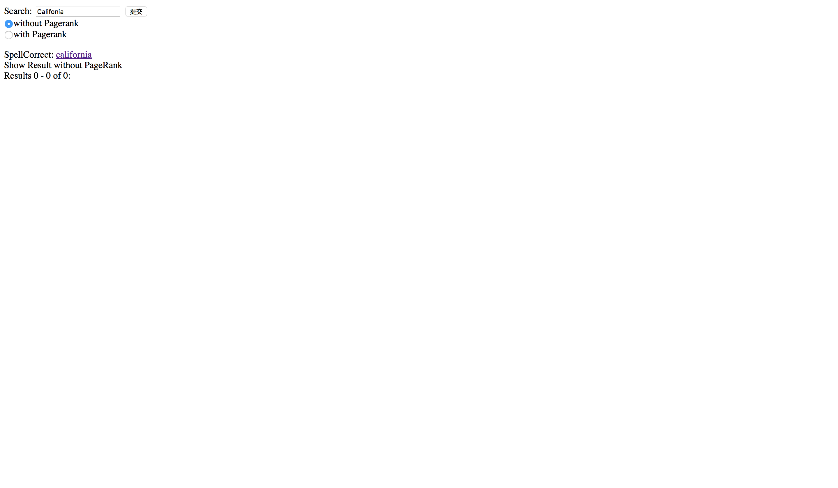

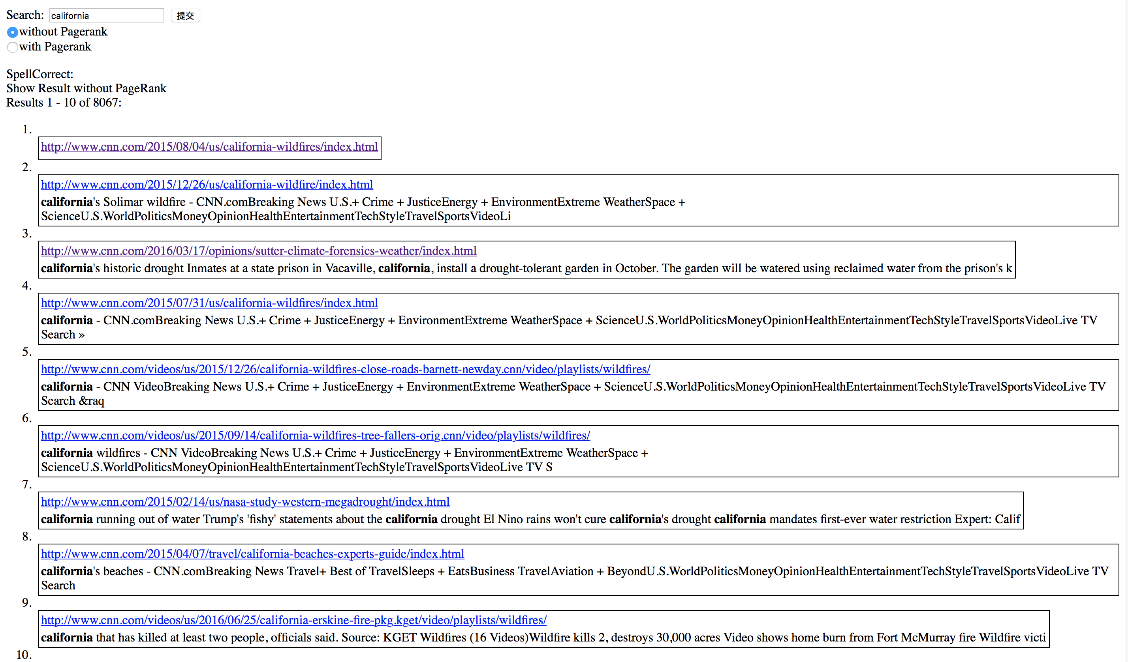

2.

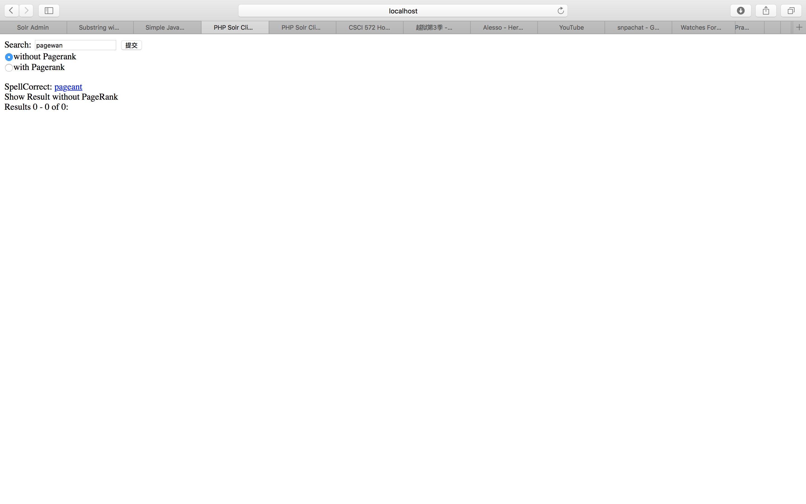

3.

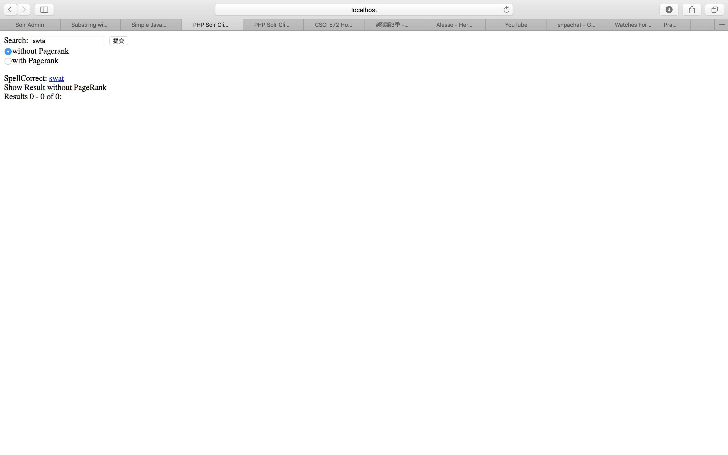

4.

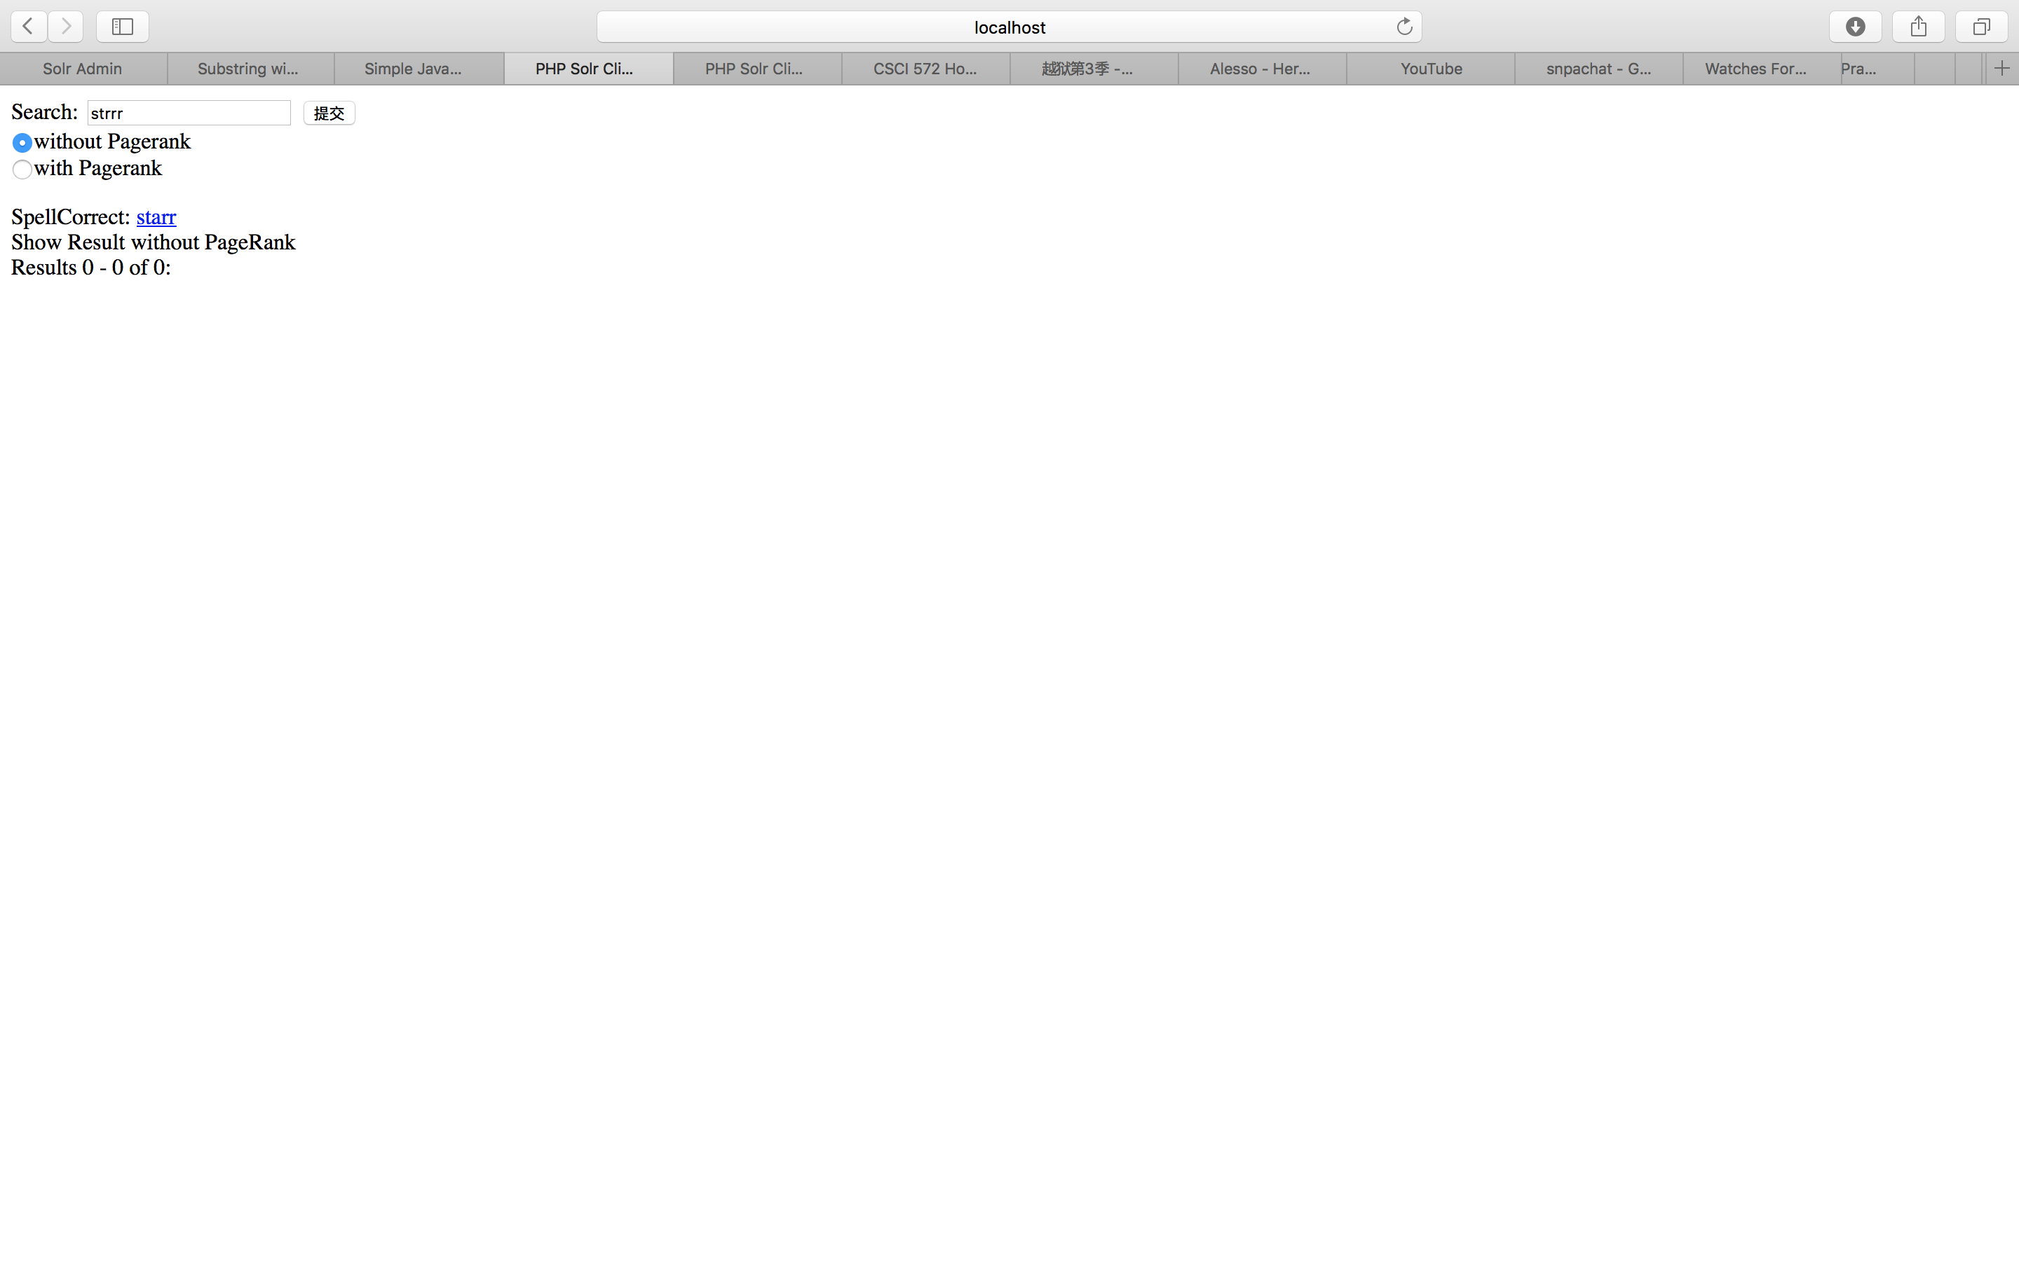

5.

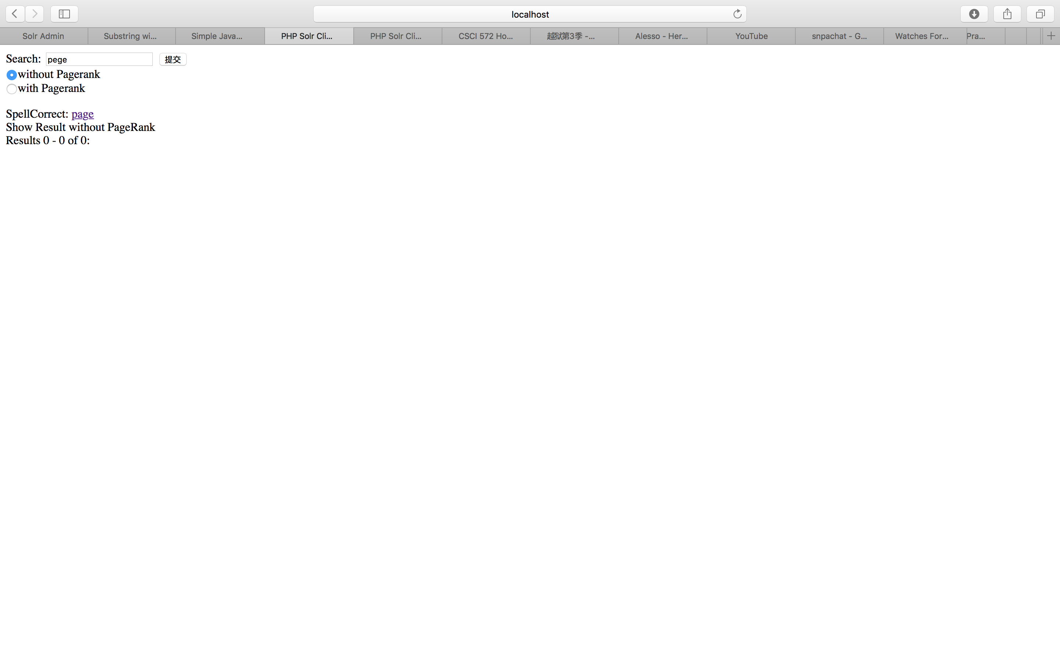

Auto Completion:

In the following screenshot, we see that after input character(s) we can get a list of suggest component.

1.

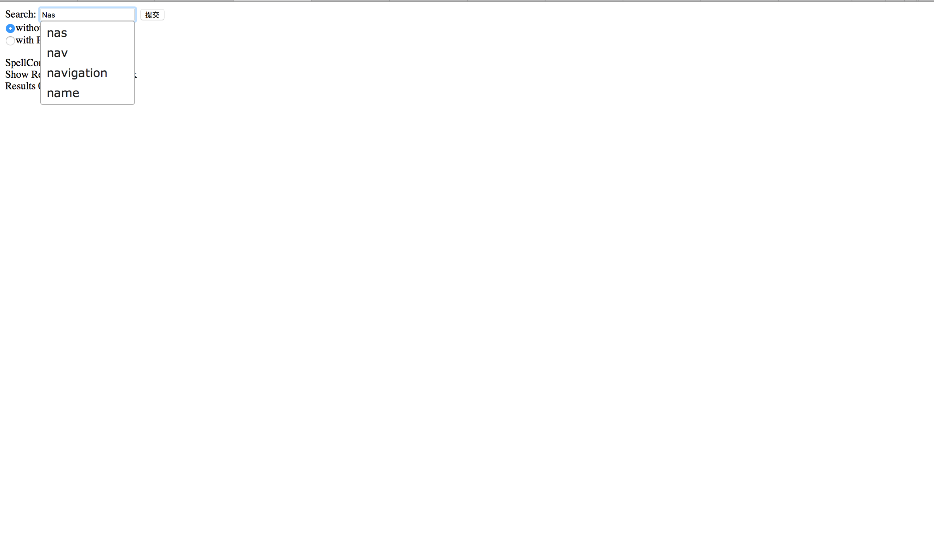

2.

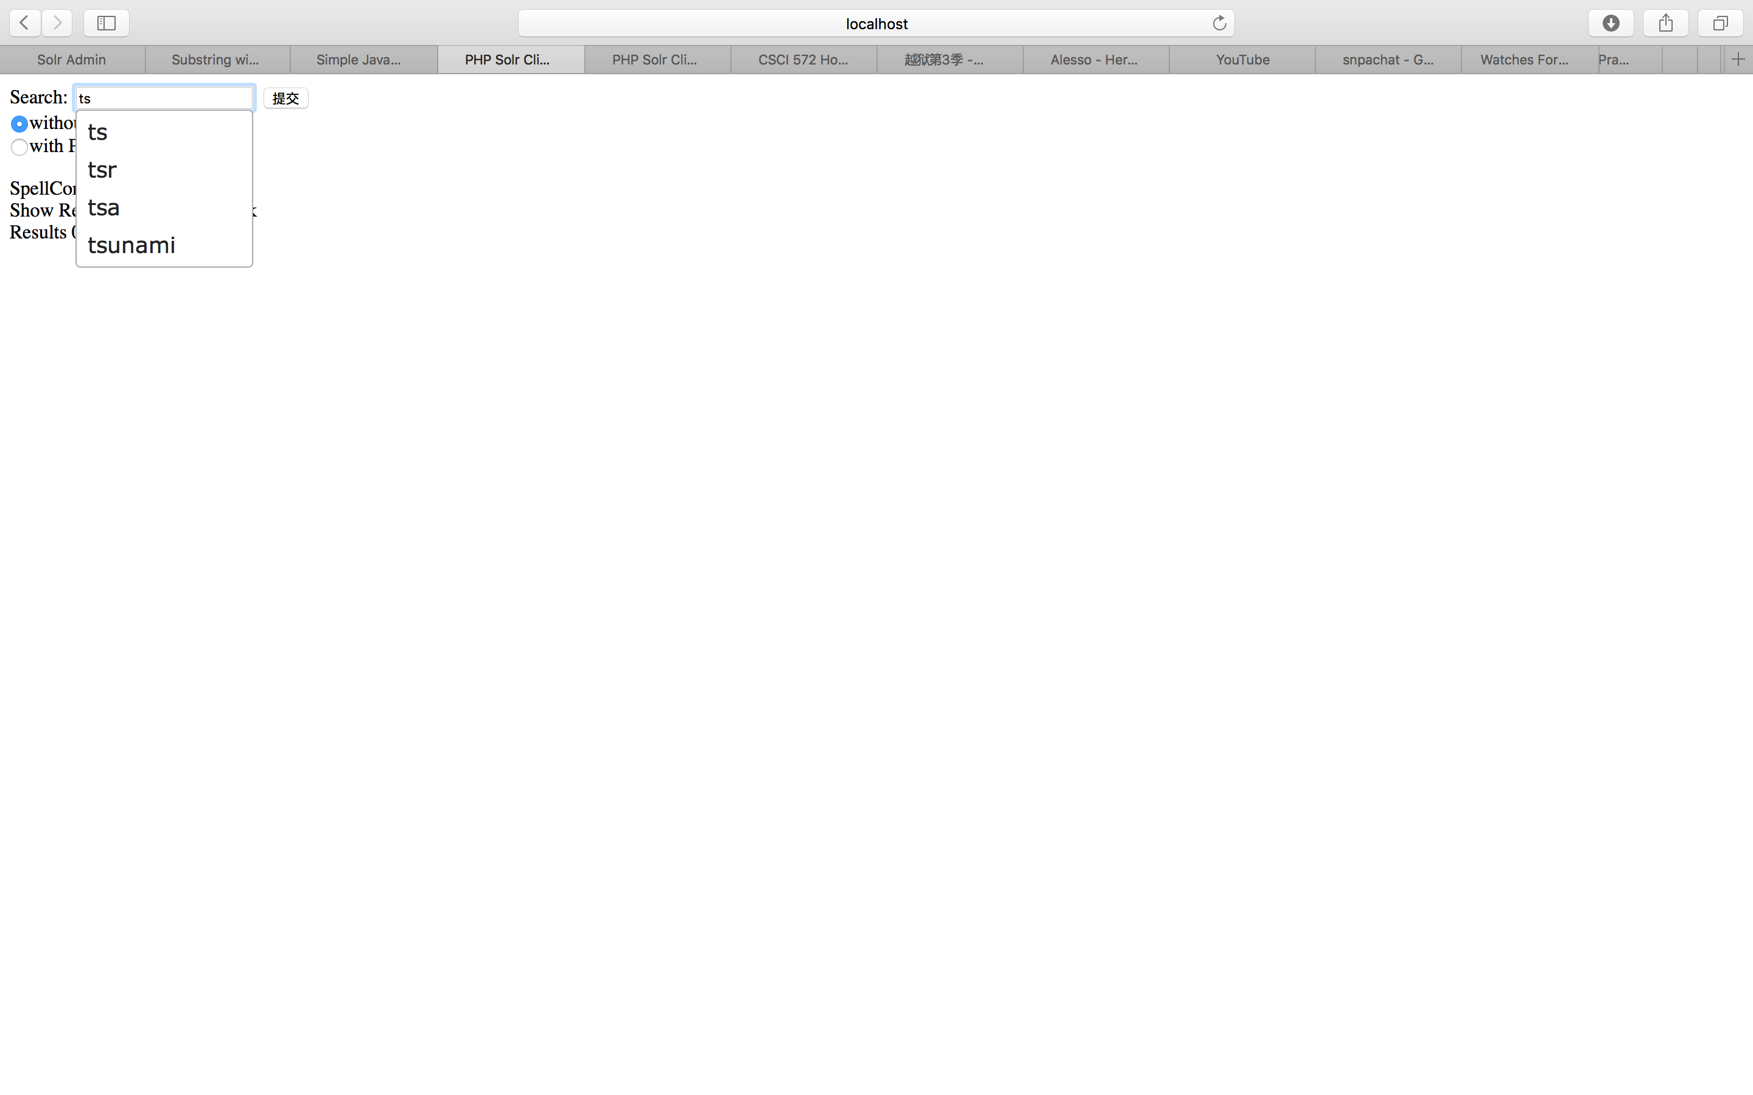

3.

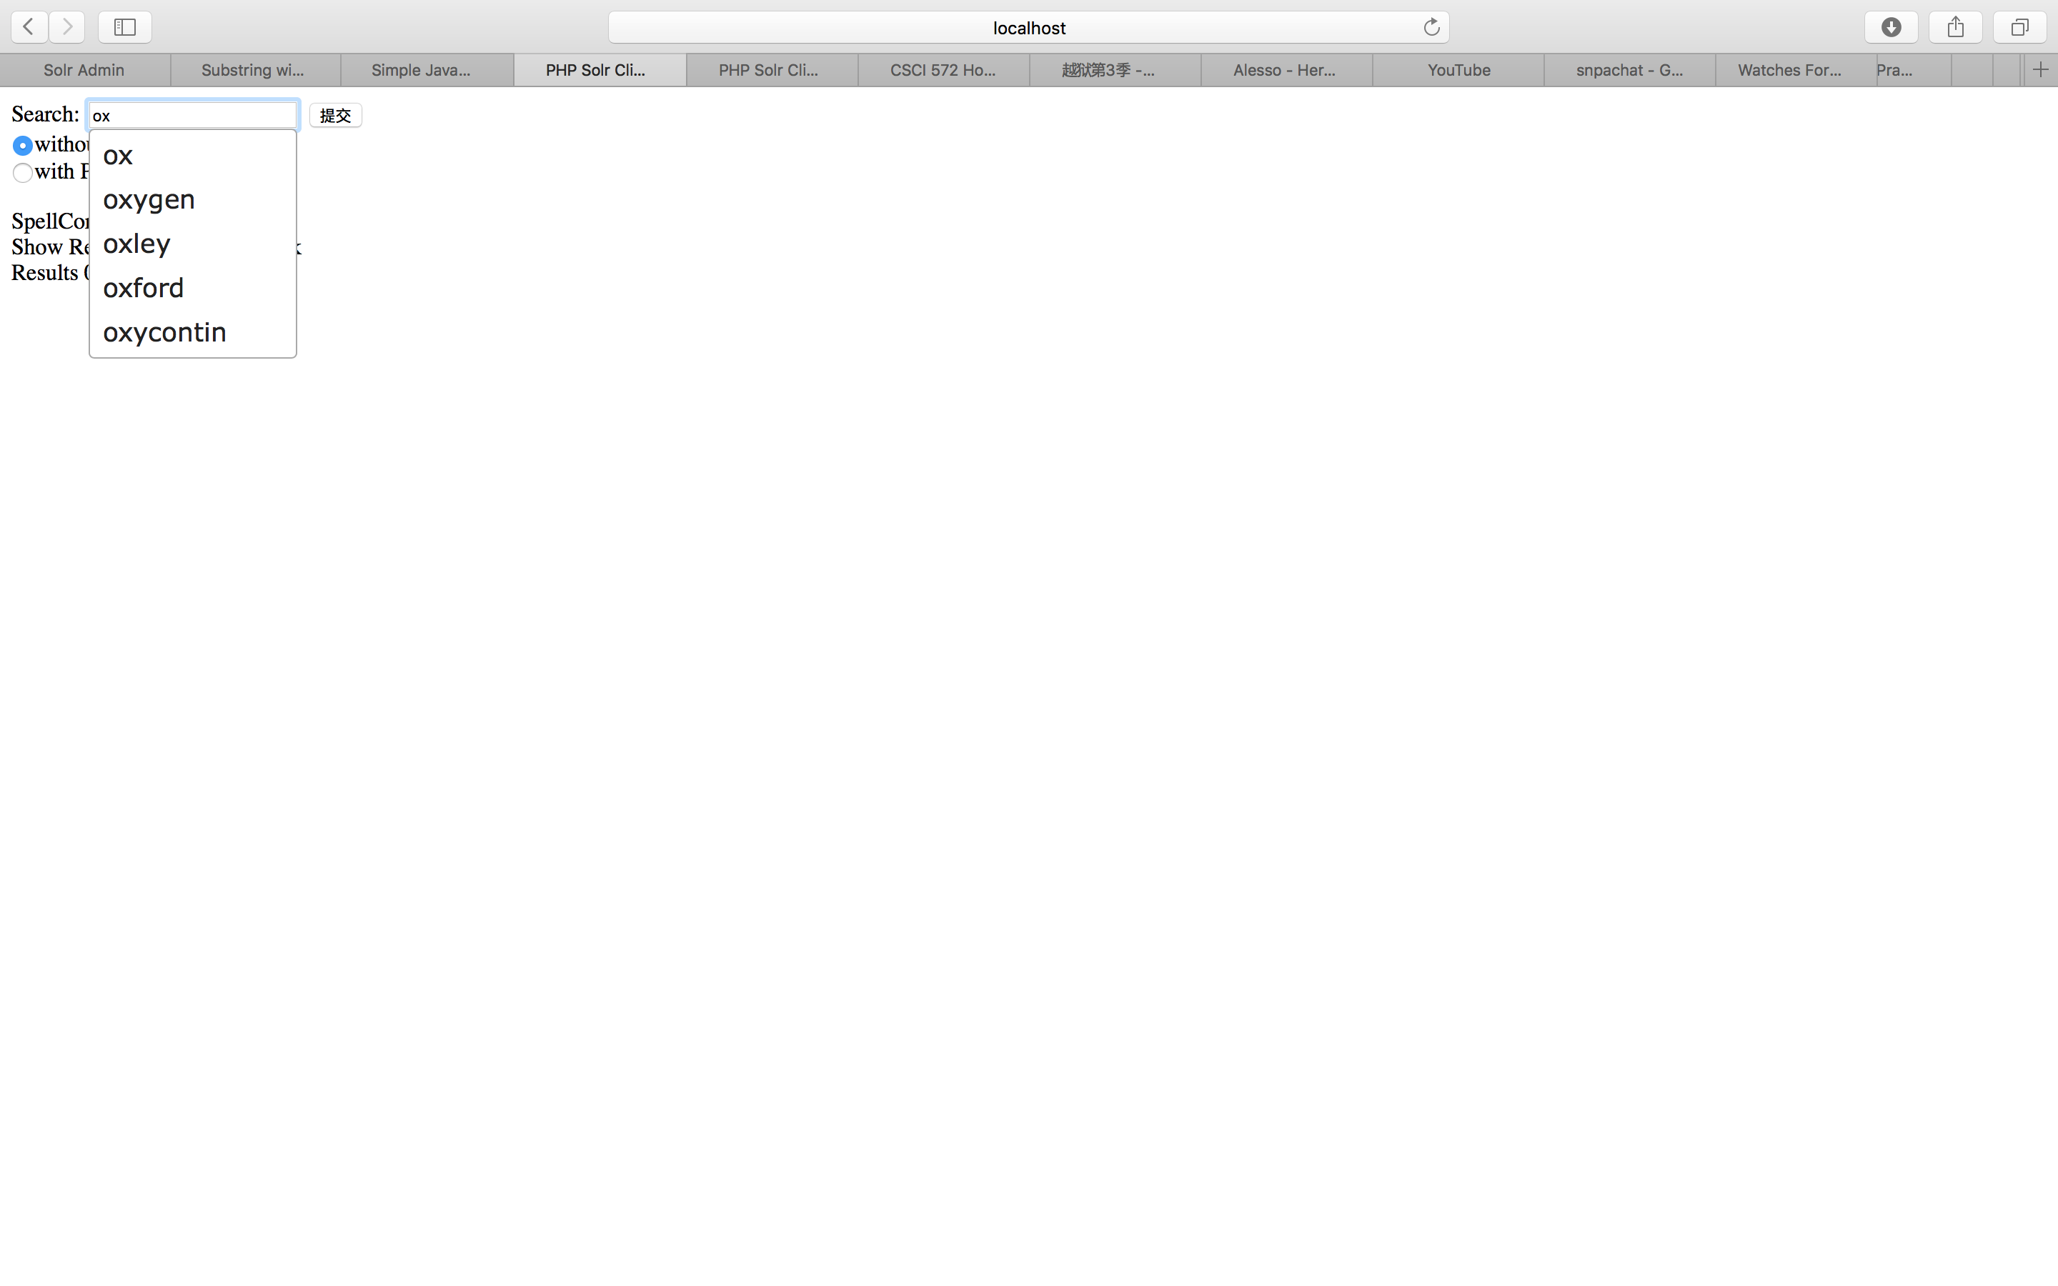

4.

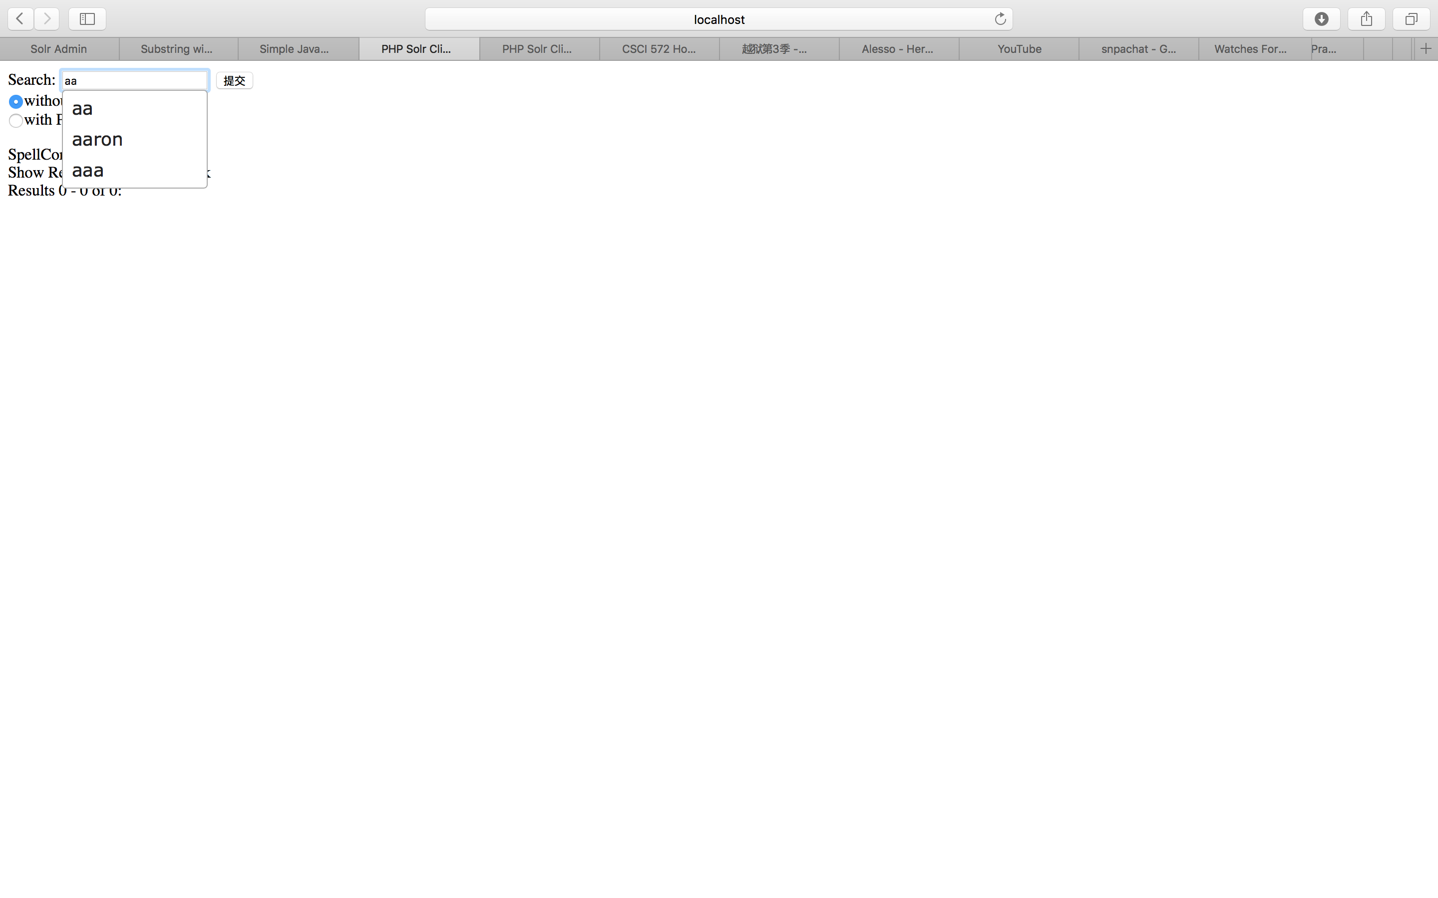

5.

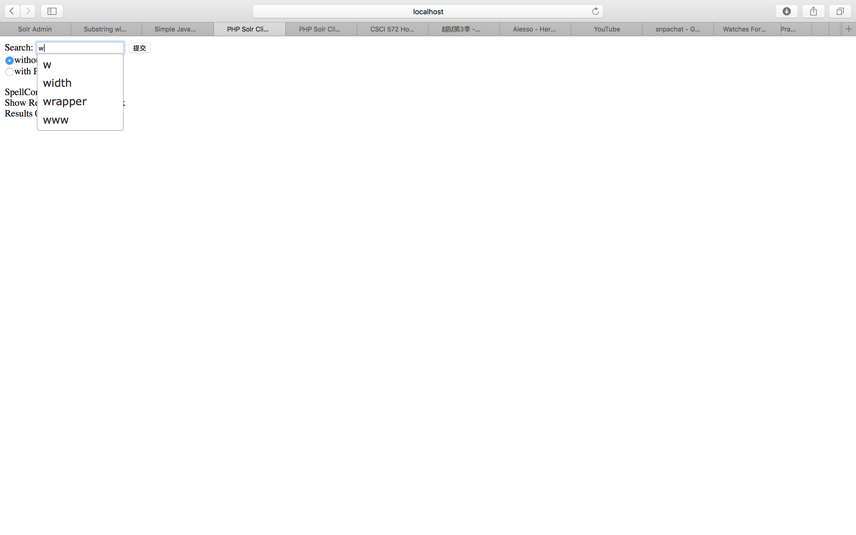

Snippet:

