Name: Ethan Grant

Uni: erg2145

Class: STAT W4400

Hw num: HW03

1.4

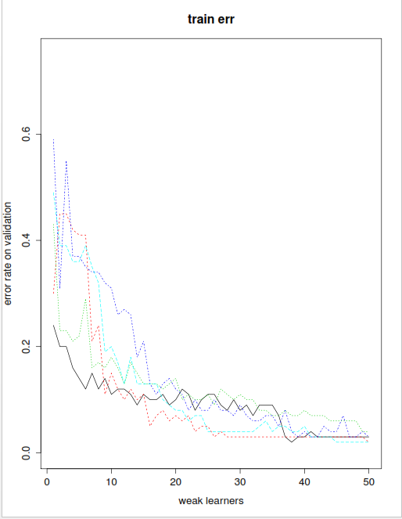

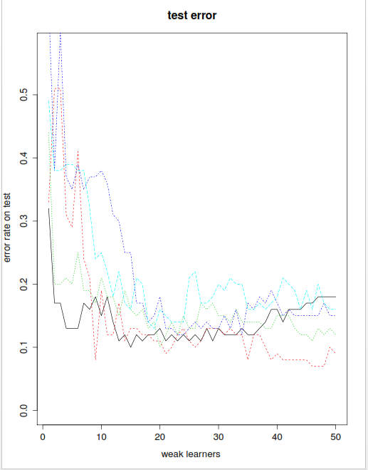

2.1) q=.5 encourages sparsity the penalty of a few large solutions is reduced while the penalty of smaller betas is not so they are pushed towards 0. q=4 does not encourage sparsity because it will favor entries of similar values as defined on the slides.

2.2) q=.5 the smallest cost is achieved by x_{3} since it is located on the axis which is what the q=.5 favors. For Q=4 the smallest cost is achieved by x_{4} because it lies within the penalty boundary