Hypergeometry and plotting, cdf (cumulative density function) and ppf its inverse
import: from scipy.stats import hypergeom
import numpy as np
import matplotlib.pyplot as plt (important for plotting)
example: suppose we have 20 animals, 7 of which are dogs; if we take a random sample of
12 animals what is the probability a given number of them will be dogs
hypergeom + pmf code:
[M,n,N] = [20,7,12] # givens
rv = hypergeom(M,n,N) # this 'freezes' rv
x = np.arange(0,n+1) # evenly spaced x array from 0 to n+1
pmf_dog = rv.pmf(x) # prob mass function for values of rv related to x
plot: fig = plt.figure()
ax = fig.add_subplot(111) # position of subplot (?)
ax.plot(x,pmf_dogs,'bo') # like matlab, (x,y,'symbol+color')
ax.vlines(x,0,pmf_dogs,lw=2) # actual stem lines (at each pt x from 0 tp value of
# pmf_dogs at that x pt with width of 2
ax.set_xlabel('# of dogs')
ax.set_ylabel('hypergeom PMF')
plt.show()
hypergeom cdf + pff (inverse):
prb = hypergeom.cdf(x,M,n,N) # cum dens fxn (stepwise for a discrete fxn (like this))
ppf_arf = hypergeom.ppf(prb,M,n,N) # ppf = inverse of cdf; this returns original x
minimum plot commands:
fig = plt.figure()
ax = fig.add_subplot(111)
ax.plot(x, y, 'symbols')
plt.show()

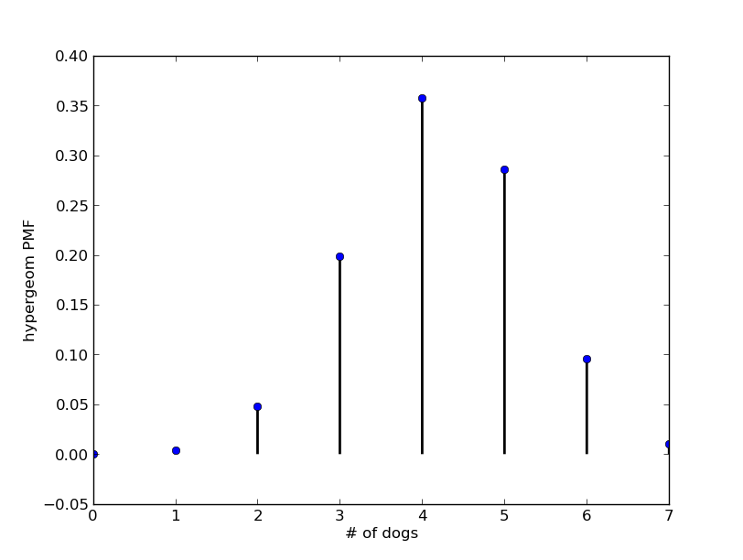  X vs pmf | 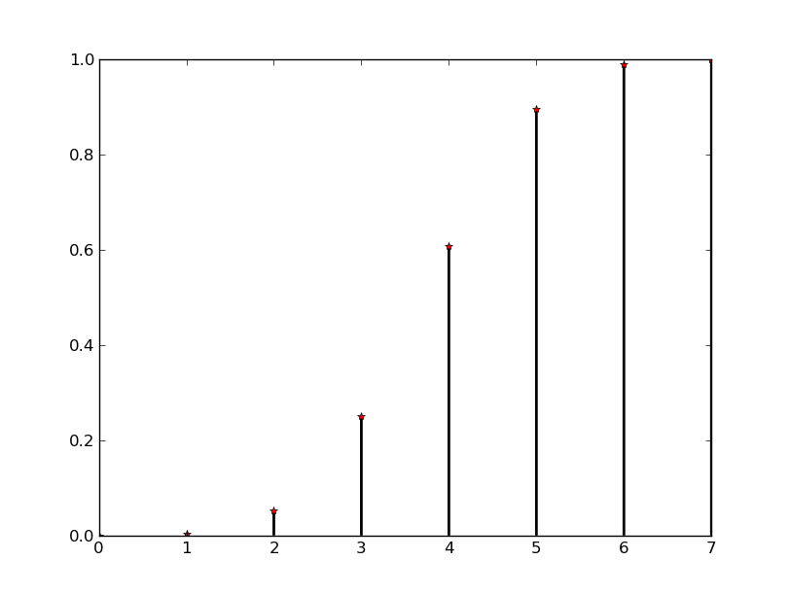  X vs cdf (cumulative)

