# Abstract

**Background:** Prostate cancer active surveillance (AS) patients undergo repeat biopsies. Treatment commonly advised when biopsy Gleason grade $≥$ 2 (reclassification). Many patients never experience reclassification, yet undergo biopsies frequently. Reclassification risk based personalized biopsy schedules may reduce patient burden.

**Objective:** Develop web-application to assist patients/doctors make better biopsy decisions than fixed biopsies.

**Design, Setting, and Participants Model development:** World's largest AS study PRIAS, 7813 patients, 1134 experienced reclassification; External validation: largest five GAP3 database cohorts; Data: prostate-specific antigen (PSA), repeat biopsy Gleason grade.

**Outcome Measurements, and Statistical Analysis:** Bayesian joint model fitted to PRIAS dataset. Model predicted patient-specific reclassification risk utilized for personalized biopsy decisions. Model validated in GAP3 cohorts using risk prediction error, calibration, area under ROC (AUC). Risk calculator, personalized schedules implemented in web-application, for PRIAS and validated GAP3 cohorts.

**Results and Limitations: Reclassification rate at year five of follow-up:** 35% in PRIAS, at most 50% in GAP3 cohorts. PSA velocity stronger predictor of reclassification (Hazard Ratio: 2.47, 95%CI: 1.93-2.99), than PSA value (Hazard Ratio: 0.99, 95%CI: 0.89-1.11). Validation: Moderate AUC (0.55-0.75) in PRIAS and GAP3 cohorts. Moderate prediction error (0.1-0.3) in GAP3 cohorts with Reclassification rate similar to PRIAS, large (0.3-0.45) otherwise. Model recalibrated for external GAP3 cohorts.

**Conclusions:** We successfully developed and validated web-application for predicting reclassification risks, and risk based personalized biopsy decisions, in prostate cancer AS. Available for PRIAS, and largest five GAP3 database cohorts. Enables shared decision making of biopsy schedules by comparing fixed and personalized schedules on total biopsies and expected time delay in detection of reclassification.

**Patient Summary:** Reclassification risk based personalized biopsy schedules are novel alternative to fixed biopsy schedules. They are implemented in our web-application. May offer better balance between total biopsies and time delay in detection of reclassification than fixed schedules.

# Introduction

Patients with low- and very low-risk screening-detected localized prostate cancer are usually advised active surveillance (AS) instead of immediate radical treatment~\citep{briganti2018active}. In AS, cancer progression is routinely monitored via prostate-specific antigen (PSA), digital rectal examination, and repeat biopsies. Among these, the strongest indicator of cancer-related outcomes is the biopsy Gleason grade~\citep{epsteinGG2014}. When the Gleason grade increases from grade~1 (Gleason 3+3) to 2 (Gleason 3+4) or higher, called *reclassification*, patients are commonly advised curative treatment~\citep{bul2013active}.

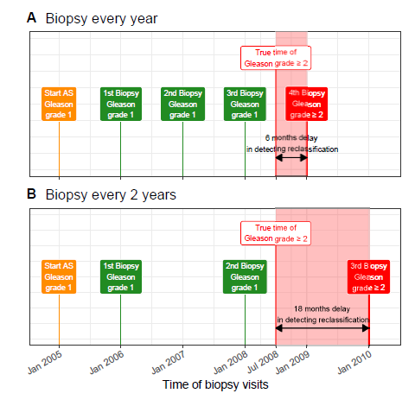

\caption{\textbf{Trade-off between the number of biopsies and time delay in detecting reclassification (Increase in Gleason grade from 1 to 2 or higher):} The true time of reclassification for the patient in this figure is July 2008. When biopsies are scheduled annually (\textbf{Panel~A}), reclassification is detected in January 2009 with a time delay of six months, and a total of four biopsies are scheduled. When biopsies are scheduled biennially (\textbf{Panel~B}), reclassification is detected in January 2010 with a time delay of 18 months, and a total of three biopsies are scheduled. Since biopsies are conducted periodically, the time of reclassification is observed as an interval. For example, between Jan~2008--Jan~2009 in \textbf{Panel~A} and between Jan~2008--Jan~2010 in \textbf{Panel~B}.}

Biopsies are conducted periodically. Consequently, reclassification is always detected with a time delay (Figure~\ref{fig:delay_explanation}). For detecting reclassification timely, many AS programs schedule fixed and frequent biopsies (e.g.,~annually) for all patients~\citep{nieboer2018active,loeb2014heterogeneity}. However, this leads to many unnecessary biopsies in slow/non-progressing patients. Biopsies are invasive, painful, and prone to medical complications. Thus, biopsy burden and patient non-compliance to frequent biopsies~\citep{bokhorst2015compliance} has raised concerns regarding the optimal biopsy schedule~\citep{inoue2018comparative, bratt2013study}. To this end, infrequent schedules such as biennial biopsies have been proposed as an alternative~\citep{inoue2018comparative,de2017estimating}. Although, biennial biopsies may still lead to five unnecessary biopsies over ten years (current study period of large AS programs) for slow/non-progressing patients. A promising alternative to fixed and frequent biopsies is personalized biopsy schedules based on the patient-specific risk of reclassification (Figure~\ref{fig:riskBasedExample}).

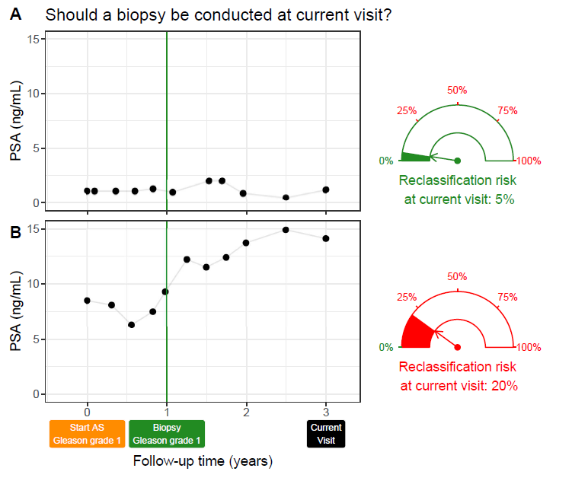\caption{\textbf{Motivation for personalized risk-based decisions of biopsy}: Patient~A (\textbf{Panel~A}) and B (\textbf{Panel~B}) had their latest biopsy at year one of follow-up (green vertical line). Patient~A's prostate-specific antigen (PSA) profile remained stable until his current visit at year three, whereas patient~B's profile has shown a rise. Consequently, patient~B's cumulative risk of reclassification at the current visit (year three) is higher than that of patient~A. This makes patient~B a more suitable candidate for biopsy than Patient~A. Risk estimates in this figure are only illustrative.}

\label{fig:riskBasedExample}

\end{figure}

The first challenge in developing personalized biopsy schedules is consolidating accumulated patient data (e.g., PSA, previous biopsy results) into risk estimates for reclassification. Existing calculators for risk of reclassification~\citep{partin1993use,makarov2007updated} use only the latest PSA measurement of a patient. In contrast, we intend to utilize all repeated measurements of PSA, previous biopsy results, and baseline characteristics of a patient. To this end, a suitable model is the joint model for time-to-event and longitudinal data~\citep{tomer2019, coley2017prediction,rizopoulos2012joint}. A joint model predicts risk of reclassification in a personalized manner. A subsequent challenge, however, is translating risks into clinical decisions. For example, a 10\% risk of reclassification can be perceived high/low depending upon the patient age. Patients may also weigh risks of reclassification with the potential \textit{consequences} of another biopsy. Two relevant \textit{consequences} of biopsies (Figure~\ref{fig:delay_explanation}) are the timing and total number of biopsies (burden), and the time delay in detecting reclassification (smaller is beneficial). The relative importance of these \textit{consequences} can vary between the patients, and also over the follow-up period for the same patient.

The goal of this work is to create a web-application for assisting patients/doctors in making better biopsy decisions during AS than fixed biopsies. Using this web-application, we intend to provide patients their current and future personalized risk of reclassification and risk-based personalized biopsy schedules. To facilitate shared decision making of biopsy schedules, we also aim to provide quantitative estimates of \textit{consequences} for both personalized and fixed schedules. In order to reach a large number of patients, we will use the world's largest AS dataset PRIAS, and Global Action Plan Prostate Cancer Active Surveillance's (GAP3) largest five AS datasets, for development and validation, respectively.