Simprotech Inc.
7375 Rollingdell Drive #41
Cupertino CA 95014 Phone: 408-257-5161 Web: www.simprotech.com Email: info@simprotech.com



ProcesSimO is a software product designed by Simprotech Inc. specifically for drying and evaporation related process simulation. It is developed by a group of internationally recognized professionals using the most advanced software technology, in the world’s technology center, the Silicon Valley.

ProcesSimO 1.0 software package includes 19 unit operations, namely solids dryer, liquid dryer, cyclone, air filter, bag filter, electro-static precipitator, wet scrubber, scrubber condenser, fan, compressor, steam jet ejector, pump, valve, heater, cooler, heat exchanger (which can be used as an evaporator), liquid-vapor separator, mixer and tee. It also includes a logical unit operation, viz. recycle, to simulate recycled gas or material stream, and two utilities, namely, humidity chart and unit converters. The humidity chart utility can be used to visualize either the state of a drying gas or an isenthalpic drying process. The unit converters utility covers all chemical engineering units. In addition to heat/mass/pressure balance calculations in all the unit operations, ProcesSimO also contains a simple dryer scoping model, a detailed cyclone rating model and simple and complex heat exchanger rating models for single phase heat transfer.

ProcesSimO can be used to simulate a drying process, an evaporation process, or a combined evaporation and drying process. Using the unit operations provided by the software, users can construct any drying and evaporation related processes they wish to model, design and analyze. They can explore different arrangements of unit operations and experiment with different operating conditions to optimize their designs and operations.

Since different units may be used in different countries, ProcesSimO has a complete unit conversion system. Users can convert the inputs and outputs of a large flowsheet from one set of units to another with just one click.

Engineers can use ProcesSimO to design drying and evaporation related plants. Based on design requirements they can quickly layout the heat/mass/pressure balance calculations using this software and obtain the necessary process parameters such as the air flow rate of a dryer, the capacity and power input a fan, the heating duty of a heater, etc. They then can choose equipments according to the simulation results. They can also simulate existing plants by easily laying out their existing plant on a flowsheet and input the operating conditions of the plant and see if their operation is efficient or not. Then they can try different operating conditions and optimize their operation.

University professors will find ProcesSimO is an efficient tool for undergraduate and postgraduate students to do projects for chemical engineering/unit operations/ food engineering and related courses. With this software package students can do what-if analysis which otherwise would take unrealistically long time to accomplish. It can also be used as a teaching tool to show students the effects of input parameters on the output parameters for a typical plant.

ProcesSimO is extremely user friendly with an intuitive user interface with maximum protection to prevent users from making simple mistakes. It also has an effective tutorial to teach users step by step how to use the software to simulate typical drying and evaporation related processes. Users of ProcesSimO will require minimal self-training and effort to use it effectively.


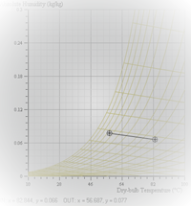

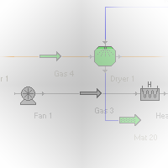
Process Simulation and Optimization

