Simprotech Inc.
7375 Rollingdell Drive #41
Cupertino CA 95014 Phone: 408-257-5161 Web: www.simprotech.com Email: info@simprotech.com



ProcesSimOTM is a software product designed by Simprotech Inc. specifically for drying and evaporation related process simulation. It is developed by a group of internationally recognized professionals using the most advanced software technology, in the world's technology center, Silicon Valley.

ProcesSimO™ 1.0 software package includes 19 unit operations, namely solids dryer, liquid dryer, cyclone, air filter, bag filter, electro-static precipitator, wet scrubber, scrubber condenser, fan, compressor, steam jet ejector, pump, valve, heater, cooler, heat exchanger (which can be used as an evaporator), liquid-vapor separator, mixer and tee. It also includes a logical unit operation, viz. recycle, to simulate recycled gas or material stream, and two utilities, namely, humidity chart and unit converters. In addition to heat/mass/pressure balance calculations in all the unit operations, ProcesSimO™ also contains a simple dryer scoping model, a detailed cyclone rating model as well as simple and complex heat exchanger rating models for single phase heat transfer.

Since different units may be used in different countries, ProcesSimO™ has a complete unit conversion system. Users can convert the inputs and outputs of a large flowsheet from one set of units to another with just one click.

ProcesSimO™ can be used to simulate any drying and evaporation related processes users wish to model, design and analyze, and to explore different arrangements of unit operations and optimize their designs and operations.

Engineers can use ProcesSimO™ to design drying and evaporation related plants. Based on design requirements they can quickly layout the heat/mass/pressure balance calculations using this software and obtain the necessary process parameters such as the air flow rate of a dryer, the capacity and power input of a fan, the heating duty of a heater, etc. They then can choose equipment according to the simulation results. They can also easily layout an existing plant on a flowsheet and optimize its operation.

University professors will find ProcesSimO™ is an efficient tool for undergraduate and postgraduate students to do projects for chemical engineering / unit operations / food engineering and related courses. With this software package students can do what-if analysis which would otherwise take an unrealistically long time to accomplish. It can also be used as a teaching tool to show students the effects of input parameters on the output parameters for a typical plant.

ProcesSimO™ has a friendly and intuitive user interface with maximum protection to prevent users from making simple mistakes. It also has an effective tutorial to teach users step by step how to use the software to simulate typical drying and evaporation related processes. Users of ProcesSimO™ will require minimal self-training and effort to use it effectively.


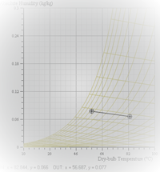

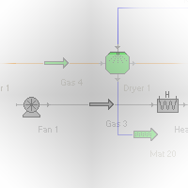
Process Simulation and Optimization

