Software Review

Although drying competes with distillation as the most energy-consuming unit operation, drying related process simulation software was almost completely neglected while several major distillation related process simulation software packages were developed and widely used in industry and academia over the past 20 years.
Drying related process simulation requires intensive calculations of not only the states of moist gas, but also special state variables such as wet-bulb temperature, absolute and relative humidities. Due to the nonlinearity and complexity of these calculations, humidity charts were developed a century ago and have been widely used. It is obviously inadequate in this electronic age for engineers and university students to still hold a ruler on a huge humidity chart to measure and read data for drying related calculations.
ProcesSimO, the world’s first drying centered process simulation software is finally available from Simprotech (www.simprotech.com). It is designed specifically for drying and evaporation related process simulations. With ProcesSimO, engineers and university students are relieved from the hassles of measuring and reading humidity charts.
The ProcesSimO 1.0 software package includes 19 unit operations, namely solid dryer, liquid dryer, cyclone, air filter, bag filter, electro-static precipitator, wet scrubber, scrubber condenser, fan, compressor, steam jet ejector, pump, valve, heater, cooler, heat exchanger (which can be used as an evaporator), liquid-vapor separator, mixer and tee. It also includes a logical unit operation, recycle, to help simulate recycled gas or material stream. Included in ProcesSimO 1.0 are simple dryer scoping, cyclone rating, simple and complex heat exchanger rating for single phase heat transfer.
ProcesSimO 1.0 also includes two utilities namely, humidity chart and unit converters. The humidity chart utility can be used to visualize either the state of a drying gas or an isenthalpic drying process. The unit converters utility covers all chemical engineering units.
ProcesSimO has a complete unit conversion system. Users can convert the inputs and outputs of a large flowsheet from one set of units to another with just one click.
ProcesSimO can be used to simulate a drying process, an evaporation process, or a combined evaporation and drying process. Using the streams and unit operations provided by the software, users can construct any drying and evaporation related processes they wish to model, design and analyze. They can also explore different arrangements of unit operations and experiment with different operating conditions to optimize their designs and operations. It can simulate not only almost any typical drying and evaporation related process but also recycled exhaust gas stream and product material stream in a drying process.
Engineers can use this software package to design drying and evaporation related plants. Based on design requirements they can quickly layout the heat/mass/pressure balance calculations using this software and obtain the necessary process parameters such as the air flow rate of a dryer, the capacity and power input a fan, the heating duty of a heater, etc. They then can choose equipments according to the simulation results. They can also simulate existing plants by easily laying out their existing plant on a flowsheet with this software and input the operating conditions of the plant and see if their operation is efficient or not. Then they can try different operating conditions and optimize their operation.
University professors can use this software as an efficient tool for undergraduate and postgraduate students to do projects for chemical engineering/unit operations/food engineering related courses. With this software package students can do a lot more than what they could do conventionally. It can also be used as a teaching tool to show students the effects of input parameters on the output parameters for a typical plant.
ProcesSimO is extremely user friendly with an intuitive user interface with maximum protections to prevent users to make simple mistakes. It also has an effective tutorial to teach users step by step on how to use the software to simulate typical drying and evaporation related processes.
Users of this software will require minimal training to use it effectively. The typical calculations of a process that may take a skilled engineer several weeks to carry out can now be accomplished in several hours with this software.
Following is a demonstrative example to simulate a combined evaporation and drying process using ProcesSimO.

Problem definition:

Liquid material of 5000 kg/hr flow rate is initially at a mass concentration of 0.13 kg/kg and a temperature of 3 ºC. It needs to be concentrated to a mass concentration of 0.57. Concentration process needs to be performed at around atmospheric pressure. After the liquid material is concentrated it needs to be dried firstly in a spray dryer and then in a vibrated fluid bed dryer. The drying air of the spray dryer needs to be at 103.2 kPa and 140 ºC. The exhaust air is at 68 ºC and material moisture content is 0.08 kg/kg (wet basis) from the spray dryer. The drying air of the vibrated fluid bed dryer needs to be at 103.2 kPa and 85ºC. The exhaust air is at 55 ºC. Material outlet from the fluid bed dryer is at 52 ºC and 0.03 kg/kg (wet basis) moisture content.
Concentration of the material can be achieved by a two-effect falling film evaporation process. The secondary steam from the first effect evaporator is compressed with a thermal pump as heating steam of the second effect evaporator.

Problem solution:

Using ProcesSimO, the flowsheet layout for this design problem is displayed in Figure 1. The simulation results of this flowsheet are displayed in Figure 2.

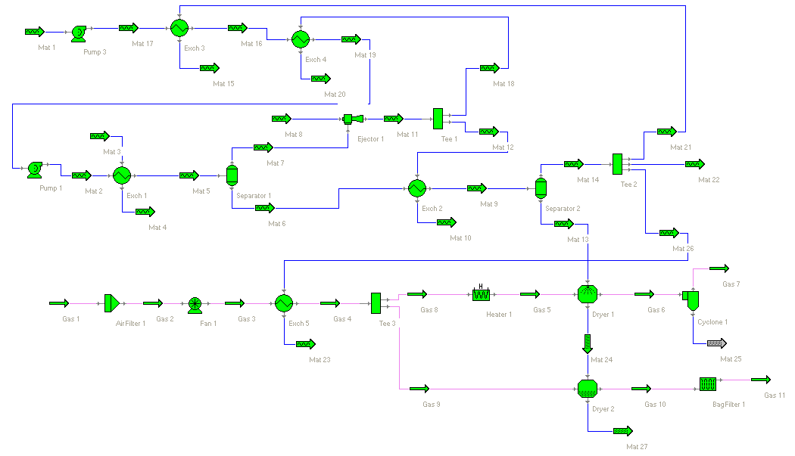
Figure 1

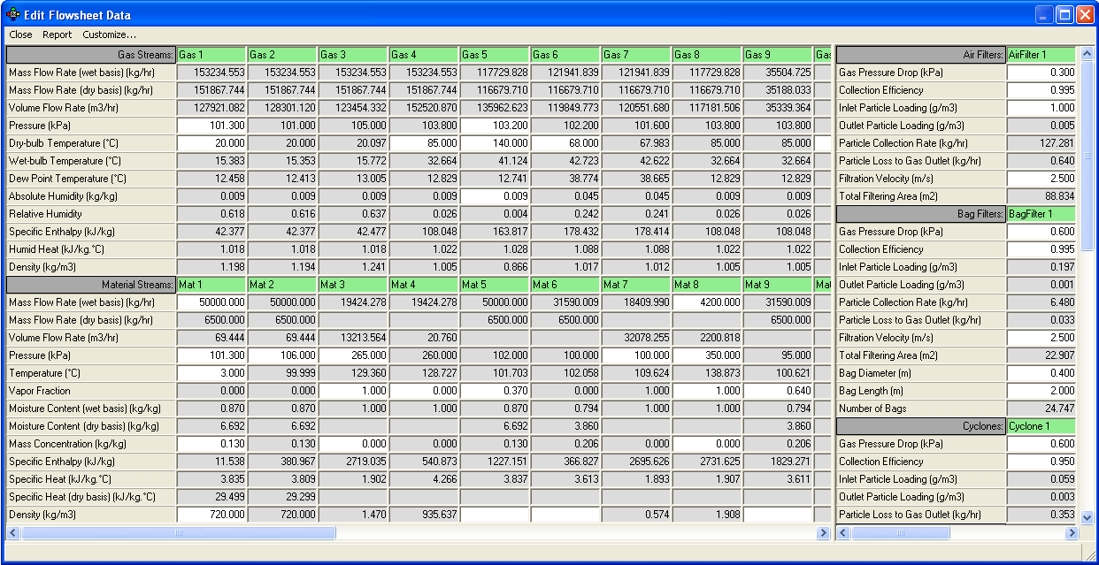

Figure 2

For details about this demonstrative example, please try the beta version of ProcesSimO from www.simprotech.com.

