Introduction

Both drying and evaporation are energy intensive processes. Designing and operating these processes in an efficient way is of economical importance due to especially recent long lasting high energy price. Simulation is an effective means to optimize these processes.

Process simulation related to drying involves intensive calculations of the states of moist air. Due to the nonlinearity and complexity of these calculations, humidity charts were developed a long time ago and has been widely used. It is very much out of synchronization for engineers and university students to still hold a ruler measuring and reading data on a huge humidity chart to do drying related calculations at this electronic age. This might be the major reason that a lot of the drying related process designs are without calculations and based on empirical estimations.

In spray drying, evaporation is usually the preprocessing to remove as much water as possible to save energy in the drying process. A combined multi-effect evaporation and drying process contains many unit operations and is quite complex. Different arrangements of the unit operations in such a process can result in significantly different energy efficiency. A process simulation software certainly helps the design and optimization of those processes.

ProcesSimO is designed specifically for drying and evaporation related process simulations. As you will see, it is extremely user-friendly and easy to use. Engineers and university students need little training to use this software package. A process that takes a skilled engineer several weeks to do the typical calculations now takes only several hours with this software package.

In addition, with ProcesSimO it is extremely simple and easy to simulate different arrangements of the unit operations and try different operating conditions to optimize the designs and operations of a process.

ProcesSimO includes a drying gas stream, a drying material stream and 19 unit operations, namely solid dryer, liquid dryer, cyclone, air filter, bag filter, electro-static precipitator, wet scrubber, scrubber condenser, fan, compressor, steam jet ejector, pump, valve, heater, cooler, heat exchanger (which can be used as an evaporator), liquid-vapor separator, mixer and tee. It also includes a logical unit operation, recycle. Humidity chart and chemical unit converters are also included as utilities. The humidity chart can be used to visualize either any state of a drying gas or an isenthalpic drying process. The chemical unit converters cover almost all possible chemical engineering units.

Users can use drying streams (either gas or material) as input and output of a unit operation. They can use the streams and unit operations as basic building blocks to construct any drying and evaporation related processes they like to model and design.

Version 1.0 of the software package covers the air-water system and mainly for heat and mass balance calculations. Extension to other gas-moisture systems and superheated steam-water systems, to drying related equipment rating as well as to dryer (and its related) equipment selection will be provided in future releases. Included also in the initial first release is simple scoping of dryer, rating of cyclone, simple and complex heat exchanger rating for single phase heat transfer.

The software package can either be used to model a drying process or an evaporation process or a combined evaporation and drying processes.

The software package has a complete unit conversion system. Users can convert the input and output from one set of units to another set of units with only one click.

Tutorial

Starting the application you will see the window below. We call the white space in the window a flowsheet.

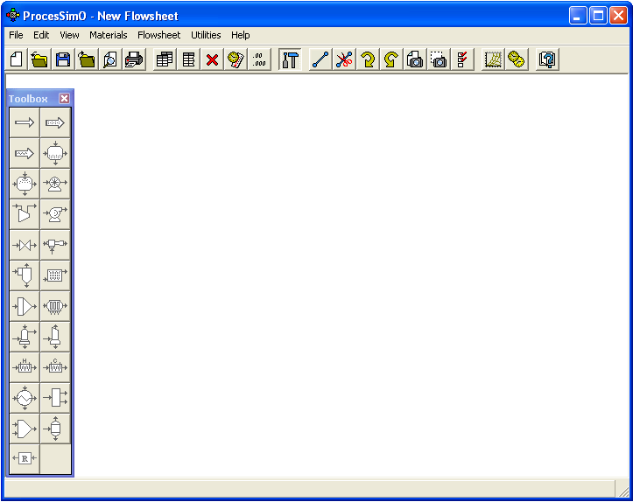

New Flowsheet

You can click the “New Flowsheet” () button to create a new flowsheet. Before creating a new flowsheet you should go to Materials | New Process Settings to select a predefined material and a predefined gas (gas currently is not selectable) for the new floowsheet. After a new flowsheet is created you can model any processes composed of the unit operations available in this application. You can also go to File | New to create a new flowsheet.

Open Flowsheet

You can click the “Open Flowsheet” () button to open a saved flowsheet. An open file dialog will be brought up and you can select any saved file and open it. After the file is open you can continue working on your modeled process by either adding or removing unit operations. You can also change whatever specified variable values to let the software recalculate the process. You can save the changed process either in the same file or in another file by giving a different file name. You can also go to File | Open to open a previously saved flowsheet.

Save Flowsheet

You can save any finished or unfinished process in a file by clicking the “Save Flowsheet” () button. A save dialog is brought up and you can input a name and save the flowsheet as a file. You can also go to File | Save to save current flowsheet.

Close Flowsheet

You can click the “Close Flowsheet” () button to close current flowsheet. If current flowsheet has changes that are not saved yet, you will be prompted to save the changes.

Print Preview

Print

This is the “Unit System Editor” button. Clicking this button will bring up a dialog where you can select a predefined set of units or you can define a named set of units by clicking “Add” and then “Edit” button in the dialog. You can select whatever unit you like for each physical quantity. You can also bring up the same dialog by clicking Edit | Application Preferences’ Unit Systems Tab.

Whenever you want to change the units of the variables in the whole application you can select a predefined unit system and set as current unit system by clicking “Set Current” button. After a new unit system is set current all variable values currently displayed on the UI will be transformed to new values according to the new unit system. All variables to be displayed within the whole application will also be displayed according to the new unit system.

This is the Numeric Format button. Clicking this button will bring up the Numeric Format editor where you can change the numeric format of the displayed variable values You can either choose “Fixed Point” or “Scientific”. You can also choose the Decimal Places for the numeric format you choose. After a new format is selected all variable values currently displayed on the UI will be redisplayed according to the format. You can also bring up this editor by clicking Edit | Application Preferences’ Numeric Format Tab.

This is the “Flowsheet Data Editor” button. Clicking this button will bring up the flowsheet data editor that includes the data tables of all streams and unit operations in the workspace (or flowhseet). You can specify variables within the flowsheet data editor. When all the necessary variables are specified and solving condition is met, the application will automatically solve the process and update the system editor with the calculated results. You can also bring up the same flowsheet data editor by clicking “Edit | Flowsheet Data” menu item.

Flowsheet data editor is generally used after a flowsheet has been fully established to study the effects of different design and operating conditions, e.g. the effects of different inlet temperature or humidity value on a whole process.

You can customize the flowsheet data editor to include/exclude any streams and unit operations in the editor. To customized the flowsheet data editor you need to go to “Customize…” menu on the top of the flowsheet data editor to bring up the “Customize Flowsheet Data” dialog to check/uncheck the streams and unit operations you want to include/exclude.

This is the “Selected Flowsheet Data Editor” button. Clicking this button will bring up the Selected Flowsheet Data Editor. You can customize the editor to include/exclude any variables in the flowsheet.

This editor is also generally used after a flowsheet has been fully established to study the effects of different design and operating conditions.

You can specify the values of the specified variables within this editor. When all the necessary variables are specified and solving condition is met, the application will automatically solve the process and update this editor with calculated results. You can also bring up the same editor by clicking “Edit | Selected Flwosheet Data” menu item.

To study the effects of specified variables on some other calculated variables you can use the flowsheet data editor if the fhowsheet you are modeling is not so large. In the case of a large flowhseet, the flowsheet data editor may contain too many variables. In this case you can use the Selected Flowsheet Data Editor.

This is the “Delete” button. Select a unit (either a stream or a unit operation) or make a multiple selection and hit this button. The selected stream(s) and/or unit operation(s) will be deleted from the flowsheet. You can also delete selected items by clicking “Edit | Delete” menu item after the selection is made.

This is the “Toolbox” button. Clicking this button will bring up the toolbox that includes the stream and unit operation creation buttons. Press down (click) any button in this toolbox and then move the mouse to the flowhseet and do another click. This will generate a stream or a unit operation depending on whatever you clicked in the toolbox. You can bring up the same Toolbox by clicking “View | Toolbox” menu item. You can also add a stream or a unit operation by clicking “Flowsheet | Add | Unit Operations, Streams…”

This is the “Connect” toggle button. Press down (click) this button and then click a stream and then a connection port (such as middle of the left or the right border of the Fan icon) of a unit operation. This will connect the stream to the unit operation. Of course if the connection port has already got a connection you are not allowed to make another connection to the same port. You can also add a connection between a stream and a unit operation by clicking “Flowsheet | Connect”

This is the “Disconnect” toggle button. Press down this button and then click on a connection between a stream and a unit operation. This will disconnect the stream from the unit operation. You can also disconnect a stream from a unit operation by clicking “Flowsheet | Disconnect” and then clicking on a connection between a stream and a unit operation.

This is the “Clockwise Rotation” button. Selecting a stream and clicking this button will rotate the stream icon clockwise. You can do the same thing by clicking “Flowsheet | Rotate Stream | Clockwise”. Please note you cannot rotate a unit operation icon.

This is the “Counterclockwise Rotation” button. Selecting a stream and clicking this button will rotate the stream icon counterclockwise. You can do the same thing by clicking “Flowsheet | Rotate Stream | Counterclockwise”

This is the “Save Flowsheet as Image” button. Clicking this button will bring up a dialog to save the flowsheet as a JPEG, BMP, GIF, PNG or TIFF file. You can do the same thing by clicking “Flowsheet | Snapshot | Flowsheet…”

This is the “Snapshot Selection” button. After clicking this button you can drag the mouse on the flowsheet to select an area that can be saved as an image. After making the selection (by releasing the mouse) a dialog will pop-up asking you to save the selection as a JPEG, BMP, GIF, PNG or TIFF file. You can do the same thing by clicking “Flowsheet | Snapshot | Selection”

This is the “Flowsheet Options” button. Clicking this button will bring up the flowsheet preferences for you to select. You can bring up the preferences by clicking “Flowsheet | Options.

This is the “Humidity Chart” button. Clicking this button will bring up the humidity chart where you can either select the “Unspecified”, “One state” or “Process” radio buttons. Clicking “One State” button will bring up a drying gas state variable table where you can specify one temperature and one humidity. Then the rest of the variables will be calculated automatically and the state of the gas will be shown on the humidity chart. You can also drag the Icon in the chart to anywhere you like and the data table will be updated according to the location of the state icon. You can bring up this utility from Utilities | Humidity Chart.

This is the “Unit Converter” button. Clicking this button will bring up the unit converter where you can do unit conversions for any chemical quantities available in this software package. You can bring up this utility from Utilities | Humidity Chart.

This is the User’s Manual button.

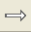

Gas stream
You can create a drying gas stream by pressing down (clicking) in the toolbox and then clicking wherever you want the stream to be located in the workspace (flowsheet). You can double click the stream icon and bring up the editor of the stream. You can input the pressure, one temperature (either the dry bulb temperature or the wet bulb temperature) and one humidity (either the humidity or relative humidity). Then the software will automatically calculate all the other variables and update the editor with the calculated result. User can also input either a mass flow rate or a dry base mass flow rate or volume flow rate. The software will automatically calculate the rest of the flow rate variables and update the editor with the calculated result.

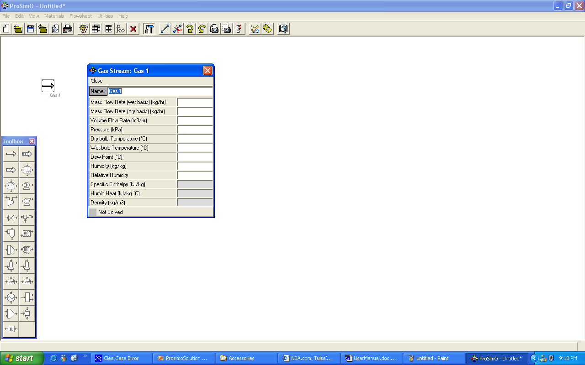

Material stream

You can create a solid drying material stream by pressing down the solid material stream button () in the toolbox and then clicking wherever you want the stream to be located in the workspace (flowsheet). You can double click the stream icon and bring up the editor of the stream. You can input one moisture content (either the dry basis one the wet basis one). Then the software will automatically calculate the other moisture content and update the editor with the calculated results. User can also input either a mass flow rate or a dry basis mass flow rate or volume flow rate. The software will automatically calculate the rest of the flow rate variables and update the editor with the calculated results.

User can also create a liquid drying material stream by pressing down the solid material stream button (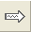) in the toolbox and then clicking wherever you want the stream to be located in the workspace (flowsheet). When a liquid material stream is created the user can input the pressure, temperature and mass concentration of the material and the software will calculate the rest of the variables including vapor fraction, moisture contents and update the editor with the calculated result.

Solid Dryer
You can create a solid dryer by pressing down the solid dryer button (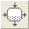) in the toolbox and then clicking wherever you want the stream to be located in the workspace (flowsheet). You can double click the solid dryer icon and bring up the editor of the solid dryer. You can specify the material input and output such as mass flow rate, temperature, and moisture content and the drying gas input and some of the output variables and leave two variables to be calculated. The software will automatically calculate the rest of the variables.

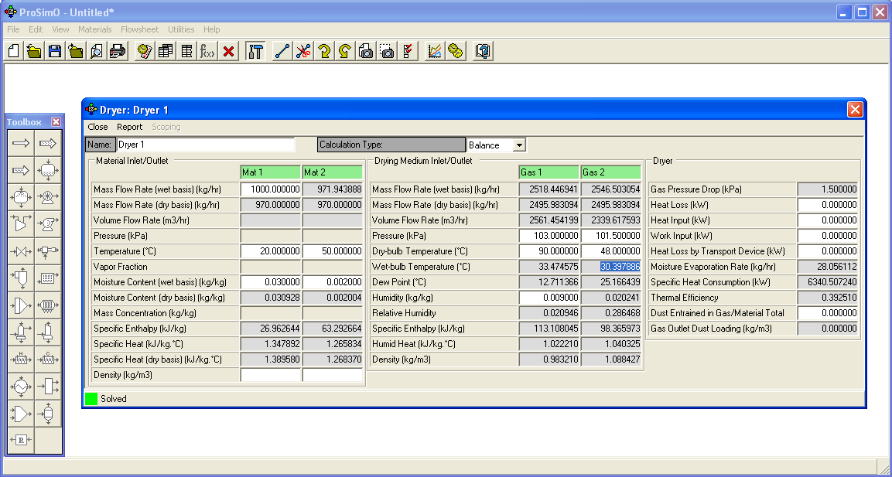

Liquid Dryer
You can create a liquid dryer by pressing down the liquid dryer button (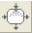) in the toolbox and then clicking wherever you want the stream to be located in the workspace (flowsheet). You can double click the liquid dryer icon and bring up the editor of the dryer. You can specify the material input and output such as mass flow rate, temperature, and moisture content and the drying gas input and some of the output variables and leave two variables to be calculated. The software will automatically calculate the rest of the variables.

Fan
You can create a fan by pressing down the fan button (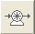) in the toolbox and then clicking wherever you want the stream to be located in the workspace (flowsheet). You can double click the fan icon and bring up the editor of the fan. You can input pressure, one temperature (wither the dry bulb temperature or the wet bulb temperature) and one humidity (either the humidity or relative humidity) in the input stream and specify the pressure of the output stream. Then the software will automatically calculate state of the output stream. The user can input the fan efficiency and the outlet diameter and the software will automatically calculate the power input.

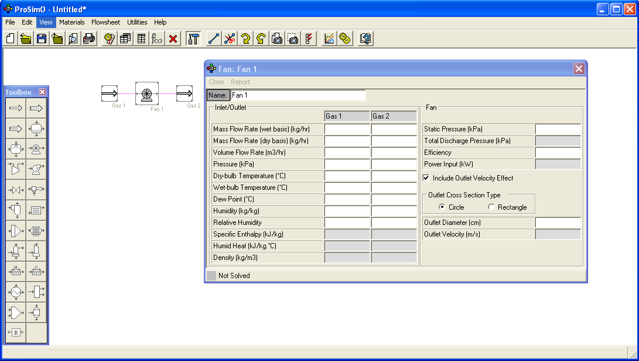

A Combined Heater and Dryer

Create a heater first and then delete the outlet of the fan. Then create a dryer. Press down the “Connect” button. Then click the inlet gas stream of the dryer and then click the mid of the left border of the fan icon (the connection port). The heater and the dryer are connected. You can also connect the heater and the dryer by clicking the fan connection port first and then clicking the dryer inlet gas stream. You can edit the inlet and outlet of the heater and dryer one by one. You can also bring up the global system editor to input variable values.
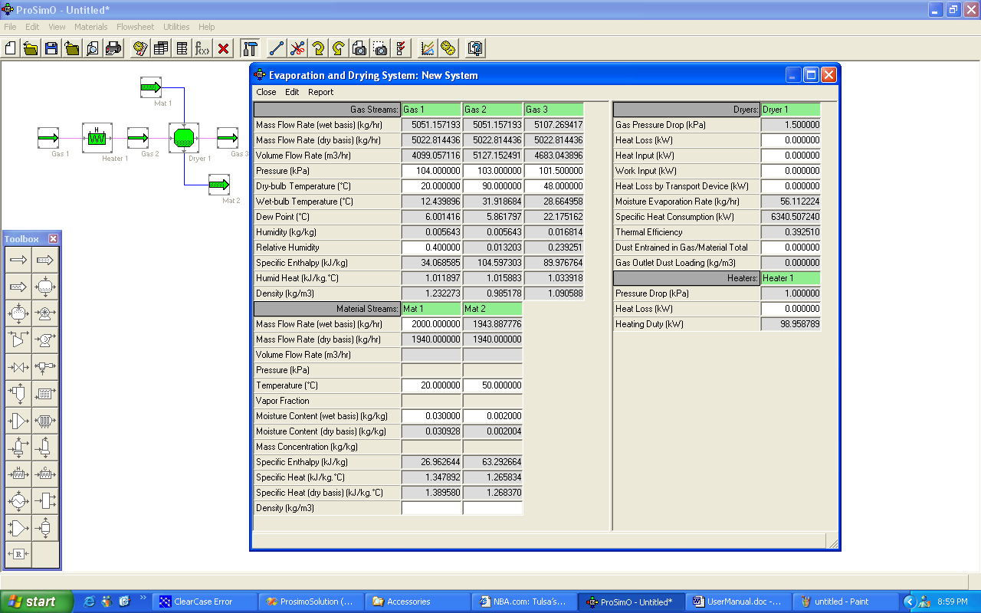

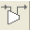

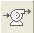

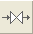

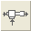

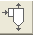

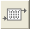

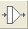

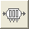

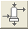

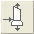

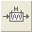

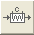

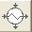

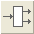

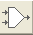

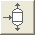

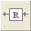

Using Recycle

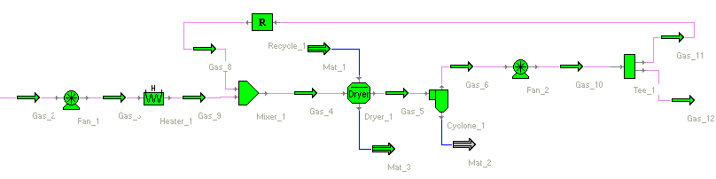

If you want to recycle a portion of the exhaust gas you can split the exhaust gas into two streams using a tee. Then attach the recycled stream to the inlet of the recycle (). Create another stream and attach it to the outlet of the recycle and then mix the outlet from the outlet of the recycle with the fresh gas in the mixer.

Customize Units

Whenever you want to create your own unit system you can go to Edit | Application Preferences’ Unit Systems Tab and first duplicate a unit system by selecting an existing unit system in the left list box on this tab and then click “Duplicate” button. A newly duplicated unit system will be added to the list box. Select the newly duplicated unit system and click “Edit” button the Edit Unit System dialog will be brought up. In this dialog you can edit you unit system’s name and each variable’s unit.

Humidity Chart

You can go to Utilities | Humidity Chart to bring up the humidity chart. From this humidity chart utility you can either visualize any one state of the drying gas or visualize an isenthalpic process of the drying air.

Unit Converter

You can go to Utilities | Unit Converter to convert a variable value from one unit to another.

