Simprotech Inc.
7375 Rollingdell Drive #41
Cupertino CA 95014 Phone: 408-257-5161 Web: www.simprotech.com Email: info@simprotech.com



ProcesSimO is a software product designed by Simprotech Inc. specifically for drying and evaporation related process simulation. It is developed by a group of internationally recognized professionals using the most advanced software technology, in the world’s technology center, Silicon Valley.

The ProcesSimO software package includes a drying gas stream, a drying material stream and 19 unit operations, namely solid dryer, liquid dryer, cyclone, air filter, bag filter, electro-static precipitator, wet scrubber, scrubber condenser, fan, compressor, steam jet ejector, pump, valve, heater, cooler, heat exchanger (which can be used as an evaporator), liquid-vapor separator, mixer and tee. It also includes a logical unit operation, recycle, to help simulate recycled gas or material stream. Included in the first release of ProcesSimO are: simple dryer scoping, cyclone rating, simple and complex heat exchanger rating for single phase heat transfer.
A humidity chart and unit converters are also included in ProcesSimO as utilities. The humidity chart utility can be used to visualize either the
state of a drying gas or an isenthalpic drying process. The unit converters utility covers all chemical engineering units.

ProcesSimO can be used to model a drying process, an evaporation process, or a combined evaporation and drying process. Using the streams and unit operations provided by the software, users can construct any drying and evaporation related processes they wish to model, design and analyze. They can also explore different arrangements of unit operations and experiment with different operating conditions to optimize their designs and operations.
ProcesSimO has a complete unit conversion system. Users can convert the inputs and outputs of a large flowsheet from one set of units to another with just one click.
Version 1.0 of ProcesSimO currently covers only the air-water system and is used mainly
for heat and mass balance calculations. Extension to other gas-organic liquid systems, to
superheated steam drying, to drying related equipment rating as well as to equipment
selection will be provided in future releases.

Engineers and university students will require minimal training to use this
software package effectively. The typical calculations of a process that
may take a skilled engineer several weeks to carry out, can now be
accomplished in several hours with ProcesSimO.


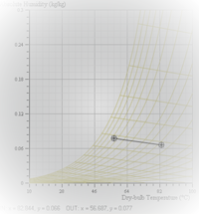

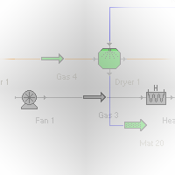
Process Simulation and Optimization

