Examples

Example 1 - Drying Gas Stream

Problem 1

Moist air has the following conditions:

Pressure = 1 atm
Dry-bulb Temperature = 25 ºC
Absolute Humidity = 0.009 kg/kg dry air

Calculate wet-bulb temperature, dew point temperature, relative humidity, humid heat, humid volume, specific enthalpy and density.

Solution Steps:

- Start Simprosys. By default, a new empty flowsheet is created with the default material of the software.
- Go to Edit | Unit Systems. Select SI-3 and click “Set Current” button to set SI-3 unit system as the current unit system. Then close the dialog.
- Create a drying gas stream on the flowsheet and double click the icon of the stream to bring up the stream’s editor.
- Input 1.0 atm at the Pressure field.
- Input 25 ºC at the Dry-bulb Temperature field.
- Input 0.009 kg/kg in the Absolute Humidity field
- After the enter key of last input is hit, wet-bulb temperature, dew point temperature, relative humidity, humid heat, humid volume and specific enthalpy are automatically calculated and displayed on the stream editor as in Figure 1.1.

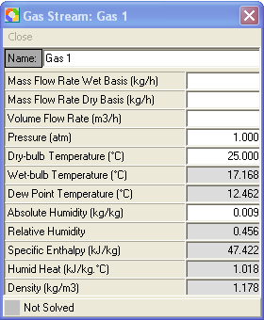

Figure 1.1

Problem 2

Moist air has the following conditions:

Pressure = 1 atm.
Temperature = 25 ºC.
Absolute Humidity = 0.009 kg/kg.
Mass Flow Rate (wet basis) = 1000 kg/hr.

Calculate the wet-bulb temperature, dew point temperature, relative humidity, humid heat, humid volume, specific enthalpy, density, mass flow rate (dry basis) and volume flow rate.

Solution Steps

- Follow the solution steps 1 through 6 in problem 1.
- Input 1000 kg/hr in Mass Flow Rate (wet basis) field
- After the enter key of the last input is hit, the stream is completely solved and the result is as shown in Figure 1.2.

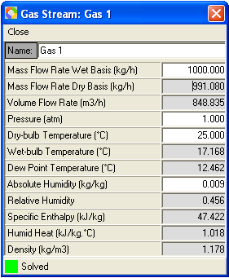

Figure 1.2

Summary

- When pressure, one of the temperatures (either Dry-bulb Temperature, or Wet-bulb Temperature or Dew Point Temperature), and one of the humidities (either Absolute Humidity or Relative Humidity) are know, the state of the moist air is determined and can be calculated, and therefore all the thermal physical properties at this state can also be calculated and automatically displayed on the stream’s editor.
- When one of the flow rates (either Mass Flow Rate (wet basis), or Mass Flow Rate (dry basis), or Volume Flow Rate) is know and the state of the moist air is determined, the other flow rates are automatically calculated and displayed on the stream editor.

Example 2 - Solid Dryer

Problem 1

Material has the following conditions:

Type: solid particles
Feed moisture content = 0.03 kg/kg wet basis.
Feed temperature = 20 ºC.
Product moisture content = 0.002 kg/kg wet basis.
Product temperature = 50 ºC.
Specific heat of the absolute dry material = 1.26 kJ/kg.ºC.
Mass flow rate wet basis = 2000 kg/hr.

Drying air has the following conditions:

Pressure at dryer inlet = 103.2 kPa.
Dry-bulb temperature at dryer inlet = 90 ºC
Absolute Humidity at dryer inlet = 0.009 kg/kg
Dry-bulb temperature at dryer outlet = 48 ºC
Pressure drop of air in dryer = 1.2 kPa

Calculate how much drying air is needed as well as what is the outlet humidity of the drying air.

Solution Steps

- Start Simprosys. A new empty flowsheet is created with the default material of the software by default.
- Go to Materials | Drying Materials to bring up the “Drying Materials” dialog. Click “Add” button to add a new drying material. In the “Name” field, change the name to “Generic Drying Material”. Input 1.26 in the “Specific Heat of Absolute Dry Material” field. Then click “OK” button and then close the “Drying Materials” dialog.
- Go to File | Close to close the current empty flowsheet.
- Go to Materials | New Flowsheet Settings to bring up the New Flowsheet Settings dialog. Select “Generic Drying Material” in the Select Drying Material list box. Then click “Set” button to set this material as the drying material of the new flowsheet to be created. Close this dialog.
- Edit | Unit Systems to select SI-2 and click “Set Current” button to set SI-2 unit system as the current unit system. Close this dialog.
- Go to File | New to create a new empty flowsheet.
- Create a solid dryer on the flowsheet and double click the icon of the dryer to bring up the dryer’s editor.
- Input in “Mat 1” column 2000 kg/hr in the Mass Flow Rate (wet basis) field, 20ºC in the Temperature field and 0.03 kg/kg in the Moisture Content (wet basis) field.
- Input in “Mat 2” column 50ºC in the Temperature field and 0.002 kg/kg in the Moisture Content (wet basis) field.
- Input in “Gas 1” column 103.2 kPa in the Pressure filed, 90 ºC in the Dry-bulb Temperature field and 0.009 kg/kg in the Absolute Humidity field.
- Input in “Gas 2” column 48 ºC in the Dry-bulb Temperature field.
- Input in “Gas Pressure Drop” field of the Dryer group box 1.2 kPa.
- After the enter key of the last input is hit, the dryer is solved and all the calculated variable values are displayed as is shown in Figure 2.1.

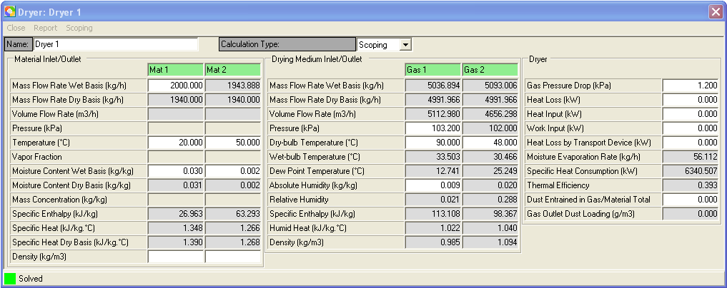

Figure 2.1

Problem 2

All conditions are the same as those in Problem 1 except that the outlet gas relative humidity is known as 0.288 rather than the outlet air temperature is known.

Solution Steps

All the steps are the same as in Problem 1 except that step 11 is replace by the following

- Input in “Gas 2” column 0.288 in the Relative Humidity field.

The calculated results are displayed in Figure 2.2.

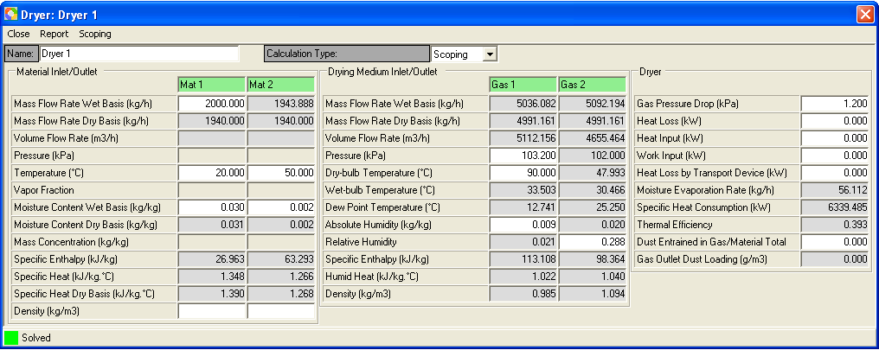

Figure 2.2

Please note that the calculated gas outlet temperature and mass flow rates are slightly different from those in problem 1. This is caused by the truncation error of the outlet Relative Humidity. The more accurate value of the outlet Relative Humidity in problem 1 is 0.28787887 (To see more decimal digits of each field in the dryer’s editor you need to go to Edit | Numeric Format tab’s Decimal Places field to increase decimal digits).

Problem 3

All conditions are the same as in problem 1 except that inlet gas mass flow rate (wet basis) is known as 5036.894 kg/hr rather than the outlet gas temperature is known.

Solution Steps

All the steps are the same as in Problem 1 except that steps 10 and 11 are replace by the following one step

- Input in “Gas 1” column 5036.894 kg/hr in Mass Flow Rate (wet basis), 103.2 kPa in the Pressure filed, 90 ºC in the Dry-bulb Temperature field and 0.009 kg/kg in the Absolute Humidity field.

The calculated results are displayed in Figure 2.3.

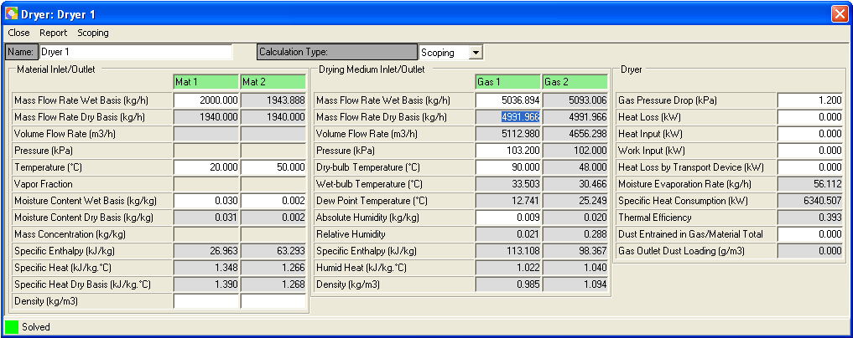

Figure 2.3

Problem 4

This problem is an extension of Problem 1. All material and drying air conditions are the same as in Problem 1.

Suppose this is a rotary dryer. The gas velocity in the dryer is 2.0 m/s. The length to diameter ratio is 8.0. Calculate the dimensions of the dryer using the simple scoping model.

Solution Steps
- After the dryer balance calculation is solved, go to Calculation Type combo box on the dryer’s editor and select “Scoping” entry.
- Click “Scoping” menu on the dryer’s editor to bring up the scoping dialog.
- Select “Circle” for the cross section type because the cross section of a rotary dryer is circular.
- Input in Gas Velocity field 2.0 and in Length/Diameter Ratio field 8.0.
- After the enter key of the last input is hit, the dryer scoping is solved and the calculated variable values are displayed as is shown in Figure 2.4.

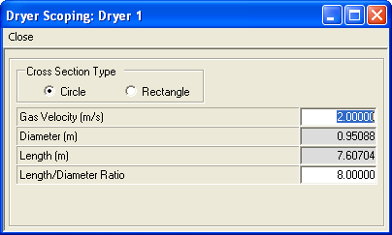

Figure 2.4

Please note that you can change the balance calculation specification and after the changed values are input into the dryer’s editor the calculated dimension variables in the scoping dialog is also automatically updated.

Summary

- If the dryer has heat loss, heat input in addition to the heat from the drying gas, work input and heat loss by transport device for some specific dryers you can input a specified value in each of the corresponding field. The calculation will take them into account.
- In addition to the 3 cases displayed in the 3 examples, you can also know one of the outlet temperatures (either dry-bulb, or web-bulb or dew point) and one of the outlet humidities (either the absolute humidity or the relative humidity) rather than the corresponding inlet variables and satisfy the dryer’s balance calculation conditions and get the dryer solved.

Example 3 - Liquid Dryer

Problem 1

Material is know as follows

Type: liquid solution
Feed mass concentration = 0.58 kg/kg.
Feed temperature = 85 ºC.
Feed pressure = 102 kPa.
Product moisture content = 0.05 kg/kg wet basis.
Product temperature = 65 ºC
Specific heat of the absolute dry material = 1.26 kJ/kg.ºC.
Mass flow rate wet basis = 5000 kg/hr

Drying air has the following conditions:

Pressure at dryer inlet = 103.2 kPa
Temperature at dryer inlet = 120 ºC
Absolute Humidity at dryer inlet = 0.009 kg/kg dry air
Temperature at dryer outlet = 55 ºC
Pressure drop of air in dryer = 1.2 kPa

Calculate how much drying air is needed as well as what is the outlet humidity of the drying air.

Solution Steps

- Save and close current flowsheet if you currently work on a flowsheet. Otherwise start Simprosys and close the new empty flowsheet.
- Go to Materials | New Flowsheet Settings to bring up the New Flowsheet Settings dialog. Select “Generic Drying Material” in the Select Drying Material list box. Then click “Set” button to set this material as the drying material of the new system to be created. Close this dialog. You can neglect this step if you come from Example 2.
- Create a new flowsheet by clicking the first icon in the toolbar or clicking File | New.
- Create a liquid dryer on the flowsheet and double click the icon of the dryer to bring up the dryer’s editor.
- Input in “Mat 1” column 5000 kg/hr in the Mass Flow Rate (wet basis) field, 85ºC in the Dry-bulb Temperature field and 0.58 in the Mass Concentration field.
- Input in “Mat 2” column 55ºC in the Dry-bulb Temperature field and 0.05 in the Moisture Content (wet basis) field.
- Input in “Gas 1” column 103.2 kPa in the Pressure field, 120 ºC in the Dry-bulb Temperature field and 0.009 kg/kg in the Absolute Humidity field.
- Input in “Gas 2” column 55 ºC in the Dry-bulb Temperature field.
- Input in “Gas Pressure Drop” field of the Dryer group box 1.2 kPa.
- After the enter key of last input is hit, the dryer is solved and all the calculated variable values are displayed as shown in Figure 3.

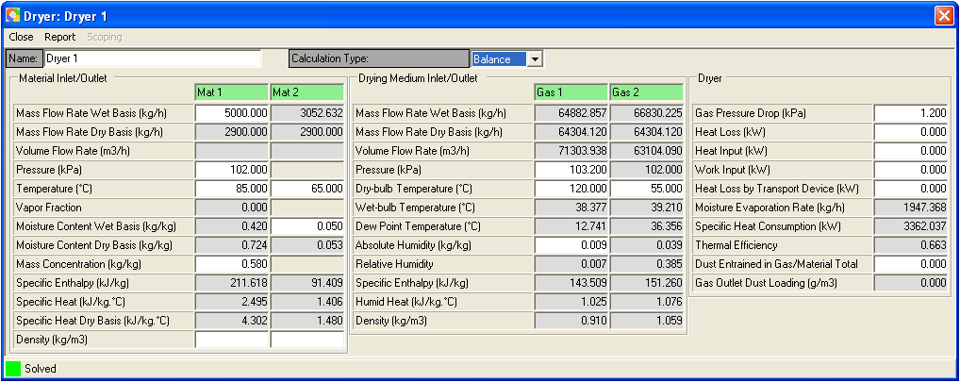

Figure 3

Example 4 – Combined Dryer and Heater

Problem

Material is known as follows

Type: solid particles
Feed moisture content = 0.03 kg/kg wet basis.
Feed temperature = 20 ºC.
Product moisture content = 0.002 kg/kg wet basis.
Product temperature = 50 ºC
Specific heat of the absolute dry material = 1.26 kJ/kg.ºC.
Mass flow rate wet basis = 2000 kg/hr

Drying air has the following conditions:

Pressure at heater inlet = 104 kPa
Temperature at heater inlet = 20 ºC
Absolute Humidity at heater inlet = 0.009 kg/kg dry air
Temperature at heater outlet = 90 ºC
Pressure drop of air in heater = 0.8 kPa
Pressure drop of air in dryer = 1.2 kPa

Calculate the required mass flow rate of the drying air, the thermal energy to heat the air as well as the outlet humidity of the drying air from the dryer.

Solution Steps

- Materials | New Material Settings. Select “Generic Drying Material” and click “Set” button to set this material as the drying material of the to-be-created new flowsheet if you have already created the Generic Drying Material in the material catalog. Otherwise, create the Generic Drying Material and then go to New Material Settings to set it.
- Create a new flowsheet by clicking the first icon in the toolbar or clicking File | New.
- Create a heater on the flowsheet.
- Delete the outlet gas stream of the heater by selecting the stream, right clicking mouse and hitting the “Delete” in the pop-up menu.
- Create a solid dryer.
- Connect the dryer’s gas inlet with the heater outlet port (the center of area on the right side of the heater’s icon)..
- Double click the heater’s icon to bring up the heater’s editor.
- Input in “Gas 1” column 104 kPa in the Pressure field, 20ºC in the Dry-bulb Temperature field and 0.009 kg/kg in the Absolute Humidity field.
- Input in “Gas 2” column 90ºC in the Dry-bulb Temperature field.
- Input in Pressure Drop field of the Heater group box 0.8 kPa.
- Double click the dryer icon to bring up the dryer’s editor.
- Input in “Mat 1” column 2000 kg/hr in the Mass Flow Rate (wet basis) field, 20ºC in the Dry-bulb Temperature field and 0.03 in the Moisture Content (wet basis) field.
- Input in “Mat 2” column 50ºC in the Dry-bulb Temperature field and 0.002 in the Moisture Content (wet basis) field.
- Input “Gas 3” column 48 ºC in the Dry-bulb Temperature field.
- Input in “Gas Pressure Drop” field of the Dryer group box 1.2 kPa.
- After the enter key of last input is hit, both the dryer and the heater are solved and all the calculated variable values are displayed as shown in Figure 4a and 4b.

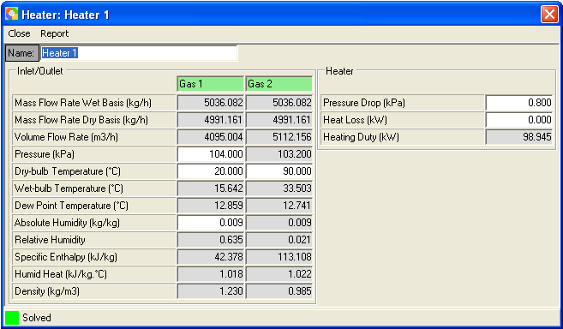

Figure 4a

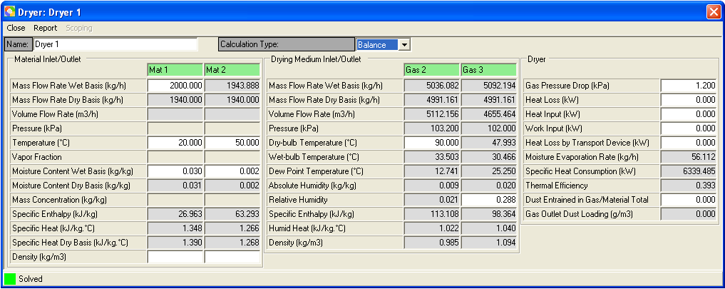

Figure 4b

Alternative Solution Steps

- Following the above solution steps 1 through 6.
- Go to Edit | Flowsheet Data to bring up the global editor
- Input the known values in the gas and material streams’ columns of Gas 1, Gas 2, Gas 3, Mat 1, Mat 2. Input the pressure drop values for the heater and dryer in the Heater 1 and Dryer 1 in the global editor.
- After the enter key of last input is hit, both the dryer and the heater are solved and all the calculated variable values are displayed as shown in Figure 4c.

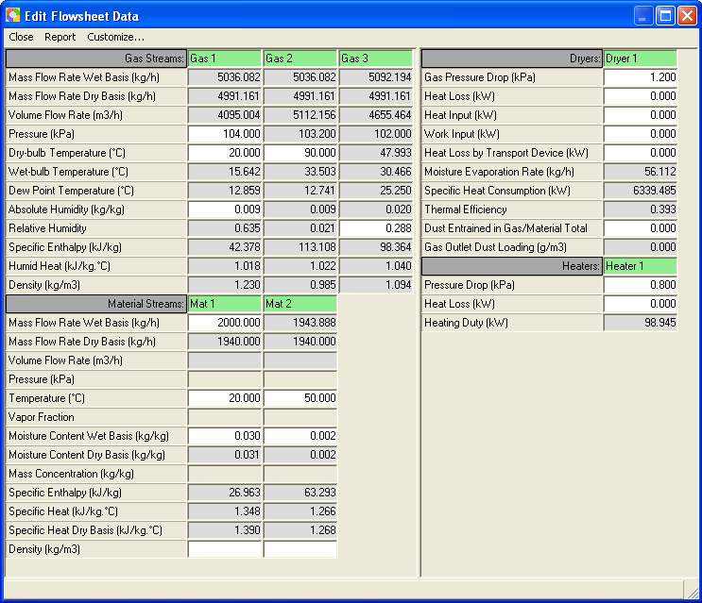

Figure 4c

Tip:

If the Heating Duty of the Heater (Heater 1) is known as 98.961 kJ/s (the same unit as kW) rather than the Temperature of the heater outlet (90 ºC), you can delete the heater’s outlet temperature and then input 98.96 in the Heating Duty field of the heater. You will get the same results for the solved heater and dryer.

Example 5 - A Simple Drying Flowsheet

Problem

Material is known as follows

Type: solid particles
Feed moisture content = 0.05 kg/kg wet basis.
Feed temperature = 20 ºC.
Product temperature = 50 ºC
Product moisture content = 0.002 kg/kg wet basis.
Specific heat of the absolute dry material = 1.26 kJ/kg. ºC.
Mass flow rate wet basis = 2000 kg/hr

Drying air has the following conditions:

Initial pressure = 101.3 kPa.
Initial temperature = 20 ºC.
Initial Absolute Humidity = 0.009 kg/kg
Mass Flow Rate wet basis = 7200 kg/hr

Drying air needs to go through an air filter first. Pressure drop in the air filter is 0.3 kPa. Assume dust volume concentration is 0.1 g/m³, collection efficiency of the air filter is 99.8% and filtration velocity is 2.5 m/s. Drying air then goes through a fan (the efficiency of the fan is 0.7.) to gain 3 kPa static pressure, then through a heater to be heated to 90 ºC before going to the dryer. Pressure drop of air in heater is 0.8 kPa. Pressure drop of air in dryer is 1.2 kPa. The exhaust air entrains 0.1% of the total material. It needs to go through a cyclone to collect the entrained dust material. Collection efficiency of the cyclone is 95%. Pressure drop of the cyclone is 0.6 kPa.

Solution Steps

- Start Simprosys.
- Close current flowsheet if a flowsheet exists.
- Go to Materials | New Flowsheet Settings. Select “Generic Drying Material” and click “Set” button to set this material as the drying material of to-be-created new flowsheet if you have already created the Generic Drying Material in the material catalog. Otherwise, create the Generic Drying Material and then go to New Material Settings to set it.
- Create a new flowsheet by clicking the first icon in the toolbar or clicking File | New.
- Go to Edit | Numeric Format tab to change Decimal Places to 4
- Go to Flowsheet | Options’ group box “Unit Operation Creation” and chose radio button “With Input Only”.
- Create an air filter (AirFilter 1), a fan (Fan 1), a heater (Heater 1), a dryer (Dryer 1), a cyclone (Cyclone 1), a solid material stream (Mat 2) and a gas stream (Gas 6)
- Connect all the pieces created in step 7 together as is displayed in Figure 5a

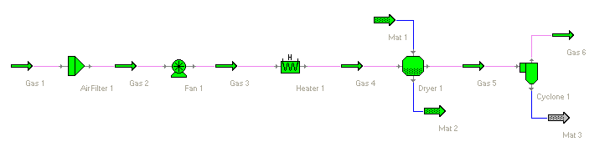
Figure 5a

- Go to Edit | Flowsheet Data to bring up the global editor
- Input all the known values and you will get the results as in Figure 5b.

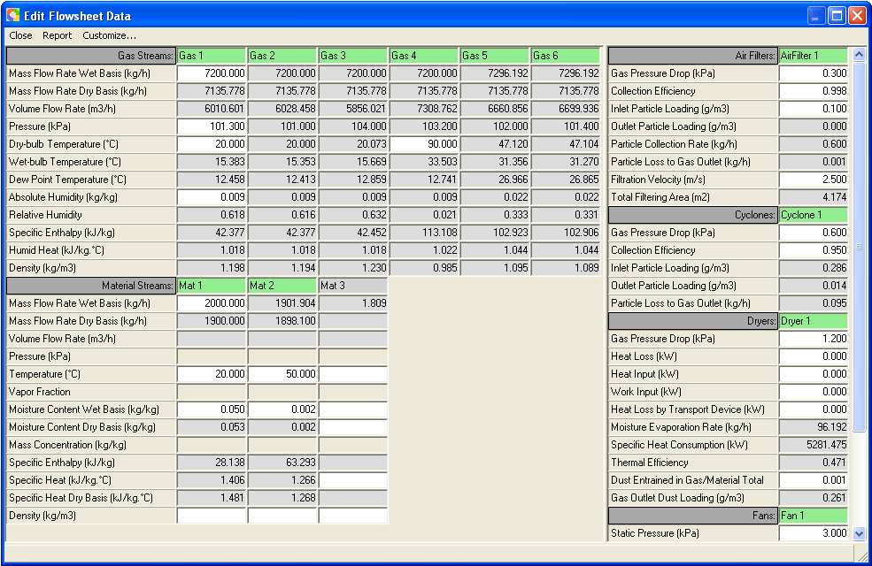

Figure 5b

Example 6 – Recycle Gas Stream

Problem

This is the same problem as in Example 5 except that half of the gas outlet from the cyclone goes through a fan to gain 1.8 kPa static pressure and then is recycled back to the dryer’s gas inlet.

Solution

To model this problem, at first a tee is required to split the gas outlet of the cyclone into two gas streams, one supposed to be discharged into the atmosphere, the other recycled back to the dryer’s gas inlet. You might think that the recycled gas stream can go through a fan to gain the required static pressure (1.8 kPa) and then be mixed through a mixer with the fresh hot gas stream coming out of the heater and introduced into the dyers gas inlet. The possible flowsheet is displayed in Figure 6a.

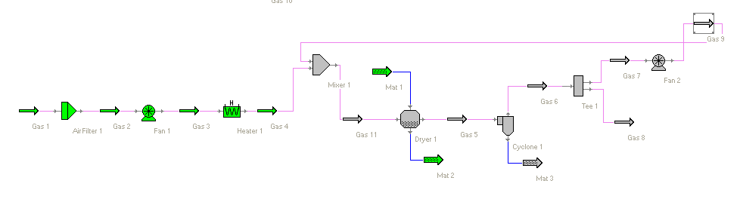
Figure 6a

Such a configuration of the flowsheet can not get the problem solved since it is necessary to know inlet gas conditions to solve the dryer’s outlet gas stream. However, a portion of the dryer’s gas outlet will be recycled as part of the dryer’s gas inlet. This is a nonlinear problem. To solve such a nonlinear problem it is necessary to assume some initial guess values for the recycled stream so that the dryer’s gas inlet is known as to solve the dryer’s gas outlet. This can be achieved by an auxiliary logical unit operation called Recycle.

The constructed flowsheet with the auxiliary recycle is displayed in Figure 6b. With the recycle the flowsheet can be solved through multiple loops of iterations by initially guessing the necessary values of the recycled stream and modifying the guessed values in each loop of iteration until the differences of the guess values between two consecutive loops are small enough to be negligible.

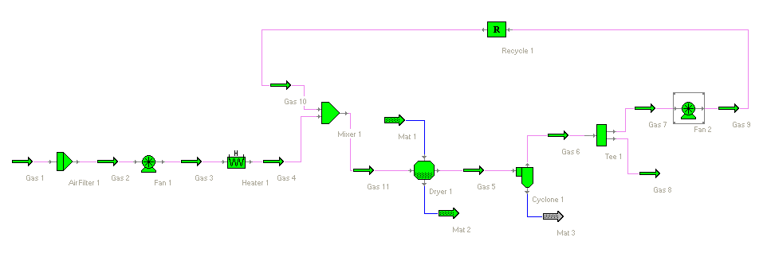
Figure 6b

The solution is shown in the global editor as follows

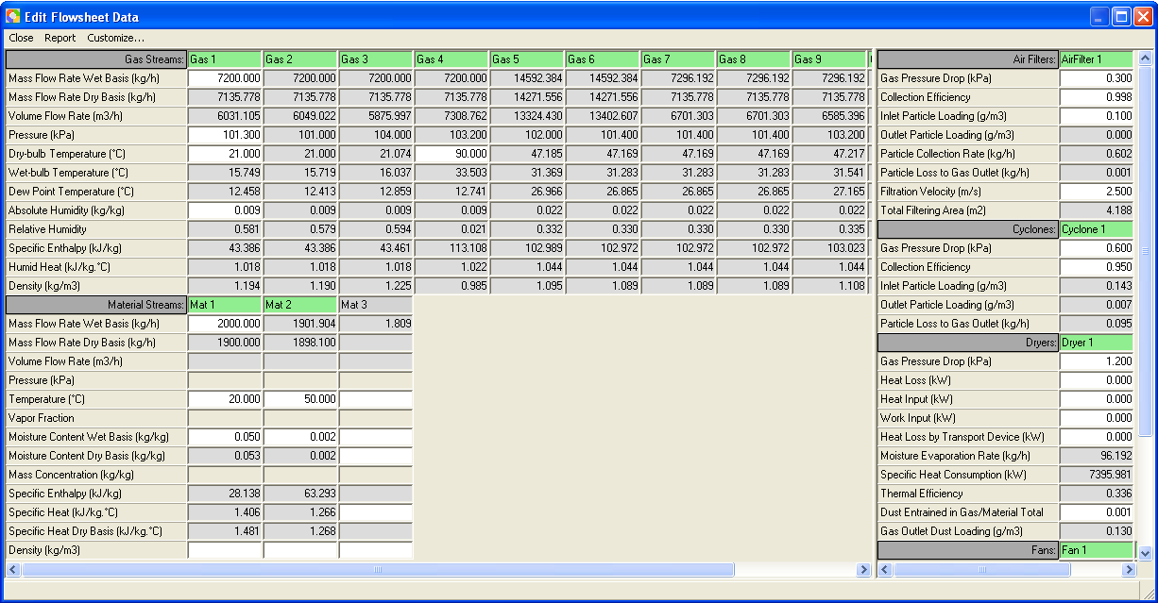

Figure 6b

Example 7 – Recycle Material Stream

Problem

Material is known as follows

Type: solid particles
Initial moisture content = 0.25 kg/kg wet basis.
Initial temperature = 20 ºC.
Product temperature = 75 ºC
Product moisture content = 0.05 kg/kg wet basis.
Specific heat of the absolute dry material = 1.26 kJ/kg. ºC.
Mass flow rate wet basis = 1000 kg/hr

Drying air has the following conditions

Initial pressure = 101.3 kPa.
Initial temperature = 20 ºC.
Initial Absolute Humidity = 0.009 kg/kg
Mass Flow Rate wet basis = 10000 kg/hr

Drying air needs to go through an air filter first. Pressure drop in the air filter is 0.3 kPa. Assume dust volume concentration is 0.1 g/m³, collection efficiency of the air filter is 99.8% and filtration velocity is 2.5 m/s. Drying air then goes through a fan (the efficiency of the fan is 0.7) to gain 3 kPa static pressure, then through a heater to be heated to 110 ºC before going to the dryer. Pressure drop of air in heater and dryer is 0.8 kPa and 1.2 kPa respectively. The exhaust air of the dryer entrains 0.1% of the total material into the dryer’s gas outlet stream. The gas outlet stream needs to go through a cyclone to collect the entrained dust material. Collection efficiency of the cyclone is 95%. Pressure drop of air in the cyclone is 0.6 kPa.

The dryer requires that the feed moisture content (wt basis) can not be greater than 0.15 kg/kg. As is known, initial moisture content (wet basis) of the material is 0.25 kg/kg. One possible solution is to mix a portion of the dried material product with the fresh material to decrease the moisture content to the required level and then feed the dryer.

A tee is required to split the product material into two halves. One half goes through a Recycle and mixes with the fresh material in a mixer and then introduced into the dryer’s material inlet.

Solution

Similar to recycling a gas stream in Example 6, a portion of the dryer’s material outlet stream is recycled in this example. To get this problem solved an auxiliary recycle unit operation is necessary. The flowsheet is constructed as in Figure 7a and the results are shown is Figure 7b.

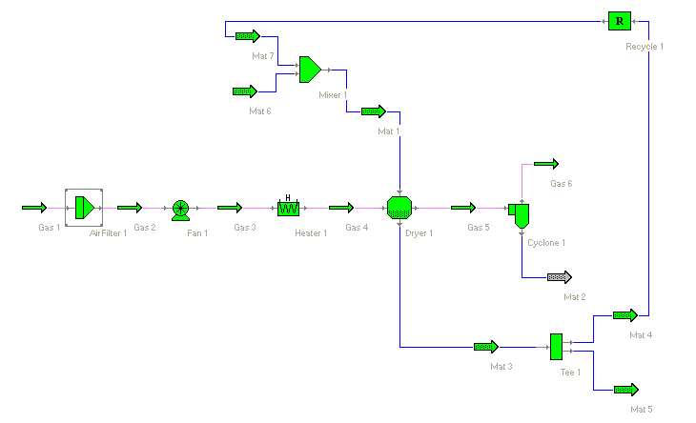
Figure 7a

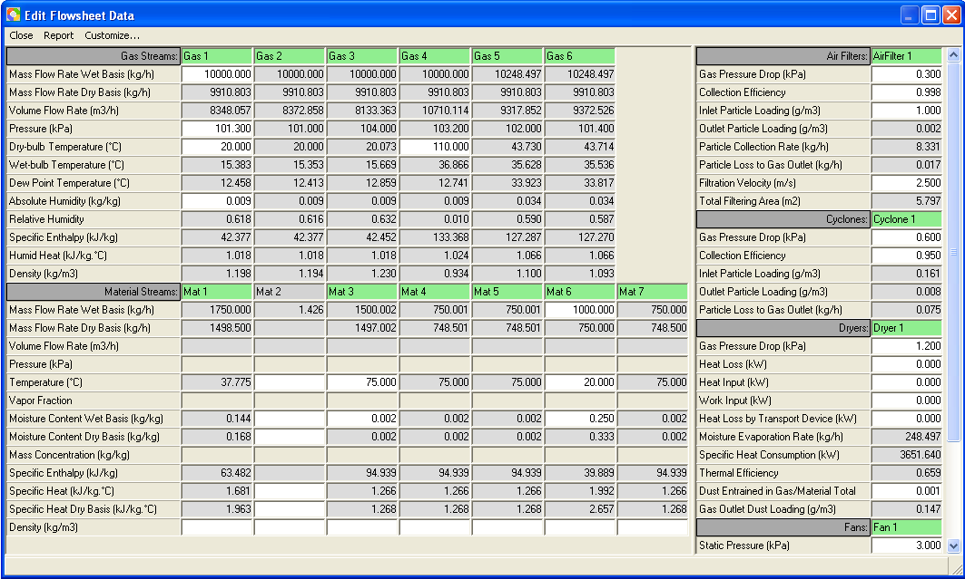

Figure 7b

Example 8 – Enclosed Drying System

Problem

A simple enclosed drying system with the following conditions for both the material and the drying gas

Material:

Feed Temperature = 20 ºC
Feed Moisture Content (wet basis) = 0.08 kg/kg
Mass Flow Rate (wet basis) = 2000 kg/hr
Product Temperature = 50 ºC
Product Moisture Content (wet basis) = 0.002 kg/kg

Drying Air

Pressure at Dryer Inlet = 102.4 kPa;
Temperature at Dryer Inlet = 120 ºC
Mass Flow Rate (wet basis) at Dryer Inlet = 7200 kg/hr

Pressure drop of the dryer is 1.2 kPa. Dust entrained in dryer gas outlet is 0.2% of the total material the dryer handles. Dryer gas outlet stream goes through a fan to gain 1.2 kPa static pressure. Efficiency of the fan is 0.75. Exhaust air coming from the fan goes through a scrubber/condenser to collect the dusts and remove the moisture carried in the exhaust air. Temperature of the exhaust air from the scrubber/condenser is 30 ºC. Air pressure drop in scrubber/condenser is 1.0 kPa. Collection efficiency of the scrubber/ condenser is 99%. The air coming out of the scrubber/condenser goes through a fan to gain some static pressure and then go through a heater to be heated to the required dryer inlet temperature (120 ºC). Pressure drop of air in the heater is 0.6 kPa.

Solution

The flowsheet is constructed and shown in Figure 8a. The result of the flowsheet is displayed in Figure 8b.

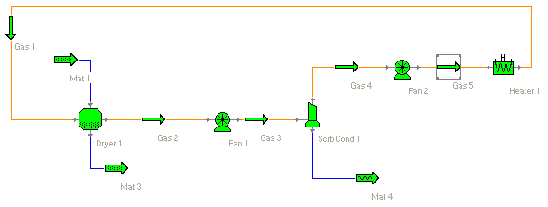
Figure 8a

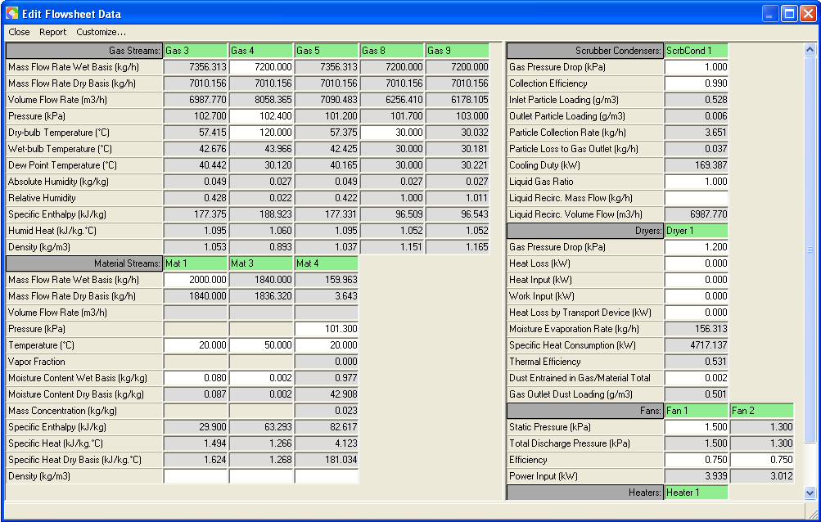

Figure 8b

Example 9 – Evaporation

Problem

Liquid material of 5000 kg/hr flow rate is initially at a mass concentration of 0.13 kg/kg and a temperature of 3 ºC. It needs to be concentrated to a mass concentration of 0.57. Material density is 720 kg/m³ at room temperature. Concentration process needs to be performed at around atmospheric pressure. Specific heat of the material without moisture is 1.26 kJ/kg. ºC. The boiling point rise of the material can be described by the following duhring lines expressed in a Table 1

Mass concentration  (kg/kg) | Start Boiling Point (ºC) |  | End Boiling Point (ºC)
Mass concentration  (kg/kg) | Solvent | Solution | Solvent | Solution
0.0 | 50 | 50 | 200 | 200
0.2 | 50 | 52 | 200 | 203
0.4 | 50 | 55 | 200 | 207
0.6 | 50 | 59 | 200 | 212

Table 1. Duhring Lines of Example 9

Solution

This can be achieved by a two-effect falling film evaporation process. The initial liquid material is first preheated using part of the secondary vapor from the second effect evaporation to about 85 ºC. Then part of the thermally compressed secondary vapor from the first effect is used to further heat the material to nearly the bubble point of the material. It then goes to the first falling film evaporator operating at a pressure of 106 kPa. Water vapor of 265 kPa is used as the heating medium for this evaporator. Vapor and liquid material mixture coming out of the first evaporator goes to a liquid-vapor separator to separate the concentrated liquid with the vapor. Secondary vapor coming out of the separator is compressed with a fresh vapor at 350 kPa using a steam jet ejector. A very small potion of the compressed vapor is used to preheat the feeding material. The majority is used as the heating medium of the second effect evaporation. The second evaporator is operating at 100 kPa. Liquid vapor mixture coming out of the second evaporator goes to another liquid-vapor separator to separate the concentrated liquid material with the vapor. As is mentioned above part of the secondary vapor coming out of the separator is use to preheat the feeding material.

A falling film evaporator can be taken as a heat exchange with phase changes. Therefore, a heat exchanger can be used to model an evaporator. The to-be-concentrated material is at the cold side of the heat exchanger. The heating steam is at the hot side of the exchanger.

Solution Steps:

- Start Simprosys.
- Go to Materials | Drying Materials to bring up the “Drying Materials” dialog. Click “Add” button to add a new drying material. In the “Name” field change the name to “Generic Evaporation Material”. Input 1.26 in the “Specific Heat of Absolute Dry Material” field.
- On the same “Drying Materials” dialog click “Duhring Lines” button to specify the duhring lines of Generic Evaporation Material according to Table 1. After all the necessary values are input you should have the following “Durhing Lines” dialog as follows,

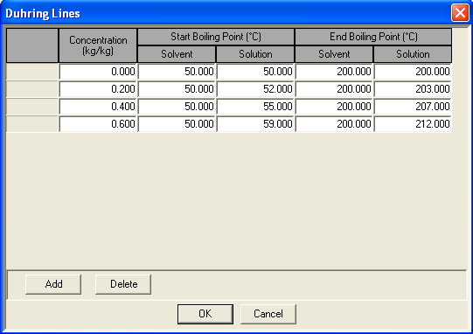

Figure 9a

- Click “OK” button to close the “During Lines” dialog. Then close the “New Drying Materials” dialog and next close “Drying Materials” dialog.
- Go to File | Close to close the current flowsheet.
- Go to Materials | New Flowsheet Settings to bring up the New Flowsheet Settings dialog. Select “Generic Evaporation Material” in the Select Drying Material list box. Then click “Set” button to set this material as the drying material of the new system to be created. Close this dialog.
- Create a new flowsheet by clicking the first icon in the toolbar or clicking File | New.
- Construct a flowsheet as in Figure 9b.

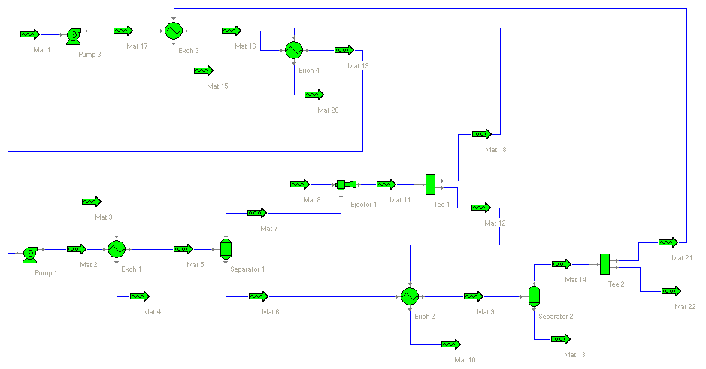
Figure 9b

- The known and calculated variable values are displayed in Figure 9c.

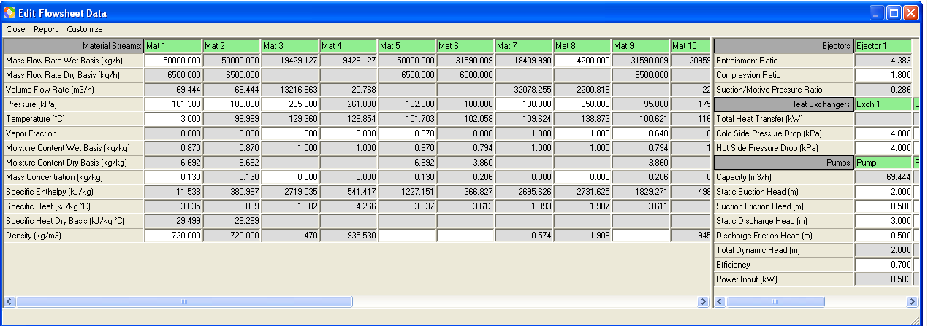

Figure 9c

Please note that not all the known values of the variables are presented in the statement of the Problem. Please load this example to the software and see all the known values of the variables for all the unit operations.

Example 10 - Evaporation and Drying 1

Problem

This example is an extension of example 9. The same liquid material needs to be spray dried after being concentrated. The evaporation process has already been described in the example 9. Concentrated liquid material goes to a spray dryer. The drying air of the spray dryer needs to be at 103.2 kPa and 140 ºC. The exhaust air is at 75 ºC. Material outlet from the spray dryer is at 55 ºC and 0.03 kg/kg (wet basis).

Solution

The flowsheet is constructed as in Figure 10a. As is seen in this flowsheet part of the secondary vapor from the second effect evaporator is used to preheat the drying air.

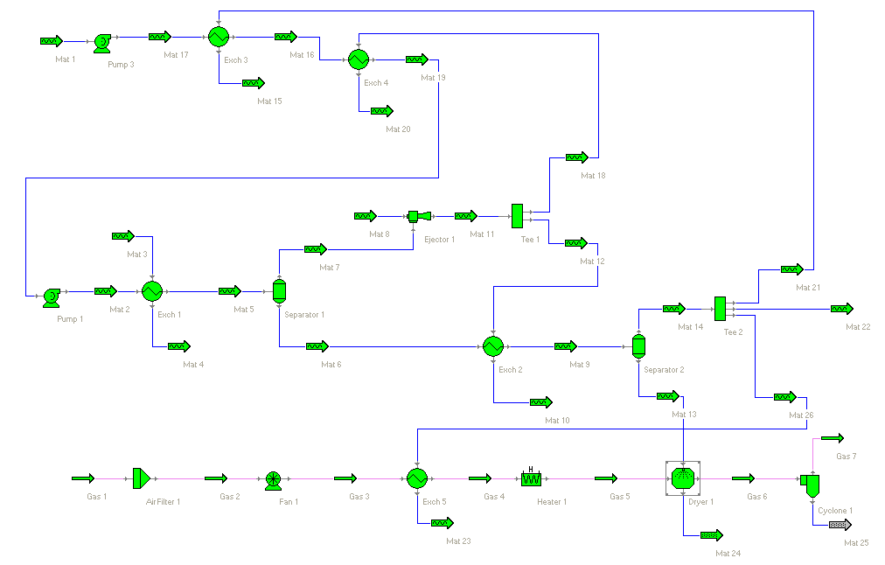
Figure 10a

The results are displayed in Figure 10b

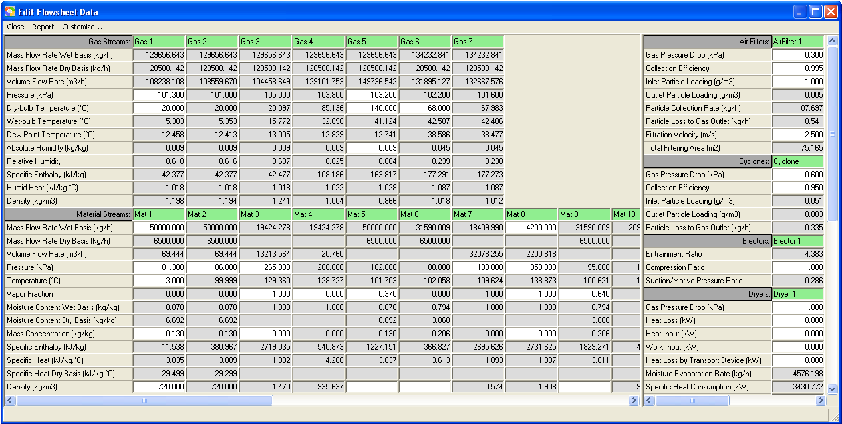

Figure 10b

Please note that not all the known values of the variables are presented in the statement of the Problem. Please load this example to the software and see all the known values of the variables for all the unit operations.

Example 11 - Evaporation and Drying 2

Problem

This example is an extension of example 10. After the same liquid material is concentrated it needs to be dried firstly in a spray dryer and then in a vibrated fluid bed dryer. The evaporation and first stage drying process has already been described in the example 10. The drying air of the spray dryer needs to be at 103.2 kPa and 140 ºC. The exhaust air is at 68 ºC. Material outlet from the spray dryer is at 55 ºC and 0.08 kg/kg (wet basis) moisture content. The drying air of the vibrated fluid bed dryer needs to be at 103.2 kPa and 85ºC. The exhaust air is at 55 ºC. Material outlet from the vibrated fluid bed dryer is at 52 ºC and 0.03 kg/kg (wet basis) moisture content.

Solution

The flowsheet is constructed as in Figure 10a. As is seen in this flowsheet part of the secondary vapor from the second effect evaporator is used to preheat the drying air.

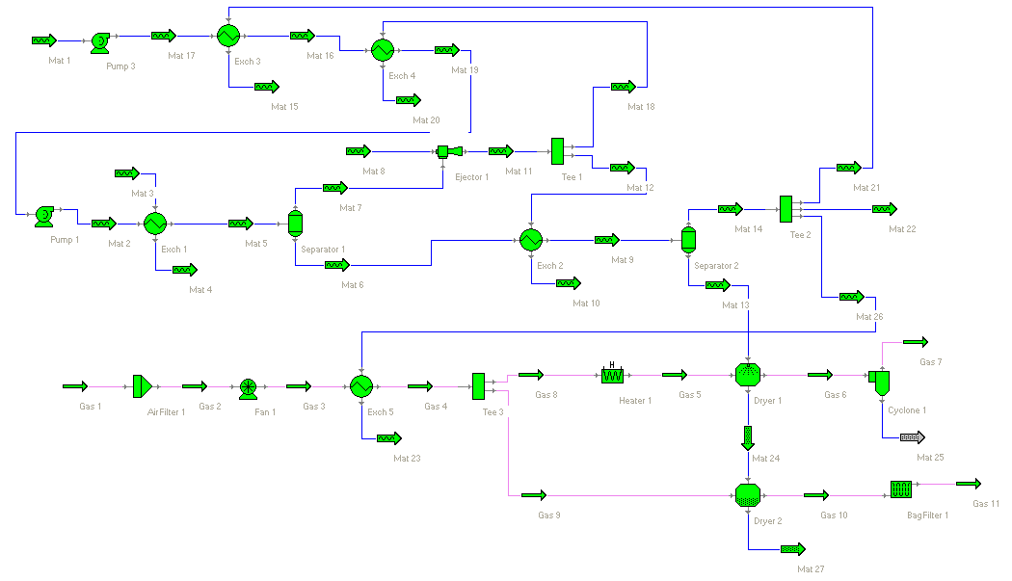
Figure 11a

The results are displayed in Figure 11b

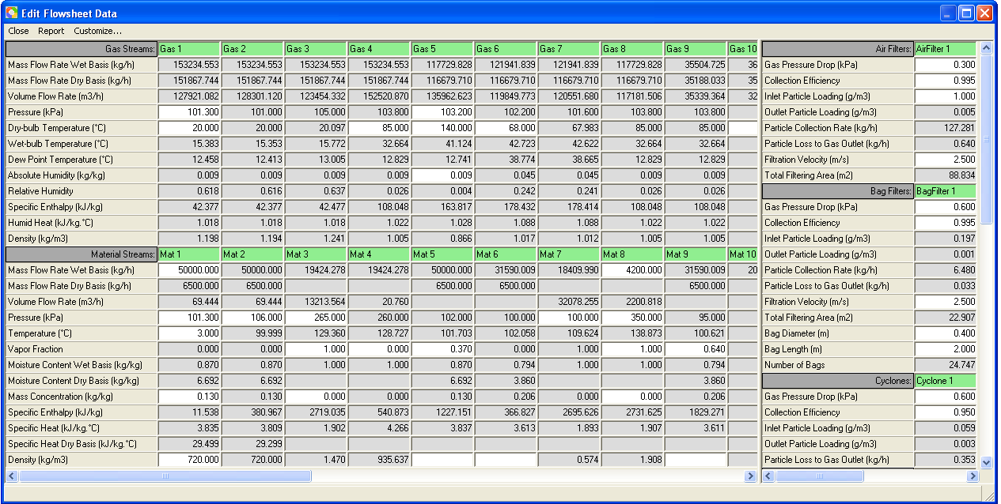

Figure 11b

