

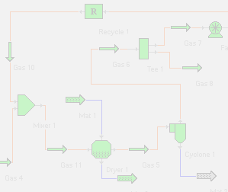

SIMPROTEK
RELEASED

SIMPROSYS 1.0

- SOFTWARE TOOL DESIGNED FOR
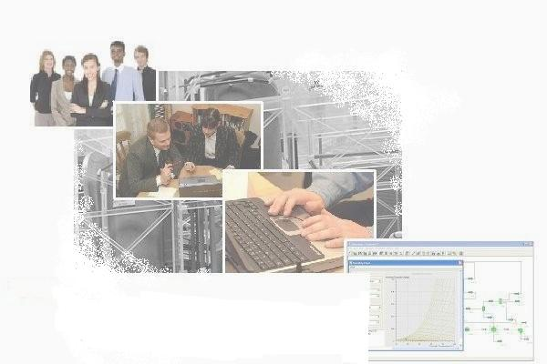
DRYING AND EVAPORATION
RELATED PROCESS SIMULATION
- THE FIRST OF ITS KIND IN THE WORLD

ENGINEERS find LIFE much EASIER with SIMPROSYS
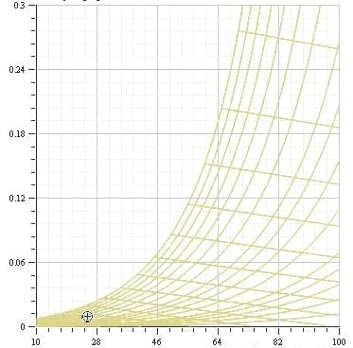
when design and optimize drying and evaporation related plants. Based on design requirements they can quickly layout the heat/mass/pressure balance of a plant using this software and obtain the necessary process parameters such as the air flow rate of the dryer, the capacity and power input of the fan, the heating duty of the heater, etc. They then can choose equipment according to the simulation results. They can also easily layout an existing plant on a flowsheet and optimize its operation.

PROFESSORS FIND SIMPROSYS AN EFFICIENT TOOL
for undergraduate and postgraduate students to do projects for chemical engineering / unit operations / food engineering and related courses. With this software package students can do what-if analysis which would otherwise take an unrealistically long time to accomplish. They can also use Simprosys as a teaching tool to show students the effects of input parameters on the output parameters for a typical plant.

SIMPROSYS 1.0 INCLUDES 19 UNIT OPERATIONS
namely solids dryer, liquid dryer, cyclone, air filter, bag filter, electro-static precipitator, wet scrubber, scrubber condenser, fan, compressor, steam jet ejector, pump, valve, heater, cooler, heat exchanger (which can be used as an evaporator), liquid-vapor separator, mixer and tee. It also includes a logical unit operation, viz. recycle, to simulate recycled gas or material stream, and two utilities, namely, humidity chart and unit converters. In addition to heat/mass/pressure balance calculations in all the unit operations, Simprosys 1.0 also contains a simple dryer scoping model, a detailed cyclone rating model as well as simple and complex heat exchanger rating models for single phase heat transfer.

Since different units may be used in different countries, Simprosys has a complete unit conversion system. Users can convert the inputs and outputs of a large flowsheet from one set of units to another with just one click.

SIMPROSYS HAS

FRIENDLY AND INTUITIVE USER INTERFACE
with maximum protection to prevent users from making simple mistakes. It also has an effective tutorial to teach users step by step how to use the software to simulate typical drying and evaporation related processes. Users of Simprosys will require minimal self-training and effort to use it effectively.
.

SIMPROSYS IS DEVELOPED
by a group of internationally recognized professionals using the most advanced software technology in the world's technology center, Silicon Valley.

Visit us at
www.simprotek.com

Simprotek Corporation
7375 Rollingdell Drive, #41
Cupertino, CA 95014, USA
Phone: (408)257-5161
Email: info@simprotek.com

