
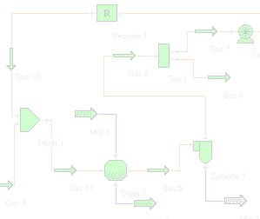


SIMPROTEK

RELEASE
SIMPROSYS 1.0

A NEW INNOVATIVE SOFTWARE SPECIFICALLY DESIGNED FOR
DRYING AND EVAPORATION
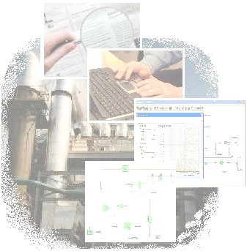
RELATED PROCESS SIMULATION

ENGINEERS’ JOB will Become EASIER with SIMPROSYS
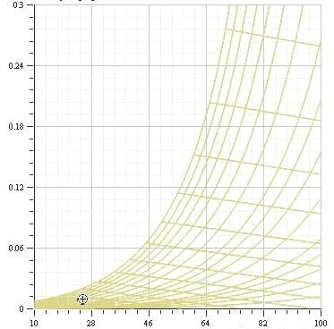
when they design and optimize drying and evaporation plants. Based on design requirements they can quickly compute the heat/mass/pressure balance of the whole plant using this software and obtain the necessary process parameters such as the air flow rate to the dryer, the capacity and power requirements for the blower, the heat duty of the heater, the exhaust dust concentration of the cyclone or scrubber, etc. They then can choose appropriate equipment based on the simulation results.

PROFESSORS Will FIND SIMPROSYS AN EFFICIENT TEACHING TOOL
for undergraduate and postgraduate students working on design and research projects in chemical engineering unit operations, food process engineering, agricultural engineering etc. With this software package students can do what-if analysis which would otherwise take an unrealistically long time to accomplish. They can also use Simprosys as a teaching tool to show students the effects of input parameters on the output parameters for a typical plant. Practicing engineers and scientists can also use this as a self-learning tool.

SIMPROSYS 1.0 COVERS 19 UNIT OPERATIONS
namely, solids dryer, liquid dryer, cyclone, air filter, bag filter, electro-static precipitator, wet scrubber, scrubber condenser, fan/blower, compressor, steam jet ejector, pump, valve, heater, cooler, heat exchanger (which can be used as an evaporator), liquid-vapor separator, mixer and tee. It also includes a logical unit operation, viz. recycle, to simulate recycled gas or material stream, and two utilities, namely, humidity chart and unit converters. In addition to heat/mass/pressure balance calculations in all the unit operations, Simprosys 1.0 also contains a simple dryer scoping model, a detailed cyclone rating model as well as simple and complex heat exchanger rating models for single phase heat transfer.

Simprosys includes a complete unit conversion system. Users can convert their inputs and outputs of a large flowsheet from one set of units to another with just one click.

SIMPROSYS HAS FRIENDLY AND INTUITIVE USER INTERFACE
with maximum protection to prevent users from making simple mistakes. It also has an effective tutorial to teach users step by step how to use the software to simulate typical drying and evaporation related processes. The tutorial is available at www.simprotek.com. Users of Simprosys require minimal self-training and effort to use it effectively because of its intuitive and user-friendly interface.
.

SIMPROSYS IS DEVELOPED
by a group of internationally recognized professionals using the most advanced software technology .Net and C# in the world's technology center, Silicon Valley.

Visit us at
www.simprotek.com

Simprotek Corporation
7375 Rollingdell Drive, Suite 41
Cupertino, CA 95014, USA
Phone: (408)257-5161
Email: info@simprotek.com

