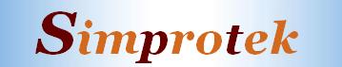

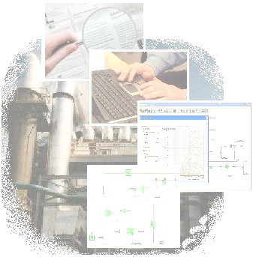
Simprotek Released Simprosys 3.0
-- An Innovative Software Package Specifically Designed for Drying System and Dryer Design

Simprosys 3.0 Supports Combustion Drying, Air Drying and typical enclosed Inert Gas Drying
It can model and simulate not only Water-Air system, but also Ethanol-Air, Ethanol-Nitrogen, Carbon Tetrachloride-Air, Benzene-Air, Toluene-Air, Acetic Acid-Air, Acetic Acid-Nitrogen, Acetone-Nitrogen, Methanol-Nitrogen, N-Propanol-Nitrogen, Isopropanol-Nitrogen, N-Butanol-Nitrogen, Isobutanol-Nitrogen systems.

Design Engineers
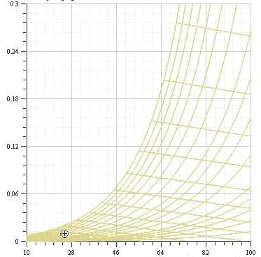
can quickly layout a drying flowsheet and compute the heat/mass balance of the whole plant using Simprosys to obtain the necessary process parameters such as the Air Flow Rate to the dryer, the Capacity and Power requirements for the blower, the Heat Duty of the heater as well as the Thermal Efficiency and Specific Heat Consumption of the dryer(s). They can explore various arrangements of the unit operations and experiment with different operating conditions to reach optimized design.

Process Engineers
can layout any drying plant as a flowsheet and analyze the whole process to obtain the process parameters as well as Thermal Efficiency and Specific Heat Consumption of the dryer(s) for trouble shooting or optimizing operating conditions.

Professors
can use Simprosys for undergraduate and postgraduate design and research projects. With Simprosis students can do what-if analysis which would otherwise take an unrealistically long time to accomplish. They can also use Simprosys as a teaching tool to show students the effects of input parameters on the output parameters for a typical plant. Practicing engineers and scientists can also use it as a self-learning tool.

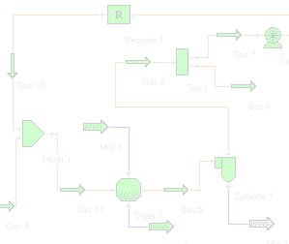
Simprosys 3.0 Contains 20 for Water Air, 16 for Nonaqueous Organic Liquids Drying, Unit Operations
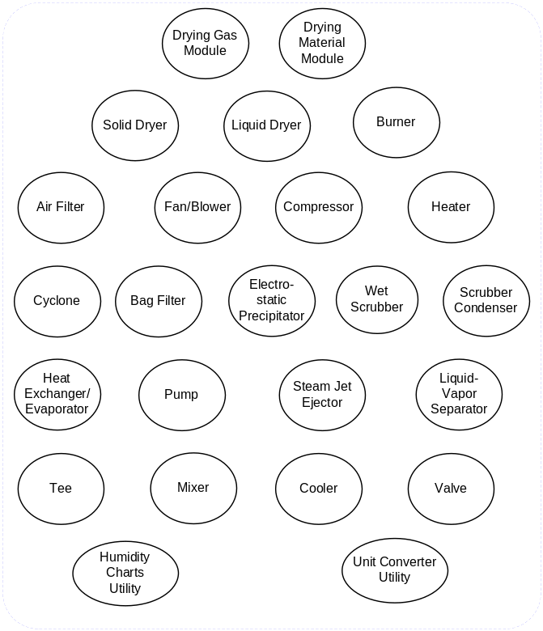

Simprosys also includes a complete unit conversion system. Users can convert their inputs and outputs of a large flowsheet from one set of units to another with just one click.

Simprosys is Intuitive and User Friendly
It also has an effective tutorial to teach users step by step how to use the software to simulate typical drying and evaporation related processes. It requires minimal self-training and effort to use it effectively.
.

Simprosys is Developed

with the expertise of internationally recognized experts on drying, process simulation and software development using the most advanced software technology, viz. Microsoft .Net and C#. For more information, please visit
www.simprotek.com
Simprotek Corporation
San Jose, CA 95135, USA
Email: support@simprotek.com

