 | State of California
 | Secretary of State
 | STATEMENT OF INFORMATION
 | (Domestic Stock Corporation)
IMPORTANT - Read instructions before completing this form.
1. CORPORATION NUMBER, NAME AND ADDRESS OF RECORD
C2884509
SIMPROTEK CORPORATION
ZHENXIANG GONG
7375 ROLLINGDELL DR NO 41
CUPERTINO, CA 95014

CALIFORNIA CORPORATE DISCLOSURE ACT (Corporations Code section 1502.1.1)
A publicly traded corporation must file with the Secretary of State a Corporate Disclosure Statement (Form SI PT) annually, within 150 days after the end of its fiscal year. Please see instructions for additional information regarding publicly traded corporations.

 | If there has been no change in any of the information contained in the last Statement of Information filed with the Secretary of State, check the box and proceed to Item 14.  If there have been any changes to the information, or no Statement of Information has been previously filed, the form must be completed in its entirety.

LIST THE NAMES AND COMPLETE ADDRESSES OF THE OFFICERS (The corporation must have these three officers.)
4. CHIEF EXECUTIVE OFFICER
FIRST | MIDDLE | LAST
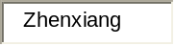 | 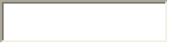 | 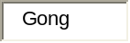
ADDRESS
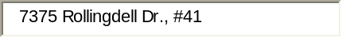
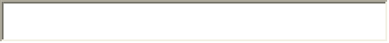
CITY | STATE | ZIP CODE | COUNTRY
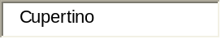 | 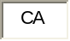 | 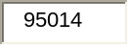

5. SECRETARY
FIRST | MIDDLE | LAST
ADDRESS
CITY | STATE | ZIP CODE | COUNTRY

6. CHIEF FINANCIAL OFFICER
FIRST | MIDDLE | LAST
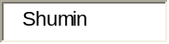 |  | 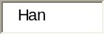
ADDRESS
CITY | STATE | ZIP CODE | COUNTRY

LIST THE NAMES AND COMPLETE ADDRESSES OF ALL DIRECTORS, INCLUDING DIRECTORS WHO ARE ALSO OFFICERS (The corporation must have at least one director.)
7.
FIRST | MIDDLE | LAST
ADDRESS
CITY | STATE | ZIP CODE | COUNTRY

8.
FIRST | MIDDLE | LAST
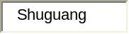 |  | 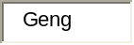
ADDRESS
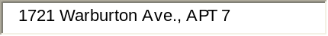
CITY | STATE | ZIP CODE | COUNTRY
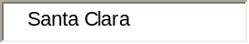 |  | 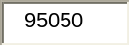

9.
FIRST | MIDDLE | LAST
 |  | 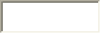
ADDRESS
CITY | STATE | ZIP CODE | COUNTRY
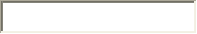 | 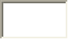 | 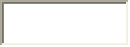


10. NUMBER OF VACANCIES ON THE BOARD OF DIRECTORS, IF ANY: 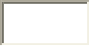
12. ADDRESS OF THE AGENT FOR SERVICE OF PROCESS IN CALIFORNIA, IF AN INDIVIDUAL
ADDRESS
CITY | STATE | ZIP CODE
 | CA

13. DESCRIBE THE TYPE OF BUSINESS OF THE CORPORATION
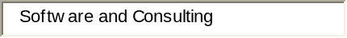
14. ENTER THE NAME AND TITLE OF THE PERSON COMPLETING THIS STATEMENT. BY SUBMITTING THIS STATEMENT OF INFORMATION TO THE SECRETARY OF STATE, THE CORPORATION CERTIFIES THE INFORMATION CONTAINED HEREIN, INCLUDING ANY ATTACHMENTS, IS TRUE AND CORRECT.
FIRST | MIDDLE | LAST | TITLE | DATE
 |  | 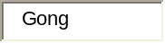 | 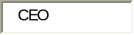 | 8/26/2006
 | 

2. STREET ADDRESS OF PRINCIPAL EXECUTIVE OFFICE (DO NOT USE PO BOX)
ADDRESS
CITY | STATE | ZIP CODE | COUNTRY
3. STREET ADDRESS OF PRINCIPAL BUSINESS OFFICE IN CALIFORNIA, IF ANY (DO NOT USE PO BOX)
ADDRESS
CITY | STATE | ZIP CODE
 | CA
11. CHECK THE APPROPRIATE PROVISION BELOW AND NAME THE AGENT FOR SERVICE OF PROCESS

  AN INDIVIDUAL RESIDING IN CALIFORNIA
  AGENT'S FIRST | MIDDLE | LAST
A CORPORATION WHICH HAS FILED A CERTIFICATE PURSUANT TO CALIFORNIA CORPORATIONS CODE SECTION 1505.
NAME OF CORPORATE AGENT View List

