Table of Contents
1. How to use Simprosys 4
1.1 Start Simprosys 4
1.2 Create New Materials 4
1.3 Create Drying Fuel 7
1.4 Create New Flowsheet 9
1.5 Create a Stream 10
1.6 Create a Unit Operation 11
1.7 Connect Two Unit Operations 12
1.8 Toolbox Buttons 13
 Gas Stream 13
 Solid Material Stream 14
 Liquid Material Stream 14
Fuel Stream 14
 Solid Dryer 14
 Liquid Dryer 15
Burner 15
 Fan/Blower 15
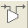 Compressor 16
 Pump 16
 Valve 16
 Steam Jet Ejector 17
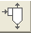 Cyclone 17
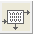Bag Filter 17
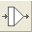 Air Filter 18
Electro-Static Precipitator 18
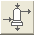 Wet Scrubber 18
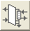 Scrubber Condenser 18
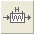 Heater 19
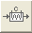 Cooler 19
 Heat Exchanger 19
 Tee 19
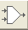 Mixer 20
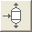 Vapor-Liquid Separator 20
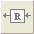 Recycle 20
1.9 Toolbar Buttons 21
(File | New) 21
(File | Open) 21
(File | Save) 21
(File | Close) 22
(File | Print Preview) 22
(File | Print) 22
(Edit | Unit Systems) 22
(Edit | Numeric Format) 23
(Edit | Flowsheet Data) 23
(Edit | Selected Flwosheet Data) 23
(Edit | Delete) 24
(View | Toolbox) 24
(Flowsheet | Connect) 24
(Flowsheet | Disconnect) 24
(Flowsheet | Rotate Stream | Clockwise) 25
(Flowsheet | Rotate Stream | Counterclockwise) 25
(Flowsheet | Snapshot | Flowsheet) 25
(Flowsheet | Snapshot | Selection) 25
(Flowsheet | Options) 25
(Utilities | Humidity Chart) 26
(Utilities | Unit Converter) 26
(Help | User’s Manual) 26
2. Principles of Simprosys 27
2.1 Introduction 27
2.2 Drying Gas Model 27
2.3 Dryer Models 27
2.4 Material Property Model 28
2.5 Other Unit Operation Models 29
2.6 Nonaqueous Systems 29
2.7 References 30

1. How to use Simprosys

1.1 Start Simprosys

When you start Simprosys the first time, a new flowsheet will be created as is displayed in Figure 1. We call the white space in the window a flowsheet. You can build a flowsheet with the streams and unit operations in the Toolbox at the right side panel.

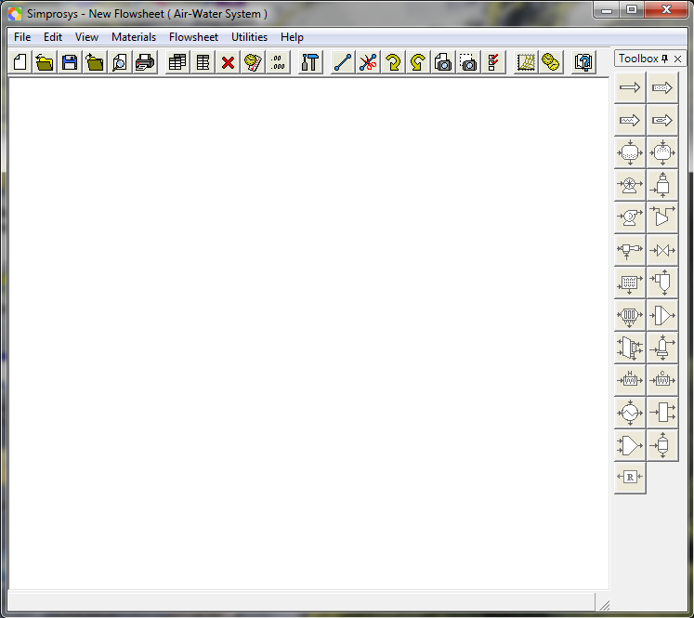

Figure 1 Empty Flowsheet

1.2 Create New Materials

Drying materials can be created independent of any flowsheet. That is to say, both before and after you create a flowsheet you can go to the drying material catalog to create a material and add it to the catalog. You can use the newly created material at any time when you create a new flowsheet.
To create a new drying material, you need to go to Materials | Drying Material Catalog to bring up the Drying Material Catalog as is displayed in Figure 2.

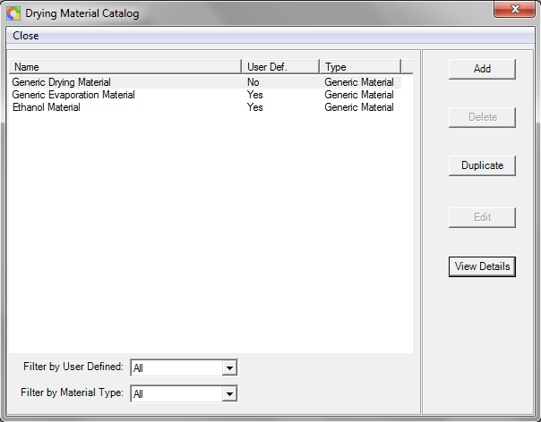

Figure 2 Drying Material Dialog

You can create a new drying material by clicking the “Add” button to bring up the New Drying Material dialog (Figure 3). In the New Drying Material Dialog you can edit the material’s name and the material type.
If Generic Material type is chosen, the specific heat of the absolute dry material needs to be specified for the material (see Figure 3a). If Generic Food type is chosen you need to specify the fraction for each basic component (Carbohydrate, Ash, Fiber, Fat and Protein) of the food (see Figure 3b).
If the new drying material is also related to evaporation simulation you need to specify the Duhring lines of the material solution to account for boiling point rise. You need to click the “Duhring Lines” button to bring up the “Dyhring Lines” dialog to specify the lines as data points.

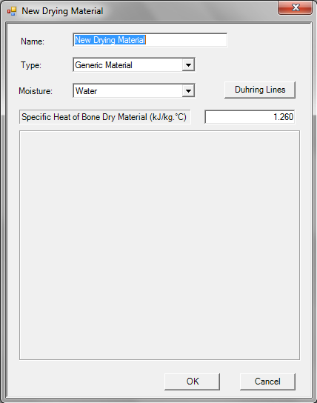

Figure 3a New Drying Material Dialog – Generic Material

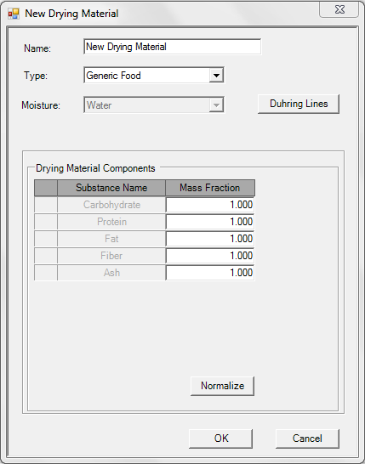

Figure 3b New Drying Material Dialog – Generic Food

Whenever a new flowsheet is created, a material needs to be specified for the flowsheet at first. After the flowsheet is created with the specified material you can not switch to another material. However, you can modify the material (say, the specific heat of absolute dry material and the duhring lines) and the established flowsheet will be recalculated and updated after you finalize the modification.

1.3 Create Drying Fuel

Drying Fuel can be created independent of any flowsheet. That is to say, both before and after you create a flowsheet you can go to the drying fuel catalog to create a drying fuel and add it to the catalog. You can use the newly created fuel at any time when you create a new flowsheet.
To create a new drying fuel, you need to go to Materials | Drying Fuel Catalog to bring up the Drying Fuel Catalog as is displayed in Figure 4.

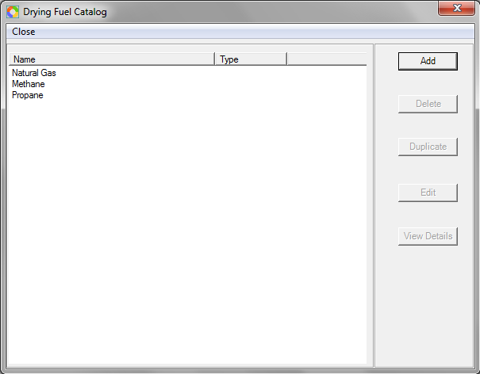

Figure 4 Drying Fuel Catalog

You can create a new drying fuel by clicking the “Add” button to bring up the Edit Drying Fuel dialog (Figure 5). In the New Drying Fuel Dialog you can edit the fuel’s name and components.

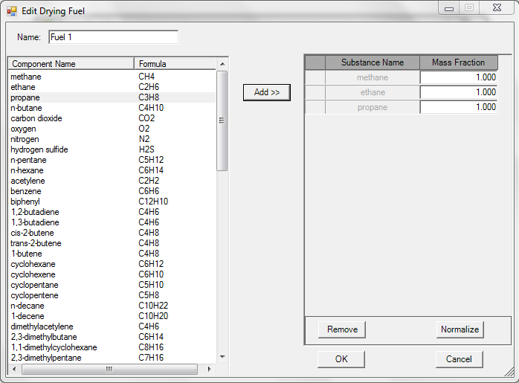

Figure 5 Edit Drying Fuel Dialog

1.4 Create New Flowsheet

Whenever a new flowsheet is created, a material needs to be specified for the flowsheet at first. After the flowsheet is created with the specified material you can not switch to another material. However, you can modify the material (say, the specific heat of absolute dry material and the Duhring lines) and the established flowsheet will be recalculated and updated after you finalize the modification.
To create a new flowsheet, you need to Materials | Set Default Flowsheet Settings menu to bring up the Set Material for Default Flowsheet dialog (Figure 4). You need to select a predefined material from the material catalog and “Set” it as the drying material of a default fhowsheet. Then you can save your current flowsheet and then click the Toolbar button or (File | New) menu to create a new flowsheet for the drying material selected.

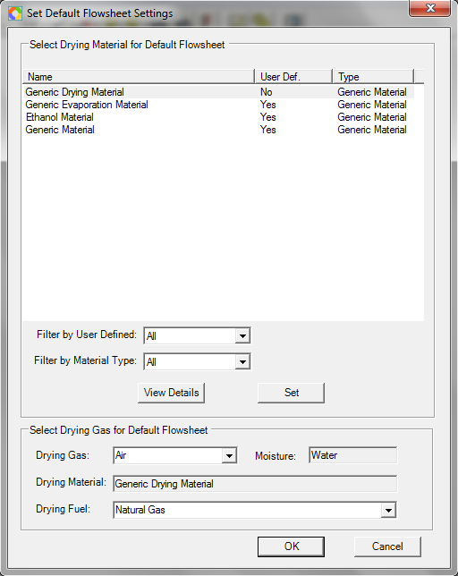

Figure 6 Set Default Flowsheet Settings

1.5 Create a Stream

You can create a stream (either a gas stream or a solid material stream or a liquid material stream) by pressing down (clicking) the corresponding button of the stream (take the gas stream for example) in the toolbox and then clicking at wherever you want the stream to be located on the flowsheet. You can double click on the stream to bring up its editor. Then you can specify the variables of the stream to get it solved.
Take the gas stream for example. You can specify the Pressure, one Temperature (either the Dry-bulb Temperature or the Wet-bulb Temperature or the Dew Point Temperature) and one Humidity (either the Absolute Humidity or the Relative Humidity). Simprosys will automatically calculate all the other variables of the stream and update the editor with the calculated results. You can then specify a flow rate (either Mass Flow Rate Wet Basis or Mass Flow Rate Dry Basis or Volume Flow Rate). Simprosys will automatically calculate the rest of the flow rates and update the editor with the calculated results (see Figure 7).

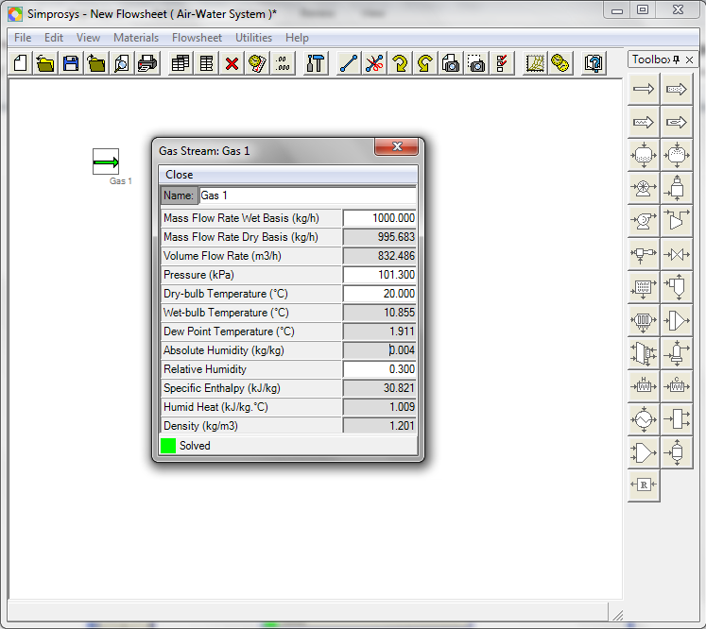

Figure 7 Gas Stream

1.6 Create a Unit Operation

You can create a unit operation by pressing down (clicking) the button of the corresponding unit operation (take the solid dryer for example) in the toolbox and then clicking at wherever you want the unit operation to be located on the flowsheet. You can double click on the unit operation to bring up its editor. Then you can specify the variables of the dryer to get it solved.
Still take the solid dryer for example. You can specify the Mass Flow Rate Wet Basis, Temperature and one Moisture Content (either wet basis or dry basis) of the input material stream, the Temperature and one Moisture Content (either wet basis or dry basis) of the output material stream, plus some variables of the gas input and output such as the Mass Flow Rate Wet Basis, the Pressure, the Dry-bulb Temperature, the Absolute Humidity of the input gas stream and the Gas Pressure Drop of the dryer. Simprosys will automatically calculate the Dry-bulb Temperature and Absolute Humidity of the gas output stream and get both the gas output stream and the dryer solved (See Figure 8).

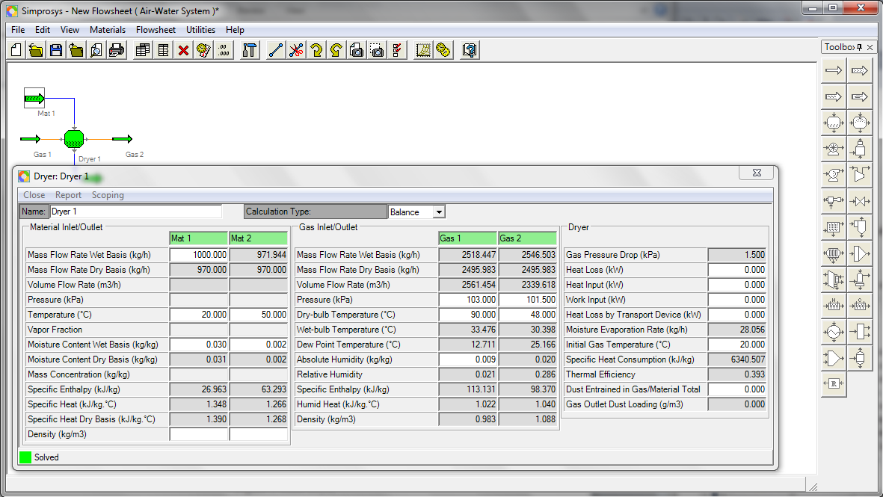

Figure 8 Solid Dryer

1.7 Connect Two Unit Operations

Take a heater and a solid dryer for example. Create a heater first and then delete the output stream of the heater. Then create a dryer. Press down the “Connect ()” button in the toolbar. Click on the gas input stream of the dryer and then click at the middle of the right border (the connection port) of the heater. You will get the heater and the dryer connected. You can also connect the heater and the dryer by clicking at the heater’s connection port first and then clicking on the gas input stream of the dryer.
You can specify the variables of the heater and the dryer through their individual editors to get them solved. You can also bring up the Flowsheet Data Editor (menu Edit | Flowsheet Data) to specify the variables of the heater and dryer to get them solved. Figure 9 shows an example of a combined heater and dryer. Please refer to Tutorial Example 4 for details about combined heater and dryer.

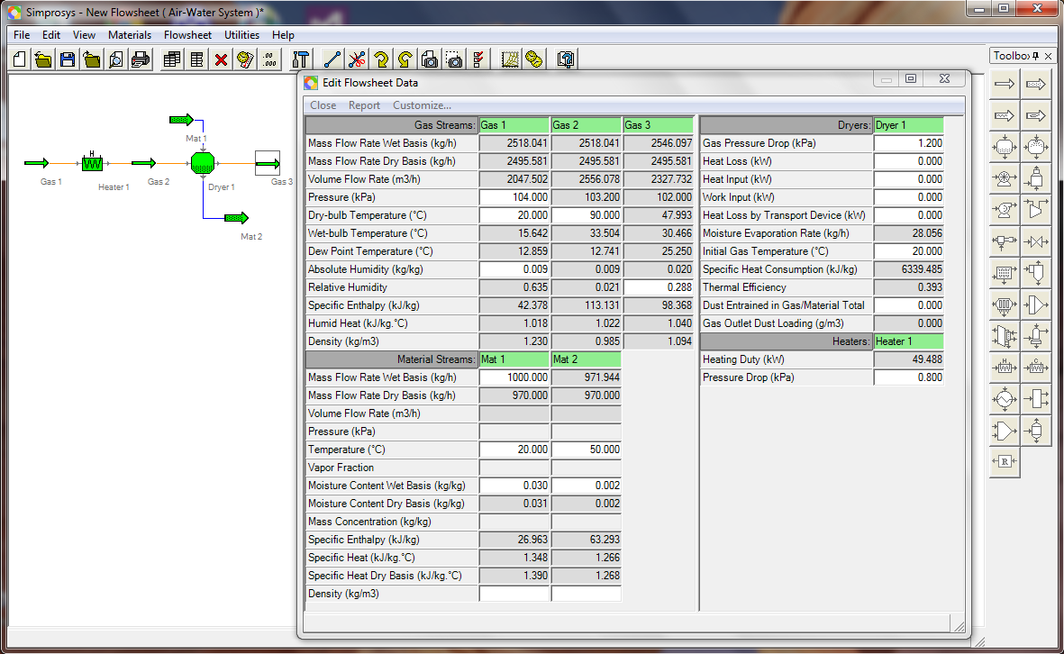

Figure 9 Combined Heater and Dryer

1.8 Toolbox Buttons

Gas Stream

This is the gas stream. In a gas stream you can specify the Pressure, one Temperature (either the Dry-bulb Temperature or the Wet-bulb Temperature or the Dew Point Temperature) and one Humidity (either the Absolute Humidity or the Relative Humidity). Simprosys will automatically calculate all the other variables of the stream and update the stream’s editor with the calculated results. You can also specify one flow rate (either Mass Flow Rate Wet Basis or Mass Flow Rate Dry Basis or Volume Flow Rate). Simprosys will automatically calculate the rest of the flow rates and update the editor with the calculated results (See Figure 4). Please refer to Tutorial Example 1 for details about gas stream.

Solid Material Stream

This is the solid material stream. If you can specify one Moisture Content (either dry basis or wet basis). Simprosys will automatically calculate the other Moisture Content and update the stream’s editor with the calculated results. You can also specify one Mass Flow Rate (either wet basis or dry basis). Simprosys will automatically calculate the other Mass Flow Rate if moisture content is available. If one mass flow rate, one moisture content and the Density of the solid material are specified, the Volume Flow Rate of the material stream is automatically calculated.

Liquid Material Stream

This is the liquid material stream. You can specify the Pressure, either the Temperature or the Vapor Fraction, and either the Mass Concentration or one Moisture Content of the material stream. Simprosys will automatically calculate the rest of the variables and update the editor with the calculated results. Please refer to Tutorial Example 1 for details about liquid dryer.

Fuel Stream

This is the drying fuel stream. You can specify the Pressure, the Temperature and the mass flow rate the fuel stream. Simprosys will automatically calculate the rest of the variables and update the editor with the calculated results.

Solid Dryer

This is the solid dryer. You can specify the Mass Flow Rate Wet Basis, the Temperature and one Moisture Content (either wet basis or dry basis) of the material input stream, the Temperature and one Moisture Content (either wet basis or dry basis) of the material output, some variables of the gas input and output such as the Mass Flow Rate Wet Basis, the Pressure, the Dry-bulb Temperature, the Absolute Humidity of the gas input stream and the Gas Pressure Drop of the dryer. Simprosys will automatically calculate the Dry-bulb Temperature and Absolute Humidity of the gas output stream and get both the gas output stream and the dryer solved.
You can also specify the dryer’s Heat Loss, Heat Input, Work Input, Heat Loss by Transport Devise and the Dust Entrained in Gas/Material Total (the ratio of dust entrained in gas output stream to the total material flow rate). The dryer will take the specified values into account and do the balance calculation.
After the dryer’s balance calculation is finalized you can calculate the dimensions of the dryer by the dryer’s scoping model. In the dryer’s scoping model you can choose the dryer’s cross section type which is either a Circle or a Rectangle, the Gas Velocity and the Length/Diameter Ratio in the case of a Circular cross section dryer. Simprosys will automatically calculate the dryer’s Diameter and Length and update the scoping editor with the calculated results. Please refer to Tutorial Example 2 for details about solid dryer.

Liquid Dryer

This is the liquid dryer. The only difference between a liquid dryer and a solid dryer is the material input. Liquid dryer has a liquid material stream as material input in stead of a solid material stream in the solid dryer.
You can perform similar specifications as in a solid dryer for a liquid dryer to get it solved. Please refer to Tutorial Example 2 for details about liquid dryer.

Burner

This is the burner button. You can specify the Pressure, Dry-bulb Temperature, Humidity (either Relative or Absolute) of the air inlet; the Mass Flow Rate, Pressure, Temperature of the fuel input stream, the Pressure of the flue gas outlet, the Excess Air % and Heat Loss %, Simprosys will automatically calculate the Mass flow rate, Dry-bulb Temperature and Humidity of the flue gas stream and get the burner solved. You can do the same specifications as mentioned above except for specifying the flue gas Mass Flow Rate instead of fuel Mass Flow Rate to get the fuel Mass Flow Rate and the flue gas Dry-bulb Temperature and Humidity calculated and get the burner solved.
You can specify the Dry-bulb Temperature of the flue gas and the Heat Loss % to get the Excess Air % calculated. You can also specify the Dry-bulb Temperature and the Excess Air % to get the Heat Loss % calculated.

Fan/Blower

This is the Fan/Blower. You can specify the necessary variables of the gas input stream to get the input stream solved. Then you can specify the Static Pressure of Fan/Blower to get the output stream solved.
After you get both the input and output streams solved you can specify the Efficiency of the fan to get the Power Input solved if you choose not to Include Outlet Diameter Effect (a check box). If you choose to Include Outlet Diameter Effect, you need also to specify the Outlet Cross Section Type (either a Circle or a Rectangle) and the outlet diameter in the case of a circular cross section type to get the Power Input solved.

Compressor

This is the compressor. You can specify the necessary variables of the gas input stream to get the input stream solved. Then you can specify the Pressure Ratio and the Compression Process (either Isothermal, or Adiabatic or Polytropic) to get the output stream and the Power Input solved if the specified Compression Process is Isothermal. If the specified Compression Process is Adiabatic you have to specify the Adiabatic Exponent to get the Power Input solved. If the specified Compression Process is Polytropic you need to specify the Polytropic Exponent to get the Power Input solved. If you have both the adiabatic and polytropic exponents specified you can get Adiabatic and Polytropic Efficiencies solved.

Pump

This is the pump. You can specify the necessary variables of the material input stream to get the input stream solved. Then you can specify the output Pressure to get the output stream solved. If you continue to specify the Static Suction Head, Suction Friction Head, Static Discharge Head, Discharge Friction Head, the Total Dynamic Head will be solved.
Continue to specify the Efficiency of the pump you can get the Power Input solved if you choose not to Include Outlet Diameter Effect (a check box). If you choose to Include Outlet Diameter Effect, you need to specify the Outlet Cross Section Type (either a Circle or a Rectangle) and the outlet diameter in the case of a circular cross section type to get the Power Input solved.

Valve

This is the valve. You can specify the necessary variables of the input stream to get the input stream solved. If then you specify the Pressure Drop, the Pressure of the output stream will be calculated and the whole output stream is solved.
The default input/output stream type of a valve is liquid material stream. You can create a valve with either liquid material steams or gas streams as the input/output. However, the input and output stream types of a valve must be the same.
To create a valve with gas stream you need to go to Flowsheet | Options menu to bring up the Flowsheet Options dialog and select the Gas radio button in the Input Stream Type of the Valve.

Steam Jet Ejector

This is the steam jet ejector. You can specify the Mass Flow Rate Wet Basis of the motive inlet stream and the Entrainment Ratio to get the Mass Flow Rate Wet Basis of the suction inlet and that of the discharge outlet solved.
You can specify the Pressures of the motive inlet and the suction inlet as well as the Compression Ratio to get the Pressure of the discharge outlet solved.
The Concentration of the motive input stream should always be specified as 0. The suction input stream generally comes as secondary steam from a vapor-liquid separator.
The calculated Vapor Fraction of the discharge outlet should be equal to 1.0. If it is less than 1.0 you should either increase the pressure or decrease the Compression Ratio to make it calculated as 1.0.

Cyclone

This is the cyclone. You can specify the necessary variables in the gas input stream to the input stream solved. Continue to specify the Gas Pressure Drop you can get the output stream solved.
After the gas input and output streams are solved, if you specify the Collection Efficiency and the Inlet Particle Loading you can get the Outlet Particle Loading, Particle Collection Rate and Particle Loss to Gas Outlet solved.

Bag Filter

This is the bag filter. You can specify the necessary variables in the input stream to get the input stream solved. Continue to specify the Gas Pressure Drop you can get the output stream solved.
If you continue to specify the Collection Efficiency and the Inlet Particle Loading you can get the Outlet Particle Loading, Particle Collection Rate and Particle Loss to Gas Outlet solved.
If you have the input Volume Flow Rate value and then specify the Filtration Velocity (defined as superficial gas velocity through filter or average gas-to-cloth-ratio, m³/s/m²) you can get the Total Filtering Area solved. Then if you specify the Bag Diameter and Bag Length you can get the Number of Bags solved.

Air Filter

This is the air filter. You can specify the necessary variables in the input stream to get the stream solved. Continue to specify the Gas Pressure Drop you can get the output stream solved.
If you continue to specify the Collection Efficiency and the Inlet Particle Loading you can get the Outlet Particle Loading, Particle Collection Rate and Particle Loss to Gas Outlet solved.
If you get the input Volume Flow Rate solved and then specify the Filtration Velocity (defined as superficial gas velocity through filter or average gas-to-cloth-ratio, m³/s/m²) you can get the Total Filtering Area solved.

Electro-Static Precipitator

This is the electro-static precipitator. You can specify the necessary variables in the input stream to get the stream solved. Continue to specify the Gas Pressure Drop you can get the output stream solved.
If you specify the Collection Efficiency and the Inlet Particle Loading you can get the Outlet Particle Loading, Particle Collection Rate and Particle Loss to Gas Outlet solved.
If you get the input Volume Flow Rate solved and then specify the Drift Velocity you can get the Total Surface Area solved.

Wet Scrubber

This is the wet scrubber. You can specify the necessary variables of the gas input stream to get the gat input solved. Then you need to specify the necessary variables of the liquid input stream to get the liquid stream solved. You can specify the Gas Pressure Drop to get the gas output Pressure solved. Then you can specify the Collection Efficiency, Inlet Particle Loading and the Pressure of the outlet liquid stream to get the wet scrubber solved.

Scrubber Condenser

This is the scrubber condenser. You can specify the necessary variables of the gas input stream to get the stream solved. You can specify the Gas Pressure Drop to get the gas output Pressure solved. You can specify the Collection Efficiency, Inlet Particle Loading, the Pressure and Temperature of the outlet liquid stream to get the wet scrubber solved. You can specify the Liquid Gas Ratio to get the Liquid Recirculation Mass Flow and Volume Flow (Rate) solved.

Heater

This is the heater. You can specify the necessary variables of the input stream to get the stream solved. You can then specify the Dry-bulb Temperature of the output stream and the Pressure Drop of the Heater to get the output stream and the Heating Duty solved. You can also specify the Heating Duty instead of the Dry-bulb Temperature of the output stream to get the latter calculated.
You can create a heater with Liquid Material streams as input and output. To do so, you need to go to Flowsheet | Options to choose Material radio button in the Input Stream Type of the Heater.

Cooler

This is the cooler. The functionality of the cooler is the same as the heater except that the cooler has a Cooling Duty instead of Heating Duty in the heater.

Heat Exchanger

This is the heat exchanger. You can specify cold side inlet Pressure, and Cold Side Pressure Drop to get the cold side outlet Pressure solved. You can do the same for the hot side pressure balance.
You can specify cold side and hot side mass flow rates, three Temperatures and Mass Concentrations among the cold input, cold output, hot input and hot output streams. To get the heat exchanger solved.
You can specify cold side input and output Vapor Fractions, one Temperature of the hot side, and Mass Concentrations of the cold and hot side to get the heat exchanger solved.

Tee

This is the tee. You can split one input stream into multiple output streams. The default number of output streams of a tee is two. You can attach as many streams as you want in the output.
You can specify the variables in the input stream and the fractions of the output streams to get the tee solved.
The default input/output stream type of a tee is gas. You can create a tee with either gas streams or solid material streams or liquid material steams as its input/outputs. However, the input and output stream types of a tee must be the same.

Mixer

This is the mixer. You can mix multiple input streams into one output stream. The default number of input streams is two. You can attach as many input streams as you want in the input.
The default input/output stream type of the mixer is gas. You can create a mixer with either gas streams or solid material streams or liquid material steams as its inputs/output. However, the input and output stream types of a mixer must be the same.

Vapor-Liquid Separator

This is the vapor-liquid separator. The input and output stream of the separator must be liquid material stream. The input stream of the vapor-liquid separator must be a mixture of vapor and liquid. You can specify the Vapor Fraction and Pressure of the input stream and the Pressure of either the vapor outlet or liquid outlet to get the separator solved.

Recycle

This is the recycle. If you want to recycle a portion of the exhaust gas you can split the exhaust gas into two streams using a tee. Then attach the recycled stream to the inlet (the left side) of the recycle (). Create another stream and attach it to the outlet of the recycle and then mix the outlet from the outlet of the recycle with a fresh gas in a mixer. Following is an example of recycled gas stream.

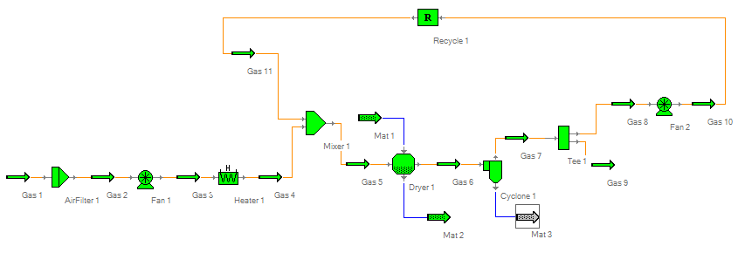
Figure 10 Recycle

You can also use the recycle to recycle a material stream in a similar way. Please refer Tutorial Example 6 for details about recycled gas stream.

1.9 Toolbar Buttons

(File | New)

This is the “New Flowsheet” button. You can click this button to create a new flowsheet. Before creating a new flowsheet you should go to Materials | New Flowsheet Settings to select a predefined material and a predefined gas (gas currently is not selectable) for the to-be-created new floowsheet. After a new flowsheet is created you can model any processes composed of the unit operations available in this application.

(File | Open)

This is the “Open Flowsheet” button. You can click this button to open a saved flowsheet in a file. When this button is clicked, an open file dialog will be brought up and you can select any saved flowsheet file (FineName.simcase) and open it. After the file is open you can continue working on your modeled process by either adding or removing unit operations. You can also change whatever specified variable values to let Simprosys recalculate the process. You can save the changed process either in the same file or in another file by giving a different file name.

(File | Save)

This is the “Save Flowsheet” button. You can save any finished or unfinished flowsheet in a file by clicking this button. When this button is clicked a save file dialog is brought up and you can type in a name and save the flowsheet as a file (with extension “simcase”).

(File | Close)

This is the “Close Flowsheet” button. You can close current flowsheet by clicking this button. If current flowsheet has changes that are not saved yet, you will be prompted to save.

(File | Print Preview)

This is the “Print Preview” button. You can preview the snapshot of the flowsheet before you print it by clicking this button.

(File | Print)

This is the “Print” button. You can print the snapshot of the flowsheet by clicking this button.

(Edit | Unit Systems)

This is the “Unit System Editor” button. Clicking this button will bring up a dialog where you can select a predefined set of units or you can define a named set of units by clicking “Add” and then “Edit” button in the dialog. You can select whatever unit you like for each physical quantity and define the unit set.
Whenever you want to change the units of the variables in the whole application you can select a predefined unit system and set it as current unit system by clicking “Set Current” button. After a new unit system is set to current all variables currently displayed in any opened editor will be immediately transformed to the new units according to the new unit system.
Whenever you want to create your own unit system you can first duplicate a unit system by selecting an existing unit system in the left list box on this tab and then click “Duplicate” button. A newly duplicated unit system will be added to the list box. Select the newly duplicated unit system and click “Edit” button, the Edit Unit System dialog will be brought up. In this dialog you can edit you unit system’s name and each quantity’s unit.

(Edit | Numeric Format)

This is the “Numeric Format” button. Clicking this button will bring up the Numeric Format editor where you can change the numeric format of the displayed variable values. You can either choose “Fixed Point” or “Scientific” format. You can also choose the Decimal Places for the numeric format you choose. After a new format is selected all variables currently displayed on any open editors will be redisplayed according to the format you choose.

(Edit | Flowsheet Data)

This is the “Flowsheet Data Editor” button. Clicking this button will bring up the flowsheet data editor that includes the data tables of all streams and unit operations on the flowhseet. You can specify variables in the Flowsheet Data Editor. When all the necessary variables are specified and solving condition is met, Simprosys will automatically solve the process and update the editor with the calculated results.
Flowsheet Data Editor is generally used after a flowsheet has been fully established to study the effects of some input variables on some output variables for different design and operating conditions, e.g. the effects of different inlet temperature or humidity value on the whole process.
You can customize the Flowsheet Data Editor to include/exclude any streams and unit operations in the editor. To customize the Flowsheet Data Editor you need to go to “Customize…” menu on the top of the Flowsheet Data Editor to bring up the “Customize Flowsheet Data” dialog to check/uncheck the streams and unit operations you want to include/exclude.
You can also adjust the “Flowsheet Data Editor” by dragging the left/right panel border line to arrange the space in both panels.

(Edit | Selected Flwosheet Data)

This is the “Selected Flowsheet Data Editor” button. Clicking this button will bring up the Selected Flowsheet Data Editor. You can customize the editor to include/exclude any variables of the stream and unit operations on the flowsheet.
This editor is generally used after a flowsheet has been fully established to study the effects of some variables on some other variables for different design and operating conditions.
You can specify the variables in this editor. When all the necessary variables are specified and solving condition is met, Simprosys will automatically solve the flowsheet and update this editor with calculated results.
To study the effects of some specified variables on some other calculated variables you can use the Flowsheet Data Editor if the flowsheet that you are modeling is not so large. In the case of a very large flowhseet, the Flowsheet Data Editor may contain too many variables. In this case you can use the Selected Flowsheet Data Editor in stead.

(Edit | Delete)

This is the “Delete” button. Select a unit (either a stream or a unit operation) or make a multiple selection and hit this button. The selected stream(s) and/or unit operation(s) will be deleted from the flowsheet.
You can do a multiple selection either by pressing down the left mouse button and drag the mouse to select an area on the flowsheet. Any unit operations and streams in the selected area are selected. You can also hold down either the “Shift” or “Ctrl” key and then click on any unit operations and streams you want to select to perform a multiple selection.

(View | Toolbox)

This is the “Toolbox” toggle button. Clicking this button will bring up the Toolbox that includes the stream and unit operation buttons. Press down (by clicking) any button in this Toolbox and then move the mouse to a spot on the flowhseet and do another click will create a stream or a unit operation depending on whatever you clicked in the Toolbox. You can also add a stream or a unit operation by clicking “Flowsheet | Add | Unit Operations, Streams…”

(Flowsheet | Connect)

This is the “Connect” toggle button. Press down (click) this button, click on a stream, then click on a connection port (such as the middle of the left or the right border of the unit operation icon) of a unit operation will connect the stream to the unit operation. Of course if the connection port of the unit operation has already got a stream connected you are not allowed to make another connection to the same port.

(Flowsheet | Disconnect)

This is the “Disconnect” toggle button. Pressing down this button and then clicking on a connection line between a stream and a unit operation disconnect the stream from the unit operation.

(Flowsheet | Rotate Stream | Clockwise)

This is the “Clockwise Rotation” button. Selecting a stream and clicking this button will rotate the stream 90 degree clockwise. Please be noted that you cannot rotate a unit operation.

(Flowsheet | Rotate Stream | Counterclockwise)

This is the “Counterclockwise Rotation” button. Selecting a stream and clicking this button will rotate the stream 90 degree counterclockwise.

(Flowsheet | Snapshot | Flowsheet)

This is the “Snapshot Flowsheet” button. Clicking this button will bring up a dialog to save the flowsheet as either a JPEG, or a BMP, or a GIF, or a PNG or a TIFF file.

(Flowsheet | Snapshot | Selection)

This is the “Snapshot Selection” button. After clicking this button you can press down the mouse and drag it on the flowsheet to select an area that can be saved as an image. After making the selection (by releasing the mouse) a dialog will pop-up asking you to save the selection as either a JPEG, or a BMP, or a GIF, or a PNG or a TIFF file.

(Flowsheet | Options)

This is the “Flowsheet Options” button. Clicking this button will bring up the Flowsheet Options dialog. From this dialog you can choose to include either all input and output streams or only input stream or only output stream when creating a unit operation. Figure 11 shows three different options when a fan is created on a flowsheet.

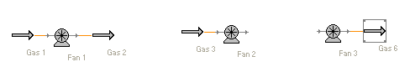
Figure 11 Flowsheet Options

On Flowsheet Options dialog you can also choose the input stream type for each (cold or hot) side of a heat exchanger, a valve, a heater, a cooler, a tee and a mixer.

(Utilities | Humidity Chart)

This is the “Humidity Chart” button. Clicking this button will bring up the humidity chart.
On the humidity chart utility you can select either “Gas State” or “Isenthalpic Process” radio button to study either the state of a moist gas or the isenthalpic process of a dryer. You also need to specify the Pressure of the humidity chart before your study.
Selecting “Gas State” button will bring up a drying gas state variable table. You can specify one temperature and one humidity parameter to get the rest of the variables calculated automatically and the state of the gas will be shown on the humidity chart. You can also drag the state icon in the chart to anywhere you want and the data table will be updated according to the position of the state icon.
Selecting “Isenthalpic Process” button will bring up a table that contains two states of a drying gas, one for the start state, the other for the end state of an isenthalpic saturation process. In this table you can specify two Temperatures (one for the start state and the other for the end state) and one Humidity parameter (either for the start state or for the end state) or two Humidity parameters (one for the start state and the other for the end state) and one Temperature (either for the start state or for the end state). Then the rest of the variables in the table will be calculated automatically and the process will be shown on the humidity chart. You can also drag the process line (a line connected with the two states’ icons) in the chart to anywhere you want and then the data table will be updated according to the position of the process line.

(Utilities | Unit Converter)

This is the “Unit Converter” button. Clicking this button will bring up the unit converter where you can do unit conversions for any chemical quantities available in this software package.

(Help | User’s Manual)

This is the User’s Manual button. Clicking this button will bring up the user’s manual.

2. Principles of Simprosys

2.1 Introduction

Simprosys is a Windows-based process simulator. It is based on extensive studies presented in some of the most authoritative handbooks by Mujumdar (2007), Masters (1985) and Perry (1997). It is developed using the most advanced software technology, viz. Microsoft .Net and C#.
Simprosys 3.0 contains 20 unit operation modules and 2 utilities. The 20 unit operation modules include solids dryer, liquid dryer, burner, cyclone, air filter, bag filter, electro-static precipitator, wet scrubber, scrubber condenser, fan/ blower, compressor, steam jet ejector, pump, valve, heater, cooler, heat exchanger which can also be used as an evaporator, liquid-vapor separator, mixer and tee. The 2 utility modules are the humidity charts utility and unit converter utility.
In addition to heat/mass/pressure balance calculations in all the unit operations, Simprosys 3.0 also contains a simple dryer scoping model, a detailed cyclone rating model as well as simple and complex heat exchanger rating models for single phase heat transfer. Since different units may be used in different countries, Simprosys 3.0 has a complete unit conversion system. Users can convert the inputs and outputs of a large flowsheet from one set of units to another with just one mouse click.
The humidity chart utility can be used to visualize either the state of a drying gas or an isenthalpic drying process. The unit converters utility covers all chemical engineering units.
Simprosys 3.0 covers not only the air-water system, but also Air-Ethanol, Nitrogen-Ethanol, Air-Carbon Tetrachloride, Air-Benzene, Air-Toluene, Air-Acetic Acid, Nitrogen-Acetic Acid, Nitrogen-Acetone, Nitrogen-Methanol, Nitrogen-N-Propanol, Nitrogen-Isopropanol, Nitrogen-N-Butanol, Nitrogen-Isobutanol systems.

2.2 Drying Gas Model

The calculations of absolute humidity, relative humidity, wet bulb temperature, dew point temperature, humid volume, humid heat, and humid enthalpy are based on information found in Pakowski and Mujumdar (2007).
For air-water system, the properties (including saturation pressure) of liquid and steam of water are calculated according to the 1967 ASME Steam Tables. The properties of dry air are based on Perry (1997) (section 2, Physical and Chemical Data). For other solvent-gas systems (which are being developed) such as air-carbon tetrachloride, air-benzene and air-toluene, the liquid and steam peroperties of the solvent are based Perry (1997) (section 2, Physical and Chemical Data).

2.3 Dryer Models

In the Simprosys dryer model, you can automatically obtain the Thermal Efficiency and Specific Heat Consumption of the dryer with the heat and mass balance calculations. You can specify the gas inlet temperature and humidity and either the gas outlet temperature or outlet relative humidity or the outlet humidity to calculate how much drying air is needed. You can also specify the gas inlet flow rate, temperature and humidity to calculate the gas temperature and humidity. Due to space limit we can not list all the functionalities of the dryer model.
In addition to the heat and mass balance calculations, the Simprosys dyer also has a simple scoping model based on Kemp and Oakley (2002). After heat and mass balance calculation you can input the drying gas velocity in the dryer to get the size of the dryer calculated.

2.4 Material Property Model

Current material model in Simprosys supports two types of materials. One is generic material type and the other is generic food type.
For drying related balance simulation of a generic material you only need to provide the specific heat of the bone dry material. The specific heat of the material with moisture content is a weighted average of the bone dry material and the moisture
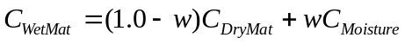 (1)
where C_{WetMat}, C_{DryMat}, C_{Moisture} represent specific heats of wet material, bone dry material, and liquid moisture respectively and w stands for the moisture content of the material.
When evaporation related balance simulation is involved, Duhring lines of the material solution to account for boiling point rise are required as input in addition to the specific heat of the bone dry material.
For a generic food material the basic compositions of the material needs to be specified. 5 basic components constitute a generic food material in addition to its moisture. They are Carbohydrate, Ash, Fiber, Fat and Protein.
The specific heat of a generic food material without moisture content is a weighted average of each of the 5 basic components. The specific heat as a function of temperature for each of the 5 basic components is based on Ibarz and Barbosa-Canovas (2003) and Heldman (2001) and listed in Table 1.

Table 1 Specific Heat of Generic Food Components

Carbohydrate
Ash
Fibe
Fat
Protein

The unit of temperature T is ºC and that of C_{p} is kJ/kg. ºC in Table 1.
For drying related balance simulation you need to specify the mass fraction for each of the 5 basic components to obtain the specific heat of the bone dry material. The specific heat of a generic food material with moisture is a weighted average of the bone dry food material and the moisture, which can be calculated by Equation 1.

2.5 Other Unit Operation Models

The heat exchanger models in Simprosys are based on Perry (1997), Kuppan (2000) Kakac and Liu (2002), McCabe, et al. (2000) and Chopey (2003). The cyclone models are based on Perry (1997), Zenz (1999) and Reynolds, et al. (2003). The electrostatic precipitator model is based on Perry (1997) and Reynolds, et al. (2003). The wet scrubber models are based Perry (1997) and Schifftner and Hesketh (1983). All the other unit operation models of Simprosys are based on Perry (1997).

2.6 Nonaqueous Systems

The peroperties of the organic liquids supported in Simprosys 3.0 are based on Perry (1997) (section 2, Physical and Chemical Data), Yaws (1999) and Yaw and Gabbula (2003). The properties of dry air and nitrogen are also based on Perry (1997) (section 2).
For a gas-liquid system, the governing equation of wet bulb temperature is (Keey (1978), Pakowski and Mujumdar (2007)):
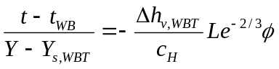 (1)
in which t and t_{WB} are the dry bulb and wet bulb temperatures, respectively; Y is the absolute humidity, Y_{s,WBT} is the saturation humidity at wet bulb temperature; 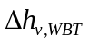is the latent heat of evaporation at wet bulb temperature; c_{H} is the humid heat; 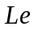and are Lewis number and humidity-potential coefficient defined by
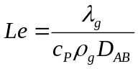 (2)
and
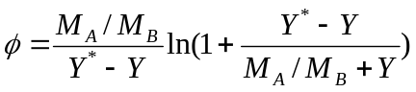 (3)
in which λ_{g}, c_{P} and ρ_{g} are the thermal conductivity, specific heat, and density of the humid gas; M_{A} and M_{B} are the molar mass of the moisture and dry gas; Y* is the saturation humidity; D_{AB} is the binary diffusivity between the moisture and the gas.
For Water-Air system 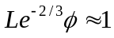 and it is well accepted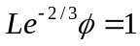.
For Carbon Tetrachloride-Air, Benzene-Air and Toluen-Air systems, the values of 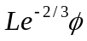 are from Perry [2] (section 12, Psychrometry, Evaporative Cooling, and Solids Drying).
For any other liquid-gas systems the value of are calculated according to equations 2, 3. The value of D_{AB} in equation 2 is based on Fuller et al. (1966, 1969) and Poling et al (2001).
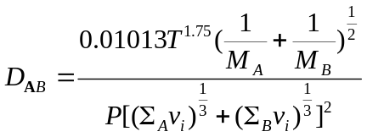 (4)
in which T and P are the temperature and pressure of the liquid-gas system. Units of T and P are K and Pa, respectively, with the resulting diffusivity in m²/sec. All v_{i} are group contribution values for the subscript component summed over atoms, groups, and structural features given in Table III of Fuller et al. (1966) or Table 11-1 of Poling et al. (2001).

2.7 References

- Mujumdar, A.S., 2007, Handbook of Industrial Drying, 3rd Ed.; CRC Press.
- Masters, K. 1985, Spray Drying Handbook, 4th Edition, John Wiley & Sons.
- Perry, R., 1997, Perry’s Chemical Engineers’ Handbook, 7th edition, McGraw-Hill.
- Pakowski, Z., Mujumdar, A.S., 2007, Basic Process Calculations and Simulations in Drying (chapter 3), in A.S. Mujumdar (Ed.) Handbook of Industrial Drying, 3rd Edition, CRC Press.
- Kemp, I.C., Oakley, D., 2002, Modeling of particulate drying in theory and practice, Drying Technology, 20, pp. 1699-1750.
- Ibarz, A., Barbosa-Canovas, G., 2003, Thermal Properties of Food (chapter 11), in Unit Operations in Food Engineering, CRC Press.
- Heldman, D.R., 2001, Prediction Models for Thermophysical Properties of Foods, in J. Irudayaraj (Ed.) Food Processing Operations Modeling: Design and Analysis, Marcel Dekker, pp. 1-23.
- Kuppan, T., 2000, Heat Exchanger Design Handbook (chapters 3 & 5), Marcel Dekker.
- Kakac, S. Liu, H., 2002, Heat Exchangers: Selection, Rating and Thermal Design, CRC Press, 2nd Edition.
- McCabe, W.L., Smith, J. Harriott, P., 2000, Unit Operations of Chemical Engineering (Chapters 12, 13, 15 & 16), McGraw-Hill, 6th Edition.
- Chopey, N.P., 2003, Handbook of Chemical Engineering Calculations (section 7), 3rd Edition, McGraw-Hill.
- Zenz, F.A., Cyclone Design (chapter 12), 1999, in W. Yang (Ed.) Fluidization, Solids Handling, and Processing: Industrial Applications, Noyes Publications.
- Reynolds, J.P., Jeris, J.S., Theodore, L., 2003, Handbook of Chemical and Environmental Engineering Calculations (chapter 15), John Wiley & Sons.
- Schifftner, K.C., Hesketh, H. E., 1983, Wet Scrubbers (chapter 1), Ann Arbor Science Publishers.
- Yaws, C.L., 1999, Chemical Properties Handbook, McGraw-Hill.
- Yaws, C.L.; Gabbula, C., 2003, Yaw’s Handbook of Thermodynamic and Physical Properties of Chemical Compounds, Knovel (eBook).
- Keey, R.B., 1978, Introduction to Industrial Drying Operations, Pergamon Press, Oxford.
- Fuller, E. N.; Shettler, P. D.; Giddings, J. C., 1966, A New Method for Prediction of Binary Gas-Phase Diffusion Coefficients, Industrial and Engineering Chemistry, 58 (5), 19-27.
- Fuller, E. N.; Ensley, K.; Giddings J.C. J., 1969, Diffusion of Halogenated Hydrocarbons in Helium-The Effect of Structure on Collision Cross Sections, The Journal of Physical Chemistry, 73 (11), 3679-3685.
- Poling, B.E.; Prausnitz, J.M.; O’Connell, J.P. 2001, The Properties of Gases and Liquids, 7th edition, McGraw-Hill.

