Simulation of Drying Nonaqueous Systems- An Application of Simprosys Software

ZHEN-XIANG GONG
Simprotek Corporation,
7375 Rollingdell Dr., Suite 41, Cupertino, California, USA 95014

ARUN S. MUJUMDAR
Department of Mechanical Engineering & Mineral, Metal & Materials Technology Centre ( M3TC) , National University of Singapore,
9 Engineering Drive 1, Singapore 117576
ABSTRACT

Drying software, Simprosys, for nonaqueous systems is described briefly and applied to a case study. A closed-loop ethanol-nitrogen drying system is modeled with Simprosys 2.1. Simulation results including a parametric evaluation are presented and discussed.

Key words and phrases: Dryer Design; Drying Simulation; Ethanol-Nitrogen Drying; Simprosys; Psychrometrics

INTRODUCTION

Drying of materials containing organic solvents or liquids is frequently encountered in the pharmaceutical and fine chemical industries. Based on the flash point of the organic liquid involved, either air or an inert gas can be used as the drying medium. For an organic liquid that has a high flash or burning point air can be used. However, an inert gas such as nitrogen has to be used for organic liquid of low burning point to prevent possible explosion. In some instances it may be possible to use flue gases with low oxygen content or superheated steam or very high humidity air to lower oxygen concentration below the flash point of the nonaqueous solvent (or solvent mixture).
Literature search leads to very limited effort devoted to drying of nonaqueous systems. Handbooks by Mujumdar [1] and Perry [2] contain only a few psychrometric charts for nonaqueous systems. With these charts users must use a ruler to measure and read data on the charts and then plug the data into their calculations. It is obviously inadequate for engineers and university students to do their drying calculations this way in this electronic age.
Simprosys, a Windows-based software package, developed by Simprotek Corporation (www.simprotek.com), provides an integrated, powerful, yet highly user-friendly, contemporary tool for the design and simulation of dryer flowsheet as well as drying systems not only for aqueous, but also for the commonly encountered nonaqueous drying systems. Since the release of its first version for Water-Air drying systems (Gong [3]), Simprosys has been developed into its advanced version 2.1 to handle eleven additional other nonaqueous drying systems. The eleven other nonaqueous drying systems include: Ethanol-Air, Ethanol-Nitrogen, Carbon Tetrachloride-Air, Benzene-Air, Toluene-Air, Acetone-Nitrogen, Methanol-Nitrogen, N-Propanol-Nitrogen, Isopropanol-Nitrogen, N-Butanol-Nitrogen and Isobutanol-Nitrogen.
For the most common Air-Water system, Simprosys 2.1 supports 19 unit operations (Gong and Mujumdar [4]). For its other eleven nonaqueous drying systems, Simprosys 2.1 supports 15 unit operations (viz solids dryer, cyclone, air filter, bag filter, electro-static precipitator, scrubber/condenser, fan/blower, compressor, valve, heater, cooler, heat exchanger, mixer, tee and pump) and a logical unit operation, recycle.
For information about software or programs applicable to drying please refer to Gong and Mujumdar [4], Kemp [5], Kemp et al. [6] and Menshatina and Kudra [7]. It is worthwhile a mention that a software package called DrySPEC2 (DRYer System for Property and Energy Control), developed by NIZO food research (The Netherlands), is available for modeling spray dryers (Straatsma et al. [8], Verdurmen, et al. [9]). Another effort worthwhile to mention is the application of Microsoft Excel combined with Visual Basic used to model and simulate dryer designs (Maroulis et al. [10]).
In the following sections a brief introduction is provided for the reader to understand the basic principles and application of this unique software.

PRINCIPLES OF SIMPROSYS 2.1

For the water-air system, the properties (including saturation pressure) of water are calculated according to the 1967 ASME Steam Tables.
The peroperties of the organic liquids supported in Simprosys 2.1 are based on Perry [2] (section 2, Physical and Chemical Data), Yaws [11] and Yaw and Gabbula [12]. The properties of dry air and nitrogen are also based on Perry [2] (section 2).
The drying flowsheet model and dryer model of Simprosys are based on comprehensive studies of the world’s most authoritative handbooks by Mujumdar [1, 13], Masters [14] and Perry [2, 15].
For details about the material property model and other unit operation models in Simpsosys please refer to Gong and Mujumdar [4].
The calculations of absolute humidity, relative humidity, wet bulb temperature, dew point temperature, humid volume, humid heat, and humid enthalpy are based on information found in Pakowski and Mujumdar [16].
For a gas-liquid system, the governing equation of wet bulb temperature is (Keey [17], Pakowski and Mujumdar [16]):
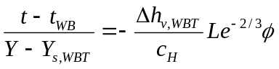 (1)
in which t and t_{WB} are the dry bulb and wet bulb temperatures, respectively; Y is the absolute humidity, Y_{s,WBT} is the saturation humidity at wet bulb temperature; 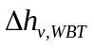is the latent heat of evaporation at wet bulb temperature; c_{H} is the humid heat; 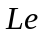and are Lewis number and humidity-potential coefficient defined by
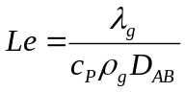 (2)
and
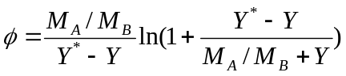 (3)
in which λ_{g}, c_{P} and ρ_{g} are the thermal conductivity, specific heat, and density of the humid gas; M_{A} and M_{B} are the molar mass of the moisture and dry gas; Y* is the saturation humidity; D_{AB} is the binary diffusivity between the moisture and the gas.
For Water-Air system 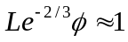 and it is well accepted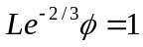.
For Carbon Tetrachloride-Air, Benzene-Air and Toluen-Air systems, the values of 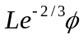 are from Perry [2] (section 12, Psychrometry, Evaporative Cooling, and Solids Drying).
For any other liquid-gas systems the value of are calculated according to equations 2, 3. The value of D_{AB} in equation 2 is based on Fuller et al. [18, 19] and Poling et al [20].
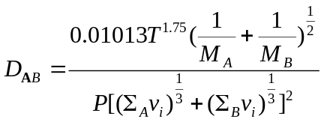 (4)
in which T and P are the temperature and pressure of the liquid-gas system. Units of T and P are K and Pa, respectively, with the resulting diffusivity in m²/sec. All v_{i} are group contribution values for the subscript component summed over atoms, groups, and structural features given in Table III of Fuller et al. [19] or Table 11-1 of Poling et al. [20].
Please note that equation 2-152 in Perry [2] cited from Fuller et al. [18] has a wrong coefficient of 0.10103 which should be 0.01013.

A CLOSED-LOOP ETHANOL-NITROGEN SYSTEM

Drying of materials containing nonaqueous solvents is generally carried out in a closed-loop system so that the exhaust gas containing nonaqueous vapors are not discharged unto the atmosphere to pollute the air.
Simprosys 2.1 is applied to the drying of a solid material containing ethanol. Due to the low flash (burning) point, nitrogen is used as the drying gas to prevent possible explosion hazard. In order not to lose both the ethanol and the nitrogen drying gas in the exhaust, a closed-loop drying system as displayed in Figure 1 is needed.
The input and output conditions of the drying material and nitrogen drying gas are as follows: Material feed temperature = 20 ºC; Feed moisture content = 0.08 kg/kg wet basis; Wet material mass flow rate = 2000 kg/hr; Product temperature = 50 ºC; Product moisture content = 0.002 kg/kg wet basis. Nitrogen pressure at dryer inlet = 102.4 kPa; Temperature at dryer inlet = 120 ºC; Mass flow rate wet basis at dryer inlet = 3000 kg/hr.
Pressure drop of the dryer is 1.2 kPa. Dryer gas outlet stream goes through a fan to gain 1.5 kPa static pressure. Efficiency of the fan is 0.75. Exhaust air coming from the fan goes through a scrubber/condenser to collect the dusts and remove the moisture carried in the exhaust air. Temperature of the exhaust air from the scrubber/condenser is 35 ºC. Air pressure drop in scrubber/condenser is 1.0 kPa. Collection efficiency and liquid gas ratio of the scrubber/condenser are 99% and 1.0 respectively. Liquid inlet pressure and temperature of the scrubber/condenser are 101.3 kPa and 20 ºC. The air coming out of the scrubber/condenser goes through a fan to gain some static pressure and then go through a heater to be heated to the required dryer inlet temperature (120 ºC). The efficiency of the fan is set at 0.75. The pressure drop of air in the heater is 0.6 kPa.
The flowsheet is constructed as shown in Figure 1. The simulation results produced using Simprosys 2.1 are displayed in Figure 2.

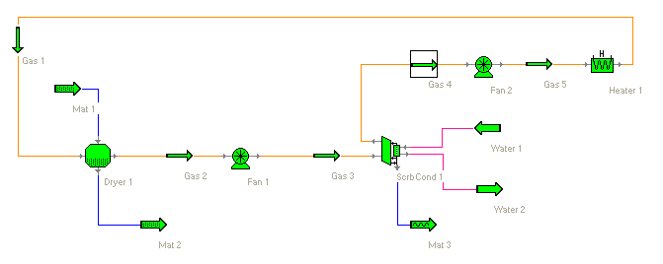
Figure 1 Flowsheet of a Closed-Loop Nitrogen-Ethanol System

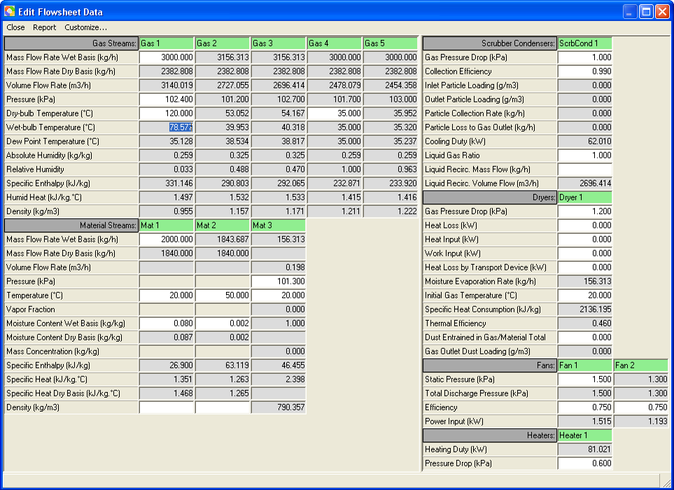

Figure 2 Simulation Results of the Nitrogen-Ethanol System

Please be noted that one can use the Heating Duty of the heater, in stead of the Dry-bulb Temperature of the dryer gas inlet; and/or the Dry-bulb Temperature of the dryer gas outlet, instead of the Moisture Content of the material inlet, as input parameter to simulate the operation of an existing drying system.
Parametric studies are carried out to investigate the effects of several major operational parameters on other process parameters such scrubber/condenser cooling duty, heater heating duty and dryer exhaust gas temperature and relative humidity.

Effects of Scrubber/Condenser Gas Outlet Temperature
All input parameter values are kept the same in the flowsheet (Figure 2) except for changing scrubber/condenser gas outlet temperature to see how it affects other process parameters. The simulation results are displayed in Table 1.

Table 1 Effects of Scrubber/Condenser Gas Outlet Temperature

Scrubber/Condenser Gas Outlet Temperature (ºC) | Scrubber/Condenser Cooling Duty (kW) | Heater Heating Duty (kW) | Dryer Gas Outlet Temperature (ºC) | Dryer Exhaust Gas Relative Humidity
25 | 69.03 | 86.82 | 51.33 | 0.345
35 | 62.01 | 81.02 | 53.05 | 0.488
45 | 55.27 | 75.86 | 55.40 | 0.676

From Table 1 one can see that with an increase of the scrubber/condenser gas outlet temperature, both the scrubber/condenser cooling duty and the heater heating duty decrease; but the dryer exhaust gas relative humidity and temperature increase.
When the scrubber/condenser gas outlet temperature is increased, the saturation moisture content of the gas increases. This leads to increased dryer gas inlet moisture content. Increased gas moisture content results in decreased mass transfer for the dryer, which means an increased dryer size for a design, which means increased equipment cost. Therefore, for the same evaporation duty in the design of such a closed-loop drying system, a larger dryer is required if a higher scrubber/condenser gas outlet temperature is adopted, with the consequence of increased equipment cost but decreased operating cost due to less energy consumption. To the contrary, a smaller dryer is required if a lower scrubber/condenser gas outlet temperature is adopted, which means lower equipment cost but increased operating cost due to higher energy consumption.

Effects of Material Inlet Moisture Content

All input parameter values (including the material outlet Moisture Content Wet Basis, 0.002) are kept the same in the flowsheet (Figure 2) except for changing the material inlet moisture content to see how it affects other process parameters. The simulation results are displayed in Table 2.

Table 2 Effects of Material Inlet Moisture Content

Material Inlet Moisture Content (kg/kg wet basis) | Scrubber/Condenser Cooling Duty (kW) | Heater Heating Duty (kW) | Dryer Gas Outlet Temperature (ºC) | Dryer Gas Outlet Relative Humidity
0.07 | 61.81 | 81.02 | 58.42 | 0.373
0.08 | 62.01 | 81.02 | 53.05 | 0.488
0.09 | 62.23 | 81.02 | 47.77 | 0.641

From Table 2 one can see that with an increase of the material inlet moisture content, the scrubber/condenser cooling duty and the heater heating duty keep almost the same; the dryer exhaust gas relative humidity increases; but the dryer exhaust gas temperature decreases.
With an increase in the material inlet moisture content the evaporation duty increases since the specified material outlet moisture content keeps the same. This results in more heat to be spent to evaporate the increased ethanol liquid. Therefore, the dryer gas outlet temperature decreases, which results in the increase of the dryer gas outlet relative humidity.
One may expect the scrubber/condenser cooling duty and the heater heating duty to increase due to the increased material inlet moisture content. As no extra heat is added into the system in spite of the increased evaporation duty, it results in the decrease of the dryer gas outlet temperature.
If the drying kinetics (which is to be developed in the future version of Simprosys) is taken into consideration for an existing system, when there is an increase in the material inlet moisture content, the dryer gas inlet temperature has to be increased to increase the heat and mass transfer to satisfy the material outlet moisture content requirement. In that case, the scrubber/condenser cooling duty and the heater heating duty will have to increase to balance the increases heat input in the system.

Effects of Dyer Gas Inlet Temperature

All input parameter values are kept the same in the flowsheet (Figure 2) except for changing the dryer gas inlet temperature to see how it affects other process parameters. The simulation results are displayed in Table 3.

Table 3 Effects of Dryer Gas Inlet Temperature

Dryer Gas Inlet Temperature (ºC) | Scrubber/Condenser Cooling Duty (kW) | Heater Heating Duty (kW) | Dryer Gas Outlet Temperature (ºC) | Dryer Exhaust Gas Relative Humidity
110 | 52.50 | 71.15 | 43.67 | 0.769
120 | 62.01 | 81.02 | 53.05 | 0.488
130 | 71.59 | 90.96 | 62.44 | 0.318

From Table 3, one can see, as is expected, with an increase of the dryer gas inlet temperature, the scrubber/condenser cooling duty, the heater heating duty and the dryer gas outlet temperature increase; but the dryer exhaust gas relative humidity decreases due to the increased dryer gas outlet temperature.

CLOSING REMARKS

Simprosys provides an integrated, powerful, highly user-friendly, contemporary, but cost-effective tool for the design and simulation of dryer and drying systems involving not only aqueous systems, but also eleven commonly encountered nonaqueous systems. Extension of Simprosys 2.1 to other nonaqueous systems is simple and easy on demand.
Simprosys makes tedious complicated thermal calculations simple for the design and simulation of dryers and drying systems. Typical calculations of a process that may take one skilled engineer weeks to carry out can now be accomplished in hours with Simprosys. This software can be used to examine (optimize and/or trouble shoot) existing drying systems, modifying existing systems and also to evaluate new systems before they are installed.
Simprosys has very intuitive user interfaces with maximum protection to prevent users from making simple mistakes. It also has an effective tutorial to teach users step by step how to use the software to simulate typical drying and evaporation related systems. Users of Simprosys will require minimal self-training and effort to use it effectively.
Interested readers may visit www.simprotek.com to download a free trial version to explore the capability of Simprosys for their own applications.

REFERENCES

- Mujumdar, A.S. Handbook of Industrial Drying, 1st Edition, Marcel Dekker, 1987.
- Perry, R. Perry’s Chemical Engineers’ Handbook, 7th edition, McGraw-Hill, 1997.
- Gong, Z. Drying Software – Simprosys: Motivation, Development, Applications and Potential Role in Practice, The Proceedings of the 5th Asia-Pacific Drying Conference, Chen, G. Editor, 2007, 1295-1301.
- Gong, Z.; and Mujumdar A. S. Software for Design and Analysis of Drying Systems, Drying Technology, 2008, 26 (7), 884-894.
- Kemp, I.C. Drying Software: Past, Present and Future, Drying Technology, 2007, 25, 1249-1263.
- Kemp, I.C.; Hallas, N.J.; Oakley, D.E. Developments in Aspen Technology Drying Software. Proceedings of 14th Intl Drying Symposium (IDS), Sao Paulo, August, 2004, Volume B, 767-774.
- Menshutina, N.V.; Kudra, T. Computer Aided Drying Technologies, Drying Technology, 2001, 19, 1825-1850.
- Straatsma, J.; Van Houwelingen, G.; Meulman, A. P.; Steenbergen, A. E. Dryspec2: A Computer Model of a Two-stage Dryer, International Journal of Dairy Technology, 2007, 44, 107-111.
- Verdurmen, R. E. M.; Straatsma, H.; Verschueren, M.; van Haren, J.J.; Smith, E.; Bargeman, G. and De Jong, P., Modeling Spray Drying Processes for Dairy Products, Lait 82, 2002, 453-463.
- Maroulis, Z.B.; Saravacos, G.D.; Mujumdar, A.S. Spreadsheet-Aided Dryer Design, Chapter 5, in Handbook of Industrial Drying, 3rd Edition, Mujumdar, A.S. Eds.; CRC Press, 2007.
- Yaws, C.L. Chemical Properties Handbook, McGraw-Hill, 1999.
- Yaws, C.L.; Gabbula, C. Yaw’s Handbook of Thermodynamic and Physical Properties of Chemical Compounds, Knovel (eBook), 2003.
- Mujumdar, A.S. Handbook of Industrial Drying, 3rd Edition, CRC Press, 2007.
- Masters, K. Spray Drying Handbook, 4th Edition, John Wiley & Sons, 1985.
- Green, D.; Perry, R. Perry’s Chemical Engineers’ Handbook, 8th edition, McGraw-Hill Professional, 2007.
- Pakowski, Z.; Mujumdar, A.S. Basic Process Calculations and Simulations in Drying, Chapter 3, in Handbook of Industrial Drying, 3rd Edition, Mujumdar, A.S. Ed.; CRC Press, 2007.
- Keey, R.B. Introduction to Industrial Drying Operations, Pergamon Press, Oxford, 1978.
- Fuller, E. N.; Shettler, P. D.; Giddings, J. C. A New Method for Prediction of Binary Gas-Phase Diffusion Coefficients, Industrial and Engineering Chemistry, 1966, 58 (5), 19-27.
- Fuller, E. N.; Ensley, K.; Giddings J.C. J. Diffusion of Halogenated Hydrocarbons in Helium-The Effect of Structure on Collision Cross Sections, The Journal of Physical Chemistry, 1969, 73 (11), 3679-3685.
- Poling, B.E.; Prausnitz, J.M.; O’Connell, J.P. The Properties of Gases and Liquids, 7th edition, McGraw-Hill, 2001.

