Energy Audit of a Fiberboard Drying Production Line using Simprosys Software

ZHEN-XIANG GONG
Simprotek Corporation,
7375 Rollingdell Dr, Suite 41, Cupertino, California, USA 95014

JÁN STANOVSKÝ
Smrečina Hofatex, a.s.
Cesta ku Smrečine 5, SK-975 45 Banská Bystrica, Slovakia

ARUN S. MUJUMDAR
Department of Mechanical Engineering & Mineral, Metal & Materials Technology Centre ( M3TC) , National University of Singapore,
9 Engineering Drive 1, Singapore 117576
ABSTRACT

This paper presents a case study of Simprosys applied to the energy efficiency evaluation of an exisisting fiberboard drying production line. An energy examination of the dryer and the drying system under current operating conditions is performed using Simprosys 2.1. Detailed parametric studies of the drying system are carried out. Possible improvements for the enegry efficiency of the dryer iteself and the drying system is proposed and discussed.

Key words and phrases: Dryer Design; Drying Simulation; Fiberboard Drying; Simprosys; Energy Efficiency

INTRODUCTION

Thermal drying is an energy-intensive operation to produce almost everything we need in our everyday life. Energy audits have shown that 13-20 percent of industrial energy consumption goes into thermal drying operations in developed countries. With industrial dryer efficiencies ranging from just 30 to 60 percent, there is a great potential for improvements especially in view of rising energy costs, sustainability issues related to carbon footprint as well as environmental constraints on greenhouse gas emissions from burning of fossil fuels.
To improve the energy efficiency of an existing thermal drying system, appropriate process data need to be measured and/or collected at the first step. Then heat and mass balance calculations of the dryer itself as well as the drying system as a whole need to be carried out to determine the thermal efficiency of the dryer and the specific heat consumption of the drying product. Based on the calculation results an energy efficiency target can be set. Then detailed parametric studies are necessary for possible process improvements such as recycling part of the exhaust gas and heat recovery from the exhaust gas. Note that such improvements may or may not need additional capital outlays.
As is well known, drying-related thermal calculations are sophisticated and tedious. However, contemporary software tools such as the Simprosys software developed by Simprotek Corporation has made such calculations very simple and fast. Simprosys can take into consideration not only the process parameters (including the thermal efficiency of the dryer and specific heat consumption of the drying product) of the dryer itself, but also the drying system as a whole including pre and post dryer operations such as fans, heaters, cyclones, scrubber/condenser, etc. It is a cost-effective and easy-to-use tool to evaluate and optimize dryers and drying systems. With the help of such a software tool, engineers can focus on the process itself and not worry about the complicated calculations. It can be used to improve an existing flowsheet and also to evaluate alternate energy-savings strategies at the design stage itself - a highly recommended step.
This paper demonstrates how to use Simprosys to evaluate drying systems and do possible process improvements using an existing fiberboard drying production line of Smrečina Hofatex, a.s., Slovakia, as an example. Readers will no doubt find newer possibilities to improve existing plant operations and also evaluate alternate design strategies at the design stage itself.

AVAILABLE DRYING SYSTEM MODELING SOFTWARE

Available commercial software for dryers and drying operations is very limited for various reasons [1]. A literature study finds only three commercial software packages specifically intended for drying. They are: Simprosys, dryPAK and DrySel. dryPAK is a DOS-based software package which does dryer design calculations including heat and mass balance and drying kinetics calculations [2]. DrySel is an expert system for dryer selection [3]. It is a proprietary software package.
Simprosys is a Windows-based process simulation software package designed for the thermal calculations of not only the dryer itself, but also the drying system including pre and post drying operations such as evaporation and exhaust gas processing operations [4, 5]. The dryer model and other unit operations’ models of Simprosys are based on the most authoritative handbooks [6-12] as well as extensive research studies and expert knowledge of two of the authors in not only drying but also process modeling and simulations. The database of Simprosys is based on publicly available data from standard references such as Perry [8], Yaws [13] and Yaws and Gabbula [14].
Simprosys can deal with not only the most common Air-Water system, but also eleven additional other non-aqueous drying systems as well [15].
For more information about the drying software, please refer to Gong and Mujumdar [5], Kemp [1], Kemp et al. [2] and Menshatina and Kudra [16]. It is worthwhile to mention that a software package called DrySPEC2 developed by NIZO food research (The Netherlands) is available for modeling spray dryers [17, 18]. In addition, attempts of using Microsoft Excel to carry out dryer related calculations have also been reported in recent years [19, 20] although this is not the mainstream drying software.

ENERGY COMSUMPTION EVALUATION OF A FIBERBOARD PRODUCTION LINE

The case of this study is an existing fiberboard drying production line of Smrečina Hofatex, a.s, Slovakia. The fiberboard products are thermo-insulating boards with Length/Width dimensions of dry boards at 5/2.5 m. The thickness of the products is in the range of 8-22 mm and the specific weight from 160 to 250 kg/m3 depending on each product.

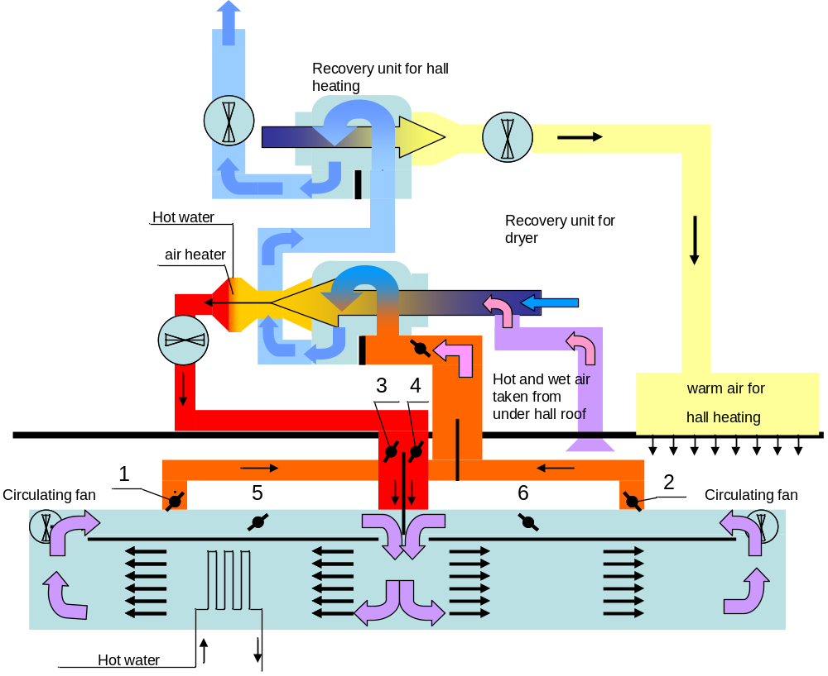

Figure 1 Process Diagram of Fiberboad Drying Production Line

Softwood logs are cut into chips which are treated using thermo-mechanical process into water-fiber suspension. The suspension is dewatered on wired dewatering machine into cake with a dryness of 35-45%. Then it is cut into boards and fed to the production line at about 35 ºC. Final moisture content of the dry boards is about 5%. Figure 1 shows a process diagram of the drying system. The bottom light blue color section in the diagram is the drying section. It is composed of two sections. One is the wet section (the left part) and the other is the dry section (the right part). Wet board enters the produciton line from left end and comes out from the right end as the dry product.
Fresh air is preheated to about 55 ºC by the exhaust air (in the recovery unit for dryer in Figure 1). Then it is heated by hot water to the needed inlet temperaure at about 120 ºC in the air heater. The left heat needed for the production line is provied by hot water through coil tubes under the production line. The heat from the hot water coil tubes is carried by circulating air and delivered to the fiberboard on the production line. Drying time varies significantly (e.g . from 50 to 350 minutes) depending very much on product thickness.
The process paremters of the fiberboad product in this study were measured and are listed below:
- Volume flow rate at dryer outlet = 5.4 m³/hr.
- Specific weight at dryer outlet = 245 kg/ m³.
- Dryness at dryer inlet = 0.43 kg/kg, equivalent to a moisture content of 0.57 kg/kg (wet basis)
- Moisture content at dryer outlet = 0.02 kg/kg (wet basis).
- Temperature at dryer inlet = 38 ºC.
- Temperature at dryer outlet = 79 ºC.
- Drying time = 300 minuts.
The process paremters of air and heating system were measured and listed as follows:
- Hot water volume flow rate = 310 m³/hr
- Hot water inlet temperature = 182.9 ºC
- Hot water outlet temperature = 176.7 ºC
- Fresh air temperature at dryer inlet = 122 ºC
- Fresh air volume flow rate at dryer inlet = 4728.3 m³/hr (at 122 ºC)
- Fresh air is preheated from 38 ºC to 56 ºC by dryer exhaust air.
- Fresh air is then heated from 56 ºC to 122 ºC by hot water before sent to the dryer.
- Exhaust air temperature = 147 ºC.
To do the needed heat and mass balance calculations for the drying operation, a simple drying flowsheet was designed as displayed in Figure 2. It is created using Simprosys 2.1. Due to lack of more detailed process data the two (the wet and dry) sections of the production line can only be modeled as a one stage drying process in this study. This is not a limitation of the software, however.

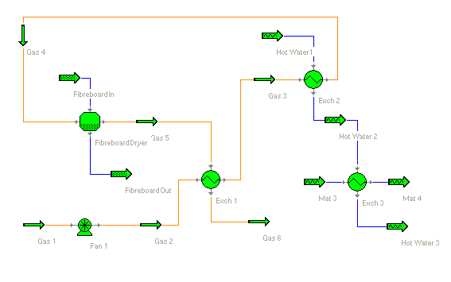
Figure 2 Fiberboard Drying Plant Flowsheet

In Figure 2, fresh air, Gas 1, goes into the drying system through Fan 1. It is then preheated by the dryer exhaust, Gas 5, in heat exchanger Exch 1. Then it is further heated by hot water in heat exchanger Exch 2 to the required inlet temperature before going into the dryer FiberboardDryer. Heat exchanger Exch 3 is used to calculate the heat loss of the hot water. The calculated heat loss is taken as the heat input of the dryer.
The net heat recovered from exhaust air to pre-heat fresh air from 38 to 56 ºC is calculated by Exch 1 as 21.4 kW. The net heat obtained from the hot water to heat the fresh air from 56 to 122 ºC is calculated by Exch 2 as 78.6 kW. The heat input of the dryer from the hot water in addition to that from the fresh air is calculated by Exch 3 as 2000.6 kW. The total heat that the dryer obtains from the hot water is 78.6 + 2000.6 = 2079.2 kW.
Since we do not have all the needed parameter values to close the heat and mass balance calculations, the following parameter values are assumed:
- Specific heat of bone dry fiberboard = 1.26 kJ/kg. ºC
- Fresh air pressure at dryer inlet = 101.8 kPa.
- Fresh air pressure at dryer outlet = 101.4 kPa.
- Fresh air relative humidity at fan inlet = 50 % which is equivalent to 0.021 kg/kg absolute humidity at 38 ºC
Parametric studies showed that the impact of the inaccuracy from the assumed values on the analysis results is trivial and negaligible.
The heat and mass balance results of the dryer are calculated by the software and displayed in Figure 3.

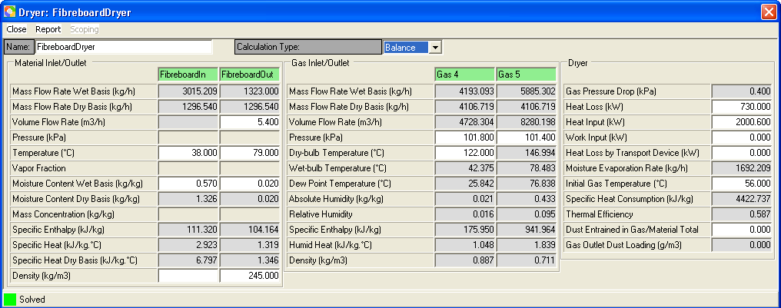

Figure 3 Heat and Mass Balance Data of Dryer with Current Operating Conditions

From Figure 3 the following major dryer parameters are obtained:

- Moisture Evaporation Rate = 1692.2 kg/hr.
- Specific Heat Consumption = 4422.7 kJ/kg water removed. This is equivalent to 1.39 GJ/m³ dried fiberboard after correction for preheat by exhaust air from 38 ºC to 56 ºC.
- Exhaust Air Relative Humidity = 0.095 or 9.5%
- Heat loss is 730.0 kW which calculates a 35.1% (730.0/2079.2) of the total heat to satisfy the 147 ºC exhaust air outlet temperature.

It is obvious that the heat loss of the dryer (more accurately, of the drying process) is excessive. This is also reflected in the high value of the specific heat consumption at 4422.7 kJ/kg water removed. However, the exhaust air relative humidity appears to be very low, only at 9.5%.
In the following sections, parametric studies will be carried out to see if some energy savings can be achieved by changing only the current operating conditions without changing existing equipment. Then we will investigate all possible potentials for energy efficiency improvements of not only the dryer but also the drying system as a whole.

EFFECTS OF OPERATING PARAMETERS

On the basis of current operating conditions, parametric studies are carried out to see how some major operating parameters such as the dryer heat input and fresh air inflow affect the energy consumption.

Effect of Heat Input

As is seen from above, the relative humidity of the exhaust air is only 9.5% which seems to be very low. One might think that it is possible for the dryer to perform its required task with a reduced heat input.
To investigate this possibility, we keep all operating conditions the same and reduce the dryer heat input to see how the exhaust air temperature and relative humidity change.
Figures 4a and 4b display the simulation results with 2 assumed dryer heat input values. Table 1 is a summary of the simulation results for Figures 3, 4a and 4b.
From Table 1 we can see that with a decrease of the dryer heat input, the exhaust air temperature drops, but relative humidity rises sharply. A sharply raised relative humidity can lead to significantly dropped drying rate, which will result in unfulfilled drying duty of the dryer.
Thus the conclusion can be reached that there is not so much room to reduce dryer heat input.

Table 1 Effects of Dryer Heat Input

Process Flow | Dryer Heat Input (kW) | Exhaust Temperature (ºC) | Exhaust Relative Humidity
Figure 3 | 2000.6 | 147.0 | 9.5%
Figure 4a | 1950.0 | 122.5 | 19.4%
Figure 4b | 1900.0 | 98.2 | 43.8%

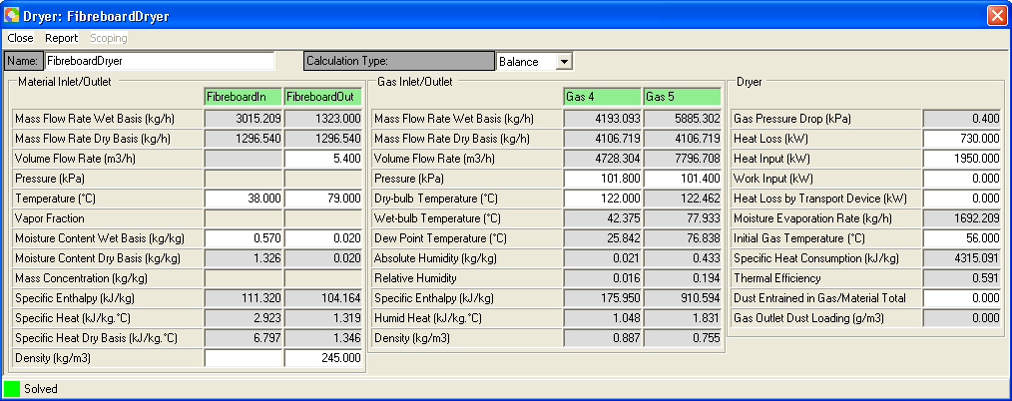

Figure 4a Dryer Heat Input at 1950 kW

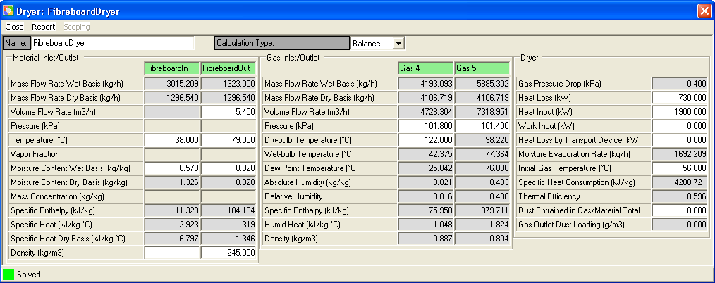

Figure 4b Dryer Heat Input at 1900 kW

Effect of Fresh Air Inflow

To investigate the effects of fresh air inflow, we keep all operating conditions the same and increase fresh air inflow (the volume flow rate of Gas 1 in Figure 2) to see how the exhaust air temperature and relative humidity change.
Figures 5a and 5b display the simulation results with 2 assumed fresh air inflow values. Table 2 is a summary of the simulation results for Figures 3, 5a and 5b.
From Table 2 we can see that with an increase of the fresh air inflow, the exhaust air temperature drops, but the exhaust relative humidity rises slightly.
Only from the heat and mass balance point of view an increased fresh air inflow has almost no effect on the energy balance of the dryer. However, it can impact the drying kinetics which will be further discussed in the following sections.

Table 2 Effects of Fresh Air Inflow

Fresh Air Inflow (m³/hr) | Fresh Air at Dyer Inlet (m³/hr) | Exhaust Temperature (ºC) | Exhaust Relative Humidity
3741.6 | 4728 | 147.0 | 9.5%
4800 | 6062 | 134.8 | 11.6%
5800 | 7277 | 125.4 | 13.6%

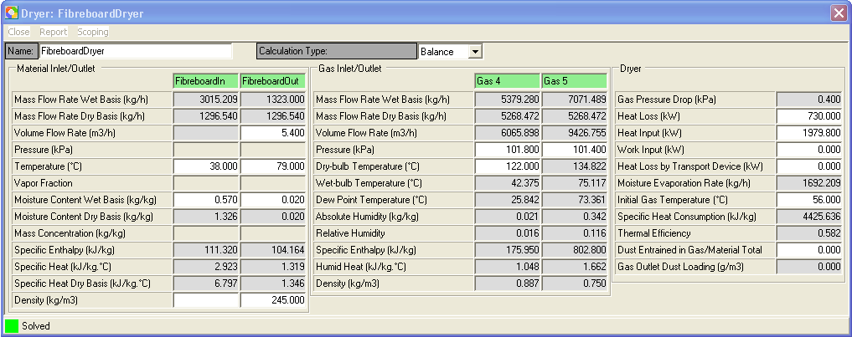

Figure 5a Fresh Air Inflow at 6065 m³/hr

It should be noted that, from Figure 5a, under the specified fresh air inflow the net heat recovered from exhaust air by heating fresh air from 38 ºC to 56 ºC is 27.1 kW. The heat duty needed to heat fresh air from 56 ºC to 122 ºC is 99.8 kW. The heat input to the dryer in addition to the fresh air is 2079.2 – 99.8 = 1979.8.

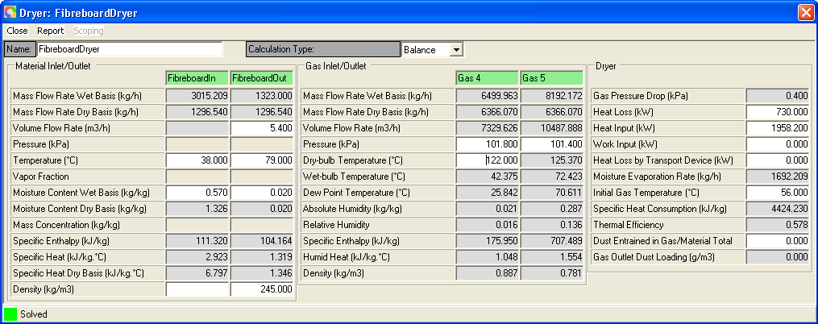

Figure 5b Fresh Air Inflow at 7229 m³/hr

Please be noted that, in Figure 5b, under the specified fresh air inflow the net heat recovered from exhaust air by heating fresh air from 38 ºC to 56 ºC is 32.9 kW. The heat duty to heat fresh air from 56 ºC to 122 ºC is 121.0 kW. The heat input to the dryer in addition to the fresh air is 2079.2 – 121.0 = 1958.2

POSSIBLE WAYS TO IMPROVE ENERGY EFFICIENCY

Based on measured process data and the heat and mass balance analysis results from Simprosys, we find that there are 3 possible ways to improve the dryer energy efficiency. They are:
- Decrease heat loss by improving insulation of the dryer and the hot water transport lines.
- Effectively recover the waste heat from the exhaust air.
- Shorten the drying time by increasing air flow in the dryer or by increasing hot water temperature or by doing both, which might be the most feasible way without significantly upgrading current equipment.
To investigate the possible improvements, a drying flowsheet as displayed in Figure 6 is created using Simprosys 2.1 for the needed parametric studies of the dryer and drying system. This flowsheet is an extension of the simple flowsheet in Figure 2.
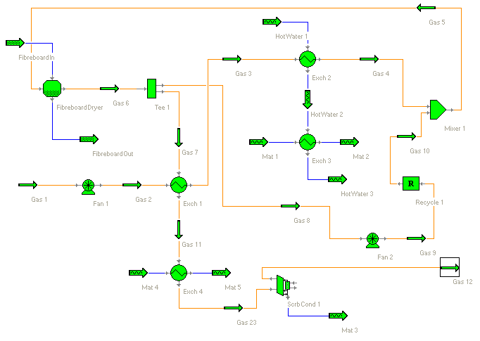
Figure 6 Fiberboard Drying Flowsheet with Recycled Exhaust and Heat Recovery

Fresh air, Gas 1, goes into the drying system through Fan 1. It is then preheated by a portion of the dryer exhaust (Gas 7) in heat exchanger Exch 1. The other portion of the dryer exhaust (Gas 8) goes through Fan 2 and recycled back into the drying system. Then the fresh air (Gas 3) is further heated by hot water in heat exchanger Exch 2 to 122 ºC before it is mixed with the recyled dryer exhaust (Gas 10) in Mixer 1. The mixed drying air (Gas 5) is introduced into the dryer. Heat exchanger Exch 3 is used to calculate the heat loss of the hot water, which is consumed as the heat input of the dryer. Heat exchanger Exch 4 is used to calculate the possible sensible heat recovery above the dew point of the dryer exhaust. Scrubber/Condenser ScrbCond 1 is used to calculate the possible heat recovery below the dew point of the dryer exhaust air.

Decreasing Heat Loss

As is analyzed, heat loss of the current drying process is approximately 35% of the total required heat for this specific drying product. Improving dryer isolation and eliminating hot air leaking are two possible ways to decrease heat loss. To achieve such goals an enclosed dryer or drying production line like the dryer hood of a paper machine may be required. However, the cost for such an equipment upgrade is not something minor. It needs to be carefully designed and a feasibility study of the equipment cost and operating benefit is necessary.

Exhaust Air Heat Recovery

Since the exhaust air is discharged at such a high temperature as 147 ºC, it contains quite an amount of sensible and latent heat that can be recovered. Currently only a very small portion (about 21.4 kW) of the exhaust heat is recovered.
To investigate the potential of heat recovery, three assumed exhaust air discharge temperatures are simulated. The simulation results are displayed in Figures 7a through 7c and summarized in Table 4.
It is calculated by heat exchanger Exch 4 that 127 kW of sensible heat can be recovered from 137.7 ºC (the temperature of Gas 11, the exhaust after preheating the fresh air) to the dew point of the exhaust air at 76.7 ºC in addition to the 21.4 kW currently recovered. Further possible recovery below the dew point of the exhaust air is summarized in table 4.
The recoverable sensible heat can be easily used to heat the fresh air if the exhaust air discharge system is well controlled. The recoverable heat can be used in other processes of the plant such as the pulping process.
It is obvious that the lower the discharge temperature of the exhaust air, the more the heat that can be recovered. However, with a decreased discharge temperature, the heat recovery cost will increase. Therefore, when the discharge temperature is decided, a trade-off must be carefully balanced for the equipment cost and operating benefit.

Table 4 Possible Heat Recovery

Exhaust Discharge Temperature (ºC) | Sensible Heat Recovery Above Dew Point (kW) | Heat Recovery Below Dew Point (kW) | Possible Total Heat Recovery (kW)
70 | 127 | 480 | 607
60 | 127 | 869 | 996
50 | 127 | 1080 | 1307

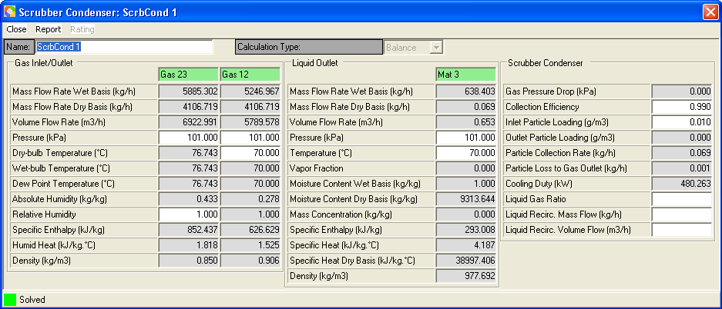

Figure 7a Possible Heat Recovery at Discharge Temperature of 70 ºC

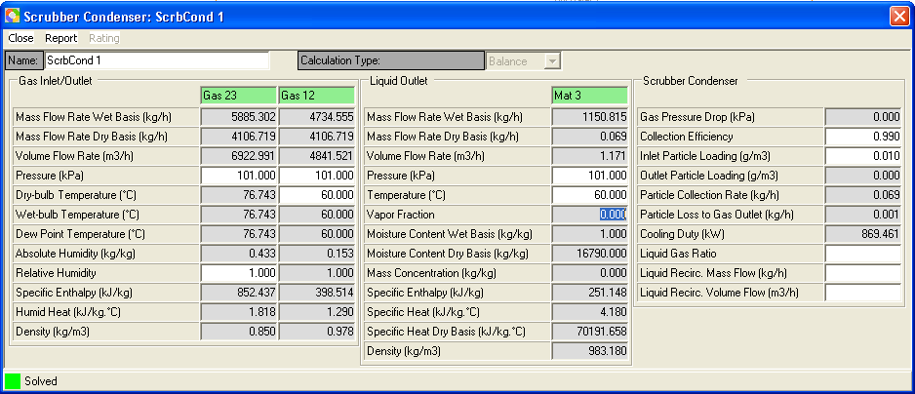

Figure 7b Possible Heat Recovery at Discharge Temperature of 60 ºC

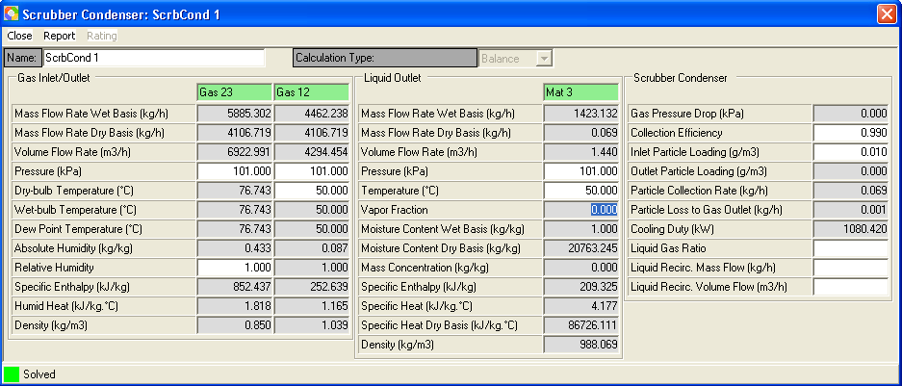

Figure 7c Possible Heat Recovery at Discharge Temperature of 50 ºC

It is always a good idea to put the exhaust air heat recovery into the energy picture of the whole plant to see if the recoverable heat can be effectively used in other processes such as the pulping process.
Simulation results (not shown here) also indicate that with an increased fresh air inflow, possible heat recovery will decrease slightly since increased fresh air means increased heat carried away by the exhaust at the same discharge temperature. Also, possible heat recovery will be different too when the exhaust air outlet temperature changes,

Increasing Air Flow

An increased airflow in the dryer will enhance the heat transfer from the air to the fiberboard, which leads to an increased drying rate for not only the constant drying period but also the falling rate drying period, which will result in a decreased drying time.
If the drying time could be shorten by 20% for the analyzed drying product, there would be about 20% less heat loss which is equivalent to about 146 kW (20% of the 730 kW) of energy saving, in addition to the benefit of the shortened production cycle.
Increasing exhaust recycle ratio and/or increasing fresh air inflow are possible ways to increase the airflow of the dryer.
To investigate the effects of exhaust air recycle ratio on the mixed air inlet temperature and relative humidity (so that we can gain some sense about the drying kinetics), we can keep all operating conditions the same and change the exhaust air recycle ratio. Figures 8a through 8c display the simulation results with 3 assumed exhaust recycle ratios. Table 3 is a summary of the simulation results for Figures 3 and 8a through 8c.
From Table 3 it is seen that with an increase of the exhaust air recycle ratio, both the mixed air inlet temperature and relative humidity are increased. An increased mixed air inlet temperature will result in an enhanced heat transfer from the air to the fiberboard, which leads to an increased drying rate. An increased mixed air inlet relative humidity may lead to a decreased mass transfer rate of the water vapor into air. However, even in the case of 70% of recycle ratio, the inlet relative humidity of the mixed air is only 8.6%, which is very low and should not decrease the drying rate.

Table 3 Effects of Exhaust Air Recycle Ratio

Exhaust Air Recycle Ratio (%) | Mixed Air Inlet Temperature (ºC) | Mixed Air Inlet Relative Humidity (%)
0% | 122 | 1.6%
30% | 132 | 6.5%
50% | 138 | 7.9%
70% | 143 | 8.6%

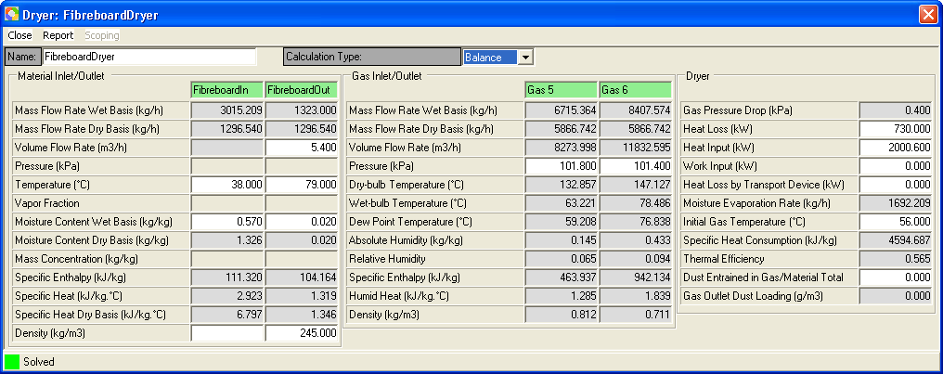

Figure 8a Exhaust Air Recycle Ratio at 30%

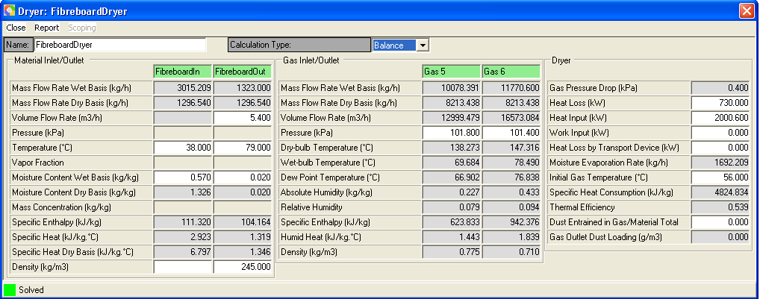

Figure 8b Exhaust Air Recycle Ratio at 50%

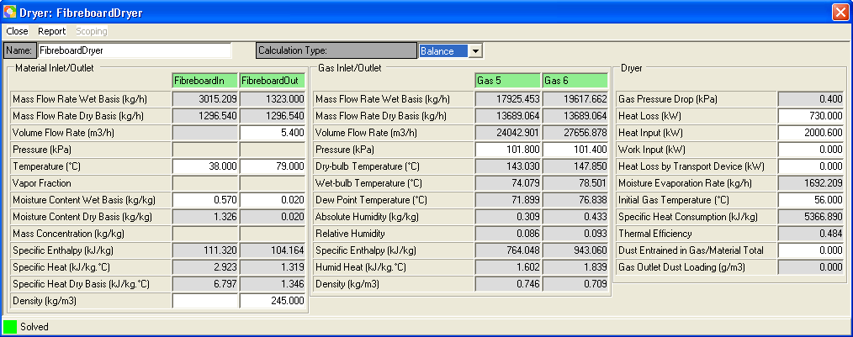

Figure 8c Exhaust Air Recycle Ratio at 70%

When air flow is increased in the dryer, the volume flow rate of the hot water needs to be increased accordingly so as to make up the increased heat input to the dryer.
Please be noted that with Simprosys it is easy to include in the parametric studies the powers of the added fans due to recycling the exhaust air if practical pressure drop data is available.

Increasing Hot Water Temperature

An increased hot water temperature will result in increased heat transfer. However, it may also lead to increased heat loss of the hot water pipe lines. Therefore, increasing hot water temperature should be used as a secondary tool for shortening drying time.
However, if the targeted drying time cannot be reached by only increasing air flow in the dryer, increasing hot water temperature can be used in combination with increasing air flow to reach the final target.
To determine the drying time for targeted airflow and hot water temperature, drying curve is needed to determine the constant rate and falling rate drying periods of the fiberboard. Then heat and mass transfer thermal dynamics calculations, in addition to heat and mass balance, are needed for each drying period to optimize the drying process from the energy point of view. At the same time product quality should be considered for the optimized design and operating conditions.

CLOSING REMARKS

Energy audit of the production line determined that excessive heat loss and lack of feasible heat recovery are two major factors attributed to the low energy efficiency of the drying system. Heat loss of the drying process is about 35% of the total heat required. Improving dryer isolation and eliminating hot air leaking are two possible ways to decrease heat loss.
There is significant potential for heat recovery from the exhaust. However, this will need extra equipment to make it more effective. To make a more effective use of the recovered heat it is necessary to put the heat recovery strategy into the energy picture of the whole plant.
Increasing the airflow of the dryer is a feasible way to shorten the drying time so as to reduce the heat loss without significantly upgrade/modify current process equipment from the drying kinetics point of view.
To further scrutinize the drying process in details and design more feasible ways for improvements of the energy efficiency, splitting the production line into a two-stage drying process is necessary with one stage for the wet and the other for the dry sections. With such a two-stage drying process we can study the effects of balancing the heat input of the two stages, recycling the exhaust air from one stage to another and different heat recovery strategies for each stage. However, this will need more detailed process data. Evaluation of parameter effects on drying kinetics and product quality should be examined concurrently with thermodynamic studies of heat and mass balances.
Interested readers are invited to visit www.simprotek.com to download a free trial version to explore the capability of Simprosys 2.1 for their own applications. The example provided here is just one relatively straightforward option for use of this software to improve the efficiency of an existing drying plant.

REFERENCES

- Kemp, I.C. Drying software: past, present and future. Drying Technology 2007, 25 (7), 1249-1263.
- Pakowski, Z. dryPAK v1.1 program for psychrometric and drying computation. Drying Technology 1994, 12 (7), 1765-1768
- Kemp, I.C.; Hallas, N.J.; Oakley, D.E. Developments in Aspen Technology drying software. Proceedings of 14th Intl Drying Symposium (IDS), Sao Paulo, August, 2004, Volume B, 767-774.
- Gong, Z. Drying software - Simprosys: motivation, development, applications and potential role in practice, The Proceedings of the 5th Asia-Pacific Drying Conference, Chen, G. Ed; 2007, 1295-1301.
- Gong, Z.; and Mujumdar A. S. Software for design and analysis of drying systems. Drying Technology 2008, 26 (7), 884-894.
- Mujumdar, A.S. Handbook of Industrial Drying, 3rd Ed.; CRC Press: 2007.
- Masters, K. Spray Drying Handbook, 4th Ed; John Wiley & Sons: 1985.
- Perry, R. Perry’s Chemical Engineers’ Handbook, 7th Ed; McGraw-Hill: 1997.
- Green, D.; Perry, R. Perry’s Chemical Engineers’ Handbook, 8th Ed; McGraw-Hill Professional: 2007.
- Keey, R.B. Introduction to Industrial Drying Operations, Pergamon Press, Oxford: 1978.
- Chopey, N.P. Handbook of Chemical Engineering Calculations, 3rd Ed; McGraw-Hill: 2003.
- Reynolds, J.P., Jeris, J.S., Theodore, L. Handbook of Chemical and Environmental Engineering Calculations, John Wiley & Sons: 2003.
- Yaws, C.L. Chemical Properties Handbook, McGraw-Hill: 1999.
- Yaws, C.L.; Gabbula, C. Yaw’s Handbook of Thermodynamic and Physical Properties of Chemical Compounds, Knovel (eBook): 2003.
- Gong, Z. and Mujumdar. A. S. Simulation of drying nonaqueous systems-An application of Simprosys software. Drying Technology 2010, 28(1), 111-115.
- Menshutina, N.V.; Kudra, T. Computer aided drying technologies. Drying Technology 2001, 19 (8), 1825-1850.
- Straatsma, J.; Van Houwelingen, G.; Meulman, A. P.; Steenbergen, A. E. Dryspec2: a computer model of a two-stage dryer. International Journal of Dairy Technology 2007, 44 (4), 107-111.
- Verdurmen, R. E. M.; Straatsma, H.; Verschueren, M.; van Haren, J.J.; Smith, E.; Bargeman, G. and De Jong, P. Modeling spray drying processes for dairy products. Lait 2002, 82 (4), 453-463.
- Kudra, T.; Platon, R.; Navarri, P. Excel-based tool to analyze energy performance of convective dryers. Drying Technology 2009, 27(12), 1302-1308.
- Maroulis, Z.B.; Saravacos, G.D.; Mujumdar, A.S. Spreadsheet-aided dryer design. In Handbook of Industrial Drying, 3rd Ed; Mujumdar, A.S., Ed.; CRC Press: 2007; ch. 5.

