Table of Contents

Introduction 2
Example 1 - Drying Gas Stream 3
Example 2 - Solid Dryer 6
Example 3 - Liquid Dryer 11
Example 4 – Combined Dryer and Heater 13
Example 5 - A Simple Drying Flowsheet 18
Example 6 - A Combustion Drying Flowsheet 21
Example 7 – Recycle Gas Stream 24
Example 8 – Recycle Material Stream 27
Example 9 – Enclosed Drying System (a Nitrogen-Ethanol system) 31
Example 10 – Evaporation 34
Example 11 - Evaporation and Drying 1 38
Example 12 - Evaporation and Drying 2 40

Introduction

Included in this tutorial are 12 step by step examples that you can follow to create either a drying flowsheet, or an evaporation flowsheet or a combined drying and evaporation flowsheet.
All the 12 examples data can be loaded into Simprosys from the “samples” folder installed with Simprosys.
You can also modify any of the samples installed with Simprosys to create your own flowsheet.

Example 1 - Drying Gas Stream

Problem 1

Moist air has the following conditions:

Pressure = 1 atm
Temperature (dry-bulb) = 25 ºC
Absolute humidity = 0.009 kg/kg (dry air)

Calculate wet-bulb temperature, dew point temperature, relative humidity, humid heat, specific enthalpy and density.

Solution Steps:

- Start Simprosys. By default, a new empty flowsheet is created with the default generic material of the software. The name of the default material is “Generic Drying Material”. The specific heat of the material is 1.26 kJ/kg·ºC when it is absolutely dry.
- Go to ‘Edit | Unit Systems’. Select SI-3 and click Set Current button to set SI-3 unit system as current unit system. Then close the dialog.
- Go to ‘Edit | Numeric Format’ to change Decimal Places to 3.
- Select ‘Flowsheet | Add | Streams | Drying Gas’, then click anywhere on the flowsheet to add a stream. Double click the stream icon to bring up the editor.
- Input 1.0 atm in the Pressure field.
- Input 25 ºC in the Dry-bulb Temperature field.
- Input 0.009 kg/kg in the Absolute Humidity field
- After the enter key of last input is hit, wet-bulb temperature, dew point temperature, relative humidity, humid heat, specific enthalpy and density are automatically calculated and displayed on the stream’s editor as in Figure 1.1.

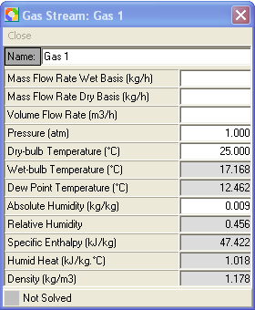

Figure 1.1

Problem 2

Moist air has the following conditions:

Pressure = 1 atm
Temperature (dry-bulb) = 25 ºC
Absolute humidity = 0.009 kg/kg (dry air)
Mass flow rate wet basis = 1000 kg/hr

Calculate the wet-bulb temperature, dew point temperature, relative humidity, humid heat, specific enthalpy, density, mass flow rate dry basis and volume flow rate.

Solution Steps

- Follow solution steps 1 through 7 in problem 1.
- Input 1000 kg/hr in Mass Flow Rate Wet Basis field
- After the enter key of the last input is hit, the stream is completely solved and the result is as shown in Figure 1.2.

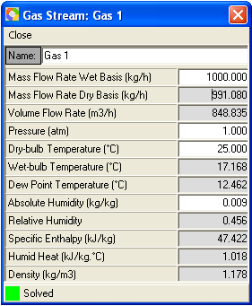

Figure 1.2

Summary

- When pressure, one of the three temperature parameters (either Dry-bulb Temperature, or Wet-bulb Temperature or Dew Point Temperature) and one of two humidity parameters (either Absolute Humidity or Relative Humidity) are specified, the state of the moist air is determined and can be calculated, and therefore all the thermal physical properties at this state can also be calculated and automatically displayed on the stream’s editor.
- When one of the flow rate parameters (either Mass Flow Rate Wet Basis, or Mass Flow Rate Dry Basis, or Volume Flow Rate) is specified and the state of the moist air is determined, the other flow rates are automatically calculated and displayed on the stream’s editor.

Example 2 - Solid Dryer

Problem 1

Material has the following conditions:

Type: solid particles
Feed moisture content = 3% wet basis
Feed temperature = 20 ºC
Product moisture content = 0.2% wet basis
Product temperature = 50 ºC
Specific heat of the absolute dry material = 1.26 kJ/kg·ºC
Mass flow rate wet basis = 2000 kg/hr

Drying air has the following conditions:

Pressure at dryer inlet = 103.2 kPa
Temperature (dry-bulb) at dryer inlet = 90 ºC
Absolute humidity at dryer inlet = 0.009 kg/kg
Temperature (dry-bulb) at dryer outlet = 48 ºC
Pressure drop of air in dryer = 1.2 kPa

Calculate how much drying air is needed as well as what is the outlet humidity of the drying air.

Solution Steps

- Save and close current flowsheet if you currently work on a flowsheet. Otherwise start Simprosys and close the new empty flowsheet created automatically by Simprosys.
- Go to ‘Edit | Unit Systems’ to select SI-2 and click Set Current button to set SI-2 unit system as the current unit system. Close this dialog.
- Go to ‘Edit | Numeric Format’ to change Decimal Places to 3.
- Go to ‘Materials | Set Default Flowsheet Settings’ to bring up the Set Default Flowsheet Settings dialog. Select “Generic Drying Material” in the Select Drying Material list box. Then click Set button to set this material as the drying material of the new flowsheet to be created. Close this dialog.
- Create a new flowsheet by clicking the first icon in the toolbar or selecting ‘File | New’.
- Select ‘Flowsheet | Add | Unit Operations | Solid Material Dryer’ and click anywhere on the flowsheet. Double click the dryer icon to bring up the editor.
- Input in “Mat 1” column 2000 kg/hr in the Mass Flow Rate Wet Basis field, 20ºC in the Temperature field and 0.03 kg/kg in the Moisture Content Wet Basis field.
- Input in “Mat 2” column 50ºC in the Temperature field and 0.002 kg/kg in the Moisture Content Wet Basis field.
- Input in “Gas 1” column 103.2 kPa in the Pressure field, 90 ºC in the Dry-bulb Temperature field and 0.009 kg/kg in the Absolute Humidity field.
- Input in “Gas 2” column 48 ºC in the Dry-bulb Temperature field.
- Input in Gas Pressure Drop field of the “Dryer” group box 1.2 kPa.
- After the enter key of the last input is hit, the dryer is solved and all the calculated variable values are displayed as in Figure 2.1.

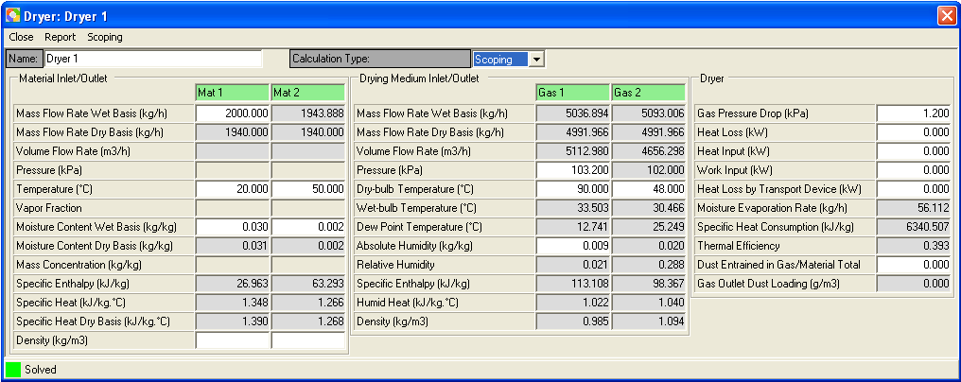

Figure 2.1

Problem 2

All conditions are the same as those in Problem 1 except that the outlet gas relative humidity is known as 0.288 rather than the outlet air temperature is known.

Solution Steps

All the steps are the same as in Problem 1 except that step 10 is replaced by the following

- Input in “Gas 2” column 0.288 in the Relative Humidity field.

A shortcut of the solution steps for this problem is to use the established flowsheet from problem 1 and then delete 48 ºC in the Dry-bulb Temperature field, and enter 0.288 in the Relative Humidity field in “Gas 2”.

The calculated results are displayed in Figure 2.2.

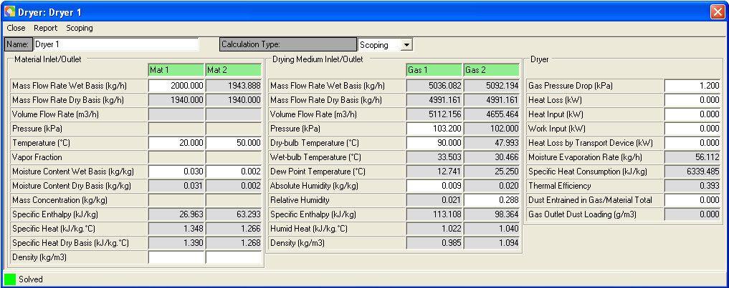

Figure 2.2

Please be noted that the calculated gas outlet temperature and mass flow rates are slightly different from those in problem 1. This is caused by the truncation error of the outlet relative humidity. The more accurate value of the outlet relative humidity in problem 1 is 0.28787887 (To see more decimal digits of each field in the dryer’s editor you need to go to ‘Edit | Numeric Format’ Decimal Places field to increase decimal digits).

Problem 3

All conditions are the same as in problem 1 except that inlet gas mass flow rate wet basis is known as 5036.894 kg/hr rather than the outlet gas temperature is known.

Solution Steps

All the steps are the same as in Problem 1 except that steps 9 and 10 are replaced by the following one step

- Input in “Gas 1” column 5036.894 kg/hr in Mass Flow Rate Wet Basis, 103.2 kPa in the Pressure field, 90 ºC in the Dry-bulb Temperature field and 0.009 kg/kg in the Absolute Humidity field.

A shortcut of the solution steps for this problem is to use the established flowsheet from problem 1 and then delete 48 ºC in the Dry-bulb Temperature field in “Gas 2”, and enter 5036.894 kg/hr in the Mass Flow Rate Wet Basis field of “Gas 1”.

The calculated results are displayed in Figure 2.3.

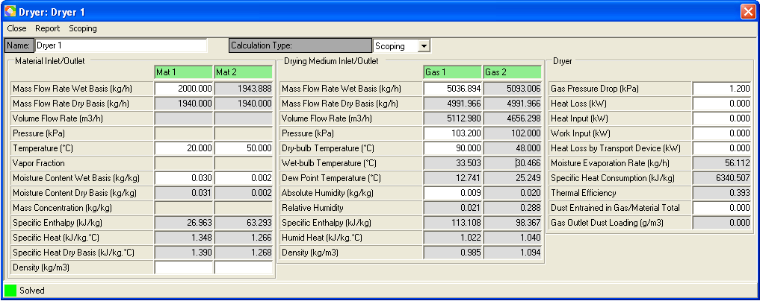

Figure 2.3

Problem 4

This problem is an extension of Problem 1. All material and drying air conditions are the same as in Problem 1.

Suppose this is a rotary dryer. The gas velocity in the dryer is 2.0 m/s. The length to diameter ratio is 8.0. Calculate the dimensions of the dryer using the simple scoping model.

Solution Steps
- After the dryer balance calculation is solved following steps 1 through 11 in problem 1, go to Calculation Type combo box on the dryer’s editor and select “Scoping” entry.
- Click “Scoping” menu on the dryer’s editor to bring up the scoping editor.
- Select “Circle” for the cross section type because the cross section of a rotary dryer is circular.
- Input in the Gas Velocity field 2.0 m/s and in the Length/Diameter Ratio field 8.0.
- After the enter key of the last input is hit, the dryer scoping is solved and the calculated variable values are displayed as in Figure 2.4.

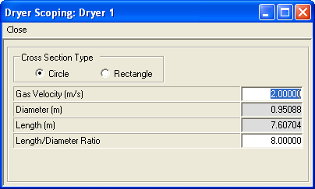

Figure 2.4

Please be noted that you can change the balance calculation specification. After the changed values are input into the dryer’s editor the calculated dimension variables in the scoping editor is automatically recalculated and updated.

Summary

- If the dryer has heat loss, heat input in addition to the heat from the drying gas, work input and heat loss by transport device for some specific dryers, you can input a specified value in each of the corresponding field. The dryer model will take them into account.
- In addition to the 3 cases of problems 1 to 3, you can also know one of the outlet temperatures (either dry-bulb, or web-bulb or dew point) and one of the two outlet humidity parameters (either absolute humidity or relative humidity) rather than the corresponding inlet variables to satisfy the dryer’s balance calculation conditions and get the dryer solved.

Example 3 - Liquid Dryer

Problem 1

Material is know as follows

Type: liquid solution
Feed mass solid content = 58%
Feed temperature = 85 ºC
Feed pressure = 102 kPa
Product moisture content = 5% wet basis
Product temperature = 65 ºC
Specific heat of the absolute dry material = 1.26 kJ/kg·ºC
Mass flow rate wet basis = 5000 kg/hr

Drying air has the following conditions:

Pressure at dryer inlet = 103.2 kPa
Temperature (dry-bulb) at dryer inlet = 120 ºC
Absolute Humidity at dryer inlet = 0.009 kg/kg dry air
Temperature (dry-bulb) at dryer outlet = 55 ºC
Pressure drop of air in dryer = 1.2 kPa

Calculate how much drying air is needed as well as what is the outlet humidity of the drying air.

Solution Steps

- Save and close current flowsheet if you currently work on a flowsheet. Otherwise start Simprosys and close the new empty flowsheet created automatically by Simprosys.
- Go to ‘Edit | Unit Systems’ to select SI-2 and click Set Current button to set SI-2 unit system as the current unit system. Close this dialog.
- Go to ‘Edit | Numeric Format’ to change Decimal Places to 3.
- Neglect this step if you come from Example 2. Go to ‘Materials | Set Default Flowsheet Settings’ to bring up the Set Default Flowsheet Settings dialog. Select “Generic Drying Material” in the Select Drying Material list box. Then click Set button to set this material as the drying material of the new flowsheet to be created. Close this dialog.
- Create a new flowsheet by clicking the first icon in the toolbar or selecting ‘File | New’.
- Select ‘Flowsheet | Add | Unit Operations | Liquid Material Dryer’ and click anywhere on flowsheet. Double click the dryer icon to bring up the editor.
- Input in “Mat 1” column 5000 kg/hr in the Mass Flow Rate Wet Basis field, 102 kPa in the Pressure field, 85ºC in the Temperature field and 0.58 in the Mass Concentration field.
- Input in “Mat 2” column 65ºC in the Temperature field and 0.05 in the Moisture Content Wet Basis field.
- Input in “Gas 1” column 103.2 kPa in the Pressure field, 120 ºC in the Dry-bulb Temperature field and 0.009 kg/kg in the Absolute Humidity field.
- Input in “Gas 2” column 55 ºC in the Dry-bulb Temperature field.
- Input in Gas Pressure Drop field of the “Dryer” group box 1.2 kPa.
- After the enter key of last input is hit, the dryer is solved and all the calculated variable values are displayed as shown in Figure 3.

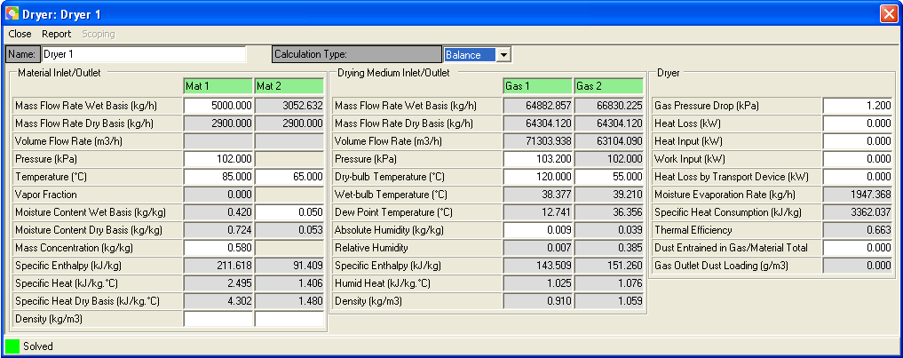

Figure 3

Example 4 – Combined Dryer and Heater

Problem

Drying material is solid food particles with a composition of Carbohydrate 60%, Protein 22%, Fat 10%, Fiber 5% and Ash 3%. Inlet and outlet conditions of the material are as follows:

Feed moisture content = 3% wet basis
Feed temperature = 20 ºC
Product moisture content = 0.2% kg/kg wet basis
Product temperature = 50 ºC
Mass flow rate wet basis = 2000 kg/hr

Drying air has the following conditions:

Pressure at heater inlet = 104 kPa
Temperature (dry-bulb) at heater inlet = 20 ºC
Absolute Humidity at heater inlet = 0.009 kg/kg dry air
Temperature (dry-bulb) at heater outlet = 90 ºC
Temperature (dry-bulb) at dryer outlet = 48 ºC
Pressure drop of air in heater = 0.8 kPa
Pressure drop of air in dryer = 1.2 kPa

Calculate the required mass flow rate of the drying air, the thermal energy to heat the air as well as the outlet humidity of the drying air from the dryer.

Solution Steps

- Save and close current flowsheet if you currently work on a flowsheet. Otherwise start Simprosys and close the new empty flowsheet created automatically by Simprosys.
- Go to ‘Materials | Drying Material Catalog’. Click Add button to bring up the ‘New Drying Material’ dialog. Give the material a name of “Food Material 1”. Select ‘Generic Food’ from the Type combo box. Then specify the ‘Drying Material Components’ table with Carbohydrate 60, Protein 22, Fat 10, Fiber 5 and Ash 3. Click Normalize button and then click OK button to close the ‘New Drying Material’ dialog. Close ‘Drying Material Catalog’.
- Go to ‘Materials | Set Default Flowsheet Settings’. Select “Food Material 1” and click Set button to set this material as the drying material of the to-be-created new flowsheet.
- Go to ‘Edit | Unit Systems’ to select SI-2 and click Set Current button to set SI-2 unit system as the current unit system. Close this dialog.
- Go to ‘Edit | Numeric Format’ tab to change Decimal Places to 3.
- Create a new flowsheet by clicking the first icon in the toolbar or selecting ‘File | New’.
- Go to ‘Flowsheet | Options’ group box “Unit Operation Creation” and choose radio button “With Input and Output”.
- Select ‘Flowsheet | Add | Unit Operations | Heater’ and click anywhere on flowsheet to create a heater.
- Delete the outlet gas stream of the heater by selecting the stream, right clicking mouse and hitting the ‘Delete’ in the pop-up menu.
- Create a solid dryer using the same way as in step 7.
- Press down the Connect () button in the toolbar. Click on the gas input stream of the dryer and then click at the middle of the right border (the connection port) of the heater. You will get the heater and the dryer connected.
- Double click the heater icon to bring up the heater’s editor.
- Input in “Gas 1” column 104 kPa in the Pressure field, 20ºC in the Dry-bulb Temperature field and 0.009 kg/kg in the Absolute Humidity field.
- Input in “Gas 2” column 90ºC in the Dry-bulb Temperature field.
- Input in Pressure Drop field of the “Heater” group box 0.8 kPa.
- Double click the dryer icon to bring up the dryer’s editor.
- Input in “Mat 1” column 2000 kg/hr in the Mass Flow Rate Wet Basis field, 20ºC in the Temperature field and 0.03 in the Moisture Content Wet Basis field.
- Input in “Mat 2” column 50ºC in the Temperature field and 0.002 in the Moisture Content Wet Basis field.
- Input in “Gas 3” column 48 ºC in the Dry-bulb Temperature field.
- Input in Gas Pressure Drop field of the “Dryer” group box 1.2 kPa.
- After the enter key of last input is hit, both the dryer and the heater are solved and all the calculated variable values are displayed as shown in Figure 4a and 4b.

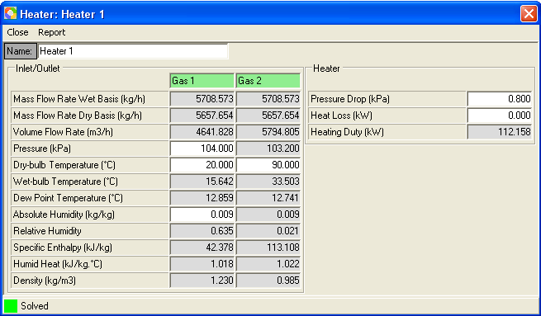

Figure 4a

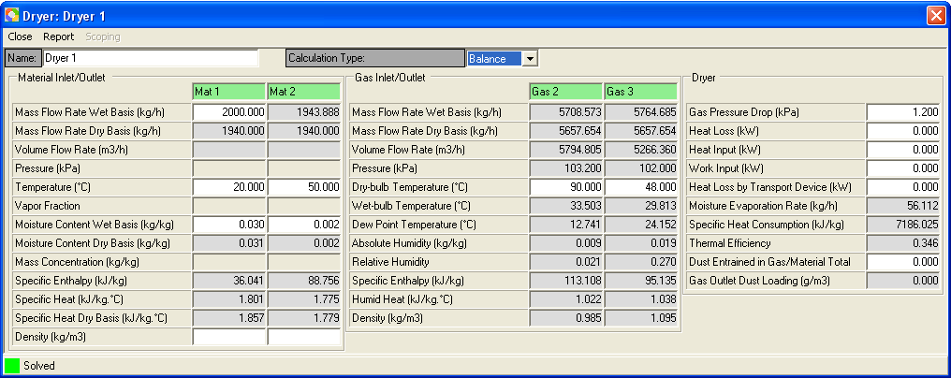

Figure 4b

Alternative Solution Steps

- Following the above solution steps 1 through 10.
- Go to ‘Edit | Flowsheet Data’ to bring up the global editor
- Input the known values in the variable fields of Gas 1, Gas 2, Gas 3, Mat 1, Mat 2. Input the pressure drop values for the heater and dryer in Heater 1 and Dryer 1 in the global editor.
- After the enter key of last input is hit, both the dryer and the heater are solved and all the calculated variable values are displayed as in Figure 4c.

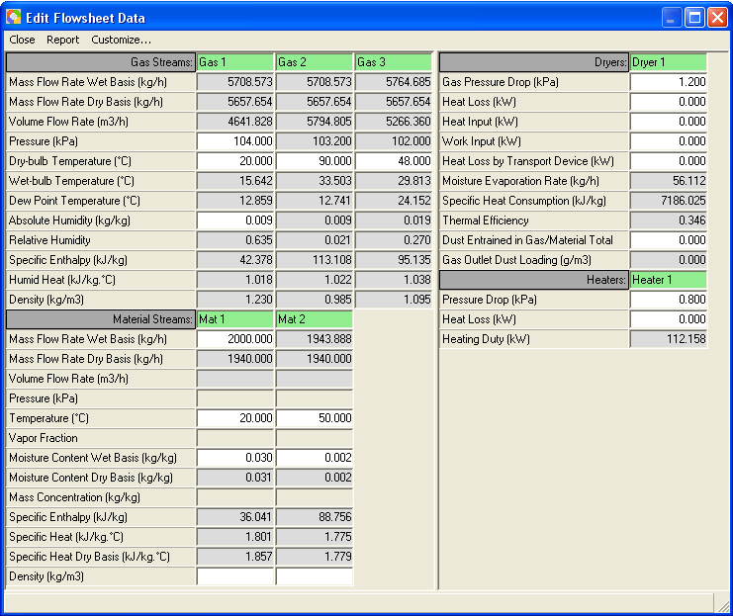

Figure 4c

Tip 1:

If the heating duty of the heater (Heater 1) is known as 112.158 kJ/s (the same unit as kW) rather than the temperature of the heater outlet (90 ºC), you can delete the heater’s outlet temperature and then input 112.158 in the Heating Duty field of the heater. You will get the same results for the solved heater and dryer.

Tip 2:

If the outlet air relative humidity of dryer (Dryer 1) is know as 0.270 rather than the outlet temperature (48 ºC), you can delete the outlet temperature (48 ºC) and then input 0.270 in the Relative Humidity field of Gas 3. You will get the same results for the solved heater and dryer.

Tip 3:

If the inlet air flow rate (wet basis) of the dryer (Dryer 1) is know as 5708.573 rather than the outlet temperature (48 ºC), you can delete the outlet temperature (48 ºC) and then input 5708.573 in the Mass Flow Rate Wet Basis field of Gas 2. You will get the same results for the solved heater and dryer.

Tip 4:

If the relative humidity at heater inlet is know as 0.635 rather than the absolute humidity 0.009 kg/kg is known, you can delete 0.009 in the Absolute Humidity and input 0.635 in the Relative Humidity field of Gas 1. You will get the same results for the solved heater and dryer.

Example 5 - A Simple Drying Flowsheet

Problem

Material is known as follows

Type: solid particles
Feed moisture content = 5% wet basis
Feed temperature = 20 ºC.
Product temperature = 50 ºC
Product moisture content = 0.2% wet basis
Specific heat of the absolute dry material = 1.26 kJ/kg·ºC
Mass flow rate wet basis = 2000 kg/hr

Drying air has the following conditions:

Initial pressure = 101.3 kPa
Initial temperature (dry-bulb) = 20 ºC
Initial absolute humidity = 0.009 kg/kg
Mass flow rate wet basis = 7200 kg/hr

Drying air needs to go through an air filter first. Pressure drop in the air filter is 0.3 kPa. Assume dust volume concentration is 0.1 g/m³, collection efficiency of the air filter is 99.8% and filtration velocity is 2.5 m/s. Drying air then goes through a fan (the efficiency of the fan is 0.7) to gain 3 kPa static pressure, then through a heater to be heated to 90 ºC before going to the dryer. Pressure drop of air in heater is 0.8 kPa. Pressure drop of air in dryer is 1.2 kPa. The exhaust air entrains 0.1% of the total material. It needs to go through a cyclone to collect the entrained dust material. Collection efficiency of the cyclone is 95%. Pressure drop of the cyclone is 0.6 kPa.

Solution Steps

- Save and close current flowsheet if you currently work on a flowsheet. Otherwise start Simprosys and close the new empty flowsheet created automatically by Simprosys.
- Go to ‘Edit | Unit Systems’ to select SI-2 and click Set Current button to set SI-2 unit system as the current unit system. Close this dialog.
- Go to ‘Edit | Numeric Format’ tab to change Decimal Places to 4.
- Go to ‘Materials | Set Default Flowsheet Settings’. Select “Generic Drying Material” and click Set button to set this material as the drying material of the to-be-created new flowsheet if you have already created the Generic Drying Material in the material catalog. Otherwise, create the Generic Drying Material and then go to ‘Materials | Set Default Flowsheet Settings’ to set it.
- Create a new flowsheet by clicking the first icon in the toolbar or selecting ‘File | New’.
- Go to ‘Flowsheet | Options’ group box “Unit Operation Creation” and choose radio button “With Input Only”.
- Select ‘Flowsheet | Add | Unit Operations | Air Filter’ and click anywhere on the flowsheet to create an air filter (AirFilter 1).
- Use the same way as in step 7 to create a fan (Fan 1), a heater (Heater 1), a solid dryer (Dryer 1), a cyclone (Cyclone 1), a solid material stream (Mat 2) and a gas stream (Gas 6).
- Press down the Connect () button in the toolbar. Click on the Gas 2 and then click at the middle of the right border (the connection port) of AirFilter 1. You will get AirFilter 1 and Fan 1 connected.
- Use the same way as in step 9 to get Fan 1 and Heater 1, Heater 1 and Dryer 1, Dryer 1 and Cyclone 1, Mat 2 and Dryer 1, Gas 6 and Cyclone 1 connected. The established flowsheet is as displayed in Figure 5a

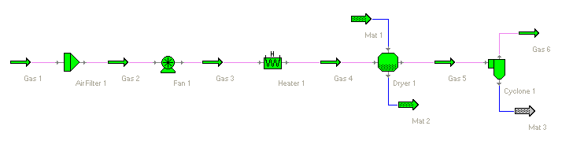
Figure 5a

- Go to ‘Edit | Flowsheet Data’ to bring up the global editor and input all the known values as follows:
  - Gas 1: Mass Flow Rate Wet Basis 7200 kg/hr, Pressure 101.3 kPa, Dry-bulb Temperature 20 ºC, Moisture Content Wet Basis 0.009 kg/kg.
  - Gas 4: Dry-bulb Temperature 90 ºC.
  - Mat 1: Mass Flow Rate Wet Basis 2000 kg/hr, Temperature 20 ºC, Moisture Content Wet Basis 0.05 kg/kg.
  - Mat 2: Temperature 50 ºC, Moisture Content Wet Basis 0.002 kg/kg.
  - AirFilter 1: Gas Pressure Drop 0.3 kPa; Collection Efficiency 0.998, Inlet Particle Loading 0.1 g/m³, Filtration Velocity 2.5 m/s.
  - Fan 1: Static Pressure 3.0 kPa, Efficiency 0.7.
  - Heater 1: Pressure Drop 0.8 kPa.
  - Dryer 1: Gas Pressure Drop 1.2 kPa, Dust Entrained in Gas/Material Total 0.001.
  - Cyclone 1: Gas Pressure Drop 0.6 kPa, Collection Efficiency 0.95.

You can get the results as in Figure 5b.

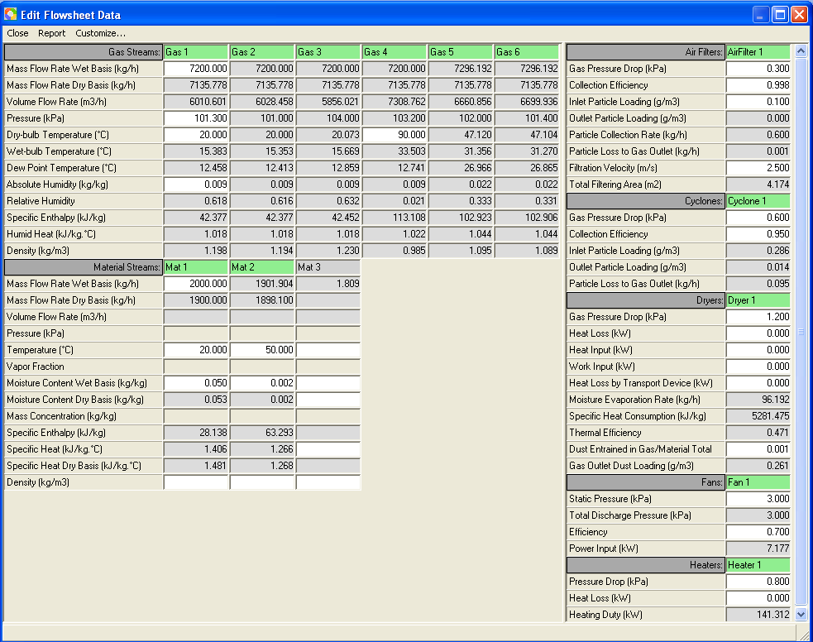

Figure 5b

Example 6 - A Combustion Drying Flowsheet

Problem

Material is known as follows

Type: solid particles
Feed moisture content = 22% wet basis
Feed temperature = 20 ºC
Product temperature = 50 ºC
Product moisture content = 0.2% wet basis
Specific heat of the absolute dry material = 1.26 kJ/kg·ºC
Mass flow rate wet basis = 2000 kg/hr

Air has the following conditions:

Initial pressure = 101.3 kPa
Initial temperature (dry-bulb) = 20 ºC
Initial absolute humidity = 0.009 kg/kg

Natural gas as the drying fuel has the following conditions:

Pressure = 101.3 kPa
Temperature = 20 ºC
Mass flow rate = 34 kg/hr

Drying air needs to go through an air filter first. Pressure drop in the air filter is 0.3 kPa. Assume dust volume concentration is 0.1 g/m³, collection efficiency of the air filter is 99.8% and filtration velocity is 2.5 m/s. Drying air then goes through a fan (the efficiency of the fan is 0.7) to gain 3 kPa static pressure, then through a burner to be heated before going to the dryer. Excess air % of the burner is 500%. Heat loss of the burner is 10%. Flue gas outlet pressure is 103.2. Pressure drop of air in dryer is 1.2 kPa. The exhaust air entrains 0.1% of the total material. It needs to go through a cyclone to collect the entrained dust material. Collection efficiency of the cyclone is 95%. Pressure drop of the cyclone is 0.6 kPa.

Solution Steps

- Save and close current flowsheet if you currently work on a flowsheet. Otherwise start Simprosys and close the new empty flowsheet created automatically by Simprosys.
- Go to ‘Edit | Unit Systems’ to select SI-2 and click Set Current button to set SI-2 unit system as the current unit system. Close this dialog.
- Go to ‘Edit | Numeric Format’ tab to change Decimal Places to 4.
- Go to ‘Materials | Set Default Flowsheet Settings’. Select “Generic Drying Material” and click Set button to set this material as the drying material of the to-be-created new flowsheet if you have already created the Generic Drying Material in the material catalog. Otherwise, create the Generic Drying Material and then go to ‘Materials | Set Default Flowsheet Settings’ to set it. Make sure Drying Fuel is selected as Natural Gas.
- Create a new flowsheet by clicking the first icon in the toolbar or selecting ‘File | New’.
- Go to ‘Flowsheet | Options’ group box “Unit Operation Creation” and choose radio button “With Input Only”.
- Select ‘Flowsheet | Add | Unit Operations | Air Filter’ and click anywhere on the flowsheet to create an air filter (AirFilter 1).
- Use the same way as in step 7 to create a fan (Fan 1), a Burner (Burner 1), a solid dryer (Dryer 1), a cyclone (Cyclone 1), a solid material stream (Mat 2) and a gas stream (Gas 6).
- Press down the Connect () button in the toolbar. Click on the Gas 2 and then click at the middle of the right border (the connection port) of AirFilter 1. You will get AirFilter 1 and Fan 1 connected.
- Use the same way as in step 9 to get Fan 1 and Burner 1, Burner 1 and Dryer 1, Dryer 1 and Cyclone 1, Mat 2 and Dryer 1, Gas 6 and Cyclone 1 connected. The established flowsheet is as displayed in Figure 6a

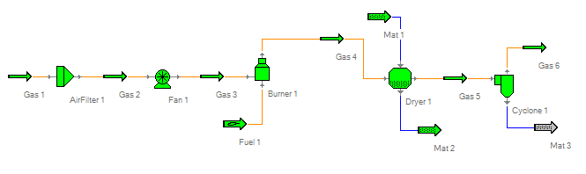
Figure 6a

- Go to ‘Edit | Flowsheet Data’ to bring up the global editor and input all the known values as follows:
  - Fuel 1: Select “Natural Gas” in the Drying Fuel dropdown list, Mass Flow Rate Wet Basis 34 kg/hr, Pressure 101.3 kPa, Temperature 20 ºC,
  - Gas 1: Pressure 101.3 kPa, Dry-bulb Temperature 20 ºC, Moisture Content Wet Basis 0.009 kg/kg.
  - Gas 4: Pressure 103.2 kPa.
  - Mat 1: Mass Flow Rate Wet Basis 2000 kg/hr, Temperature 20 ºC, Moisture Content Wet Basis 0.22 kg/kg.
  - Mat 2: Temperature 50 ºC, Moisture Content Wet Basis 0.002 kg/kg.
  - AirFilter 1: Gas Pressure Drop 0.3 kPa; Collection Efficiency 0.998, Inlet Particle Loading 0.1 g/m³, Filtration Velocity 2.5 m/s.
  - Fan 1: Static Pressure 3.0 kPa, Efficiency 0.7.
  - Burner 1: Excess Air % 500, Heat Loss % 10.
  - Dryer 1: Gas Pressure Drop 1.2 kPa, Dust Entrained in Gas/Material Total 0.001.
  - Cyclone 1: Gas Pressure Drop 0.6 kPa, Collection Efficiency 0.95.

You can get the results as in Figure 6b.

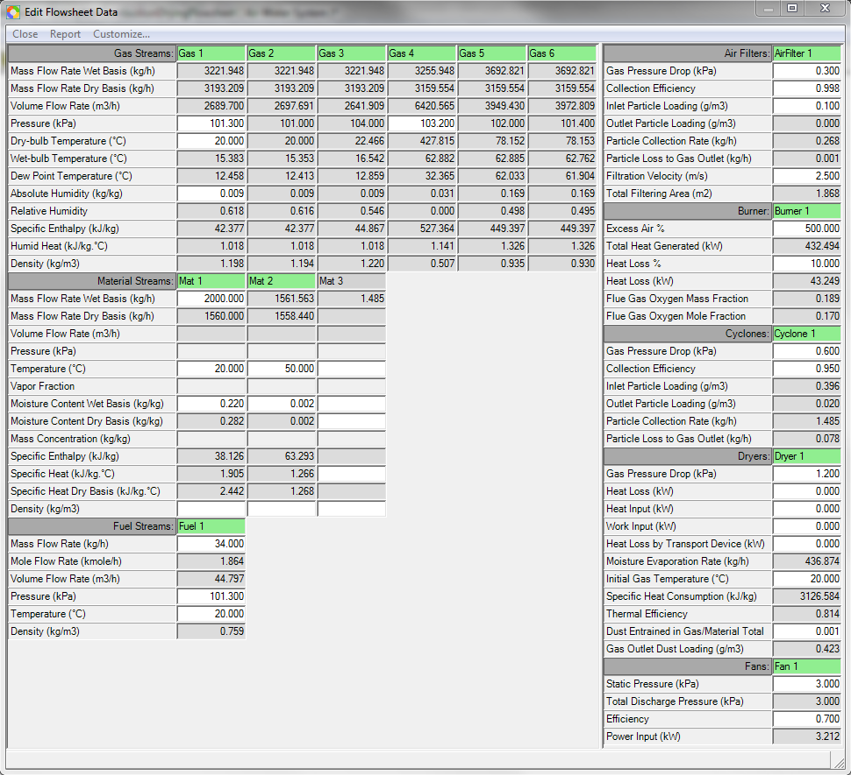

Figure 6b

Example 7 – Recycle Gas Stream

Problem

This is the same problem as in Example 5 except that half of the gas outlet from the cyclone goes through a fan to gain 1.8 kPa static pressure and then is recycled back to the dryer’s gas inlet.

Solution

To model this problem, at first a tee is required to split the gas outlet of the cyclone into two gas streams, one supposed to be discharged into the atmosphere, the other recycled back to the dryer’s gas inlet. You might think that the recycled gas stream can go through a fan to gain the required static pressure (1.8 kPa) and then be mixed through a mixer with the fresh hot gas stream coming out of the heater and introduced into the dyer’s gas inlet. The possible flowsheet is displayed in Figure 7a.

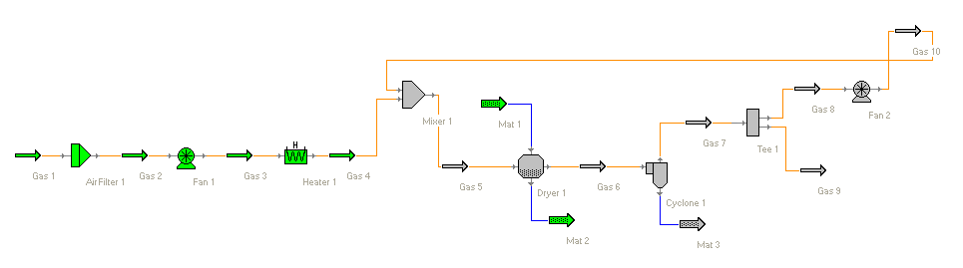
Figure 7a

Such a configuration of the flowsheet can not get the problem solved since it is necessary to know inlet gas conditions to solve the dryer’s outlet gas stream. However, a portion of the dryer’s gas outlet will be recycled as part of the dryer’s gas inlet. This is a nonlinear problem. To solve such a nonlinear problem it is necessary to assume some initial guess values for the recycled stream so that the dryer’s gas inlet is known to solve the dryer’s gas outlet. This can be achieved by an auxiliary logical unit operation called Recycle.

Solution Steps

- Follow all solution steps in example 5 you get the flowsheet as in Figure 5a.
- Go to ‘Flowsheet | Options’ “Unit Operation Creation” group box to select “With Input and Output” radio button. Choose radio button “Gas” in both group boxes “Tee” and “Mixer” since the tee and mixer in this flowsheet deal with gas streams.
- Select ‘Flowsheet | Add | Unit Operations | Tee’ and click anywhere on the flowsheet to create a tee (Tee 1).
- Use the same way as in step 3 to create a fan (Fan 2), a recycle (Recycle 1) and a mixer (Mixer 1).
- Delete the input stream of the Tee 1.
- Delete the input stream of the Fan 2.
- Delete one of the two input streams (the lower input stream) of Mixer 1.
- Press down the Disconnect () button in the toolbar. Click on the connection line between Gas 4 and Dryer 1 to break up the connection of Gas 4 from the inlet of Dryer 1.
- Press down the Connect () button in the toolbar. Click on Gas 6 and then click at the middle of the left border (the connection port) of Tee 1. You will get Tee 1 and Cyclone 1 connected.
- Use the same way as in step 9 to connect Gas 8 with Fan 2, Gas 4 with Mixer 1, Gas 12 with Dryer 1.
- Press down the Connect () button in the toolbar. Click on Gas 11 and then click at the middle of the right border (the connection port) of Recycle 1. You will get Tee 1 and Recycle 1’s inlet connected.
- Double click the icon of Tee 1 to bring up the tee editor. Input 0.5 in the Gas 8 field of the “Outlet Fractions” group box.
- Bring up Fan 1’s editor. Input 1.8 kPa in the Static Pressure field and 0.7 in the Efficiency field of the Fan group box.
- Bring up Dryer 1’s editor. Input 103.2 in the Pressure field of Gas 12.
- Press down the Connect () button in the toolbar. Click on the Gas 13 and then click at the middle of the left border (the connection port) of Recycle 1. You will get Mixer 1 and Recycle 1 connected. Then the flowsheet is automatically solved through multiple loops of iterations.
- You can rename Gas 6 to Gas 7, Gas 5 to Gas 6, Gas 11 to Gas 10, Gas 12 to Gas 5 and Gas 13 to Gas 11 to get the flowsheet as displayed in Figure 7b.

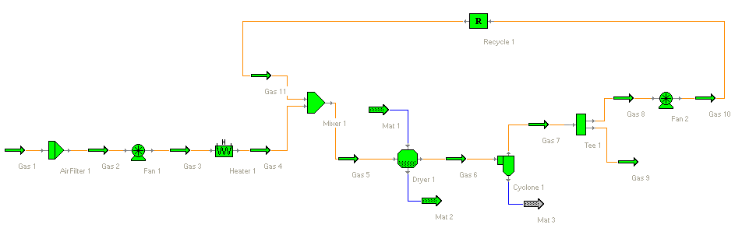
Figure 7b

The solution is shown in the global editor as follows

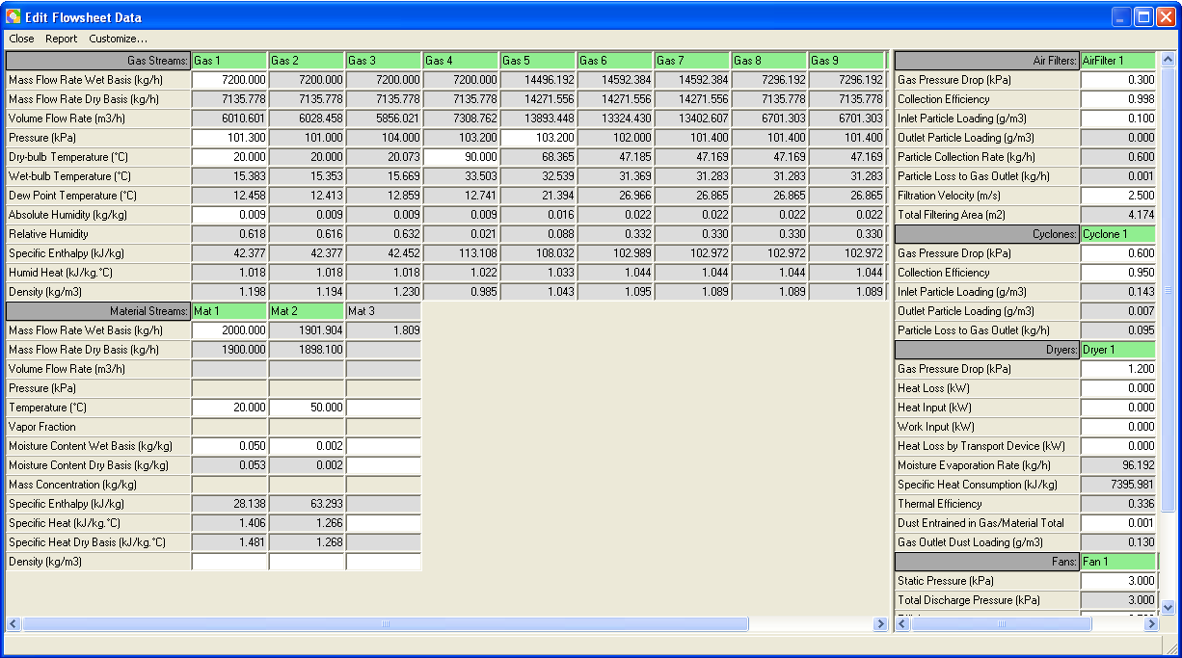

Figure 7c

Example 8 – Recycle Material Stream

Problem

Material is known as follows

Type: solid particles
Initial moisture content = 25% wet basis
Initial temperature = 20 ºC
Product temperature = 75 ºC
Product moisture content = 0.2% wet basis
Specific heat of the absolute dry material = 1.26 kJ/kg·ºC
Mass flow rate wet basis = 1000 kg/hr

Drying air has the following conditions

Initial pressure = 101.3 kPa
Initial temperature = 20 ºC.
Initial Absolute Humidity = 0.009 kg/kg
Mass Flow Rate wet basis = 10000 kg/hr

Drying air needs to go through an air filter first. Pressure drop in the air filter is 0.3 kPa. Assume dust volume concentration is 0.1 g/m³, collection efficiency of the air filter is 99.8% and filtration velocity is 2.5 m/s. Drying air then goes through a fan (the efficiency of the fan is 0.7) to gain 3 kPa static pressure, then through a heater to be heated to 110 ºC before going to the dryer. Pressure drop of air in heater and dryer is 0.8 kPa and 1.2 kPa respectively. The exhaust air of the dryer entrains 0.1% of the total material into the dryer’s gas outlet stream. The gas outlet stream needs to go through a cyclone to collect the entrained dust material. Collection efficiency of the cyclone is 95%. Pressure drop of air in the cyclone is 0.6 kPa.

The dryer requires that the feed moisture content (wt basis) can not be greater than 0.15 kg/kg wet basis. As is known, initial moisture content (wet basis) of the material is 0.25 kg/kg. One possible solution is to mix a portion of the dried material product with the fresh material to decrease the moisture content to the required level and then feed the dryer.

A tee is required to split the product material into two halves. One half goes through a Recycle and mixes with the fresh material in a mixer and then introduced into the dryer’s material inlet.

Solution

Similar to recycling a gas stream in Example 6, a portion of the dryer’s material outlet stream is recycled in this example. To get this problem solved an auxiliary recycle unit operation is necessary.

Solution Steps

- Save and close current flowsheet if a flowsheet exists. Otherwise, start Simprosys and close current flowsheet created automatically by Simprosys.
- Go to ‘Edit | Unit Systems’ to select SI-2 and click Set Current button to set SI-2 unit system as the current unit system. Close this dialog.
- Go to ‘Edit | Numeric Format’ tab to change Decimal Places to 4.
- Go to ‘Materials | Set Default Flowsheet Settings’. Select “Generic Drying Material” and click Set button to set this material as the drying material of the to-be-created new flowsheet if you have already created the Generic Drying Material in the material catalog. Otherwise, create the Generic Drying Material and then go to ‘Materials | Set Default Flowsheet Settings’ to set it.
- Create a new flowsheet by clicking the first icon in the toolbar or clicking ‘File | New’.
- Go to ‘Flowsheet | Options’ “Unit Operation Creation” and choose radio button “Without Input and Output”. Choose radio button “Solid Material” in both group boxes “Tee” and “Mixer” since the tee and mixer in this flowsheet deal with solid material streams.
- Select ‘Flowsheet | Add | Unit Operations | Air Filter’ and click anywhere on the flowsheet to create an air filter (AirFilter 1).
- Use the same way as in step 7 to create a fan (Fan 1), a heater (Heater 1), a solid dryer (Dryer 1), a Tee (Tee 1), a Mixer (Mixer 1), a Cyclone (Cyclone 1), 6 gas streams (Gas 1 to Gas 6) and 7 solid material streams (Mat 1 to Mat 7)
- Press down the Connect () button in the toolbar. Click on the Gas 1 and then click at the middle of the left border (the connection port) of AirFilter 1. You will get Gas 1 and AirFilter 1 connected.
- Use the same way as in step 9 to get Gas 2 and AirFilter 1, Gas 2 and Fan 1 etc. connected. The connected flowsheet is as displayed in Figure 8a except that Mat 6 is not connected with Recycle 1.
- Go to Edit | Flowsheet Data to bring up the global editor and input all the known values as follows:
  - Gas 1: Mass Flow Rate Wet Basis 10000 kg/hr, Pressure 101.3 kPa, Dry-bulb Temperature 20 ºC, Absolute Humidity 0.009 kg/kg.
  - Gas 4: Dry-bulb Temperature 110 ºC.
  - Mat 1: Mass Flow Rate Wet Basis 1000 kg/hr, Temperature 20 ºC, Moisture Content Wet Basis 0.25 kg/kg.
  - Mat 3: Temperature 75 ºC, Moisture Content Wet Basis 0.002 kg/kg.
  - AirFilter 1: Gas Pressure Drop 0.3 kPa, Collection Efficiency 0.998, Inlet Particle Loading 0.1 g/m³, Filtration Velocity 2.5 m/s.
  - Fan 1: Static Pressure 3.0 kPa, Efficiency 0.7.
  - Heater 1: Pressure Drop 0.8 kPa.
  - Dryer 1: Gas Pressure Drop 1.2 kPa, Dust Entrained in Gas/Material Total 0.001.
  - Cyclone 1: Gas Pressure Drop 0.6 kPa, Collection Efficiency 0.95.
- Click the icon of Tee 1 to bring up the tee editor. In put 0.5 in the Mat 4 field of “Outlet Fractions” group box.
- Press down the Connect () button in the toolbar. Click on Mat 6 and then click at the middle of the right border (the connection port) of Recycle 1 to get Mixer 1 and Recycle 1 connected.

The solved flowsheet is as displayed in Figure 8a and the results are shown is Figure 8b.

Please be noted that you can adjust the ratio of the recycled material product to make the moisture content of the dryer material inlet satisfy a specified condition. If, for example, the moisture content of the dryer material inlet has to be less than 0.13 rather the previously specified 0.15, you can increase the ratio of the recycle material product from 0.5 to 0.56 (in the Mat 4 field of “Outlet Fractions” group box of Tee 1) to get this condition satisfied.
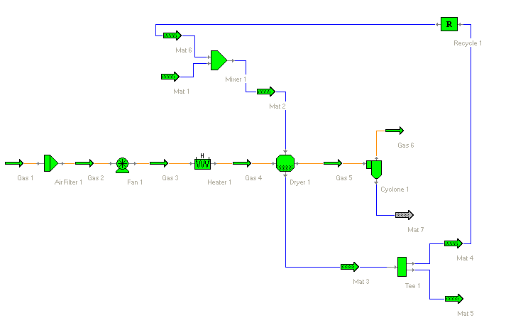
Figure 8a

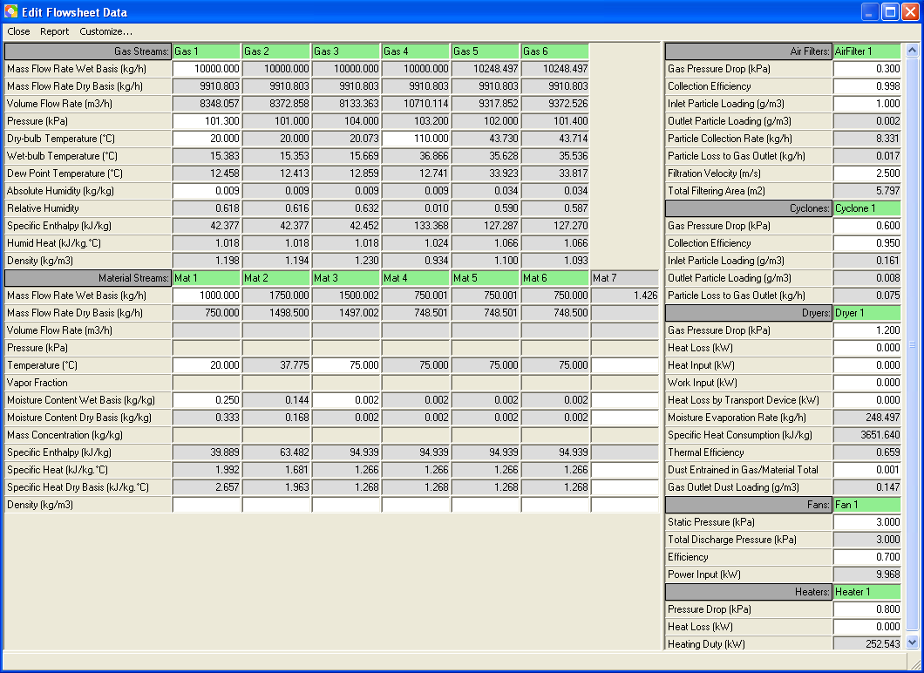

Figure 8b

Example 9 – Enclosed Drying System (a Nitrogen-Ethanol system)

Problem

The moisture in of the drying material is Ethanol, the drying gas is Nitrogen. A simple enclosed drying system with the following conditions for both the material and the drying gas:

Material:

Feed temperature = 20 ºC
Feed moisture content = 8% wet basis
Mass flow rate wet basis = 2000 kg/hr
Product temperature = 50 ºC
Product moisture content = 0.2% wet basis

Drying Gas

Pressure at dryer inlet = 102.4 kPa
Temperature at dryer inlet = 120 ºC
Mass flow rate wet basis at dryer Inlet = 3000 kg/hr

Pressure drop of the dryer is 1.2 kPa. Dryer gas outlet stream goes through a fan to gain 1.5 kPa static pressure. Efficiency of the fan is 0.75. Exhaust air coming from the fan goes through a scrubber/condenser to collect the dusts and remove the moisture carried in the exhaust air. Temperature of the exhaust air from the scrubber/condenser is 30 ºC. Air pressure drop in scrubber/condenser is 1.0 kPa. Collection efficiency and liquid gas ratio of the scrubber/ condenser are 99% and 1.0 respectively. Liquid inlet pressure and temperature of the scrubber/condenser are 101.3 kPa and 20 ºC. The air coming out of the scrubber/condenser goes through a fan to gain some static pressure and then go through a heater to be heated to the required dryer inlet temperature (120 ºC). The efficiency of the fan is 0.75. The pressure drop of air in the heater is 0.6 kPa.

Solution Steps

- Save and close current flowsheet if a flowsheet exists. Otherwise, start Simprosys and close current flowsheet created automatically by Simprosys.
- Go to ‘Edit | Unit Systems’ to select SI-2 and click Set Current button to set SI-2 unit system as the current unit system. Close this dialog.
- Go to ‘Edit | Numeric Format’ tab to change Decimal Places to 4.
- Go to ‘Materials | Drying Material Catalog’ to bring up the drying material catalog.
- Click the “Add” button to add a new material to bring up the “New Drying Material” dialog.
- Change the material name from “New Drying Material” to “Material_Ethanol” and then select Ethanol from the Moisture combo box.
- Go to ‘Materials | Set Default Flowsheet Settings’ to bring up the “Set Default Flowsheet Settings” dialog.
- Select “Material_Ethanol” and click Set button to set this material as the drying material of the to-be-created new flowsheet.
- Select “Nitrogen” from the Drying Gas combo box
- Create a new flowsheet by clicking the first icon in the toolbar or selecting ‘File | New’ menu.
- Go to ‘Flowsheet | Options’ group box “Unit Operation Creation” and choose radio button “With Input Only”.
- Select ‘Flowsheet | Add | Unit Operations | Dryer’ and click anywhere on the flowsheet to create a dryer (Dryer 1).
- Use the same way as in step 7 to create a material stream (Mat 2), a fan (Fan 1), a scrubber/condenser (ScrbCond 1), another fan (Fan 2) and a Heater (Heater 1).
- Press down the Connect () button in the toolbar. Click on the Gas 2 and then click at the middle of the left border (the connection port) of Dryer 1. You will get Dryer 1 and Fan 1 connected.
- Use the same way as in step 9 to get Fan 1 and ScrbCond 1, ScrbCond 1 and Fan 2, Heater 1 and Dryer 1, Mat 2 and Dryer 1 connected.
- Go to Edit | Flowsheet Data to bring up the global editor and input all the known values as follows:
  - Gas 1: Mass Flow Rate Wet Basis 3000 kg/hr, Pressure 102.4 kPa, Dry-bulb Temperature 120 ºC.
  - Gas 4: Dry-bulb Temperature 30 ºC.
  - Mat 1: Mass Flow Rate Wet Basis 2000 kg/hr, Temperature 20 ºC, Moisture Content Wet Basis 0.08 kg/kg.
  - Mat 2: Temperature 50 ºC, Moisture Content Wet Basis 0.002 kg/kg.
  - Dryer 1: Gas Pressure Drop 1.2 kPa.
  - Fan 1: Static Pressure 1.5 kPa, Efficiency 0.75.
  - Heater 1: Pressure Drop 0.6 kPa.
  - Mat 3: Pressure 101.3 kPa, Temperature 20 ºC.
  - ScrbCond 1: Gas Pressure Drop 1.0 kPa, Collection Efficiency 0.99, Liquid Gas Ratio 1.0.
  - Fan 2: Efficiency 0.75.

The flowsheet is constructed as shown in Figure 9a. The result of the flowsheet is displayed in Figure 9b.
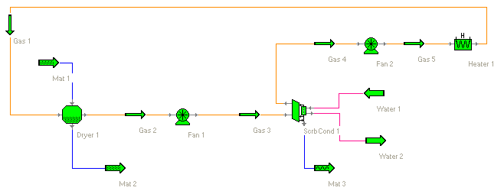
Figure 9a

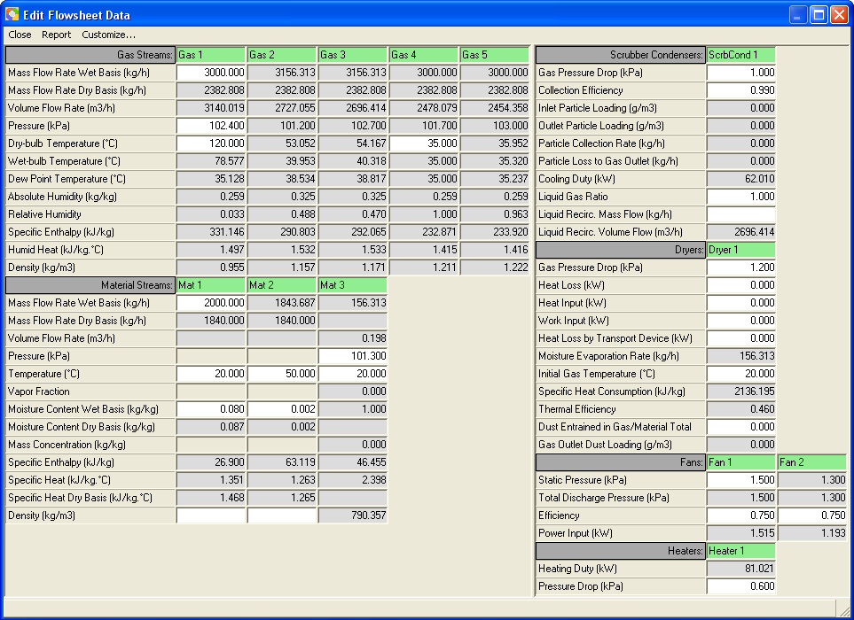

Figure 9b

Example 10 – Evaporation

Problem

Liquid material of 50000 kg/hr flow rate is initially at a mass concentration of 0.13 kg/kg and a temperature of 3 ºC. It needs to be concentrated to a mass solid content of 57%. Material density is 720 kg/m³ at the initial temperature. Concentration process needs to be performed at around atmospheric pressure. Specific heat of the material without moisture is 1.26 kJ/kg·ºC. The boiling point rise of the material solution can be described by the following Durhing lines expressed in a Table 1

Table 1. Durhing Lines of Example 10

Mass concentration  (kg/kg) | Start Boiling Point (ºC) |  | End Boiling Point (ºC)
Mass concentration  (kg/kg) | Solvent | Solution | Solvent | Solution
0.0 | 50 | 50 | 200 | 200
0.2 | 50 | 52 | 200 | 203
0.4 | 50 | 55 | 200 | 207
0.6 | 50 | 59 | 200 | 212

Solution

This can be achieved by a two-effect falling film evaporation process. The initial liquid material is first preheated using part of the secondary vapor from the second effect evaporation to about 81 ºC. Then part of the thermally compressed secondary vapor from the first effect is used to further heat the material to nearly the bubble point of the material. It then goes to the first falling film evaporator operating at a pressure of 106 kPa. Water vapor of 265 kPa is used as the heating medium for this evaporator. Vapor and liquid material mixture coming out of the first evaporator goes to a liquid-vapor separator to separate the concentrated liquid with the vapor. Secondary vapor coming out of the separator is compressed with a fresh vapor at 350 kPa using a steam jet ejector. A very small potion of the compressed vapor is used to preheat the feeding material from 81 ºC as to nearly the bubble point as indicated before. The majority is used as the heating medium of the second effect evaporation. The second evaporator is operating at about 100 kPa. Liquid-vapor mixture coming out of the second evaporator goes to another liquid-vapor separator to separate the concentrated liquid material with the vapor. As is mentioned above part of the secondary vapor coming out of the separator is use to preheat the feeding material.

A falling film evaporator can be modeled by a heat exchange. The to-be-concentrated material is at the cold side of the heat exchanger. The heating steam is at the hot side of the exchanger.

Solution Steps:

- Save and close current flowsheet if a flowsheet exists. Otherwise, start Simprosys and close current flowsheet created automatically by Simprosys.
- Go to ‘Edit | Unit Systems’ to select SI-2 and click Set Current button to set SI-2 unit system as current unit system. Close this dialog.
- Go to ‘Edit | Numeric Format’ tab to change Decimal Places to 4.
- Go to ‘Materials | Drying Material Catalog’ to bring up the “Drying Material Catalog” dialog. Click Add button to add a new drying material. In the “Name” field change the name to “Generic Evaporation Material”. Input 1.26 in the Specific Heat of Absolute Dry Material field.
- On the same “Drying Material Catalog” dialog click Durhing Lines button to specify the Durhing lines of Generic Evaporation Material according to Table 1. After all the necessary values are input you should have the following “Durhing Lines” dialog as follows,

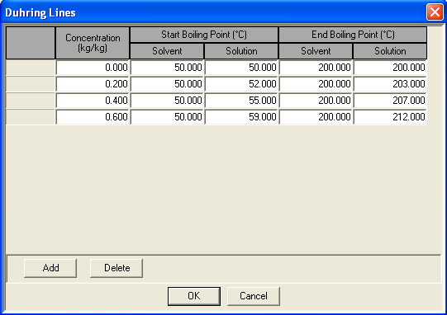

Figure 10a

- Click OK button to close the “Durhing Lines” dialog. Then close the “New Drying Material” dialog and then close “Drying Material Catalog” dialog.
- Go to ‘Materials | Set Default Flowsheet Settings’ to bring up the Set Default Flowsheet Settings dialog. Select “Generic Evaporation Material” in the Select Drying Material list box. Then click Set button to set this material as the drying material of the new flowsheet to be created. Close this dialog.
- Create a new flowsheet by clicking the first icon in the toolbar or selecting ‘File | New’.
- Go to ‘Flowsheet | Options’ group box “Unit Operation Creation” and choose radio button “Without Input and Output”.
- Select ‘Flowsheet | Add | Unit Operations | Pump’ and click anywhere on the flowsheet to create a pump (Pump 1).
- Use the same way as in step 10 to create two heat exchangers (Exch 1 and Exch 2), another pump (Pump 2), another heat exchanger (Evap 1), a separator (Separator 1), an ejector (Ejector 1), a tee (Tee 1), another heat exchanger (Evap 2), another separator (Separator 2) and another tee (Tee 2).
- Select ‘Flowsheet | Add | Streams | Liquid Material’ and click anywhere on flowsheet to create a liquid material stream (Mat 1).
- Use the same way as in Step 12 to add another 21 liquid material streams (Mat 2 to Mat 22
- Rename Mat 10 through Mat 22 to Steam 1 through Steam 13.
- Connect the material streams and the unit operations as in Figure 10b.
- Double click the icon of Pump 1 to bring up the pump editor and input the known values as follows:
- Mat 1: Mass Flow Rate Wet Basis 50000 kg/hr, Pressure 101.3 kPa, Temperature 3 ºC, Mass Concentration 0.13 kg/kg, Density 720 kg/m³.
- Mat 2: Pressure 108 kPa.
- Static Suction Head 2.0 m, Suction Friction Head 0.5 m, Static Discharge Head 2.0 m, Discharge Friction Head 3.0 m, Efficiency 0.7.
- Bring up Exch 1’s editor and input in
- Mat 3: Temperature 81 ºC.
- Cold Side Pressure Drop 3.0 kPa, Hot Side Pressure Drop 3.0 kPa.
- Bring up Exch 2’s editor and input in
- Mat 4: Temperature 100 ºC, Density 720 kg/m³.
- Cold Side Pressure Drop 3.0 kPa, Hot Side Pressure Drop 3.0 kPa.
- Bring up Pump 2’s editor and input in
- Mat 5: Pressure 106 kPa.
- Static Suction Head 2.0 m, Suction Friction Head 0.5 m, Static Discharge Head 3.0 m, Discharge Friction Head 0.5 m, Efficiency 0.7.
- Bring up Evap 1’s editor and input in
- Mat 6: Vapor Fraction 0.37.
- Steam 1: Pressure 265 kPa, Vapor Fraction 1.0, Mass Concentration 0 kg/kg.
- Steam 2: Vapor Fraction 0,
- Cold Side Pressure Drop 4.0 kPa, Hot Side Pressure Drop 4.0 kPa
- Bring up Separator 1’s editor and input in
- Steam 4: Pressure 100 kPa
- Bring up Ejector 1’s editor and input in
- Mat 1: Mass Flow Rate Wet Basis 4200 kg/hr, Pressure 350 kPa, Vapor Fraction 1.0, Mass Concentration 0 kg/kg.
- Compression Ratio 1.8
- Bring up Evap 2’s editor and input in
- Mat 8: Vapor Fraction 0.64
- Cold Side Pressure Drop 5.0 kPa, Hot Side Pressure Drop 5.0 kPa
- Bring up Separator 2’s editor and input in
- Steam 3: Pressure 93 kPa
- Bring up Tee 1’s editor and input in
- Steam 6 of Outlet Fractions group box 0.073
- Bring up Tee 1’s editor and input in
- Steam 12 of Outlet Fractions group box 0.322
- The known and calculated variable values are displayed in Figure 10c.

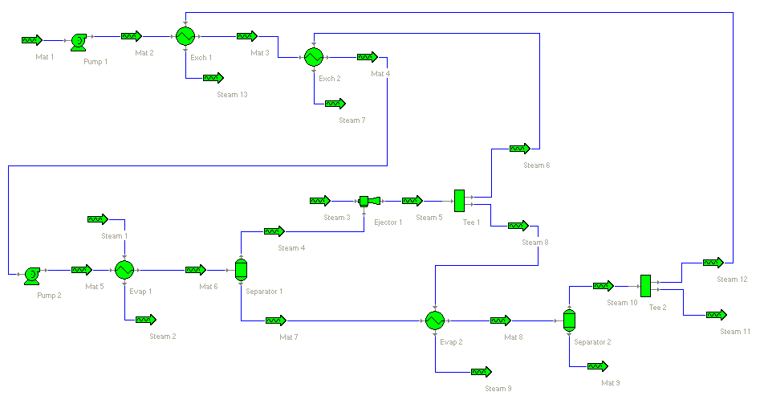
Figure 10b

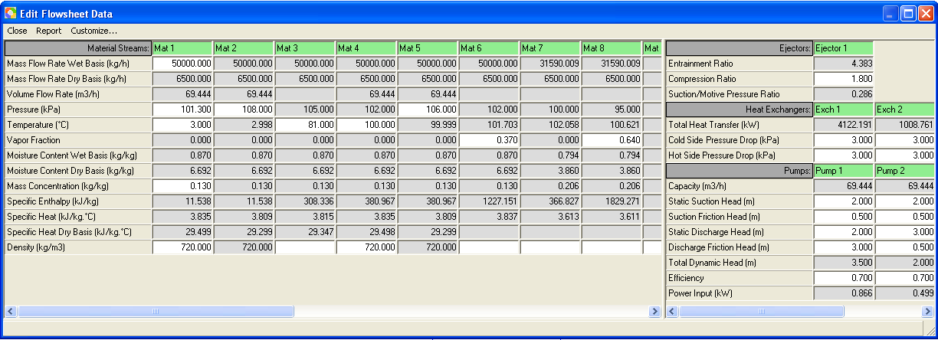

Figure 10c

Please be noted that not all the known values of the variables are presented in the statement of the Problem. However, the missing variable values are assumed and input as in the solution steps.

Example 11 - Evaporation and Drying 1

Problem

This example is an extension of Example 10. The same liquid material needs to be spray dried after being concentrated. The evaporation process has already been described in Example 10. Concentrated liquid material goes to a spray dryer. The drying air of the spray dryer needs to be at 103.2 kPa and 140 ºC. The exhaust air is at 68 ºC. Material outlet from the spray dryer is at 55 ºC and 3% (wet basis). Part of the secondary vapor from the second effect evaporator is used to preheat the drying air.

Solution Steps

Following the solution steps in example 10, the following extra steps are needed:

- Add an air filter (AirFilter 1), a fan (Fan 1), a heat exchanger (Exch 3), a heater (Heater 1), a liquid dryer (Dryer 1) and a cyclone (Cyclone 1), 7 gas streams (Gas 1 through Gas 7), two liquid material stream (Steam 14 and Stream 15), two solid material streams (Mat 10 and Mat 11).
- Connect the gas and material streams with the unit operations as in Figure 11a.
- Bring up AirFilter 1’s editor and input in
  - Gas 1: Pressure 101.3 kPa, Dry-buld Temperature 20 ºC.
  - Gas Pressure Drop 0.3 kPa, Collection Efficiency 0.995, Inlet Particle Loading 0.1 g/m³, Filtration Velocity 2.5 m/s.
- Bring up Fan 1’s editor and input in
- Static Pressure 4.0 kPa, Efficiency 0.73.
- Bring up Tee 2’s editor and input in
- Steam 14 of “Outlet Fractions” group box 0.184
- Bring up Exch 3’s editor and input in
- Steam 15: Vapor Fraction 0.
- Cold Side Pressure Drop 1.2, Hot Side Pressure Drop 3.0 kPa.
- Bring up Heater 1’s editor and input in
- Gas 5: Temperature 140 ºC, Absolute Humidity 0.009 kg/kg.
- Pressure Drop 0.6 kPa.
- Bring up Dryer 1’s editor and input in
- Mat 5: Temperature 55 ºC, Moisture Content Wet Basis 0.03 kg/kg.
- Gas 6: Dry-bulb Temperature 68 ºC.
- Gas Pressure Drop 1.0 kPa, Dust Entrained in Gas/Material Total 0.001.
- Bring up Cycone 1’s editor and input in
- Gas Pressure Drop 0.6 kPa, Collection Efficiency 0.95.

The results are displayed in Figure 11b

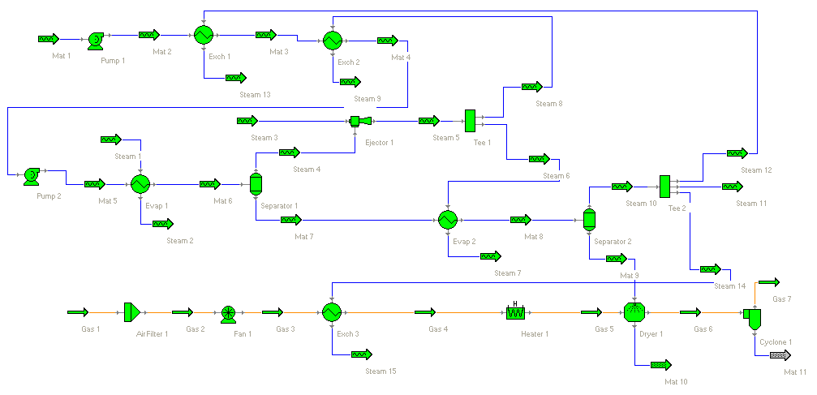
Figure 11a

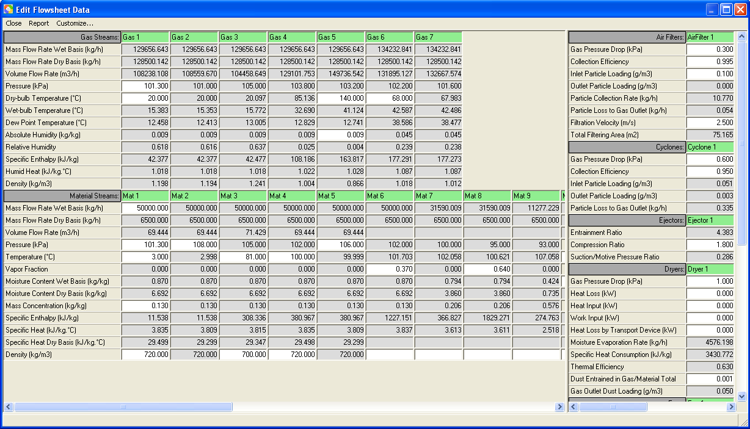

Figure 11b

Please be noted that not all the known values of the variables are presented in the statement of the problem. However, the missing variable values are assumed and input as in the solution steps.

Example 12 - Evaporation and Drying 2

Problem

This example is an extension of example 10. After the same liquid material is concentrated it needs to be dried at first in a spray dryer and then in a vibrated fluid bed dryer. The evaporation and first stage drying process has already been described in Example 11 (The drying air of the spray dryer needs to be at 103.2 kPa and 140 ºC. The exhaust air is at 68 ºC. Material outlet from the spray dryer is at 55 ºC and 8% (wet basis) moisture content). The drying air of the vibrated fluid bed dryer needs to be at 103.2 kPa and 85ºC. The exhaust air is at 50 ºC. Material outlet from the vibrated fluid bed dryer is at 52 ºC and 0.3% (wet basis) moisture content. Part of the secondary vapor from the second effect evaporator is used to preheat the drying air as is described in Example 11.

Solution Steps:

Following the solution steps in example 10, the following extra steps are needed:

- Add an air filter (AirFilter 1), a fan (Fan 1), a heat exchanger (Exch 3), a tee (Tee 3), a heater (Heater 1), a liquid dryer (Dryer 1), a solid dryer (Dryer 2), a cyclone (Cyclone 1), a bag filter (BagFilter 1), 8 gas streams (Gas 1 through Gas 8), two liquid material stream (Steam 14 and Stream 15), three solid material streams (Mat 10 through Mat 12).
- Connect the gas and material streams with the unit operations as in Figure 12a.
- Bring up AirFilter 1’s editor and input in
  - Gas 1: Pressure 101.3 kPa, Dry-buld Temperature 20 ºC.
  - Gas Pressure Drop 0.3 kPa, Collection Efficiency 0.995, Inlet Particle Loading 0.1 g/m³, Filtration Velocity 2.5 m/s.
- Bring up Fan 1’s editor and input in
- Static Pressure 4.0 kPa, Efficiency 0.73.
- Bring up Tee 2’s editor and input in
- Steam 14 of Outlet Fractions group box 0.218
- Bring up Exch 3’s editor and input in
- Steam 15: Temperature 85 ºC.
- Cold Side Pressure Drop 1.2 kPa, Hot Side Pressure Drop 3.0 kPa.
- Bring up Heater 1’s editor and input in
- Gas 5: Dry-bulb Temperature 140 ºC, Absolute Humidity 0.009 kg/kg.
- Pressure Drop 0.6 kPa.
- Bring up Dryer 1’s editor and input in
- Mat 5: Temperature 55 ºC, Moisture Content Wet Basis 0.08 kg/kg.
- Gas 6: Dry-bulb temperature 68 ºC.
- Gas Pressure Drop 1.0 kPa, Dust Entrained in Gas/Material Total 0.001.
- Bring up Cycone 1’s editor and input in
  - Gas Pressure Drop 0.6 kPa, Collection Efficiency 0.95.
- Bring up Dryer 2’s editor and input in
- Mat 5: Temperature 52 ºC, Moisture Content Wet Basis 0.003 kg/kg
- Gas 10: Dry-bulb Temperature 50 ºC.
- Gas Pressure Drop 1.0 kPa, Dust Entrained in Gas/Material Total 0.001
- Bring up BagFilter 1’s editor and input in
- Gas Pressure Drop 0.6 kPa, Collection Efficiency 0.995, Filtration Velocity 2.5 m/s, Bag Diameter 0.4 m, Bag Length 2.0 m.

The results are displayed in Figure 12b

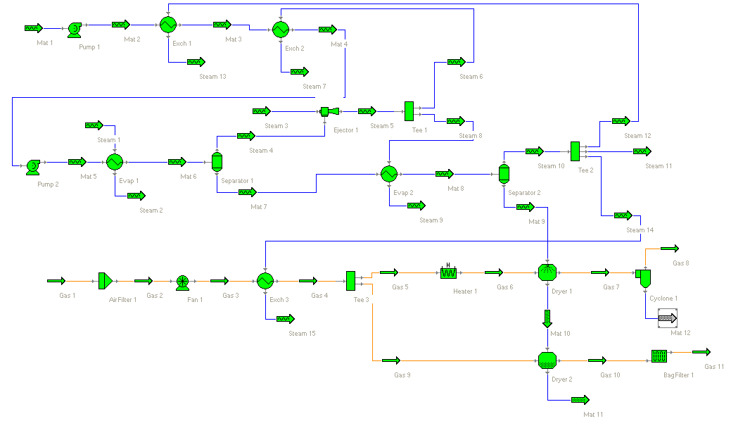
Figure 12a

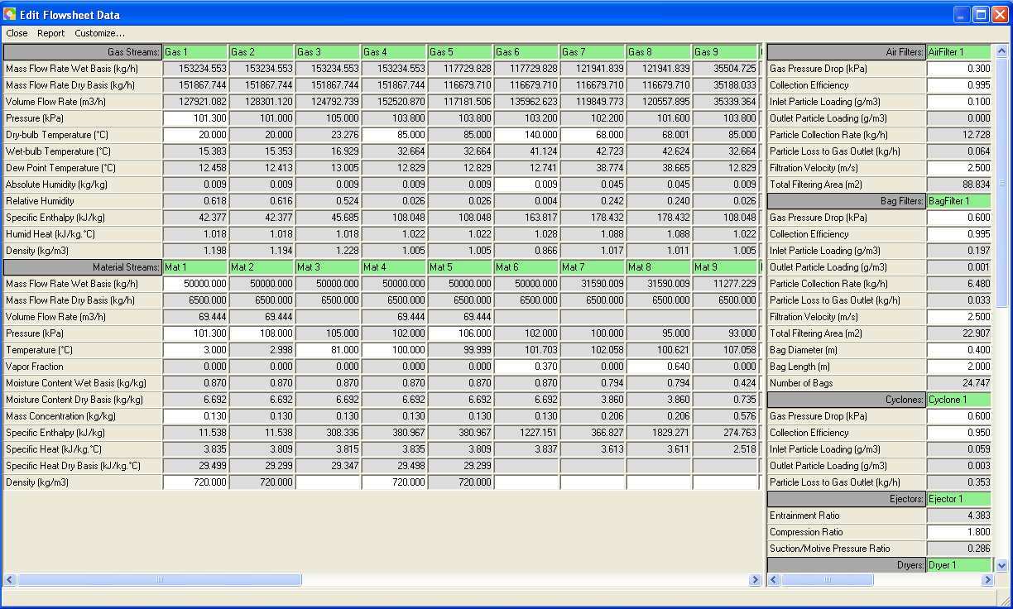

Figure 12b

