DRYING SOFTWARE – SIMPROSYS: MOTIVATION, DEVELOPMENT, APPLICATIONS AND POTENTIAL ROLE IN PRACTICE

ZHENXIANG GONG
Simprotek Corporation, 7375 Rollingdell Dr., Suite 41, Cupertino, California, 95014 USA, email: zhenxiang_gong@simprotek.com
This paper presents a new drying software package, Simprosys, the purpose for its development, and its applications in drying related process simulation. It also discusses the potential role of this software in practice.
- Introduction
Although drying competes with distillation as the most energy-consuming unit operation, development of drying-related software was almost completely neglected. Meanwhile, several major distillation-related software products were developed and widely used in industry and academia over the past 20 years.
A dryer is essentially a heat/mass exchanger. Design and analysis software for conventional heat exchanger has played an important role in teaching and design for over two decades. This has not been the case of dryers.
Drying related process simulation requires intensive calculations of not only the states of moist gas for convective dryers, which constitute over 90 percent of all industrial dryers, but also special state variables such as wet-bulb temperature as well as absolute and relative humidity. Due to the nonlinearity and complexity of these calculations, humidity charts were developed a century ago and have been widely used. However, using the century old humidity charts for drying related calculations is obviously inadequate in this electronic age.
Given the high price of oil during the past few years and the likelihood that this will not change soon energy conservation technology will once again become a focal point for both industry and academia.
Simprosys, probably the first software of its kind, has been developed by Simprotek Coporation (www.simprotek.com) specifically for drying and evaporation. It was developed to be an effective and easy-to-use tool that can help improve the energy efficiency for the drying industry.
- Motivation and Development of Simprosys
The idea of Simprosys dated back to 1996 when I took the drying course of Professor Mujumdar at McGill University. In that course he invited a consulting engineer to give us a special lecture on some practical drying problems. The engineer presented a good degree of process data. I asked him whether he used any drying software to generate his data. He replied that there was no drying software available. Therefore he could only use Microsoft Excel to process his data. Obviously, Excel is never an appropriate tool for drying related calculations. This became the first time I pondered on a drying software package that could help engineers.
In 1997, I left McGill for Hyprotech Ltd. in Calgary, Canada after I completed my Ph.D program. Hyprotech is well known for its process simulation software, Hysys, which is a very successful software package for oil and gas related process simulations in chemical industry. Hysys has a very good philosophy to handle user interaction with the software. With Hysys it is really easy for engineers to quickly layout out a flowsheet and do the necessary heat/mass/pressure balance calculations. They can easily study the effects of input parameters on output parameters in a big flowsheet that contains dozens of unit operations.
Not long after I joined Hyprotech I consulted professor Mujumdar on whether there had already been any drying software available on the market. The answer was still no. Then I thought a software package, that applies the philosophy of Hysys to drying-related simulations, would be a very useful tool for related engineers. That was the seed for Simprosys.
As is known, Hysys was designed mainly for materials of very well defined chemical compositions and its calculations are mainly based on gas state equations. Therefore, its foundation, the stream model, is based on temperature, pressure, and enthalpy. This Hysys stream model has difficulties in dealing with materials that does not have a well defined molecular composition, such as food and agricultural products. It also has difficulties in dealing with drying related simulation since such simulations need specific state variables such as wet bulb temperature as well as relative and absolute humidity that are difficult to incorporate into the Hysys stream model.
Simprosys was developed using the most advanced software technology, Microsoft .Net and C#, to fill the void of process simulation for materials that do not have a clear definition of compositions. It is started with drying and evaporation as its typical target processes. However, this does not limit the software only to such processes.
The drying models of Simprosys are based on extensive studies of the most authoritative handbooks by Mujumdar [1], Masters [2] and Perry [3] etc. and many advanced drying literatures such as by Kemp [4, 5]. The other unit operation models in Simprosys are based on Perry [4], Ibarz and Barbosa-Canovas [6] and Chopey [7], Reynolds [8] etc. and many other handbooks.
- Applications of Simprosys
Using the unit operation modules provided by Simprosys, one can construct any drying and evaporation related process you want to model, design and analyze it. One can also readily explore different arrangements of unit operations and experiment with different operating conditions to optimize alternate designs and operations.
Two examples are selected here to demonstrate applications of Simprosys.
Example 1 -- A Drying Flowsheet with Recycled Exhaust Gas Stream
The drying material is solid particles. Feed moisture content = 0.05 kg/kg wet basis. Feed temperature = 10 ºC. Product temperature = 50 ºC. Product moisture content = 0.002 kg/kg wet basis. Specific heat of the absolute dry material = 1.26 kJ/kg·ºC. Mass flow rate wet basis = 2000 kg/hr.
Drying air: Initial pressure = 101.3 kPa. Initial temperature (dry-bulb) = 10 ºC. Initial relative humidity = 0.3. Mass flow rate wet basis = 6400 kg/hr.
Drying air goes through an air filter with a pressure drop of 0.3 kPa. Assume dust volume concentration is 0.1 g/m³, collection efficiency of the air filter is 99.8% and filtration velocity is 2.5 m/s. Drying air then goes through a fan (the efficiency is 0.7) to gain 3 kPa static pressure, then through a heater to be heated to 90 ºC before going to the dryer. Pressure drop of air in heater is 0.8 kPa. Pressure drop of air in dryer is 1.2 kPa. The exhaust air entrains 0.1% of the total material. It goes through a cyclone to collect 95% of the entrained dust material. Pressure drop of the cyclone is 0.6 kPa. Half of the exhaust gas from the cyclone goes through a fan (the efficiency of the fan is 0.7) to gain 1.8 kPa static pressure and then is recycled back to the dryer’s gas inlet.
The established flowsheet using Simprosys is displayed in Figure 1. The simulated result is shown in Figure 2.

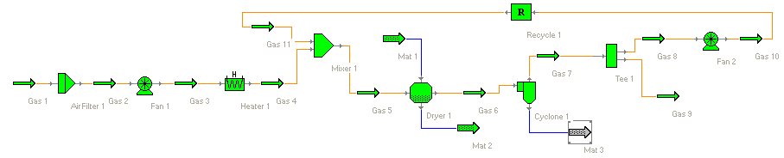

Figure 1. A Flowsheet with Recycled Exhaust Gas Stream

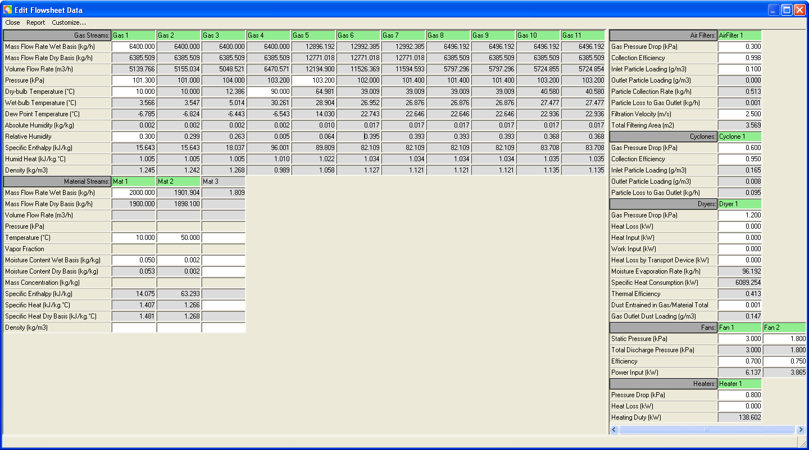

Figure 2. Simulation Results of Example 1

With Simprosys it is easy specify the absolute humidity of the fresh air in stead of relative humidity, or specify the heating duty of the heater rather than the air inlet temperature of the dryer to simulate the flowsheet. One can also change the material inlet temperature and/or moisture content to see how the air outlet temperature and humidity change.
Example 2 -- A Drying Flowsheet with Recycled Material Stream
The drying material is solid particles. Initial moisture content = 0.25 kg/kg wet basis. Initial temperature = 20 ºC. Product temperature = 75 ºC. Product moisture content = 0.002 kg/kg wet basis. Specific heat of the absolute dry material = 1.26 kJ/kg·ºC. Mass flow rate wet basis = 1000 kg/hr.
Drying air has the following conditions: Initial pressure = 101.3 kPa. Initial temperature = 20 ºC. Initial Relative Humidity = 0.3. Mass Flow Rate wet basis = 10000 kg/hr
Drying air needs to go through an air filter first. Pressure drop in the air filter is 0.3 kPa. Assume dust volume concentration is 0.1 g/m³, collection efficiency of the air filter is 99.8% and filtration velocity is 2.5 m/s. Drying air then goes through a fan (the efficiency of the fan is 0.7) to gain 3 kPa static pressure, then through a heater with a heating duty of 246 kW. Pressure drop of air in heater and dryer is 0.8 kPa and 1.2 kPa respectively. The exhaust air of the dryer entrains 0.1% of the total material into the dryer’s gas outlet stream. The gas outlet stream needs to go through a cyclone to collect the entrained dust material. Collection efficiency of the cyclone is 95%. Pressure drop of air in the cyclone is 0.6 kPa.
The dryer requires that the feed moisture content (wet basis) is less than 0.15 kg/kg. As is known, initial moisture content (wet basis) of the material is 0.25 kg/kg. One solution is to mix a portion of the dried material product with the fresh material to decrease the moisture content to the required moisture content level and then feed the dryer.
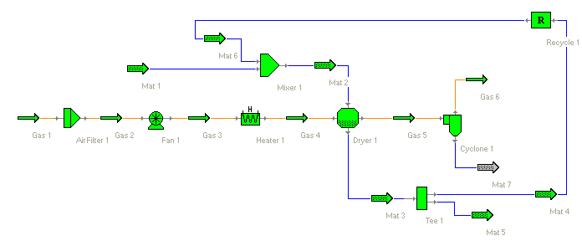

Figure 3. A Flowsheet with Recycled Material Stream

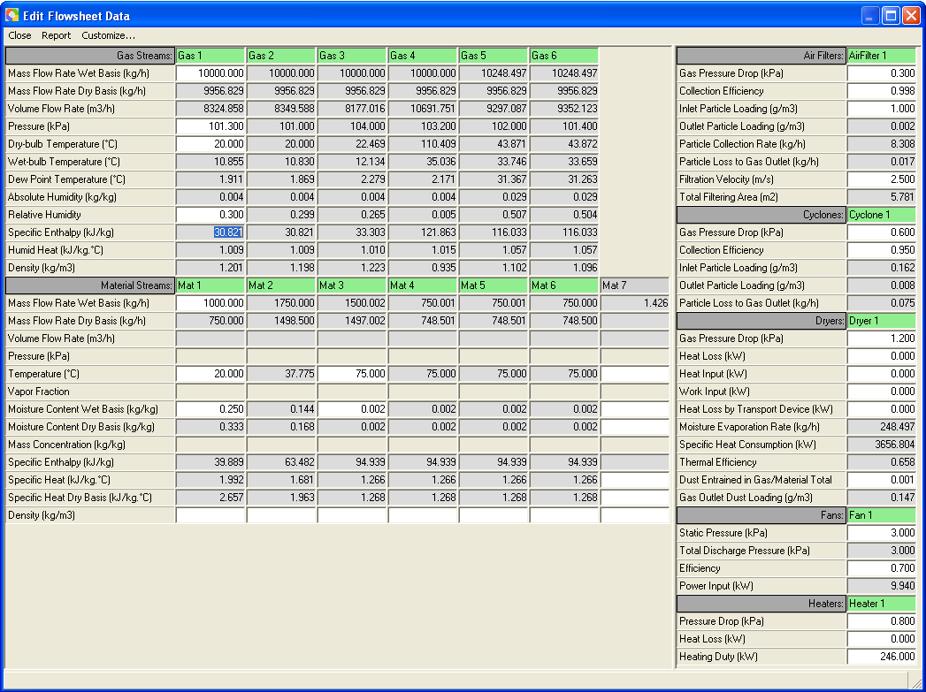

Figure 4. Simulation Results of Example 2

A tee is required to split the product material into two streams. One goes through a recycle and mixes with the fresh material in a mixer and then introduced into the dryer material inlet.
The established flowsheet is displayed in Figure 3. The simulated result is shown in Figure 4.
Simulation results indicate that one half of the dry product from the dryer needs to be mixed with the original material to satisfy the material inlet moisture content requirement.
With Simprosys the designer can easily specify the absolute humidity of the fresh air in stead of relative humidity, or specify the air inlet temperature of the dryer rather than the heating duty of the heater to simulate the flowsheet. It is also possible to change the material inlet temperature and/or moisture content, or the dry product ratio recycled (e.g. 40% or 60% dry product to be recycled) to see how the air outlet temperature and humidity are affected.
- Potential Roles of Simprosys in Practice
Based on design requirements an engineer can quickly layout his/her flowsheet and compute heat/mass/pressure balances for their designed plant using Simprosys and obtain the necessary process parameters e.g. air flow rate to the dryer, the capacity and power requirements of the blower, the heat duty of the heater, the exhaust dust concentration of the cyclone or scrubber, etc. He/she can then specify appropriate equipment based on the simulation results.
A process engineer can simulate an existing plant by easily laying out the plant on a flowsheet with Simprosys and input the operating conditions of the plant to see how efficient the operation is. Then he/she can try different operating conditions and optimize the energy efficiency of the operation.
University instructors will find Simprosys an efficient teaching tool for undergraduate and postgraduate teaching of process design in chemical engineering, food and agricultural engineering, etc. With this software package students can readily perform extensive what-if analysis which will otherwise take an unrealistically long time to accomplish. They can also use Simprosys to demonstrate effects of various input parameters on the output parameters for a typical plant. Practicing engineers and scientists can use Simprosys as a self-learning tool.
- Concluding Remarks
One of the paramount missions of scientific research is to improve productivity for industry. With the emergence of the computer, software has played a tremendous role in realizing this mission for research. Achievements in research in almost all academic areas have successfully been converted to software tools that significantly increase the efficiency of not only industry but also academia itself. Software in computational solid mechanics, CFD, heat transfer, and distillation are among the successful examples in mechanical and chemical engineering. However, drying software is a rare exception in this aspect.
Simprosys is an effort to provide an affordable but powerful and easy-to-use software tool to help drying industry and academia. Simprosys 1.0 is only the first step toward this effort. More unit operations and features are being developed for future versions of Simprosys.
Demonstrated examples show only a very small part of the functionalities Simprosys possesses. Interested readers may visit www.simprotek.com to download a free trial version of Simprosys and follow the examples in the tutorial of the software package. They will find Simprosys an extremely efficient and useful tool in the analysis and design of dryers and drying related engineering calculations.

Acknowledgments
My sincere thanks go to Professor Arun S. Mujumdar, my Ph.D. supervisor at McGill University, also my lifetime mentor, for his constant support and invaluable input to the development of Simprosys.

References
- Mujumdar, A. S. Editor, Handbook of Industrial Drying, 3rd Edition, CRC, 2006.
- Masters, K. Spray Drying Handbook, 4th Edition, John Wiley &
Sons, 1985.
- Perry, R. Perry’s Chemical Engineers’ Handbook, 7th edition, McGraw-Hill, 1997.
- Kemp, I.C.; Oakley, D. Modeling of particulate drying in theory and practice, Drying Technology 2002, 20 (9), 1699-1750.
- Kemp, I.C. Drying software: past, present and future, Proceedings of the 15th International Drying Symposium (IDS 2006), Budapest, Hungary, August 20-23, 2006
- Ibarz, A.; Barbosa-Canovas, G. Unit Operations in Food Engineering, CRC Press, 2003.
- Nicholas P. Chopey, Handbook of Chemical Engineering Calculations, 3rd Edition, McGraw-Hill, 2003.
- Reynolds, J.P.; Jeris, J.S.; Theodore, L. Handbook of Chemical and Environmental Engineering Calculations, John Wiley & Sons, 2003.

