Paradise Hotel Frontend
Module: Developing Software Systems II_25_SE2
Lecturer: Dimitar Kazakov
Student: Yevhen Pimenov
Student ID: 2419081
Project: Paradise Hotel
Frontend built with React and TypeScript
Main deliverable | React frontend that consumes the supplied Paradise Hotel backend API
Included in this package | Source code, tests, README, and this documentation file

1. Project overview
Paradise Hotel is a React frontend application created for the supplied hotel backend API. The application provides a complete guest, authenticated user, and administrator experience.
The frontend follows the documented request and response DTOs and does not change the backend contract. The main goals are clear structure, responsive layout, correct API integration, form validation, route protection, and user-friendly error handling.
2. Implemented features
Area | Implemented items | Notes
Static pages | Home, About, Login, Register, Search Rooms, My Reservations, Admin Dashboard, Admin Reservations, Admin Locations | All routes are wired in React Router
Authentication | Register, login, session restore with /api/auth/me, logout | JWT token stored client-side and attached automatically
Reservations | Availability search, reservation creation, reservation cancellation | Search uses live backend data and date validation
Administration | Dashboard charts, reservations table, locations create/edit/delete | Delete errors are handled gracefully when backend rejects deletion
Quality | Client-side validation, error messages, loading states, component tests | Vitest and React Testing Library are configured
3. Technology stack
- React 18 with TypeScript
- Vite for development and build tooling
- Axios for HTTP communication with the backend API
- React Router for page navigation and route protection
- Recharts for the admin dashboard visualizations
- Vitest and React Testing Library for component tests
- Custom responsive CSS for layout and styling
4. Project structure
The frontend source code is organized to keep API calls, UI components, route pages, state management and utilities separated into clear folders.
Folder | Purpose
src/api | Axios client and API service modules for auth, rooms, reservations and admin actions
src/components | Reusable UI pieces, layout, room cards, reservation cards, route guards and admin widgets
src/context | Authentication context and session state
src/pages | Page-level route components
src/types | TypeScript DTO and model definitions
src/utils | Formatting, validation, HTTP error parsing and local storage helpers
src/test | Vitest setup file for component tests
5. Running the backend
- Open the supplied Paradise Hotel backend folder.
- Run npm install.
- Run npm run dev.
- Confirm that the API is available at http://localhost:4000 and that the /api/health endpoint responds successfully.
- Seeded administrator credentials from the backend README: admin@paradise.local / Admin123!
6. Running the frontend
- Open the frontend project folder paradise-hotel-frontend.
- Run npm install.
- Copy .env.example to .env if needed.
- Run npm run dev.
- Open the Vite URL shown in the terminal, normally http://localhost:5173.
7. Testing the application
- Run npm test to execute the component tests.
- Run npm run coverage to generate the coverage report.
- Major covered areas include route protection, validation helpers, room card behavior, search form validation and admin summary rendering.

The application includes automated tests using Vitest and React Testing Library.
Core functionality such as authentication, search forms, protected routes, and admin components are covered.

The overall test coverage is approximately 60%, focusing on the most important parts of the application.
8. Suggested manual testing checklist
- Register a new user account.
- Login with the new account.
- Search for available rooms with valid dates.
- Create a reservation from a room card.
- Open My Reservations and cancel the reservation.
- Login as the seeded admin user.
- Open the admin dashboard and verify all charts load.
- Open Admin Reservations and verify that reservations are listed.
- Open Admin Locations, create a location, edit it, and test deletion behavior.
- Screenshots
Home page
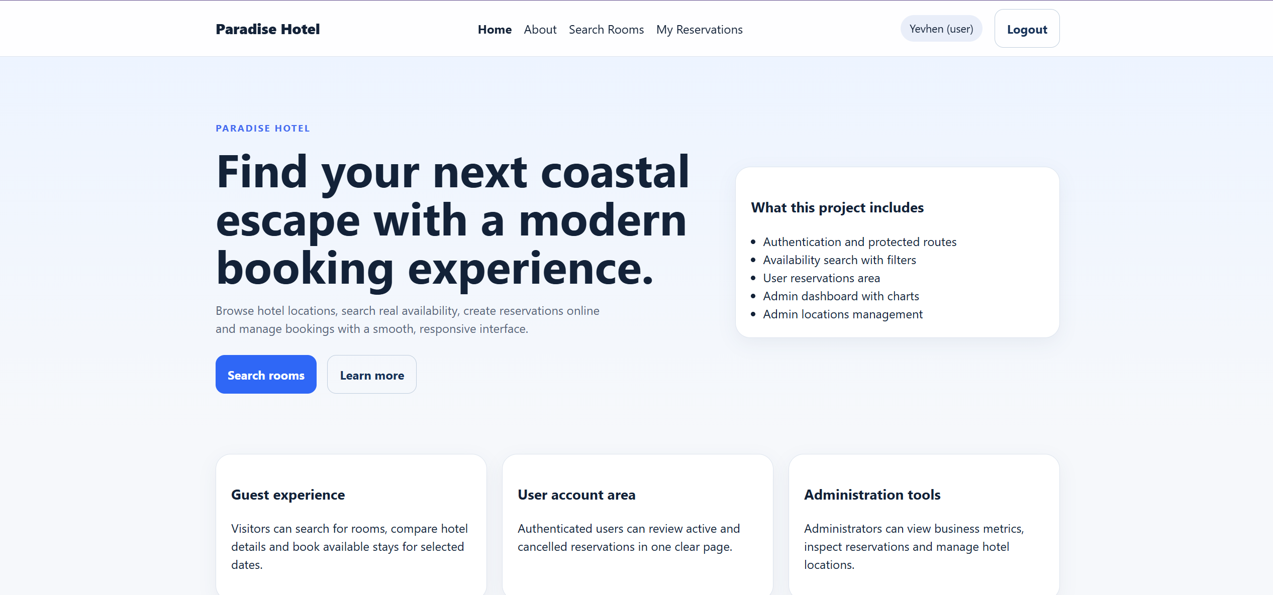

Login page
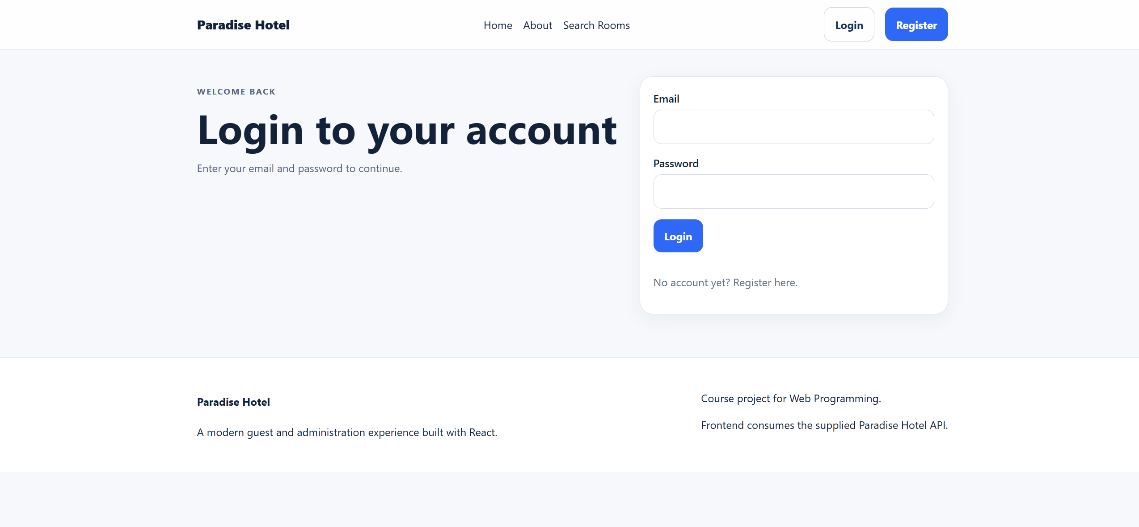

Search Rooms
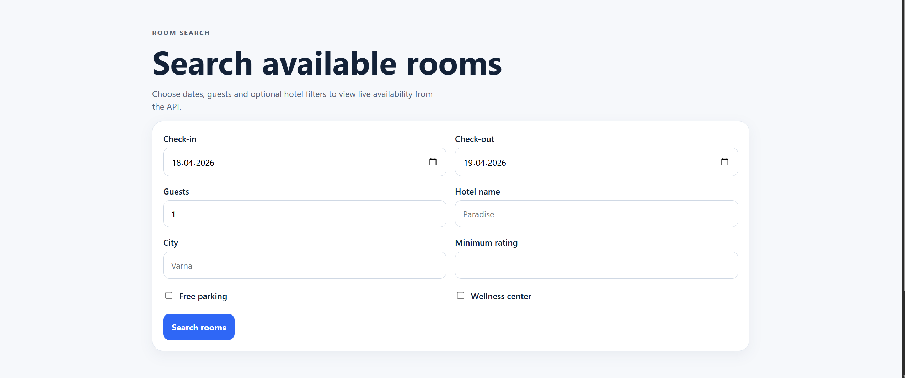
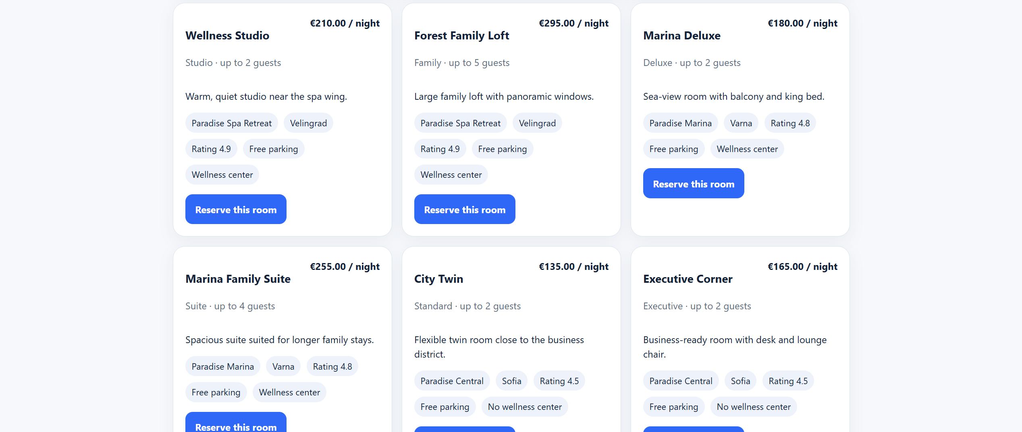

My Reservations
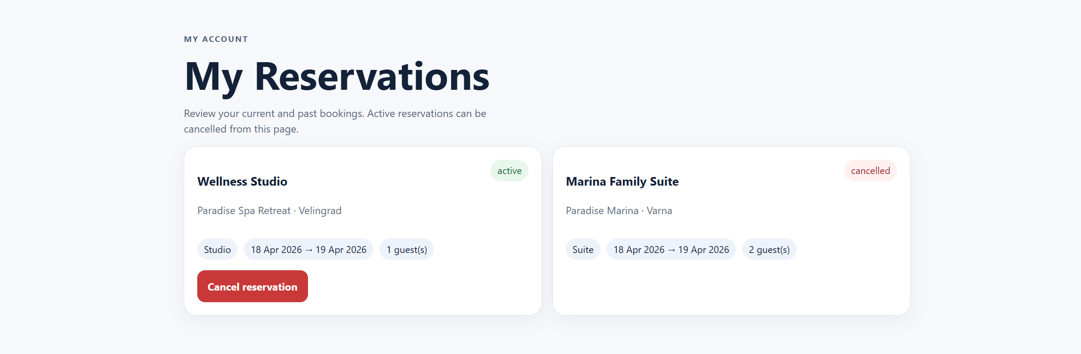

Admin Dashboard
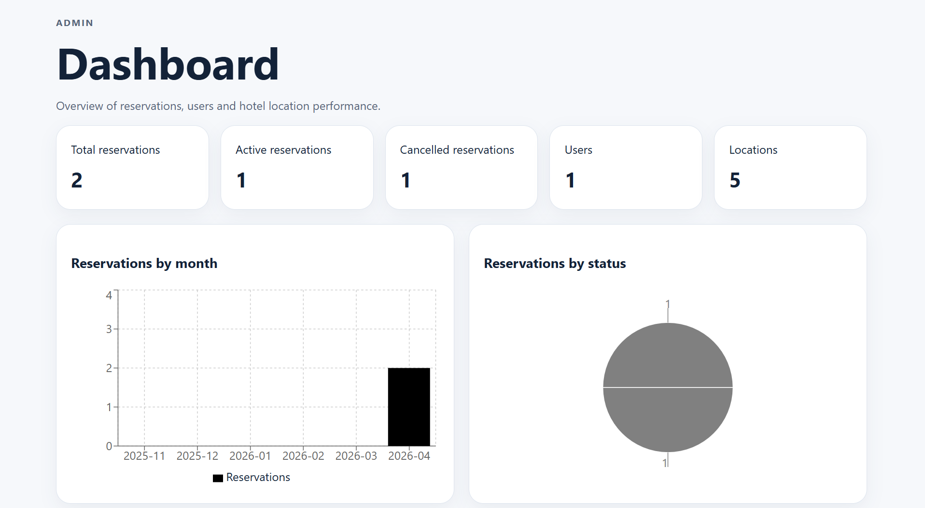
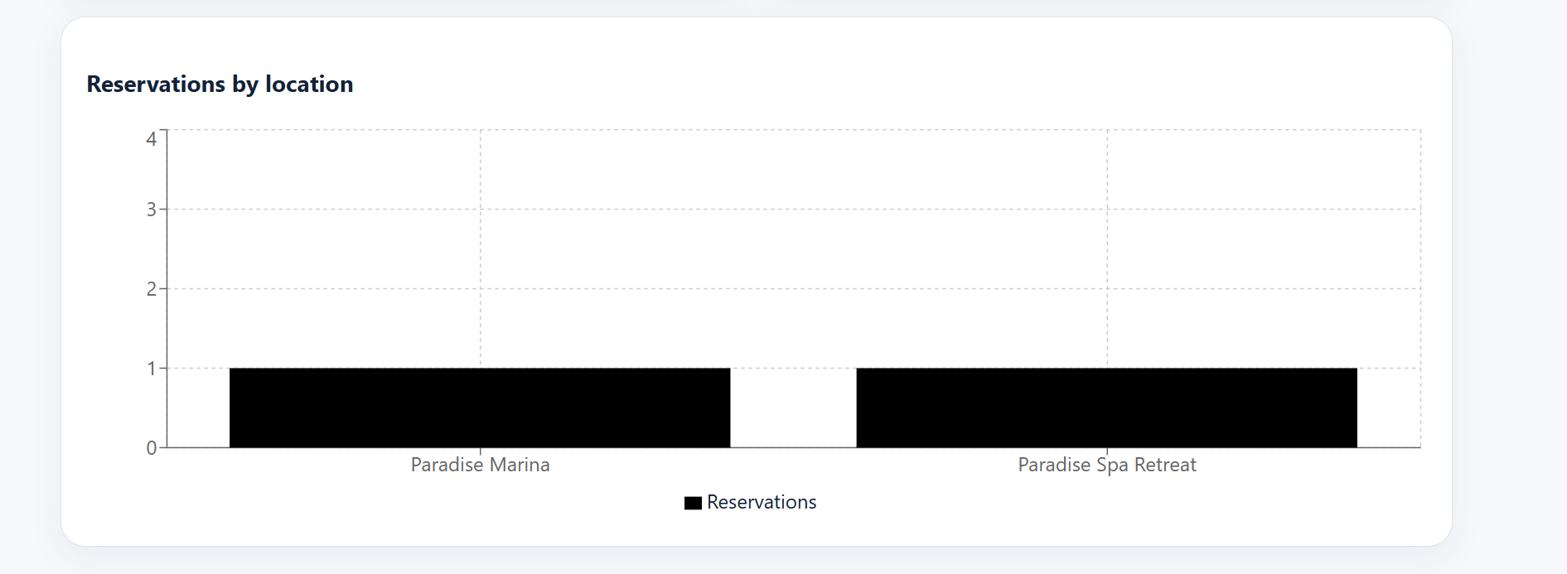

Admin Reservations
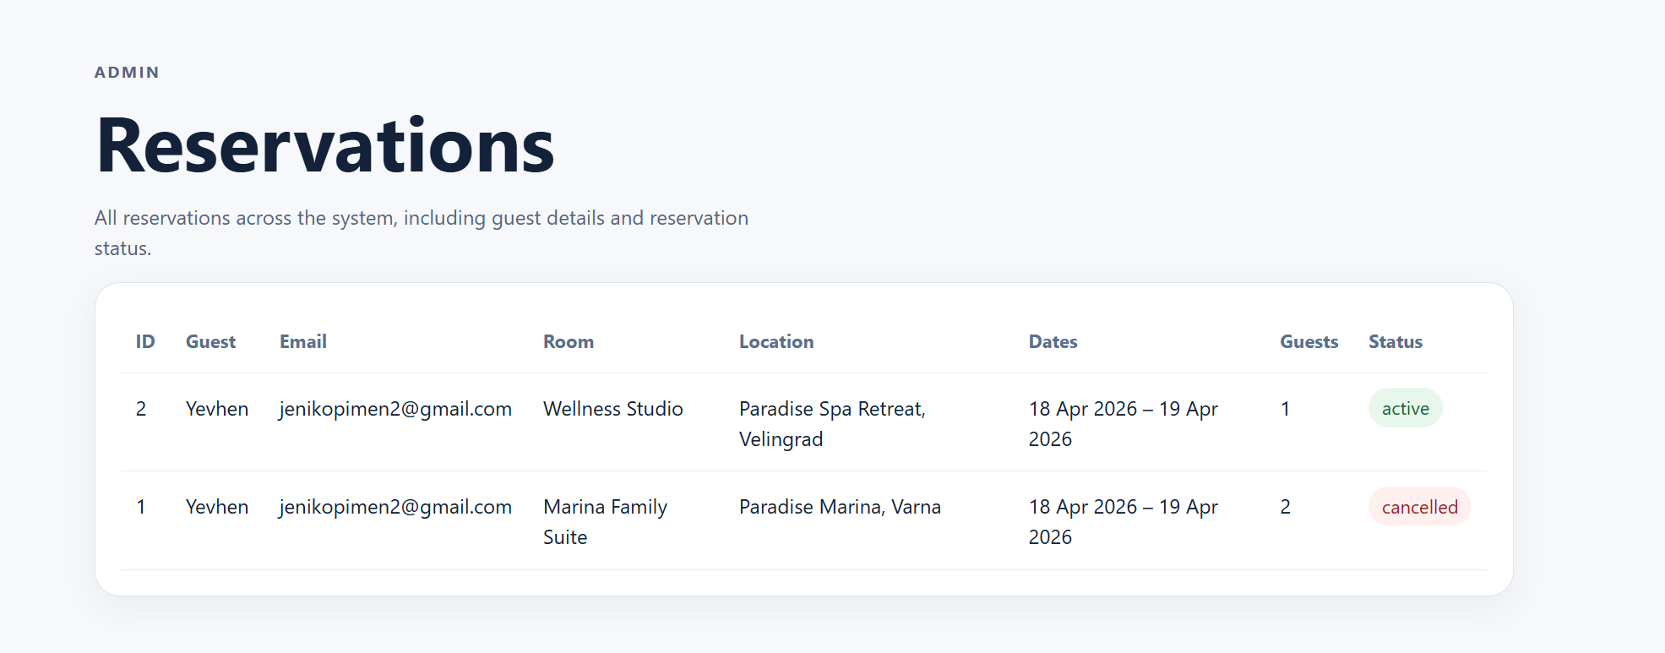

Admin Locations
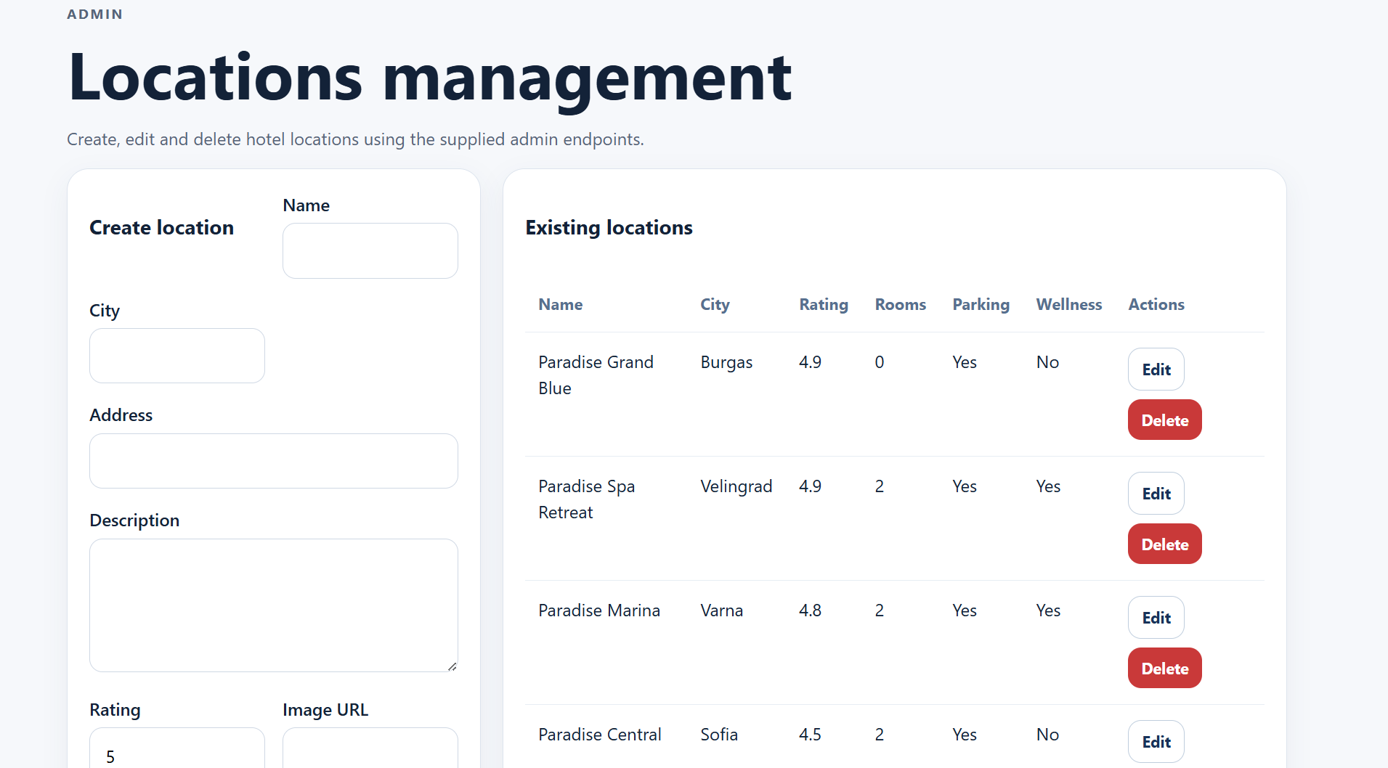
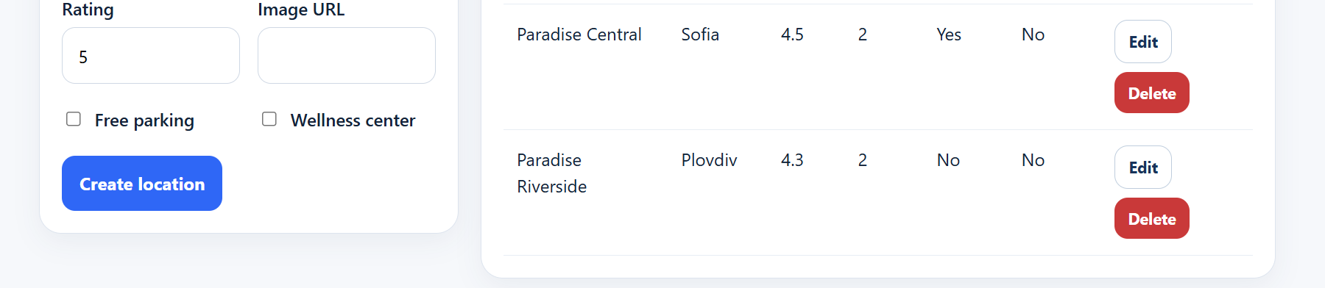
10. Known notes
- The frontend intentionally follows the provided API contract and does not modify backend endpoints or DTO field names.
- The backend includes extra room-management admin endpoints, but they were not required by the brief and were therefore not added to the frontend.
- The backend may reject location deletion when reservations already exist for that location; this case is handled with a user-friendly error message in the frontend.

11. Conclusion

- The project successfully demonstrates a full frontend implementation for a hotel booking system, including user authentication, reservations, and admin management features.

- The application follows modern frontend practices, uses reusable components, and includes testing to ensure reliability.

