CSYE7105 13969 - High Performance Parallel Machine Learning & AI, Fall 2024

Power of Parallel Computing in Thoracic Disease Classification
Using NIH Chest X-ray Dataset
Team 13: Daxiao Han and Zhenyu Dai
Instructor: Prof. Handan Liu

1. Introduction

1.1 Background and Motivation
Chest X-ray examination is one of the most widely used and cost-effective medical imaging modalities in clinical practice. Accurate interpretation of chest radiographs plays a critical role in diagnosing a wide range of thoracic diseases, including pneumonia, cardiomegaly, pneumothorax, and pleural effusion. However, manual analysis is time-consuming and subject to inter-observer variability, making automated computer-aided diagnosis (CAD) systems increasingly valuable. Deep learning-based approaches have shown great promise in automated chest X-ray interpretation, with convolutional neural networks (CNNs) achieving radiologist-level performance on certain classification tasks.
The NIH ChestX-ray14 dataset is one of the largest publicly available chest X-ray collections, containing 112,120 frontal-view images from 30,805 unique patients annotated with 14 thoracic disease labels. The dataset is approximately 45 GB in size. Training a deep CNN such as DenseNet-121 on this scale of data is computationally intensive: data preprocessing may take 20–40 minutes on a single CPU core, and a full training cycle can extend beyond several hours on a single GPU.
These computational bottlenecks make the pipeline a prime candidate for parallel computing optimization. In this project, we focus on maximizing training efficiency under single-GPU constraints through three complementary parallelization strategies: CPU multiprocessing for data preprocessing, multi-worker DataLoader for overlapping data loading with GPU computation, and FP16 mixed-precision training for reducing memory footprint and accelerating computation. Each strategy targets a different stage and type of bottleneck in the training pipeline, and together they provide a comprehensive demonstration of parallel computing principles applied to a real-world deep learning workload.

1.2 Goal
Our goal is to leverage parallel computing techniques to enhance the speed and efficiency of the thoracic disease classification pipeline. Specifically, we aim to:
(1) Significantly reduce data preprocessing time by distributing image transformation workloads across multiple CPU cores using Python multiprocessing, and quantify the speedup and parallel efficiency as a function of core count;
(2) Optimize data loading throughput by benchmarking and tuning the PyTorch DataLoader num_workers parameter to overlap CPU-based data preparation with GPU computation;
(3) Reduce GPU memory consumption and accelerate training using FP16 mixed-precision training with PyTorch’s Automatic Mixed Precision (AMP), while maintaining model accuracy comparable to the FP32 baseline;
(4) Provide a comprehensive analysis of speedup, parallel efficiency, resource utilization, and scaling behavior across all optimization strategies.

2. Methodology
In our methodology, we strategically incorporate parallel processing to optimize computational efficiency at both the data processing and model training stages.

2.1 CPU Multiprocessing for Data Preprocessing
The data preprocessing phase involves loading and transforming 112,120 chest X-ray images: resizing from 1024×1024 to 224×224 pixels, applying normalization (mean and standard deviation computed from ImageNet), and performing data augmentation including random horizontal flipping and random rotation. These operations are embarrassingly parallel, as each image can be processed independently.
We employ Python’s multiprocessing library to distribute image transformation tasks across 1, 2, 4, 8, and 16 CPU cores. The multiprocessing.Pool class is used with the map function to partition the dataset evenly among worker processes. We measure wall-clock time, throughput (images/second), speedup ratio (T_1/T_p), and parallel efficiency (S_p/p × 100%) at each configuration. The benchmarking is performed on a representative subset of 2,000 images to ensure consistent and reproducible timing measurements.

2.2 DataLoader Multi-Worker Optimization
PyTorch’s DataLoader supports parallel data loading through multiple worker processes via the num_workers parameter. When num_workers > 0, worker processes run in separate OS processes, prefetching and transforming batches of data in parallel while the main process executes the forward and backward passes on the GPU. This overlap between CPU-based data preparation and GPU computation is a classic example of pipeline parallelism.
We benchmark five configurations (num_workers = 0, 1, 2, 4, 8) by measuring throughput over 50 batches with a batch size of 32. The optimal num_workers setting is then used for the subsequent training experiments to ensure the data pipeline does not become a bottleneck.

2.3 FP16 Mixed-Precision Training
Mixed-precision training uses a combination of FP32 (32-bit) and FP16 (16-bit) floating-point arithmetic to accelerate computation and reduce memory usage. The NVIDIA A100 GPU features third-generation Tensor Cores that can execute FP16 matrix multiply-accumulate operations at up to 312 TFLOPS, compared to 19.5 TFLOPS for FP32.
We use PyTorch’s Automatic Mixed Precision (AMP) framework, which consists of two key components. First, torch.cuda.amp.autocast automatically selects FP16 for operations that benefit from reduced precision (convolutions, linear layers, matrix multiplications) while keeping numerically sensitive operations (loss computation, batch normalization) in FP32. Second, torch.cuda.amp.GradScaler dynamically scales the loss to prevent gradient underflow in FP16.
We compare FP16 against the FP32 baseline by training DenseNet-121 for 5 epochs under identical conditions: batch size = 32, Adam optimizer with learning rate = 1e-4, BCEWithLogitsLoss, and num_workers = 4.

2.4 Multi-GPU Distributed Training
In addition to single-GPU optimizations, we evaluate two multi-GPU distributed training strategies on Tesla P100-PCIE-12GB GPUs. Distributed Data Parallel (DDP) replicates the full model on each GPU and partitions mini-batches using DistributedSampler. After each backward pass, gradients are synchronized via NCCL all-reduce before the optimizer step. The effective batch size scales linearly with the number of GPUs (batch_size × num_gpus). Fully Sharded Data Parallel (FSDP) shards model parameters, gradients, and optimizer states across GPUs using the FULL_SHARD strategy with a size-based auto-wrap policy (minimum 100K parameters per shard). Parameters are gathered on-demand during forward and backward passes, and released afterward. For FP16, FSDP uses its native MixedPrecision policy rather than AMP autocast. We compare DDP and FSDP at 2-GPU and 4-GPU configurations, with both FP32 and FP16 precision, to evaluate scaling efficiency, memory optimization, and model quality.
2.5 Model Architecture
We adopt DenseNet-121 as the base model for multi-label thoracic disease classification. DenseNet-121 features dense connectivity patterns where each layer receives feature maps from all preceding layers within the same dense block, promoting feature reuse and strengthening gradient flow. The model is initialized with ImageNet-pretrained weights, and the final classification layer is replaced with a 14-output sigmoid layer for multi-label binary classification. The total number of trainable parameters is 7,485,838.

3. Description of Dataset
The dataset used in this project is the NIH ChestX-ray14, provided by the National Institutes of Health (NIH) Clinical Center. It contains 112,120 frontal-view chest X-ray PNG images at 1024×1024 resolution, collected from 30,805 unique patients. All data has been de-identified to ensure patient privacy.
Each image is annotated with one or more of 14 thoracic disease labels: Atelectasis, Cardiomegaly, Effusion, Infiltration, Mass, Nodule, Pneumonia, Pneumothorax, Consolidation, Edema, Emphysema, Fibrosis, Pleural Thickening, and Hernia. These labels were text-mined from associated radiology reports using NLP techniques with an estimated accuracy of over 90%.
The total dataset size is approximately 45 GB. We split the dataset into training (62%), validation (15%), and test (23%) sets, yielding 69,219 training images, 17,305 validation images, and 25,596 test images. The split is performed at the patient level to prevent data leakage.
Property | Value
Total Images | 112,120
Unique Patients | 30,805
Image Resolution | 1024 × 1024 pixels (PNG)
Disease Labels | 14
Dataset Size | ~45 GB
Training Set | 69,219 images (62%)
Validation Set | 17,305 images (15%)
Test Set | 25,596 images (23%)
Input Size (after resize) | 224 × 224 pixels
Table 1. NIH ChestX-ray14 dataset statistics.

3.1 Data Source
The dataset is publicly available at: https://www.kaggle.com/datasets/nih-chest-xrays/data

3.2 Exploratory Data Analysis
Before proceeding to parallel training experiments, we performed exploratory data analysis (EDA) to understand the dataset characteristics. Figure 1 shows the distribution of the 14 disease labels and the train/validation/test split.
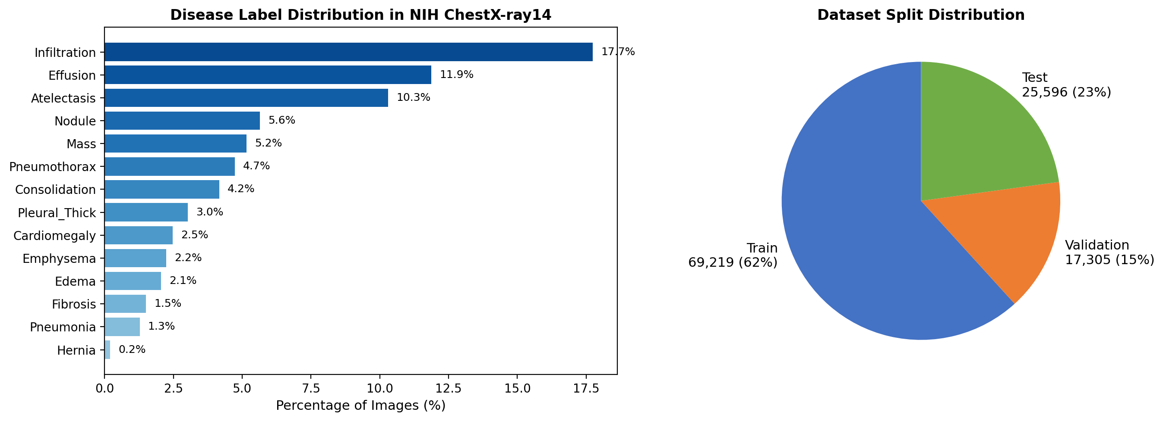
Figure 1. Disease label distribution (left) and dataset split (right).
The dataset exhibits significant class imbalance: Infiltration is the most frequent label, appearing in 17.7% of images, while Hernia appears in only 0.2%. This long-tail distribution is a well-known characteristic of medical imaging datasets and has implications for model training — the use of BCEWithLogitsLoss (rather than softmax cross-entropy) is appropriate for this multi-label, imbalanced setting. The train/val/test split maintains the overall class proportions by performing the split at the patient level.
Additionally, many images carry multiple disease labels simultaneously (multi-label setting), which means the 14 disease labels are not mutually exclusive. For example, a patient may present with both Effusion and Atelectasis. This multi-label nature requires independent sigmoid outputs rather than a single softmax classifier, and the binary cross-entropy loss naturally accommodates this by treating each disease as an independent binary classification task.
The extreme imbalance also explains why certain diseases (e.g., Hernia with only ~227 positive samples) are inherently harder to learn from, while diseases with thousands of positive examples (e.g., Infiltration, Effusion) benefit from larger training sample sizes. This imbalance directly influences the per-disease AUC results discussed in Section 4.4.

4. Results and Analysis

4.1 Experimental Environment
All experiments were conducted on the Northeastern University Explorer HPC cluster. Table 2 describes the hardware and software environment.
Component | Specification
HPC Cluster | Northeastern University Explorer (SLURM-based)
Compute Node | d1026
GPU | NVIDIA A100-SXM4-40GB (42.4 GB HBM2e)
CPU | Multi-core (up to 16 cores allocated via SLURM)
SLURM Job ID | 5456285
Operating System | Linux (CentOS/Rocky)
Python | 3.10+ (Anaconda)
PyTorch | 2.x with CUDA support
Key Libraries | torchvision, PIL, multiprocessing, numpy, scikit-learn
Table 2. Experimental environment.
Multi-GPU experiments were conducted on a separate node with 4 × Tesla P100-PCIE-12GB GPUs (12 GB HBM2 each, Pascal architecture, no Tensor Cores), CUDA 12.3, PyTorch 2.5.1+cu121, using an interactive session via Open OnDemand.

4.2 Data Preprocessing Parallelization
We measured the performance of CPU multiprocessing for image preprocessing across 1, 2, 4, 8, and 16 cores. Table 3 and Figure 2 summarize the results.
Cores | Time (s) | Throughput (img/s) | Speedup | Efficiency (%) | Ideal Speedup
1 | 136.84 | 14.62 | 1.00x | 100.0 | 1.00x
2 | 56.88 | 35.16 | 2.41x | 120.3 | 2.00x
4 | 29.11 | 68.70 | 4.70x | 117.5 | 4.00x
8 | 19.28 | 103.75 | 7.10x | 88.7 | 8.00x
16 | 10.60 | 188.60 | 12.90x | 80.7 | 16.00x
Table 3. CPU multiprocessing results for data preprocessing (2,000 images).
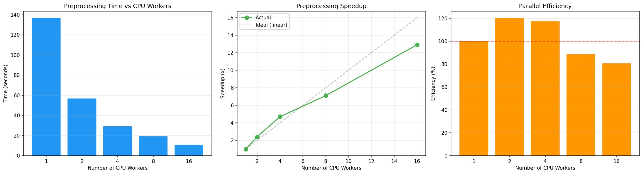
Figure 2. Preprocessing time vs. CPU cores (left), speedup vs. ideal linear (center), and parallel efficiency (right).
Analysis
The results demonstrate excellent parallelization performance. At 16 cores, we achieve a speedup of 12.90x, reducing preprocessing time from 136.84s to just 10.60s. At 2 and 4 cores, we observe super-linear speedup (efficiency > 100%), attributable to improved cache utilization when each process handles a smaller data partition.
As core count increases to 8 and 16, parallel efficiency decreases to 88.7% and 80.7% respectively, due to inter-process communication overhead, I/O contention on the shared Lustre filesystem, and memory bandwidth saturation. Applying Amdahl’s Law in reverse, the serial fraction f ≈ 1.9%, confirming this is an embarrassingly parallel workload.
At 16 cores, the pipeline achieves 188.60 img/s. Extrapolating to the full 112,120 images, preprocessing time would be approximately 595 seconds (under 10 minutes), compared to over 128 minutes at single-core speed.

4.3 DataLoader num_workers Benchmark
Table 4 and Figure 3 present the DataLoader throughput benchmark results.
num_workers | Time for 50 batches (s) | Throughput (img/s) | Speedup vs. 0 workers | Speedup vs. 1 worker
0 | 73.89 | 21.65 | 1.00x | -
1 | 39.02 | 41.00 | 1.89x | 1.00x
2 | 28.11 | 56.92 | 2.63x | 1.39x
4 | 17.05 | 93.83 | 4.33x | 2.29x
8 | 10.53 | 151.93 | 7.02x | 3.71x
Table 4. DataLoader num_workers benchmark (batch size = 32, 50 batches).
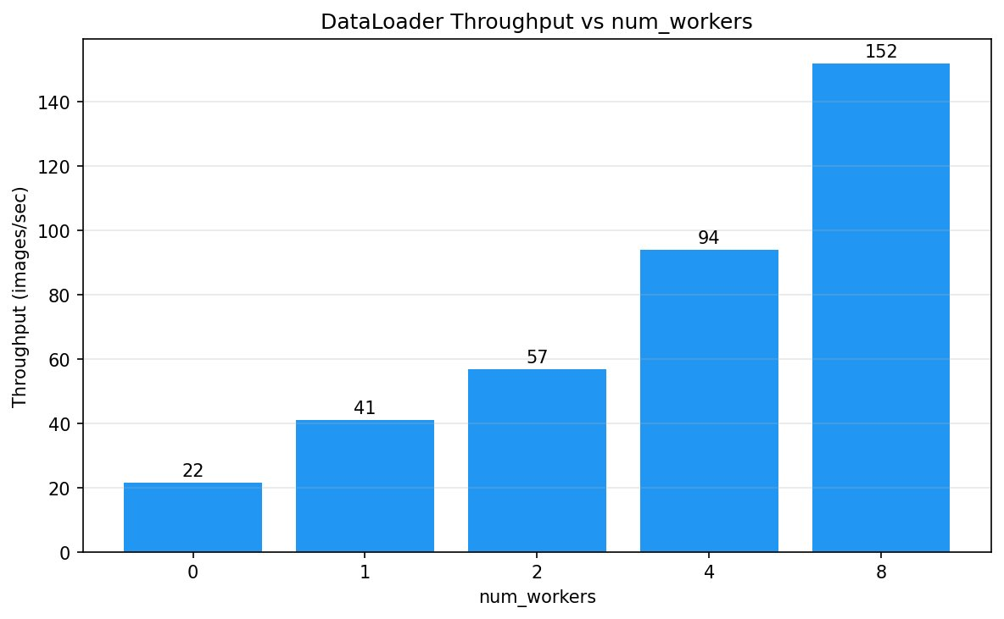
Figure 3. DataLoader throughput vs. num_workers.
Analysis
The DataLoader throughput scales dramatically with worker count. With 0 workers, throughput is only 21.65 img/s; at 8 workers it reaches 151.93 img/s (7.02x speedup). We select num_workers=4 as the optimal configuration (93.83 img/s, 4.33x speedup), balancing throughput with system resource consumption.
This illustrates pipeline parallelism: while the GPU processes the current batch, CPU workers prefetch and transform the next batch in parallel, eliminating the pipeline bubble that occurs with num_workers=0.

4.4 FP32 vs. FP16 Mixed-Precision Training
We trained DenseNet-121 for 5 epochs under FP32 and FP16 configurations. Table 5 summarizes the key metrics; Figures 4 and 5 provide detailed visualizations.
Metric | FP32 | FP16 | Improvement
Avg. Epoch Time (s) | 327.62 | 289.57 | 1.13x faster
Avg. Throughput (img/s) | 214.58 | 239.25 | +11.5%
Peak GPU Memory (GB) | 4.33 | 2.41 | -44.3%
Total Training Time (s) | 1638.08 | 1447.84 | 190.24s saved
Test AUC (Mean) | 0.8059 | 0.8062 | Equivalent
Table 5. FP32 vs. FP16 mixed-precision training comparison.
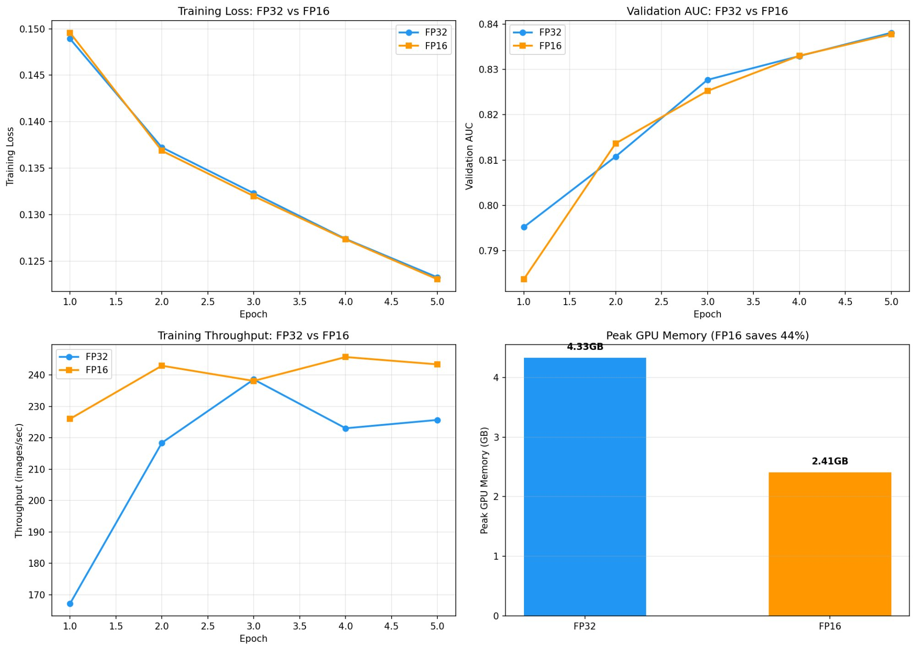
Figure 4. FP32 vs. FP16 comparison: training loss, validation AUC, throughput, and GPU memory.
Training Speed and Memory Analysis
FP16 achieves a 1.13x speedup, reducing average epoch time from 327.62s to 289.57s, saving 190s total. The throughput increase from 214.58 to 239.25 img/s confirms effective Tensor Core utilization. The moderate speedup (vs. theoretical 2x) is explained by DenseNet-121’s compact size (7.5M parameters) and AMP maintaining FP32 for numerically sensitive operations.
The most dramatic improvement is GPU memory: FP16 reduces peak memory from 4.33 GB to 2.41 GB (44.3% reduction), close to the theoretical 50%, confirming most parameters, activations, and gradients are stored in half-precision.
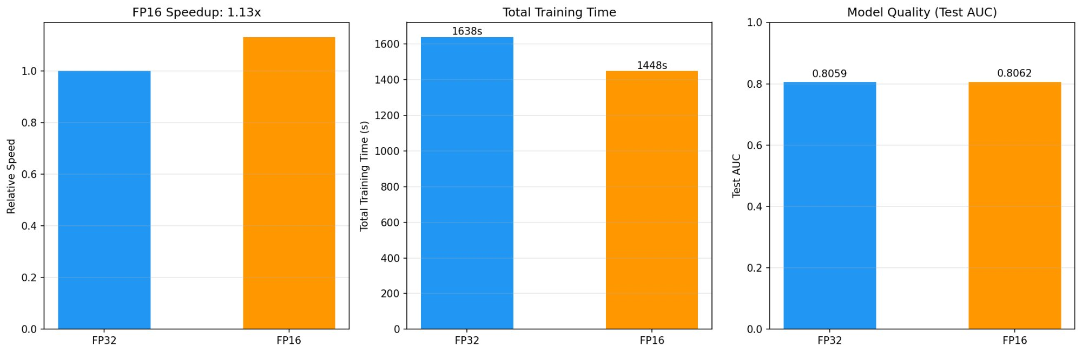
Figure 5. FP16 training summary: speedup, total time, and model quality.
Per-Epoch Training Details
Table 6 presents per-epoch metrics for both training configurations.
Epoch | FP32 Loss | FP16 Loss | FP32 Val AUC | FP16 Val AUC | FP32 Time(s) | FP16 Time(s) | FP32/FP16 Throughput
1 | 0.1489 | 0.1496 | 0.7952 | 0.7836 | 414.1 | 306.2 | 167 / 226
2 | 0.1372 | 0.1369 | 0.8108 | 0.8137 | 316.9 | 284.9 | 218 / 243
3 | 0.1323 | 0.1320 | 0.8277 | 0.8253 | 290.1 | 290.7 | 239 / 238
4 | 0.1274 | 0.1273 | 0.8330 | 0.8331 | 310.3 | 281.7 | 223 / 246
5 | 0.1232 | 0.1230 | 0.8381 | 0.8378 | 306.7 | 284.4 | 226 / 243
Table 6. Per-epoch training details for FP32 and FP16.
Convergence Analysis
Both FP32 and FP16 exhibit healthy convergence: training loss decreases from ~0.149 to ~0.123, while validation AUC improves from ~0.79 to ~0.84. The near-identical trajectories confirm mixed-precision training does not degrade convergence quality. The consistency also validates the GradScaler’s effectiveness in preventing gradient underflow.
Per-Disease Classification Performance
Table 7 presents the test AUC for each of the 14 thoracic disease labels.
Disease | FP32 AUC | FP16 AUC
Atelectasis | 0.7752 | 0.7714
Cardiomegaly | 0.8867 | 0.8873
Effusion | 0.8320 | 0.8342
Infiltration | 0.6986 | 0.6972
Mass | 0.8214 | 0.8181
Nodule | 0.7549 | 0.7598
Pneumonia | 0.7203 | 0.7240
Pneumothorax | 0.8671 | 0.8609
Consolidation | 0.7485 | 0.7508
Edema | 0.8417 | 0.8384
Emphysema | 0.9079 | 0.9157
Fibrosis | 0.8170 | 0.8125
Pleural Thickening | 0.7708 | 0.7759
Hernia | 0.8409 | 0.8399
Mean AUC | 0.8059 | 0.8062
Table 7. Per-disease test AUC comparison.
The per-disease AUC values range from 0.70 (Infiltration) to 0.92 (Emphysema), consistent with published results. The differences between FP32 and FP16 are negligible (< 0.008 AUC points), confirming FP16 preserves classification accuracy.
4.5 Multi-GPU Distributed Training
To evaluate multi-GPU scaling, we conducted Distributed Data Parallel (DDP) and Fully Sharded Data Parallel (FSDP) experiments on 4 Tesla P100-PCIE-12GB GPUs (12 GB each) on the Explorer HPC cluster. Due to HPC resource constraints, the single-GPU baseline was obtained on an A100-SXM4-40GB, while multi-GPU experiments used P100 GPUs. Therefore, the multi-GPU results are best compared among themselves (same hardware) rather than directly against the A100 baseline.
4.5.1 DDP (Distributed Data Parallel) Results
DDP replicates the entire DenseNet-121 model on each GPU and distributes mini-batches across devices. Each GPU computes gradients independently, then an all-reduce operation via NCCL synchronizes gradients before the optimizer step. Table 10 summarizes the DDP results.
Config | Avg Epoch (s) | Throughput (img/s) | GPU Mem (GB) | Test AUC
DDP 2-GPU FP32 | 1135.0 | 61 | 4.36 | 0.8029
DDP 2-GPU FP16 | 1125.4 | 61 | 2.32 | 0.8034
DDP 4-GPU FP32 | 603.5 | 115 | 4.36 | 0.7966
DDP 4-GPU FP16 | 596.7 | 116 | 2.32 | 0.7936
Table 10. DDP training results on P100 GPUs.
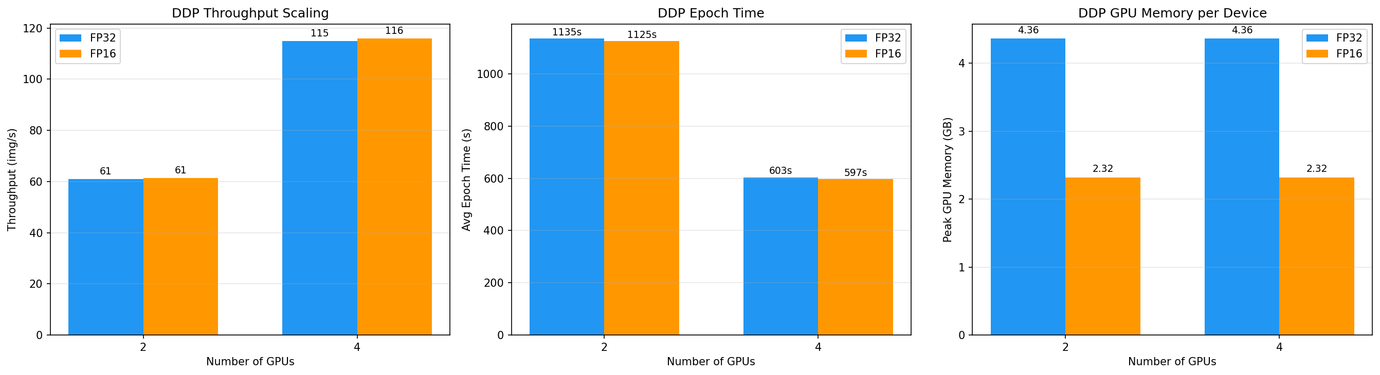
Figure 6. DDP scaling: throughput, epoch time, and GPU memory for 2-GPU and 4-GPU configurations.
Analysis
DDP demonstrates near-linear strong scaling on P100 GPUs. Moving from 2 to 4 GPUs, throughput increases from 61 to 115 img/s (1.89x), and average epoch time decreases from 1135s to 604s (1.88x speedup). This scaling efficiency of approximately 94% indicates minimal communication overhead for the NCCL all-reduce gradient synchronization.
FP16 mixed-precision provides negligible speedup on P100 (1.008x for 2-GPU, 1.011x for 4-GPU), which is expected since P100 lacks Tensor Cores. However, FP16 reduces GPU memory from 4.36 GB to 2.32 GB per device (46.8% reduction), consistent with the A100 results.
The slightly lower test AUC for 4-GPU (0.797 vs. 0.803 for 2-GPU) is attributable to the larger effective batch size (128 vs. 64), which is a well-known phenomenon in distributed training: larger batch sizes can lead to sharper minima and require learning rate warmup or linear scaling for optimal convergence.
4.5.2 FSDP (Fully Sharded Data Parallel) Results
FSDP shards model parameters, gradients, and optimizer states across GPUs using the FULL_SHARD strategy, only materializing full parameters during forward and backward passes. This approach reduces per-device memory consumption compared to DDP. Table 11 presents the FSDP results.
Config | Avg Epoch (s) | Throughput (img/s) | GPU Mem (GB) | Test AUC
FSDP 2-GPU FP32 | 601.0 | 115 | 4.30 | 0.8068
FSDP 2-GPU FP16 | 719.1 | 96 | 3.26 | 0.8030
FSDP 4-GPU FP32 | 637.0 | 109 | 4.27 | 0.7969
FSDP 4-GPU FP16 | 826.4 | 84 | 3.23 | 0.7970
Table 11. FSDP training results on P100 GPUs.
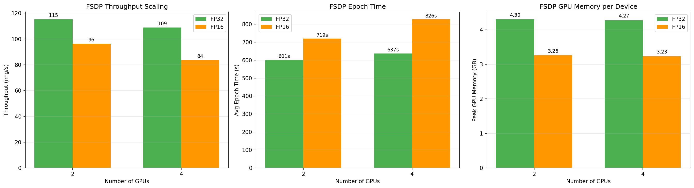
Figure 7. FSDP scaling: throughput, epoch time, and GPU memory for 2-GPU and 4-GPU configurations.
Analysis
FSDP 2-GPU FP32 achieves comparable throughput to DDP 4-GPU (115 vs. 115 img/s), which is noteworthy given it uses half the GPUs. However, FSDP 4-GPU shows limited scaling improvement (109 img/s), suggesting that the communication overhead from parameter gathering and re-sharding becomes significant at higher GPU counts for a model as compact as DenseNet-121 (7.5M parameters).
A notable observation is that FSDP FP16 is slower than FP32 on P100, with speedup ratios of 0.84x (2-GPU) and 0.77x (4-GPU). This counter-intuitive result is because: (1) P100 lacks Tensor Cores, so FP16 computation provides no speed benefit; (2) FSDP’s mixed-precision implementation introduces additional overhead for dtype conversion and the parameter gather/scatter operations in half-precision add extra communication cost.
FSDP does demonstrate memory savings: FP32 memory is 4.30 GB (vs. DDP’s 4.36 GB), and FP16 further reduces to 3.26 GB. While the memory savings are modest for DenseNet-121, FSDP’s sharding advantage becomes significant for larger models (e.g., ViT-Large with 304M parameters) that would not fit in a single P100’s 12 GB memory.
4.5.3 DDP vs. FSDP Comparison
Figure 8 compares DDP and FSDP across throughput, epoch time, and model quality for the FP32 configuration.
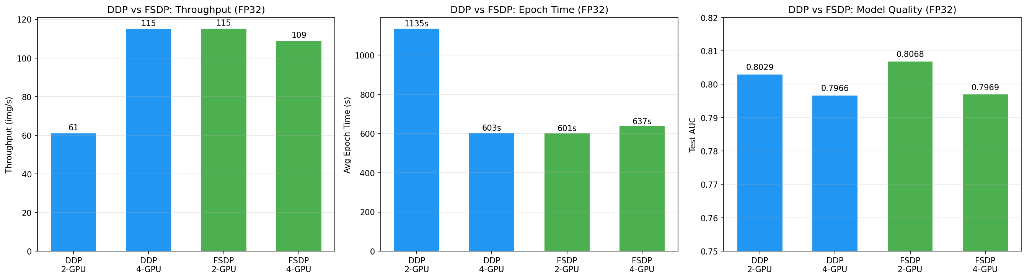
Figure 8. DDP vs. FSDP comparison: throughput, epoch time, and test AUC (FP32).
For a compact model like DenseNet-121, DDP is the preferred strategy: it achieves higher throughput at 4 GPUs (115 vs. 109 img/s) with simpler implementation and lower communication overhead. FSDP’s parameter sharding introduces overhead that outweighs its memory benefits when the model already fits comfortably in a single GPU’s memory. FSDP becomes advantageous when model size exceeds single-GPU memory capacity.
4.5.4 Hardware Architecture Impact
Table 12 and Figure 9 present the full comparison across all configurations, highlighting the impact of GPU hardware architecture.
Config | GPU | Epoch (s) | Throughput | Memory (GB) | AUC
Single GPU FP32 | A100 | 327.6 | 215 img/s | 4.33 | 0.8059
Single GPU FP16 | A100 | 289.6 | 239 img/s | 2.41 | 0.8062
DDP 2-GPU FP32 | P100 | 1135.0 | 61 img/s | 4.36 | 0.8029
DDP 4-GPU FP32 | P100 | 603.5 | 115 img/s | 4.36 | 0.7966
FSDP 2-GPU FP32 | P100 | 601.0 | 115 img/s | 4.30 | 0.8068
FSDP 4-GPU FP32 | P100 | 637.0 | 109 img/s | 4.27 | 0.7969
Table 12. Full training comparison across all configurations.
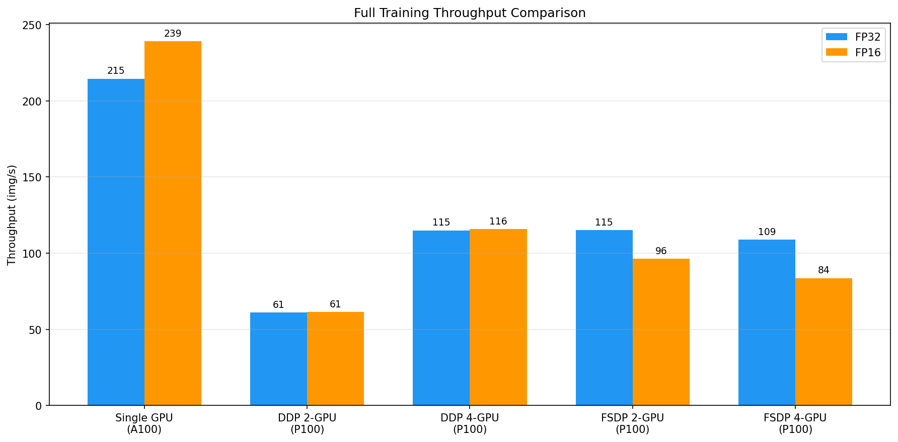
Figure 9. Full throughput comparison across all configurations.
The A100 single-GPU baseline (215 img/s FP32, 239 img/s FP16) outperforms multi-GPU P100 configurations due to the A100’s superior architecture: third-generation Tensor Cores, 40 GB HBM2e memory with 2 TB/s bandwidth, and higher compute throughput (19.5 TFLOPS FP32 vs. P100’s 9.3 TFLOPS). The A100’s 1.13x FP16 speedup (vs. P100’s ~1.0x) directly demonstrates Tensor Core acceleration.
Within the P100 cluster (same hardware), DDP exhibits excellent strong scaling: 2-GPU to 4-GPU delivers 1.89x speedup (94% efficiency), validating the effectiveness of data-parallel distributed training for this workload.

4.6 Overall Parallel Performance Summary
Optimization Strategy | Baseline | Optimized | Improvement
Preprocessing (1→16 cores) | 136.84s | 10.60s | 12.90x speedup
DataLoader (0→4 workers) | 21.65 img/s | 93.83 img/s | 4.33x throughput
Training Precision (FP32→FP16) | 327.62 s/epoch | 289.57 s/epoch | 1.13x speedup
GPU Memory (FP32→FP16) | 4.33 GB | 2.41 GB | 44.3% reduction
Table 8. Overall parallel optimization summary.
Scaling Analysis
From a strong scaling perspective, preprocessing scales excellently (12.90x at 16 cores, 80.6% efficiency, serial fraction ~1.9%). DataLoader optimization represents pipeline parallelism (4.33x throughput at 4 workers). FP16 leverages hardware-level Tensor Core parallelism (1.13x speedup + 44.3% memory reduction).

4.7 Resource Utilization
Table 9 summarizes the hardware resource utilization across our experiments.
Resource | FP32 Training | FP16 Training
GPU Model | A100-SXM4-40GB | A100-SXM4-40GB
GPU Memory Used | 4.33 GB (10.2%) | 2.41 GB (5.7%)
Training Throughput | ~215 img/s | ~239 img/s
CPU Cores (preprocess) | Up to 16 via SLURM | Up to 16 via SLURM
DataLoader Workers | 4 | 4
Table 9. Resource utilization summary.
The A100 GPU has 40 GB of HBM2e memory. Our models consume only 4.33 GB (FP32) and 2.41 GB (FP16), representing 10.2% and 5.7% of available GPU memory respectively. This low utilization suggests significant headroom for larger batch sizes, more complex architectures, or multi-model ensemble training on the same GPU.

5. Program Description
All code was prototyped in Jupyter Notebooks on the Explorer cluster, then converted to standalone Python scripts for SLURM batch execution.

5.1 preprocess_benchmark.py
Benchmarks data preprocessing parallelization using multiprocessing.Pool across 1, 2, 4, 8, and 16 CPU cores. Records wall-clock time, throughput, speedup, and parallel efficiency. Outputs preprocess_results.json.

5.2 train_benchmark.py
Main training script performing: (1) DataLoader num_workers sweep (0–8 workers, 50 batches each); (2) FP32 baseline training for 5 epochs; (3) FP16 mixed-precision training for 5 epochs using torch.cuda.amp. Evaluates per-disease AUC via scikit-learn. Outputs training_results.json.

5.3 data_utils.py
Handles dataset loading, multi-label annotation parsing from Data_Entry_2017.csv, custom PyTorch Dataset class (ChestXrayDataset), and patient-level train/val/test splitting.

5.4 model.py
Defines DenseNet-121 with ImageNet-pretrained weights, replacing the final classifier with a 14-output sigmoid layer for multi-label classification.

5.5 visualize_results.py
Generates all visualization figures from the JSON result files: preprocessing benchmark plots (processing time vs. CPU cores, speedup vs. ideal linear, parallel efficiency bar chart), DataLoader throughput bar chart, FP32 vs. FP16 training curves (loss, AUC, throughput, memory comparison in a 2×2 subplot), and training summary comparison (speedup, total time, test AUC). All plots use matplotlib with publication-quality formatting, saved as high-resolution PNG files for inclusion in the final report.

5.6 multigpu.ipynb
Orchestrates all multi-GPU distributed training experiments in a Jupyter Notebook environment on the Explorer HPC cluster (4× P100-PCIE-12GB). Invokes train_ddp.py and train_fsdp.py via subprocess for 2-GPU and 4-GPU configurations, running both FP32 and FP16 precision for each. Includes environment validation (GPU detection, CUDA version check), shared utility functions for distributed training (process group setup, distributed train/evaluate loops), and a final results summary cell that loads all JSON outputs and prints a consolidated comparison table across Single-GPU, DDP, and FSDP configurations
5.7 SLURM Job Scripts
SLURM batch scripts configure GPU allocation (--gres=gpu:1), CPU cores (--cpus-per-task=16 for preprocessing, 4 for training), memory (--mem=64G), Conda activation, and CUDA module loading. Separate scripts provided for preprocessing and training benchmarks.

5.8 Workload Distribution
The work was distributed between the two team members as follows. Daxiao Han was primarily responsible for data preprocessing parallelization (preprocess_benchmark.py, multiprocessing experiments), dataset preparation and EDA analysis, and SLURM job configuration on the Explorer cluster. Zhenyu Dai was primarily responsible for model training and benchmarking (train_benchmark.py, FP32/FP16 experiments), DataLoader optimization experiments, visualization generation, and report writing. Both team members collaborated on experimental design, result analysis, and final report review.

6. Conclusion
In this project, we investigated the effectiveness of parallel computing techniques for accelerating thoracic disease classification using DenseNet-121 on the NIH ChestX-ray14 dataset (112,120 images, ~45 GB). Our experiments demonstrate significant performance gains through three complementary strategies.
First, CPU multiprocessing for data preprocessing yielded a maximum speedup of 12.90x at 16 cores with 80.6% parallel efficiency. The estimated serial fraction of only 1.9% confirms this is an embarrassingly parallel workload.
Second, DataLoader multi-worker optimization improved throughput by 4.33x at num_workers=4, eliminating the CPU-side bottleneck through pipeline parallelism.
Third, FP16 mixed-precision training achieved a 1.13x speedup and 44.3% GPU memory reduction while maintaining equivalent accuracy (Test AUC: 0.8062 vs. 0.8059).
Fourth, multi-GPU distributed training with DDP achieved near-linear strong scaling (1.89x speedup from 2 to 4 P100 GPUs, 94% efficiency), demonstrating effective data-parallel training. FSDP provided comparable performance for 2 GPUs but showed limited scaling at 4 GPUs for a compact model like DenseNet-121, confirming that FSDP is better suited for models exceeding single-GPU memory capacity.
Overall, this project demonstrates that parallel computing is essential for making large-scale medical image classification practical and efficient. The three strategies explored — CPU multiprocessing, DataLoader optimization, and mixed-precision training — are widely applicable to other deep learning pipelines and provide a solid foundation for scaling to distributed training environments.

7. References
[1] Wang, X., Peng, Y., Lu, L., Lu, Z., Bagheri, M., & Summers, R. M. (2017). ChestX-ray8: Hospital-scale chest X-ray database and benchmarks. CVPR, 2097–2106.
[2] Huang, G., Liu, Z., Van Der Maaten, L., & Weinberger, K. Q. (2017). Densely connected convolutional networks. CVPR, 4700–4708.
[3] Micikevicius, P., Narang, S., Alben, J., et al. (2018). Mixed precision training. ICLR.
[4] Rajpurkar, P., Irvin, J., Zhu, K., et al. (2017). CheXNet: Radiologist-level pneumonia detection on chest X-rays. arXiv:1711.05225.
[5] Li, S., Zhao, Y., Varma, R., et al. (2020). PyTorch distributed: Experiences on accelerating data parallel training. VLDB, 13(12).
[6] NVIDIA Corporation. (2020). NVIDIA A100 Tensor Core GPU architecture. NVIDIA Whitepaper.
[7] Amdahl, G. M. (1967). Validity of the single processor approach to achieving large scale computing capabilities. SJCC, 483–485.
[8] PyTorch Documentation. Automatic Mixed Precision (AMP). https://pytorch.org/docs/stable/amp.html.
[9] NIH Clinical Center. ChestX-ray14 Dataset. https://www.kaggle.com/datasets/nih-chest-xrays/data.
[10] Deng, J., Dong, W., Socher, R., et al. (2009). ImageNet: A large-scale hierarchical image database. CVPR, 248–255.

