The Information and Communication Technology (ICT)

ICT’s carbon footprint in 2020

The emission of ICT sector is almost five times smaller than the global footprint of the iron and steel sector, and smaller than many other large industries.

Within this footprint, end-user devices account for the greatest portion of emissions (401 MtCO2 e), followed by networks (198 MtCO2 e) and data centers (141 MtCO2 e).

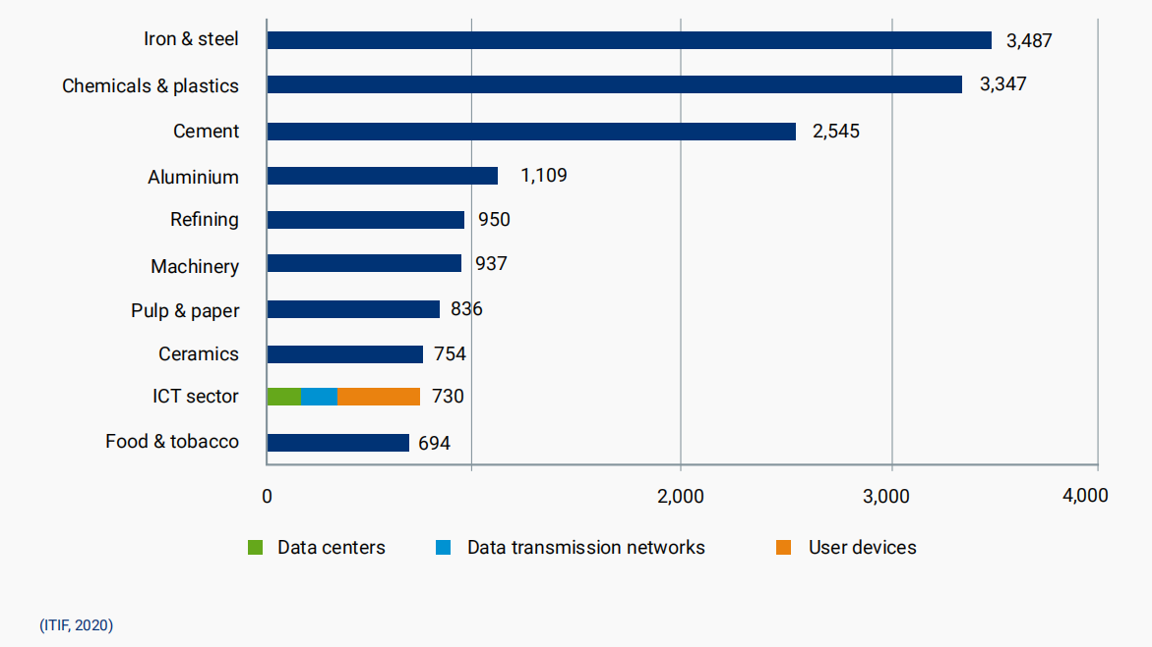

This finding supports the view that efficiency improvements and reductions in emissions intensity of electricity continue to effectively stabilize the emissions of the sector even as computing service demands rise.

Historical carbon footprint of ICT

The growth of data traffic has not resulted in a proportional growth in the energy consummation of ICT.

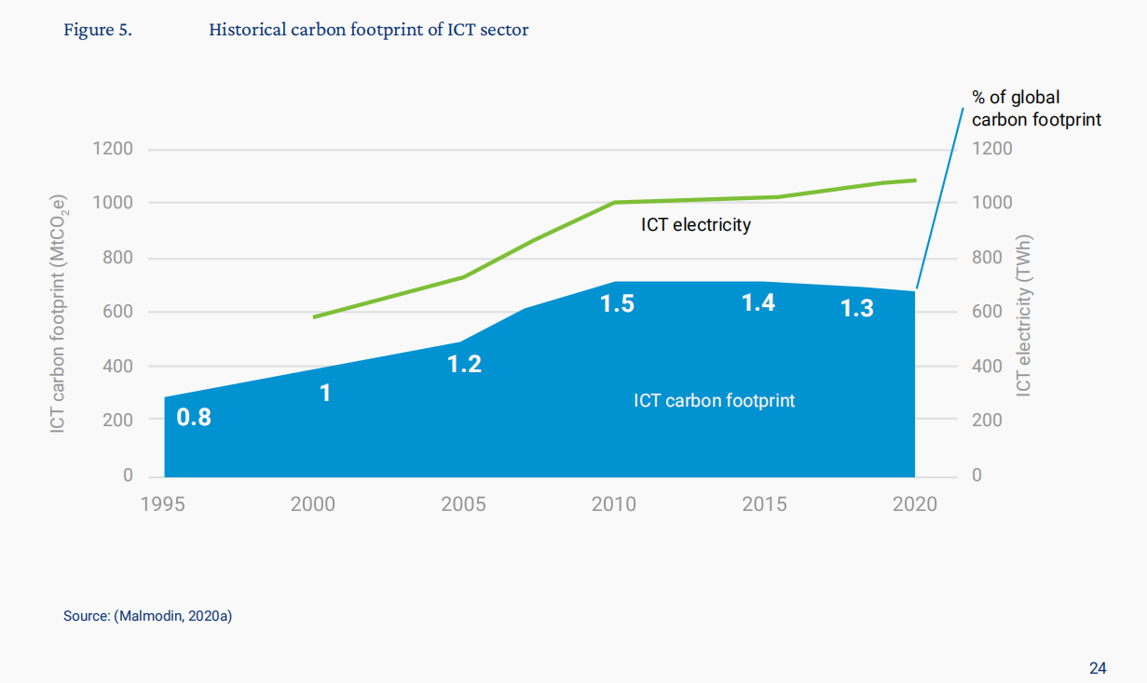

Even if there are overall increases in energy consumption, the total emissions of the ICT sector are likely to fall significantly, as larger numbers of network and data center operators move to using 100% renewable electricity, and the national electricity grids continue to decarbonize.

* The amount of carbon and energy consumed per year in Europe is little.
* The local electrical grid’s carbon intensity has a critical effect on the carbon impact of video streaming
* Some user devices have a main influence in energy consummation of all video streaming