# Chapter Two Trigger Strategy

## 2.1 Trigger Strategy Design

The trigger strategy design of Trident should not bear any physics loss, at the same time, suppress the bandwidth to satisfy the workload of data transmission. In one hDOM, 31 PMTs and 24 SiPMs are equipped. Large bandwidth from numerous photon sensors demand relative strict trigger criterion.

The framework of trigger constitutes two level. The first level is hDOM-internal trigger, abbreviated as L1 Trigger. It is the first stage to suppress the bandwidth by considering the number of PMT photon hits. The second one is referred as physics filter, generally called L2 Trigger. This part considers photon hits in adjacent or next-to-adjacent hDOMs. Physics signals will be extracted in this stage since photon hits are related mutually in space and time.

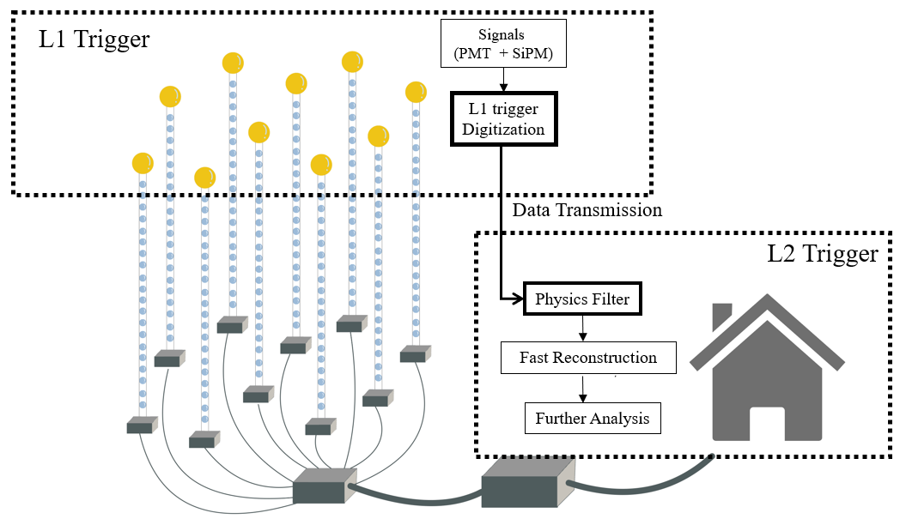

Figure Conceptual Framework of our data system. For the trigger system discussed in this paper, hDOM Internal Trigger (L1 Trigger) and Physics Filter (L2 Trigger) are two main components. Updated position information will be appended in data on shore for calculations in physics filter. The White Rabbit clock synchronization system are not involved above. From left to right, hDOM side, transmission site and on-shore site are listed in order.

Data from a local cluster of hDOMs, such as a hDOMs inside a cylinder or a sphere space will be extract for next-stage reconstruction. Some of the particle identifications can also be implemented in this phase. This part of trigger is finished at the on-shore station. Principally, in the junction boxes, part of these works can be conducted. While considering the engineering below the sea surface should be as simple and reliable as possible, we probably move the complexity on shore.

## 2.2 L1 Trigger

L1 trigger decisions will be made by only PMT. Since the dark count rate of SiPM is in the order of $O({10}^{6})$, the trigger of SiPM is not very practical. Trigger in this level is implemented inside hDOMs. The waveform of L1-triggered events will be read out for particle identification and reconstruction.

The implementation of the L1 trigger is summarized as follows:

1. If at least two different PMTs receive at least two photons in 10ns, then it is an L1-triggered event.
2. The waveform of a total of 1000ns will be read out. The first 300ns is before the L1-triggered event and the second 700ns is after L1.
3. The 1000ns read-out time window is for the entire hDOM, including 31 PMTs and 24 SiPMs.

We expect that this part, the foundation of all later data processing, will suppress background, and make no influence on the physics events. A detail that needs to be emphasized is that only two different PMTs are hit, it is an L1 trigger event. This is a tight version of the L1 trigger. It is also acceptable to loosen the criterion by allowing the two photons distributed in the same PMT. We will evaluate both the tight version of L1 (two photons in different PMT) and the loose version (two photons can be in the same PMT).

Other neutrino telescopes transmit all data to the shore and then use a series of triggers to process data. However, since the bandwidth of Trident is super high($O(TB/s)$,for all waveforms without trigger) and the workload of optical fiber in the sea cable is limited, we may design an FPGA inside each hDOM to process this L1 trigger. All the signals will be stored in analog form in a buffer. When the coincidence condition computed by FPGA is satisfied, the triggered signals will be digitized by ADC and transmitted by cable. Otherwise, only the time and the charge of a hit will be obtained by TDC and much less information is transmitted. The physics loss in this phase is unretrievable, the criterion design must be very careful.

It is an obvious drawback that only two or more than two photons can form an L1 trigger. Single-photon condition can never satisfy the L1 trigger. This single photon from physics events can still carry some information that may be helpful for energy and direction reconstruction. Since the dark count and most K-40 decay generate single photon hit, it is quite difficult to distinguish a photon’s origin. A possible solution is that when a higher-level trigger is satisfied, all data from the entire detection array or a large cluster of hDOMs are read out. Moreover, TDC readout method should also be considered, because the bandwidth from TDC is quite small. L1 trigger itself cannot save single photon from physics signals. A no-loss solution of readout method can be proposed:

1. No-trigger readout of the TDC information of PMT (preliminary estimation result of this part of bandwidth is 20MB/s/hDOM)
2. When the number of PMT coincidence photon number is greater than 2/3/4, PMT waveform ADC readout + SiPM TDC readout (bandwidth estimation will be discussed in the latter chapter)

The specific number will be determined by the bandwidth upper limit.

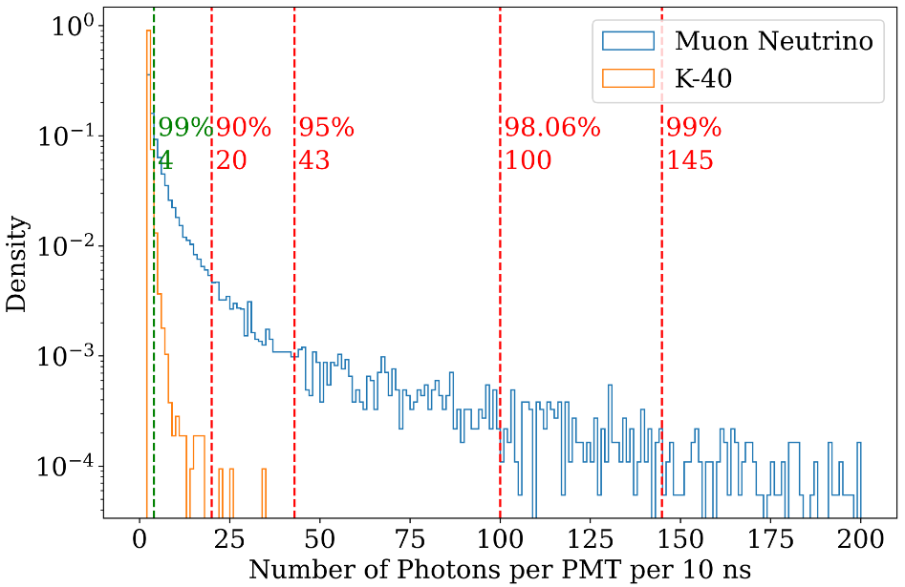

Figure The photon number distribution for a single PMT in 10 ns trigger time window. 10k muon neutrinos ranges from 1TeV to 10 PeV are simulated. The number of landed photon is much larger than the K-40 events. This characteristics of photon multiplicity is the foundation of our L1 trigger. K-40 events mostly generate less than 4 photon hit, while muon neutrino events can generate up to hundreds of photon hits.

The implementation of L1 Trigger relies on electronics design. The general framework of electronics is described below.

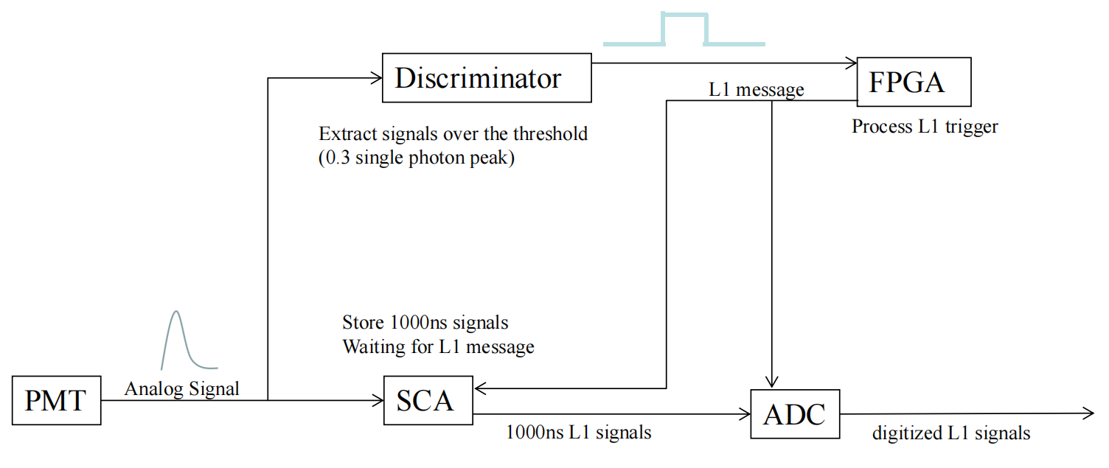

Figure The conceptual framework of electronics. It is worth mentioning that when ADC reads triggered data from SCA, time consuming is around three times of trigger time window, which is 1000 ns. So 3000ns dead time is expected for each L1 trigger, due to the read-out process of ADC.

## 2.3 L2 Trigger

L2 Trigger is generally referred as physics filter. The main purpose of this part is to extract physics signals. This part is the subsequent procedure of L1 trigger and the guiding process before reconstruction. The function will be implemented in the computation infrastructure on the shore. The idea can be generally summarized as convex envelop search. For a series of photon hits distributed in 3D space and time(4 dimensional linear space), we should find a boundary to capsule all points without physics loss by considering the characteristic of physics signals, and the boundary should be as small as possible to reduce data amount.

For muon neutrino events, tau neutrino events, electron events, and atmospheric events, the signatures are widely different. Different reaction channels and different energies of the event corresponds to different size of boundary. Normally, for a 100TeV shower event, tens of hDOMs will be lightened. For 100 TeV track event, hundreds of photons will land in tens to hundreds of hDOMs. Time distribution for single PMT ranges from ten to one thousand nanoseconds. This feature requires that the physics filter should be loose and run in parallel to involve all situations. A strict ‘envelop’ involving all hits without redundancy is not practical without detailed reconstruction. Physics Filter phase does not involve complex computation. Simple and fast methods should be developed.

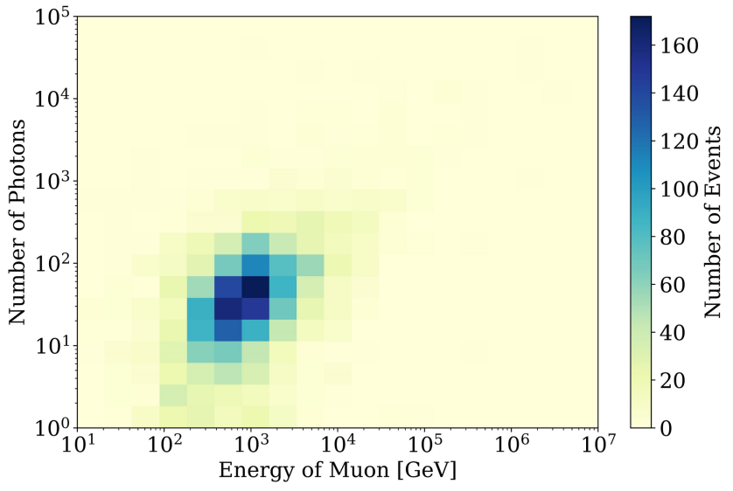

Figure Number of photons received from muon events from simulation. Quantum efficiency of photon sensors is considered. Large white area in the picture is due to a lack of statistics. If enough events are simulated, a linear blue band are expected since the number of photons should be proportional to the energy. But we can conclude that the photon number is distributed in very wide range for the events with the same energy. The wide distribution leads to relatively loose parallel physics filter.

We can first use a L2 trigger(level 2, a higher level than L1) to mark those corelated events, which is an indication of physics signals. The L2 trigger’s idea is basically the same as L1 trigger. It only considers the coincidence between 2 adjacent or next-to-adjacent hDOMs. If two L1-triggered hDOMs are adjacent or next-to-adjacent within around 1000ns, then these two hDOMs are L2-triggered. L2 triggered events is a strong indication of physics event instead of ambient noise.

Cylinder method and sphere method are proposed as preliminary solution for muon events and shower events. Once there are multiple L2 events or mixing of L1 and L2 events in the same cluster, these methods can be applied to the cluster of data for latter analysis.

1. cylinder method

The idea of the cylinder method is that photons from track-like events propagates within several times of absorption length of seawater. It is very safe to argue that almost 100 percent of direct photons are constraint in the length of 5 times of attenuation length (99.32% around 100m). So for track events, hDOMs in a large cylinder can involve all physics information. In this sense, data from only a proportion of detection arrays is processed. This helps to release the pressure of latter reconstruction computation. The direction of the cylinder can be selected from simply calculate the expected arrival time of photons. The complexity of the calculations is *O*(n). The calculated value should be close to the real occasions. The vertex of the muon track can simply use the center of mass of photon hits.

1. sphere method

For cascade-like events, electrons and gamma rays generate large optical photon shower within tens of meters. The photons from same events all obey the law of causality since they originate the same high-energy particle. When the number of L2 events occurs and their maximum distance is smaller than a certain value, data from hDOMs inside a sphere will be transmitted for reconstruction. The radius of sphere will be a redundancy length (for example, 100m) plus the maximum distance from the center of mass to the photon hits point.

In essence, these two methods rely on the characteristics that all physics events are local. A portion of hDOMs is enough to include all information. So not all hDOMs are used for reconstruction. The preliminary quantitative discussion is in the latter chapter.