# Chapter Three Performance of Trigger

The quantitative evaluation of the hDOM internal trigger (L1 trigger) is presented in this chapter. We conduct a Geant4 (a platform in C++ using Monte Carlo methods to describe the passage of particles through matter) simulation to test its background suppression ability and the physics loss due to the trigger. The bandwidth estimation of both noise and signals is also conducted for the guidance of hardware design. The upper limit of bandwidth should be in the range of the workload of our data system. The data amount in the future detection array should be computable and transmissible. Also, theoretical calculations are conducted specifically for dark noise.

## Simulation Framework

In our simulation framework, we construct one hDOM in the center of a sphere water world. When muon events are injected, the radius of the water world is 100m. When K-40 events are sampled, the radius of the water world is only 30m, since most coincidence events are in very short-range limits. Cherenkov radiation can be generated in the process and captured by the PMTs inside the hDOM in the center. When the Cherenkov photon hits the PMT surface, their time, energy, and PMT ID will be stored in a root file. A Python analysis program will apply the L1 trigger algorithm to the dataset generated from Geant4. The purpose of the framework is to generate simulation signals and noise in one hDOM, and apply the trigger algorithm with adjustable parameters such as the time window, to finally evaluate the general performance of a certain set of parameters. The parameters of the L1 trigger are named as the coincidence photon number and the time window . If photons are captured in ns, then the hDOM is L1-triggered. The difference between the two versions, namely the requirement of different PMTs, of the L1 trigger will also be discussed. And a 1000ns length digitized signal will be transmitted.

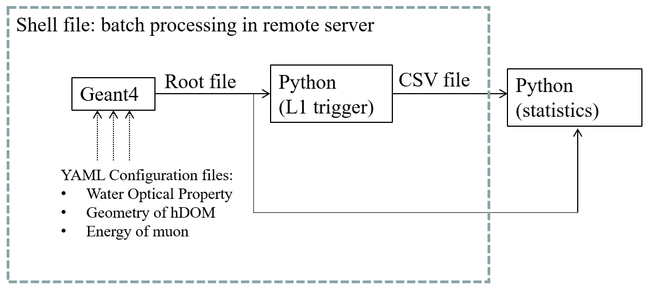

Figure Workflow of the simulation project. The geometry layout of PMTs and SiPMs in hDOM, muon energy, and the water optical property are adjustable. Batch processing, which helps to significantly reduce the running time, replaces parallel computing to some extent.

The optical property of seawater including phase refractive index, Rayleigh scattering length, Mie scattering length, Mie scattering angle, and absorption length is set for all wavelengths. The group refractive index can be automatically processed by the Geant4 build-in function.

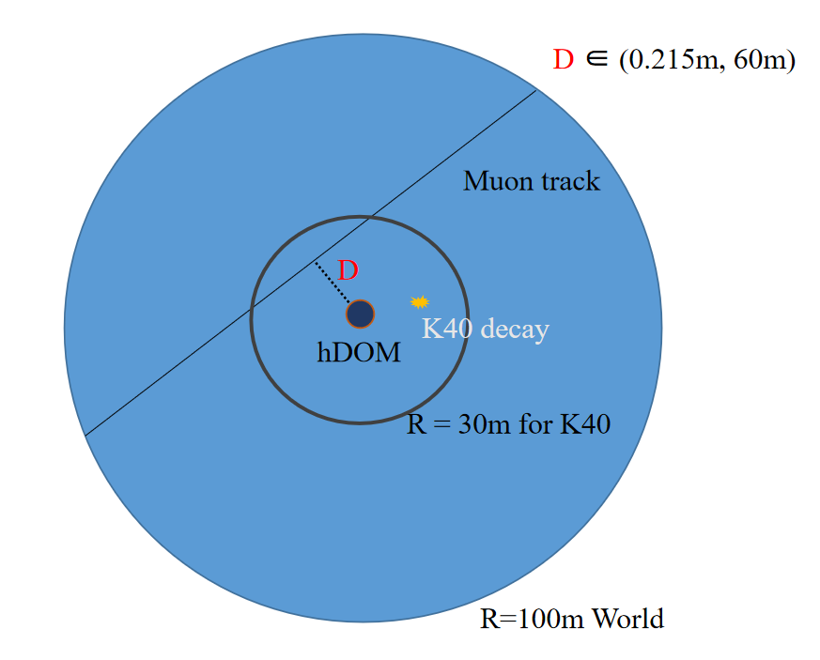

Figure 17 Geometry of Geant4 simulation project. The geometry of hDOM is set basically the same as the situation in Figure 3. The outer glass shell, optical gel, and part-sphere-shaped PMTs are established.

For K-40 decay events, there are two branches. 10.698% of events generate 1.459 MeV mono-energy gamma rays, and 89.302% of events generate electrons. The energy of electrons ranges from 0.1MeV to 1MeV. Other secondary particles such as neutrinos from this beta decay are not observable. The source of optical photons in essence is around ten percent gamma rays and ninety percent electrons. So we inject electrons and gammas corresponding to the branching ratio and energy spectrum to simulate the decay events. As for the position of the decay events, uniform distribution in 3D space is assumed. The seawater is homogeneous in terms of radioactivity.

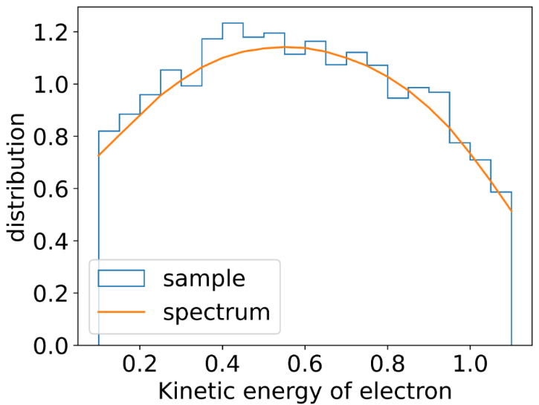

Figure kinetic energy spectrum of electrons from K-40. The yellow line is from theoretical results. The histogram is sampling results from the Geant4 simulation. Most of the electrons possess enough energy to emit Cherenkov radiation.

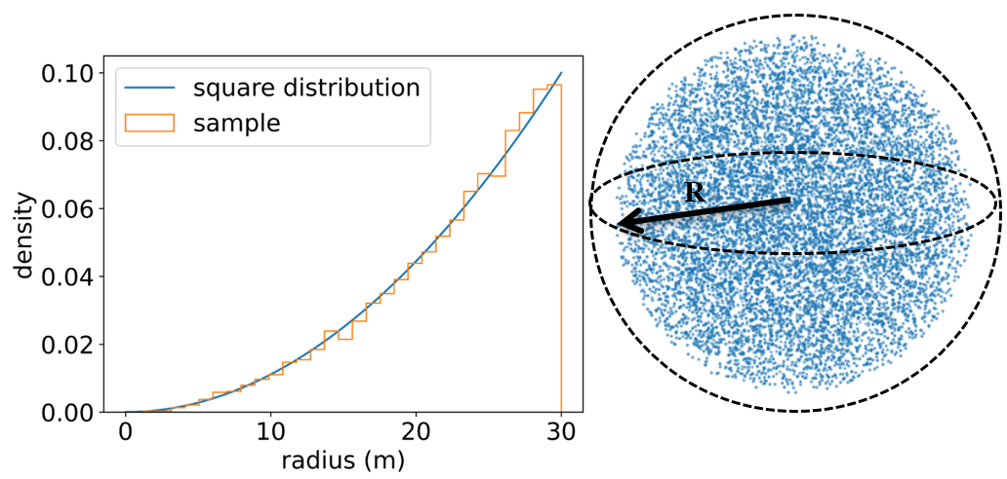

Figure The position sampling of K-40 decay. Left panel: theoretical results of square distribution and the sampling result. The radius of uniform positioning in a sphere should obey square distribution. Right panel: 3D scatter visualization of the sampling result.

For the muon track, the distance from the hDOM to the track and the energy can be manually adjusted in each simulation. The direction of muons is uniformly distributed. We focus on the distance at around 30m and the energy is around hundreds of GeV to several TeV. Since this part is the subtlest region. When the energy is higher, or the distance is closer, the specific trigger algorithm does not matter anymore, since the event is bright enough.

### 3.1.1 Analysis method

To process the root file from Geant4, a Python script is created. Part of the photons are abandoned according to the quantum efficiency property of PMT. Then the photons are sorted by the arrival time in ascending order.

Then, in order to check if there are photons in ns, the time difference of the previous photon and the latter photon is calculated. The complexity of this step is *O*(n). Secondly, we check if the sum of intervals is smaller than ns. If it is smaller, then an L1 trigger event is set. All photons within 1000ns time window will be labeled as L1 photons. It is very fast if the numpy or pandas package in Python is included in the second step since they all run in parallel. If the coincidence photons are required to fall on different PMTs, an additional ‘if’ statement is implemented.

The PMT ID of L1 photons is sometimes also put in use. Since we may pick up the photons landed in adjacent PMTs for other analysis purposes.

All L1 photons will be selected and stored in another CSV file for latter analysis. The rate of the K-40 L1-trigger event is calculated by the number of L1 photons divided by . As for the success ratio of muon events, we check if a muon can generate L1-triggered photons. If there is, then the muon is labeled as successfully L1 triggered. The success ratio of muon events is calculated by the L1-triggered muon divided by the total injected muon.

The Python script can process different and in parallel. The most time-consuming process in the analysis generally is readout and write-in procedure. The total run time in the server is controlled down to several seconds for one single set. We scanned the phase space of L1 trigger set.

## Background Reduction

### 3.2.1Dark Noise

This part is conducted by theoretical calculation. Dark noise, or dark count, is the inherent thermal property of photon sensors. We assume the frequency of the dark noise is . This number is 300Hz/PMT or 300kHz/9mm^2 SiPM at around 2 degree in Celsius(deep sea temperature from experiment). And the time of dark noise photon is sampled in uniform distribution. The probability to expect photons in ns is described by the integral of the gamma distribution. L1 false trigger rate R by dark noise is given below.

The parameter is the expected time interval between two dark photon hits. The parametrized function is defined as:

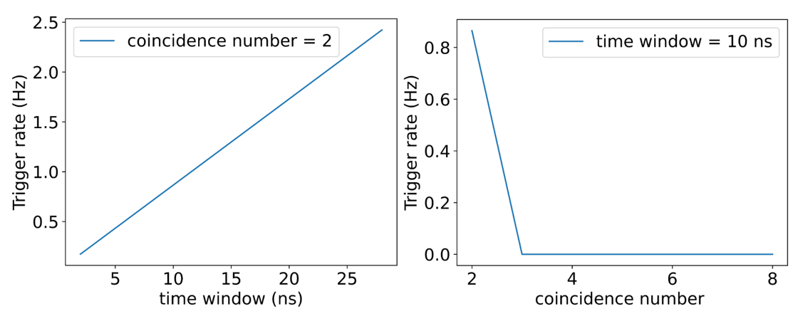

Figure The left panel: the trigger rate vs time window

The right panel: the trigger rate vs coincidence number . At most, when , the trigger rate is 2.4Hz, three orders of magnitude smaller compared with K-40. For those coincidence photon number is larger than 2, the trigger rate is negligible. When , the trigger rate is 0.00005Hz.

The calculation above does not consider the requirement that two photons should be in different PMTs. It is the loose version of L1. Even though we choose the loose version, the rate is still negligible.

The difference between the loose and tight versions of L1 on dark noise is quite small in fact. It is quite rare that two coincidence photons happen in the same PMT among 31 PMTs, so whether or not to regulate the two coincidence photons occur in different is not important at all. Probability calculation shows that there is only a relative difference between the two versions of L1.

### 3.2.2 K-40

The K-40 decay events are the most dominant noise source for Trident. So we should understand the behavior of hDOM response to K-40 well. The activity of K-40 is around 10Bq/L (10.87Bq/L as simulation input in this chapter), and seawater within tens of meters can contribute to photon hits. The Cherenkov threshold for electrons in seawater is around 0.3MeV. Most electrons from K-40 decay can generate numerous optical photons by Cherenkov radiation. This leads to the result that the rate of noise hit from K-40 can reach up to around 60k Hz per 31PMTs in one hDOM (), according to the previous simulation result. We generally present the results analyzed under the loose version of L1. The different PMT condition is not added. This shows the lower limit of the background reduction ability.

After L1 Trigger processing, the K-40 event rate is reduced by around two orders of magnitude. The L1 event rate per hDOM (31PMT) induced by K-40 is studied. We adjust two parameters of L1 trigger, coincidence photon number and time window . An L1 event is defined as at least photons occur in ns at different PMTs in one hDOM.

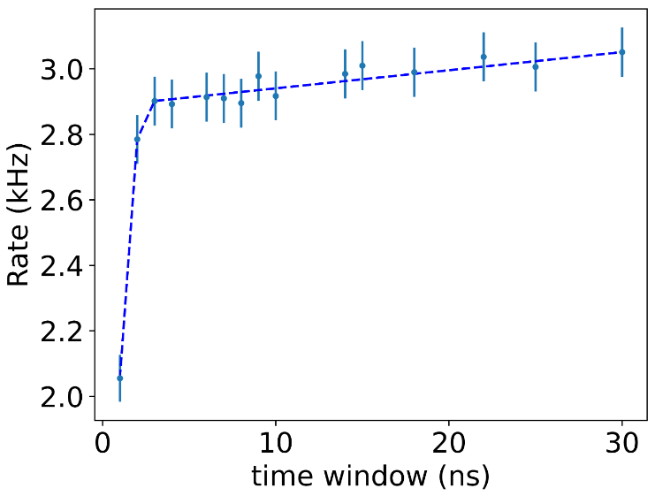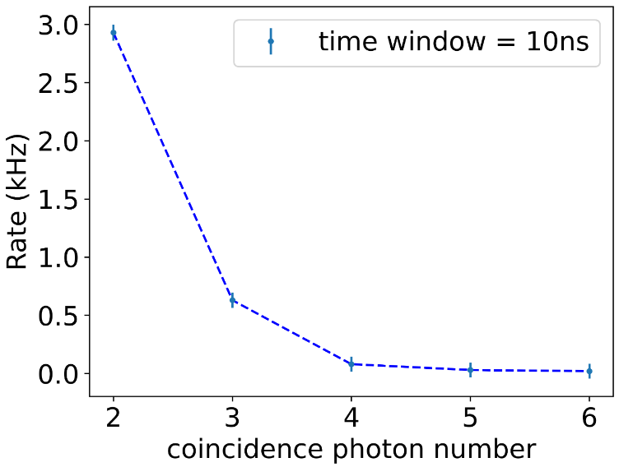

Figure K-40 Trigger Rate in one hDOM. The left panel is the K-40 trigger rate changing along with the time window . The right panel is the K-40 trigger rate decreases as the coincidence photon number increasing. We do not require that two coincidence photons should be in different PMTs. If do so, the rate shown above will drop around 50%.

These coincidence photons mostly come from the same decay events, so the expected time interval of coincidence photon pairs is quite small in fact, as shown in Figure 23. As the time window increases, those photons which possess a larger time interval can pass the L1 trigger. So The trigger rate is gradually increasing. After the time window becomes larger than 10 ns, almost all coincidence photons have already been involved and the trigger rate become gradually saturated.

Finally, as the time window approaches 30 ns, the trigger rate seems to converge to around 3kHz (If the different PMT condition is added, it will be 1.5kHz ). The message we can take from the trend is that after a certain value, such as 10 ns, the time window is not important for the L1 trigger. The algorithm is not sensitive to this parameter anymore.

The coincidence photon number is another parameter in the L1 trigger algorithm. It describes the threshold in the photon multiplicity. The K-40 L1 trigger rate decreases sharply as the number increases. It is intuitive to think that if the probability that one K-40 decay generates a photon that can land in the hDOM is , then the two-photon case corresponds to and the three-photon case is . The probability here describes mainly the absorption effect of seawater. And the number uncertainty of Cherenkov photon emission can also influence slightly. Consider 2 photons in 10ns and 3 photons in 10ns, the former one is 2.9kHz while the later one is 0.6kHz. Increasing the photon number threshold is quite effective in L1 trigger to reduce the K-40 decay events.

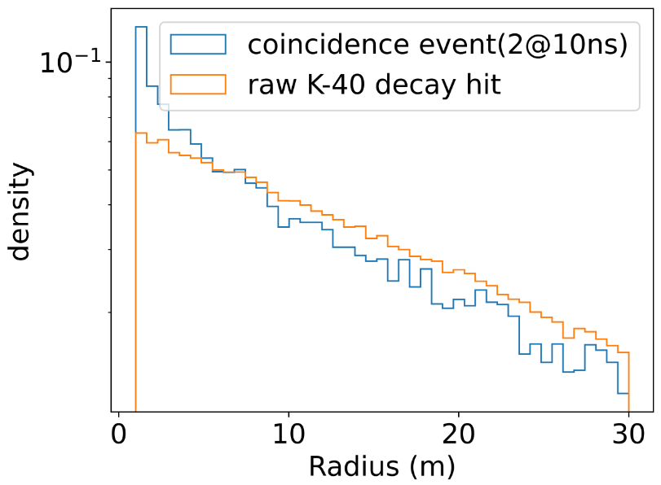

Figure The radius that detected K-40 decay events occur. The x-axis denotes the distance between K-40 events and the hDOM. We can notice that captured double coincidence events are more likely to happen near the hDOM, which leads to the fact that double coincidence is rarer than single hits. This is also a reason for our simulation to choose 30 m as the total radius of the world. Coincidence events basically only happen near the hDOM. If conducting raw hit rate analysis, a larger radius is required.

As the radius increases, the volume of water space increases (). Meanwhile, the solid angle of hDOM to the K-40 events is decreasing correspondingly (). The radius factor is canceled mutually. So the trend that coincidence events are closer to hDOM in Figure 22 comes from the absorption of seawater. If the K-40 decay event is far from hDOM, then emitted photons will be largely absorbed. This absorption effect reduces the photon multiplicity, which providing the guidance of L1 trigger design.

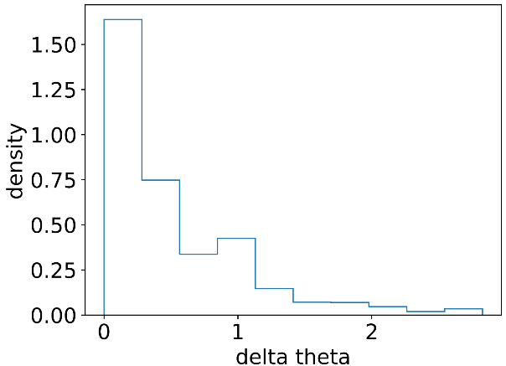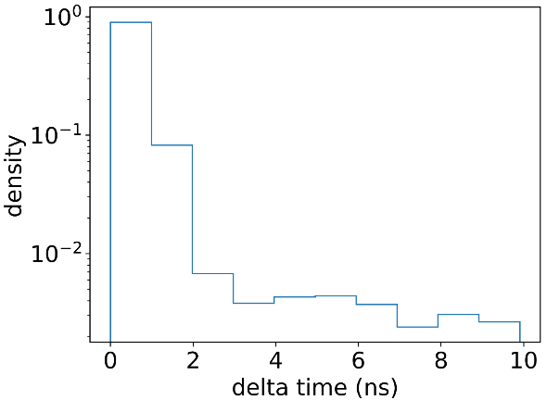

(rad)

Figure The left panel: time interval of two coincidence photons. The left panel: the angle difference of two coincidence photons on the hDOM. The trends in two pictures are similar.

The space and time distribution of photons from K-40 decay on the hDOM is the key factor to be considered in designing L1 trigger. The PMTs is not distributed evenly on the hDOM, while the K-40 decay events are uniformly set in space and time. In the end, all PMTs possess equal chances to capture photons all the time. The characteristic in Figure 23 shows that a coincidence pair is very likely to gather together in both space and time. 46.32% of coincidence photons fall in the same PMT. This is the reason to develop a tight version of the L1 trigger (we can reduce the 46% by regulating photons should be in different PMTs). Moreover, the time interval is quite small. This is the reason that the time window does not matter very much in the L1 trigger (the expected time interval is 0.6ns without considering the TTS of PMT. It is still much smaller than 10ns).

Another key dimension of the trigger algorithm is the output bandwidth. We choose to read all waveforms of the PMTs and all TDC information of SiPMs. The factor that converts the Hz value to the bandwidth in MB/s is given by the expression below.

f1 and f2 is computed from PMT and SiPM digitization methods correspondingly. After multiplying these two factors, Figure 21 will be converted to Figure 24. Bandwidth per hDOM is shown, which is almost the total output bandwidth for one hDOM.

Figure Bandwidth Estimation: K-40 L1 trigger rate

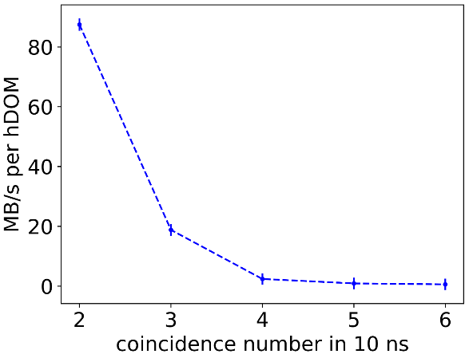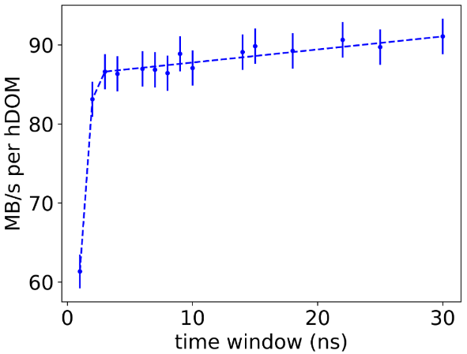

## Signal Event Evaluation

Muon events are simulated to evaluate the efficiency of L1 trigger algorithm. Muons deposit energy in water by both stochastic process and ionization. While the latter process only generates a large number of low-energy electrons, whose energy will not be recorded by hDOM. Cherenkov photons from muons as well as stochastic energy loss will be captured. Since the muon track is quite long, and the Cherenkov angle is relatively fixed, the reconstruction error is the smallest among all other neutrino reaction channels. It is the golden channel to search sources by muon for the neutrino telescope. We expect that muon events should be L1-triggered when the energy is enough or the distance is small. The results presented below are all conducted by the tight version of the L1 trigger. We demand that photons should be distributed in at least two PMTs. This shows the upper limit of physics loss of our algorithms.

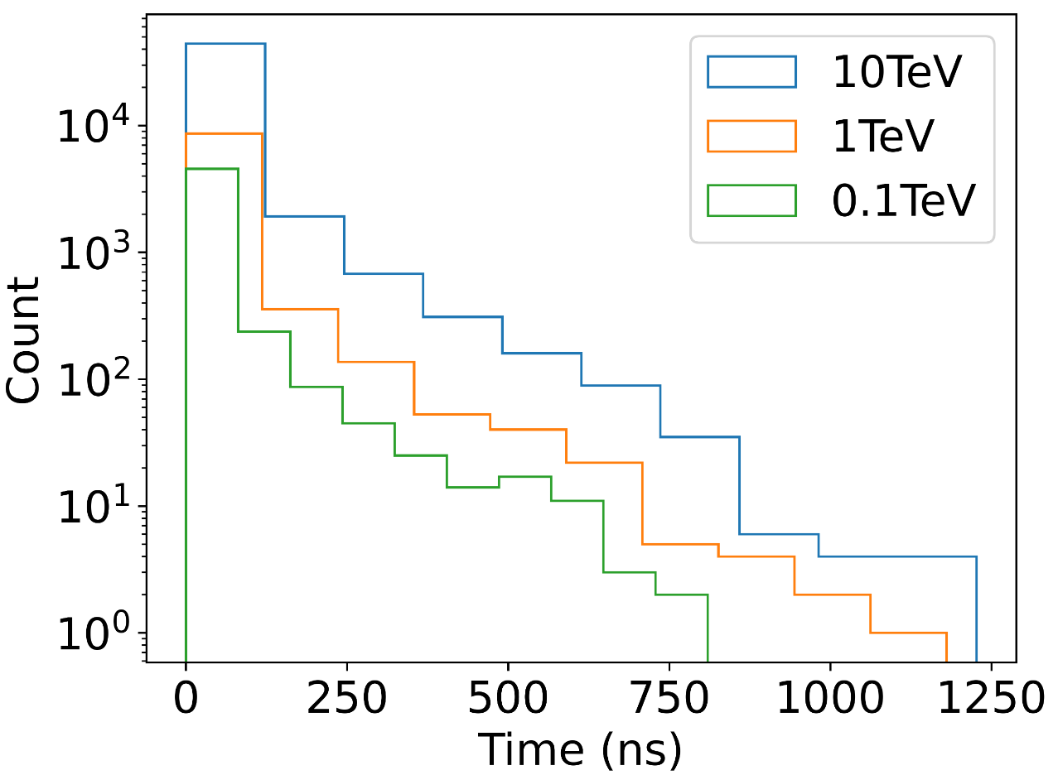

Figure Stacking hit time distribution of Muon events.

In Figure 25, 1000 muon events in three kinds of energy travel through one hDOM, and the distance is fixed at 30m. The direction of muons is randomly sampled. The total number of photons is proportional to the energy as the sample number is fixed. The time distribution shows the trend of exponential decay. Most photons are limited to a short time range. The tail of time distribution is quite long. This is due to the scattering effect as well as potential stochastic energy loss. Generally, the long tail occupies quite a small percentage.

The number of photons from a muon track satisfies the following expression:

here denotes the attenuation length. factor comes from the column symmetry. The rough fitting of the photon number from the simulation shows that is about 16.1m, close to the water optical parameter setting.

The L1 trigger ratio is calculated to mark the ability of the L1 trigger algorithm to retain muon events. This ratio is defined as

When distance between the hDOM and the track is very far, or the energy is small, the ratio will be quite small. When the distance is small or the energy is large enough, we expect that the ratio can reach 100%.

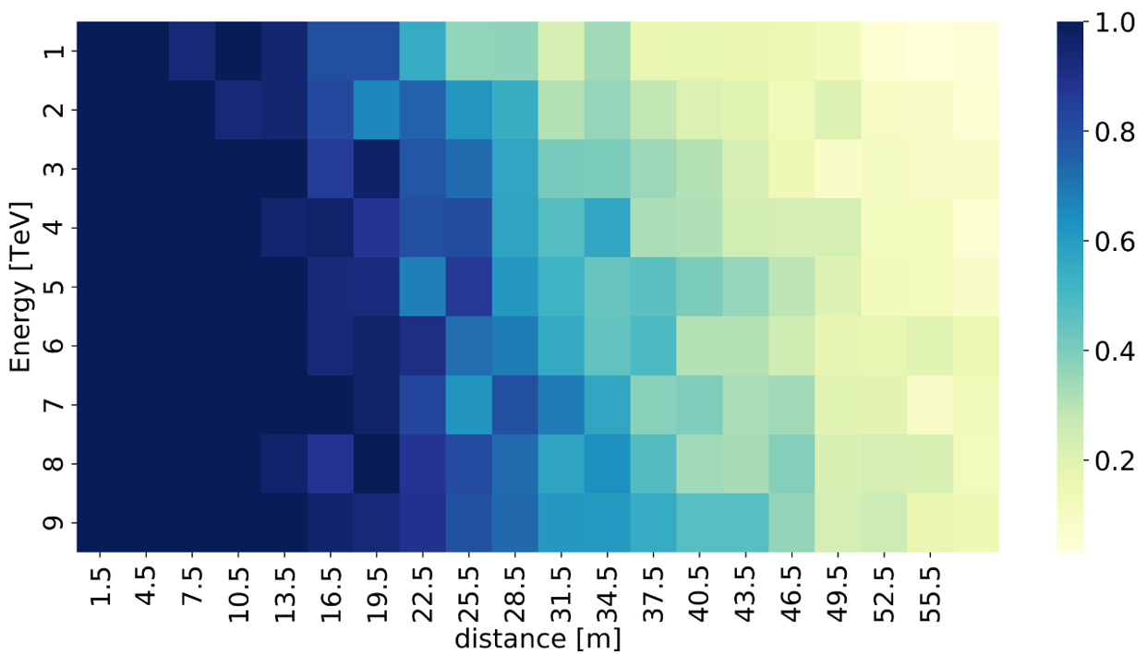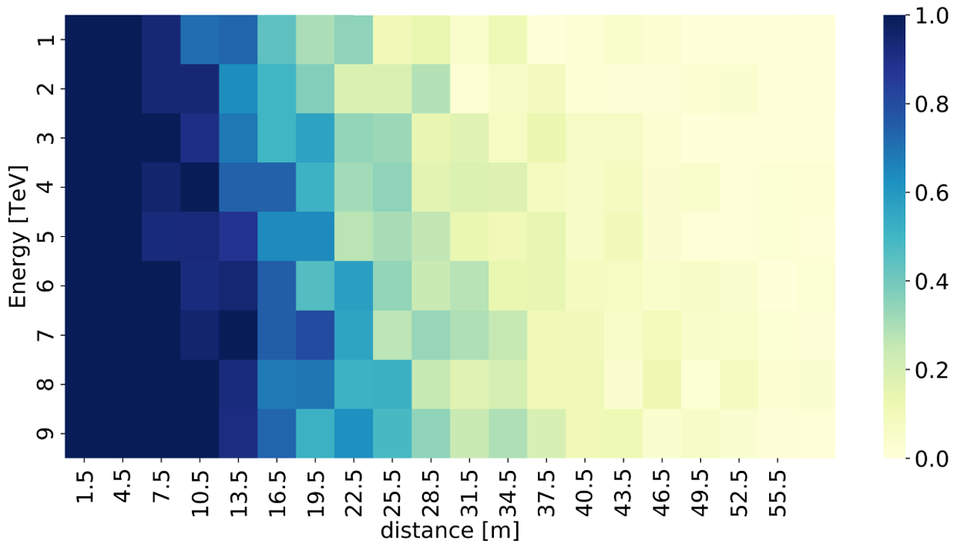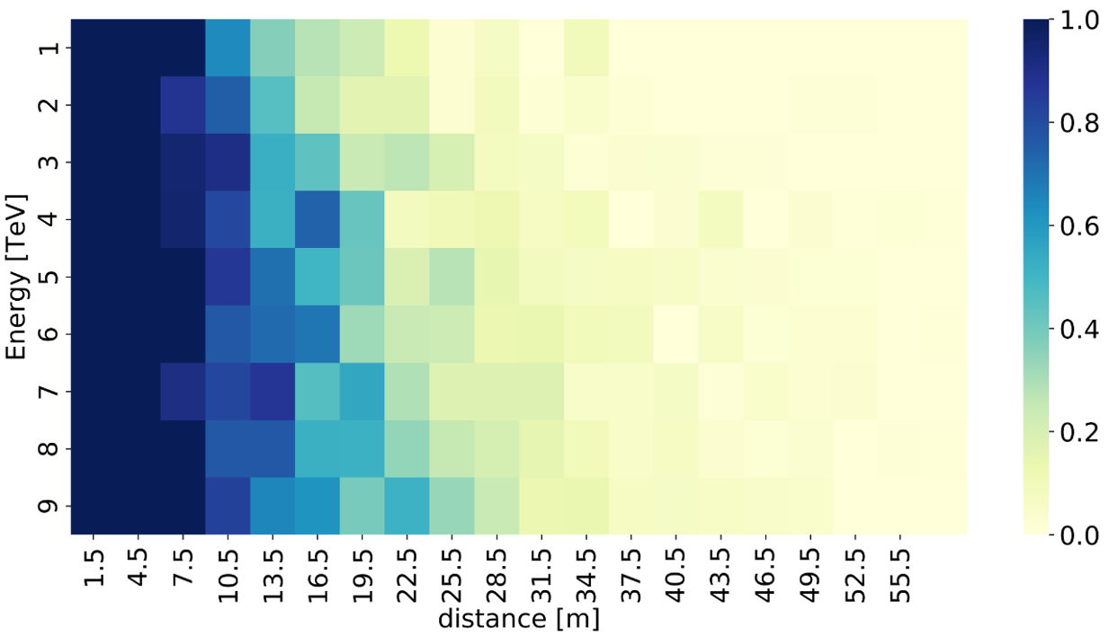

Figure The L1 trigger ratio VS the energy and the distance of the muon track.

The top panel: the ratio of muons that generate hDOM photon hit and total muon set. The middle panel: the ratio of L1 triggered muons and total muon set when.

The bottom panel: the ratio of L1 triggered muons and total muon set when

The trend from the top to bottom in Figure 26 shows that blue part (more blue, higher ratio) gradually fades, as the stricter trigger criterion is applied. L1 trigger algorithm will more or less confine the muon events in the subtle region (energy is around 1TeV, distance is around 20m). In the real case, one muon track will pass through multiple hDOMs, some of them will be L1-triggered while others are not. The L2 trigger such as the cylinder method should be involved in this analysis when making decisions.

Figure More precise depiction of the L1 trigger ratio. The left panel: the L1 trigger ratio VS the time window . The right panel: the L1 trigger ratio VS the coincidence photon number .

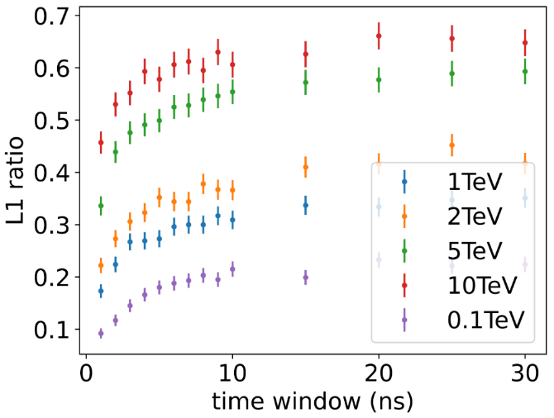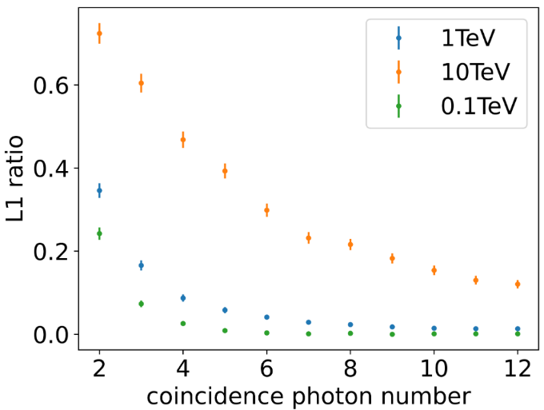

The trend meets our expectations in the above figure. The looser our L1 trigger algorithm is (larger time window and smaller coincidence photon number), the more muon events can pass the trigger. The conclusion from this figure is the same as the K-40. L1 is not sensitive to , while stays quite sensitive to . Because the time interval of coincidence photons from muons is quite limited. The photon multiplicity in the end is still the most important of all.

The bandwidth estimation of atmosphere muon events is around 1MB/s/hDOM. The calculation here is conducted by assuming 7kHz atmosphere muon rate and 100 photons on average for each muon. Then the bandwidth is calculated by

The number might not be accurate since the rate of atmosphere muon as well as the number of photon emission strongly depends on energy. It is far from accuracy to only use one number to represent all. But the order of magnitude is not that far. The bandwidth is much smaller than K-40 (~80MB/s).

## 3.3 Summary

1. dark noise

The raw dark count rate is 9000Hz for 31PMTs. After L1 trigger, this rate becomes around 1Hz. The bandwidth is negligible.

2.K-40

Reduction of K-40 strongly relies on the coincidence photon number , instead of the time window . If we regulate that those photons should be in different PMTs, 46.3% of coincidence events can be removed.

The bandwidth estimation is shown in Figure 24.

3.muon events

The time window is not a very sensitive parameter, while the coincidence photon number is. The detailed response of L1 trigger ratio with energy and distance is in Figure 26 and Figure 27.

The bandwidth of muon evens is roughly on the level of 1MB/s/hDOM if ADC information of 31 PMTs and TDC information of 24 SiPMs is transmitted.