# Chapter Four Future Improvements and Outlook

## L1 Trigger Optimization

The L1 trigger currently has two version. The tight one requires the two photons on two different PMTs, while the loose one do not involve any requirements of PMT number. Another possible solution evolved of these is to regulate that two PMTs that is very close are hit, or two PMTs that is very far are hit, then it is an L1 trigger. The K-40 background reduction ability can be estimated by checking the right panel of Figure 23. If we use two PMTs that are far from each other to conduct L1 trigger, then the K-40 rate can decrease another one order of magnitude. While its influence on the loss of physics signals such as muon events should also be considered seriously.

It is still very difficult to decide what is the ultimate L1 trigger. The stricter our trigger criterion is, the more loss we are facing and the more background we can reduce. It seems that the decision becomes an endless trade-off. We either choose to go with less burden but more loss, to go with more weight but less missing. Maybe we should develop a reasonable way to define the signal-to-noise ratio on the one-hDOM level. Or we just consider the limit from the hardware capacity and use TDC to transmit everything to shore as a backup. After all, for the neutrino telescope aiming to observe the frontier, no loss in the first step should be bared.

There are still some unfinished pieces about the L1 trigger. The first one is that after 1000ns waveform readout, there is around 3000ns dead time of SCA-ADC. This is because the speed of digitization is around three times slower than the buffer. We still lack this part of the evaluation. Is it possible to overcome this in electronics? If not, what is the impact on the physics signals? It may not be a huge difference, since the 1000ns time window is long enough to include almost all for one hDOM. It is quite rare for hDOM to observe such long photon bursts.

The second one is what is the influence of the L1 trigger on cascade-like events. It is quite natural to find out that those hDOMs near the reaction vertex get an L1 trigger, while those far hDOMs are not. Roughly speaking, only 50% hDOMs are L1-triggered for a cascade event. The results are shown in Figure 28. Those hDOMs far from the shower, carrying limited information, are not likely to be triggered. 1000 10TeV electron neutrino char-current events are simulated.

The third one is that we should more or less evaluate the trigger algorithm by accessing higher-level information. Maybe simulate tens of thousands of events and draw the effective area plot of the detector. Different L1 & L2 trigger algorithms should not influence the effective area plot very much when the energy is enough (for example, above 10TeV). Since this underlying trigger algorithm should not influence the event selection (say at least 10 photons on two strings) significantly, or the design of trigger is failed.

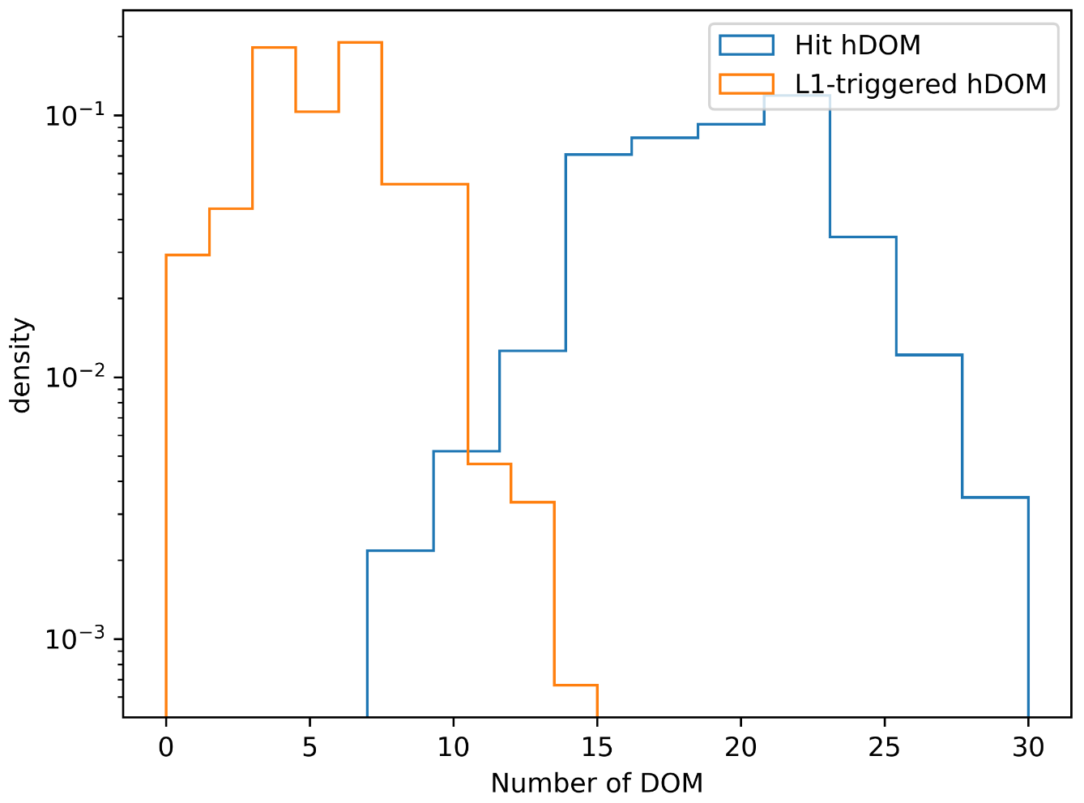

Figure 28 The number distribution of L1-triggered hDOM for an electron neutrino event.

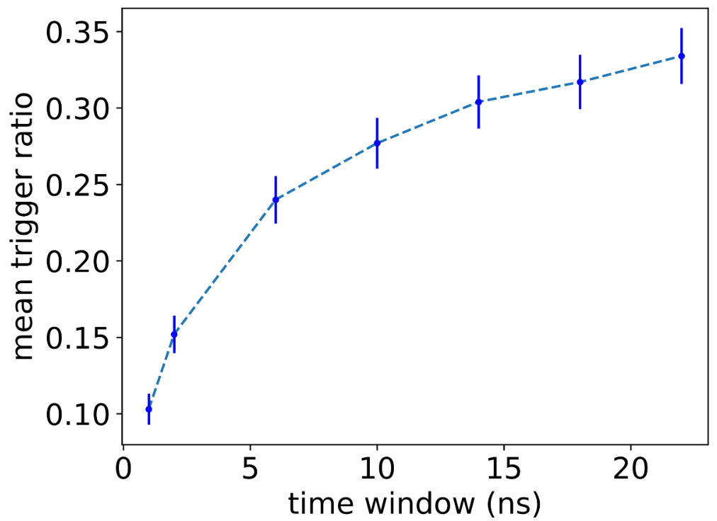

Figure 29 The mean trigger ratio VS the time window of the L1 trigger. The ratio for a cascade event is defined as the number of L1-triggered hDOMs divided by the total number of hDOMs. The curve increases slowly. After the time window is larger than 10, this ratio shows the trend of saturation. This appearance is coherent with the results from K-40 and muon events. For those hDOMs far away, only one photon is captured. It is not possible for them to pass the L1 trigger. Expansion of the time window cannot save those hDOMs.

## Physics Filter Optimization

The L1 trigger places emphasis on the K-40 background reduction. This part, named as physics filter, or the L2 trigger, will focus on the extracting of physics signals. All physics purposes can generate an L2 proposal. The threshold of a certain physics event detection should be studied. The false trigger rate induced by other physics processes and the true event trigger rate should be studied for all kinds of physics filter. The work presented here is some preliminary results. More research should be conducted in the future.

### 4.2.2 Cylinder Method

If there is several nearby L1-triggered hDOMs (say N(L1) > 3), a pre-defined set of directions which can isotropically cover the sky are tested. The following inequation is tested.

$$\left|(t_{i}-t_{j})c-(z_{i}-z_{j})\right|≤tanθ_{c}\sqrt{{(x_{i}-x_{j})}^{2}+{(y_{i}-y_{j})}^{2}}$$

A detailed description of the mathematics can be checked in (2). The idea is to extract a cylinder of hDOMs to conduct further hit selection and reconstruction. The total number of the neutrino telescope is 22420. If we only check the data from hDOMs inside a selected region, the data amount as well as the computation consumption can be significantly reduced.

In the expression, i and j are photons in the event. If most photons satisfy the inequation, then the direction is chosen.

In order to preliminarily test to the ability of the method to confine the direction, we select 100 muon neutrino events, the energy is from 10TeV to 10PeV. For each event, we randomly sample 500 directions. We check every direction by the inequations. If most photons can satisfy the inequation, then the direction is retained. Otherwise, it is dropped. We expect that only the directions that are close to the real injection direction can pass our test. If the direction is far from the real direction, most photons are not able to satisfy the inequation. Then they are viewed as ‘the wrong direction’.

The benefit of this method is that it is quite simple and straightforward. If there are N photons, there are $N(N-1)/2$ relations to be checked. In fact, it is not necessary to compute all. Randomly selecting a certain part of photons can realize our goal.

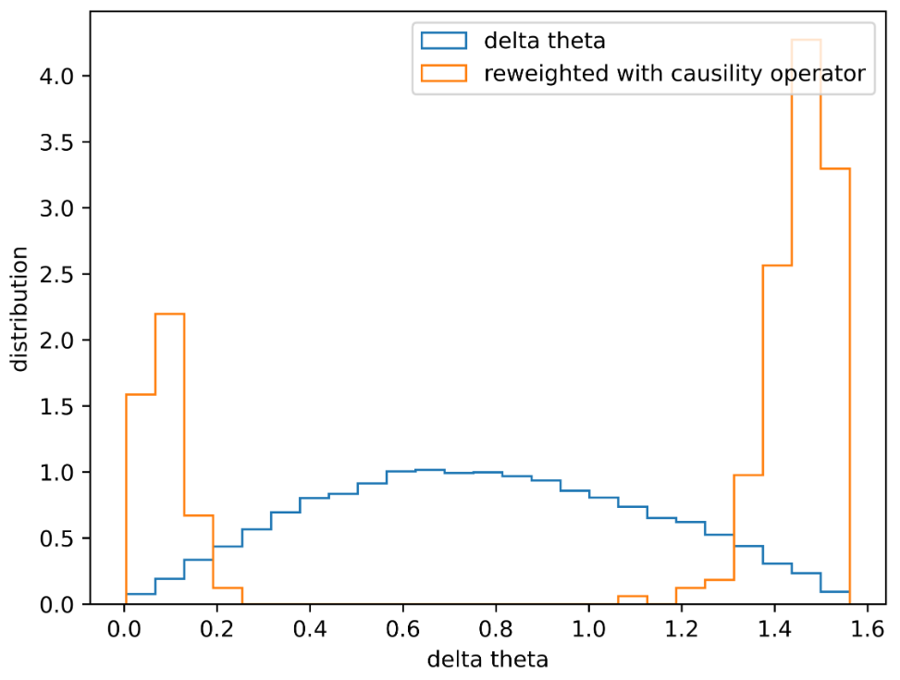

Figure 30 delta theta distribution. Delta theta here is defined as the angle between the tested direction and the real direction. The trend is consistent with the expectation. Only the direction that lays within 0.2rad error can pass the test. This result indicates that we have the ability to select a rough cylinder region for further reconstruction.

There are a lot to be done about this in the future. The generation of noise-and-signal mixed simulation dataset, the threshold of the algorithm, the radius of the cylinder, the calculation method optimization, hit selection method after this cylinder selection, and the CPU usage estimation should be analyzed and checked in detail.

### 4.2.3 Particle Identification

This step is in fact not viewed as a part of the trigger system. After the physics filter step (L2 trigger), hit selection, particle identification, and event reconstruction should be conducted. Here, we are trying to implement a fast calculation to distinguish track-like events and cascade-like events. We define the ‘inertia tensor’ of photons.

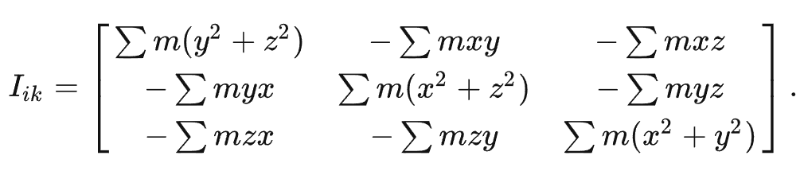

The parameter ‘m’ in fact is the charge. The x,y, and z is the coordinates of the photon hit.

We use the value T to evaluate the shape of the photons. T is defined as

$$T=\frac{I_{max}-I_{min}}{I_{max}+I_{min}}$$

$I_{max}$ and $I_{min}$ is the maximum eigenvalue and the minimum eigenvalue of the inertia tensor. For a perfect sphere, T is zero. And for a ideal thin stick, T is zero.

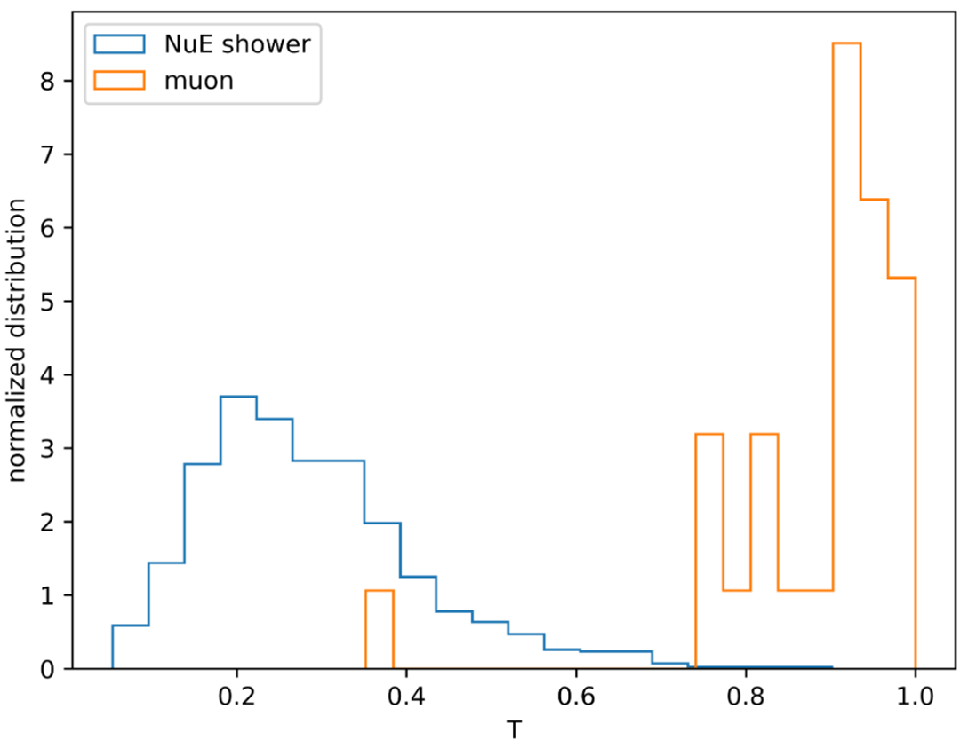

Figure 31 The T value distribution for both track-like events and cascade-like events. 29000 NuE events and 1000 muon events are simulated. Actually, two distributions are overlapped a little bit, which indicates there should be a threshold. In the future, more statistics magnitude should be involved. And energy and time dimensions should be considered and analyzed.